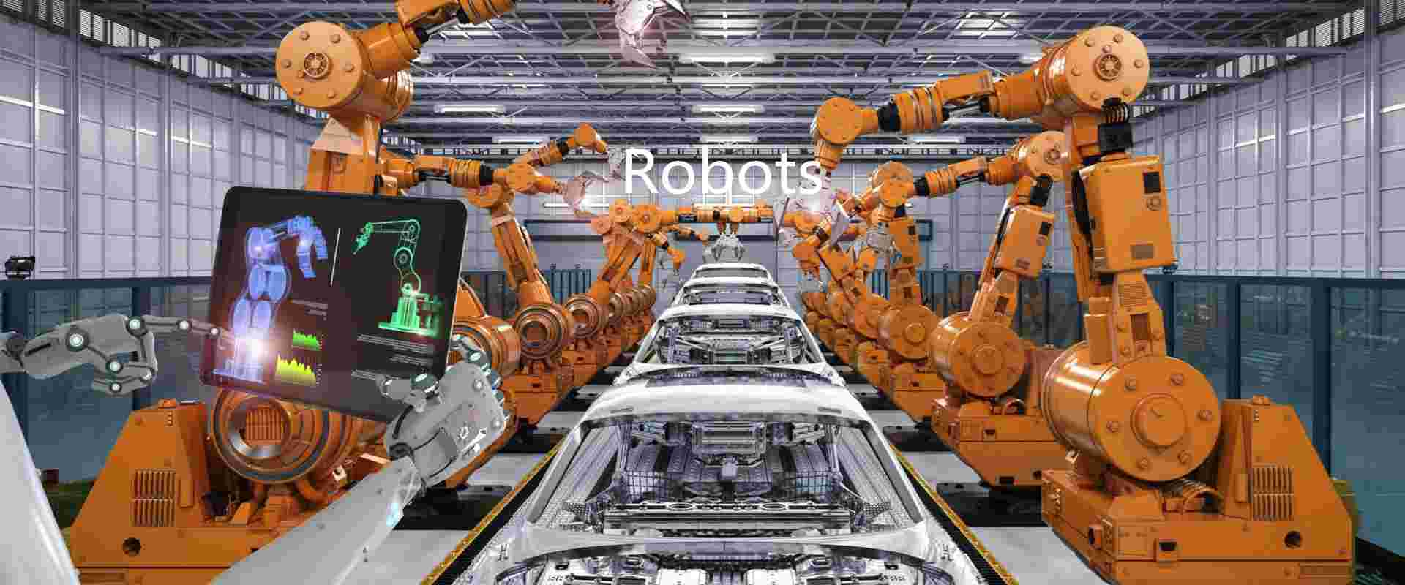**Robots in Industries**

**About the College**

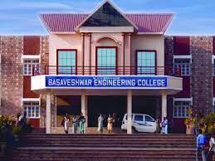Basaveshwar Engineering College was started in the year 1963 offering bachelor degrees in Civil, Mechanical and Electrical Engineering. At present it offers degree programs in ten disciplines and ten post graduate programs including MBA & MCA. The College is a Government aided institution affiliated to Visveswaraiah Technological University (VTU), Belgaum in Karnataka and approved by All India Council for Technical Education (AICTE), New Delhi. Eight departments of the college have been recognized as Research Centers by VTU. Also five departments are recognized as QIP Centers for Ph.D programs by AICTE New Delhi. The college was granted autonomous Status by VTU and UGC in the year 2007. Since then the college has introduced Academic reforms by restructuring the curriculum keeping in view the technological developments and needs of the industry. The College has been selected under TEQIP phase II for scaling up PG and demand driven Research programs. Under this program new research laboratories and facilities have been created for the benefit of PG Students and research scholars to carry out high quality research work.

Name: Devi Suma Nayaka M

Semester: 6th

Course: Bachelor of Engineering

Branch: Electrical and Electronics Engineering

**About the Company**

Headquartered in Haryana, India, JBM Ogihara Automotive India Lmt. was founded by a pool of live wire professionals having several years of combined technical and corporate expertise in providing high quality, cost-effective and complete end-to-end solutions to its valued customers. All our team members are highly qualified in their respective fields and have years of industrial experience behind them.

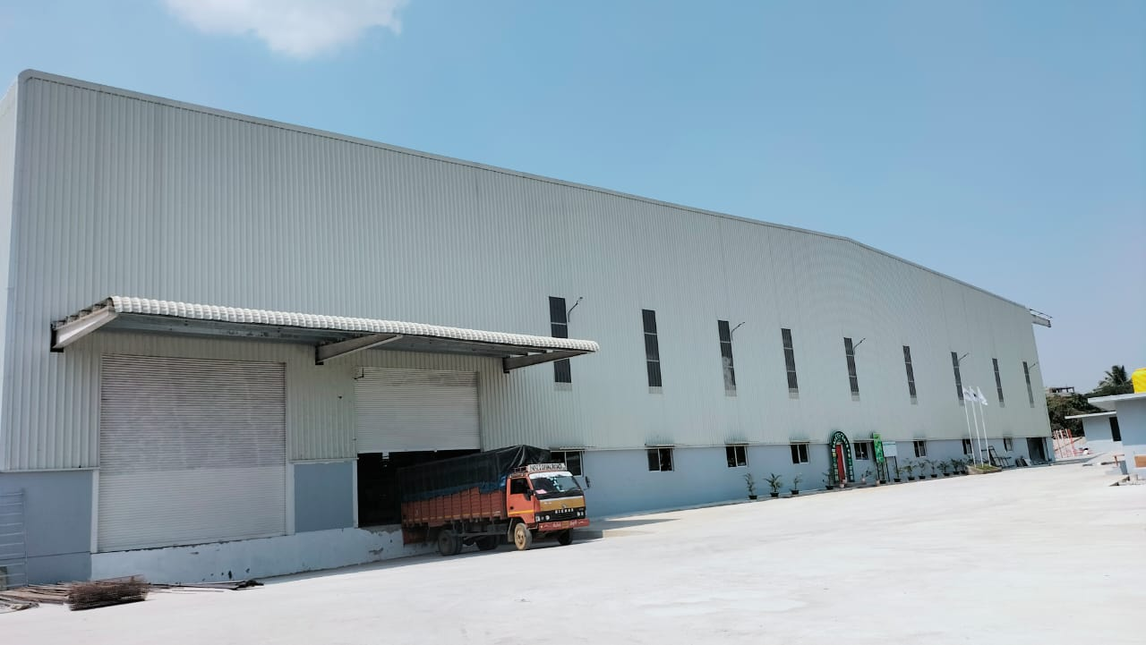JBM Ogihara is specialized in the manufacture of Japan machines and tools. As an Automotive company, we are known for our expertise in automated assembly lines, process automation, data acquisition and visual inspection. JBM Ogihara is one of the leading companies in manufacturing the automotive car components for reputed companies like Fortuner, Innova Crysta etc.

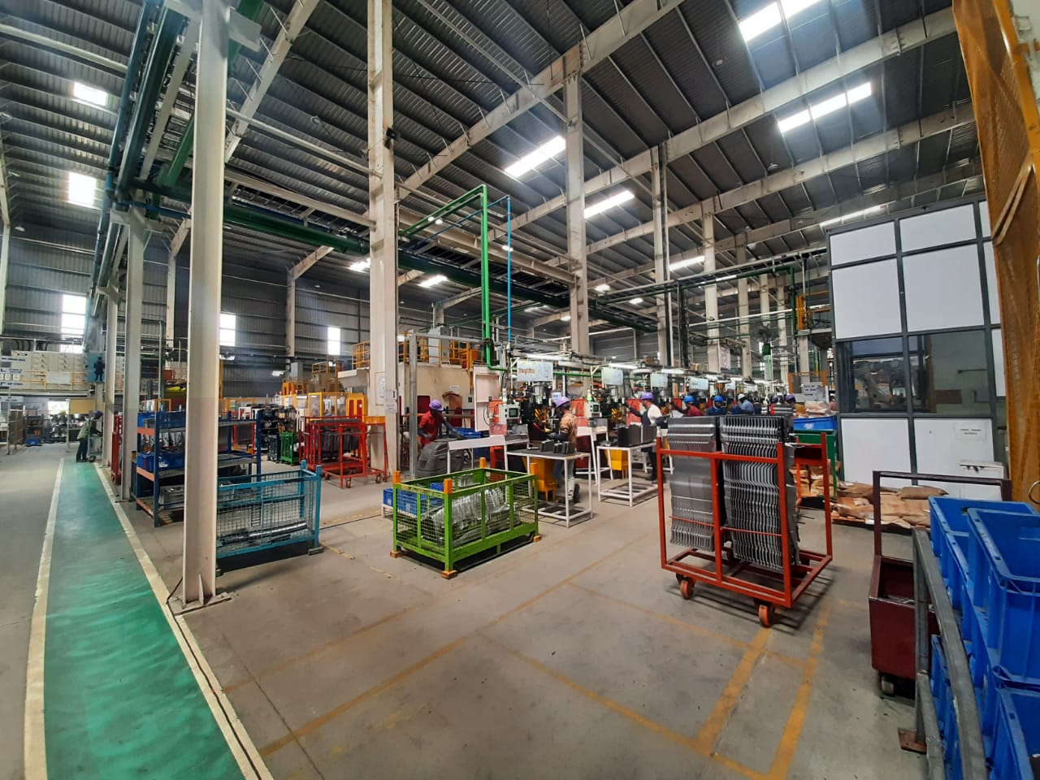

|  |  |  |
| --- | --- | --- |
| **Sl.no** | **Content** |  |
| 01. | Introduction to Robots |  |
| 02. | Types of Industrial Robots |  |
| 03. | Parts of Robot |  |
| 04. | Designing aspect of Articulated Robot |  |
| 05. | Control System of the Articulated Robot |  |
| 06. | Advantage and Disadvantages |  |
| 07. | Applications |  |
| 08. | Conclusion |  |

**Introduction to Robots:**

Robots are mechanical devices designed to perform tasks autonomously or semi-autonomously, often with a high degree of precision and efficiency. They are a product of advanced engineering and artificial intelligence, combining hardware and software components to interact with their environment and carry out specific functions.

These versatile machines have found applications in various industries, ranging from manufacturing and logistics to healthcare, exploration, and even entertainment. Robots can take on repetitive, dangerous, or complex tasks that would be challenging or unsafe for humans, making them valuable tools in modern society.

The field of robotics encompasses a wide range of designs, each tailored to the specific requirements of their intended tasks. From industrial robots found in production lines to autonomous vehicles, robotic arms in research labs, and even companion robots in households, their utility continues to expand

**Types of Industrial Robots:**

Industrial robots are widely used in manufacturing and industrial settings to automate repetitive tasks, increase efficiency, and improve precision. There are several types of industrial robots, each designed to perform specific functions. Here are some common types:

**Articulated Robots:** Articulated robots are classified by the number of points of rotation or axes they have. The most common is the 6-axis articulated robot. There are also 4- and 7-axis units on the market. Flexibility, dexterity, and reach make articulated robots ideally suited for tasks that span non-parallel planes, such as machine tending. Articulated robots can also easily reach into a machine tool compartment and under obstructions to gain access to a work piece (or even around an obstruction, in the case of a 7-axis robot).

The sophistication of an articulated robot comes with a higher cost compared to other robot types with similar payloads. And articulated robots are less suited than other types of robots for very high-speed applications due to their more complex kinematics and relatively higher component mass.

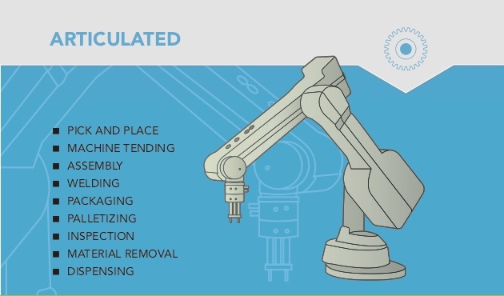

**Fig no.1: Articulated Robot**

**SCARA Robots (Selective Compliance Assembly Robot Arm):** A Selective Compliance Articulated Robot Arm (SCARA) is a good and cost-effective choice for performing operations between two parallel planes (e.g., transferring parts from a tray to a conveyor). SCARA robots excel at vertical assembly tasks such as inserting pins without binding due to their vertical rigidity. SCARA robots are lightweight and have small footprints, making them ideal for applications in crowded spaces. They are also capable of very fast cycle times. Due to their fixed swing arm design, which is an advantage in certain applications, SCARA robots face limitations when it comes to tasks that require working around or reaching inside objects such as fixtures, jigs, or machine tools within a work cell.

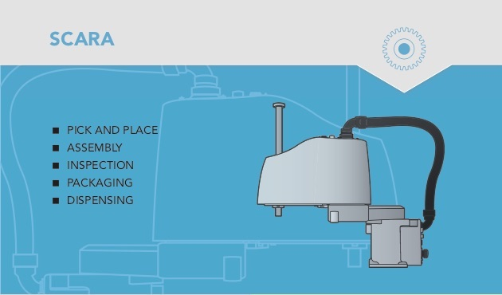

**Fig no.02: SCARA Robot**

**Cartesian Robots (Gantry Robots):** Cartesian robots typically consist of three or more linear actuators assembled to fit a particular application. Positioned above a workspace, Cartesian robots can be elevated to maximize floor space and accommodate a wide range of work piece sizes. (When placed on an elevated structure suspended over two parallel rails, Cartesian robots are referred to as “gantry robots.”) Cartesian robots typically use standard linear actuators and mounting brackets, minimizing the cost and complexity of any “custom” Cartesian system. Higher capacity units can also be integrated with other robots (such as articulated robots) as “end- effectors” to increase system capabilities. Cartesian robots are unable to reach into or around obstacles easily. And their exposed sliding mechanisms make them less suited for dusty/dirty environments.

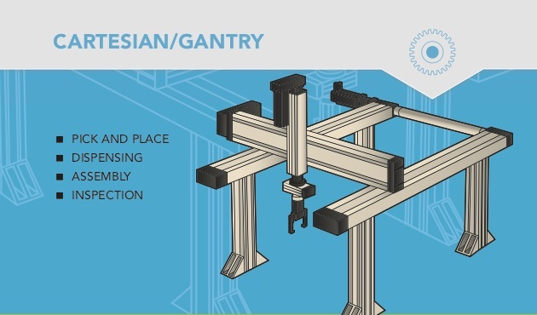

**Fig no.03: Cartesian Robot**

**Delta Robots**: Delta robots, also referred to as “spider robots,” use three base-mounted motors to actuate control arms that position the wrist. Basic delta robots are 3-axis units but 4- and 6-axis models are also available.

By mounting the actuators on, or very close to, the stationary base instead of at each joint (as in the case of an articulated robot), a delta robot’s arm can be very lightweight. This allows for rapid movement which makes delta robots ideal for very high-speed operations involving light loads.

An important thing to note as you compare delta robots to other robot types: Reach for delta robots is typically defined by the diameter of the working range, as opposed to the radius from the base, as in the case of articulated and SCARA units. For example, a delta robot with a 40” reach would only have half the reach (20” on a radius) of a 40” articulated or SCARA unit.

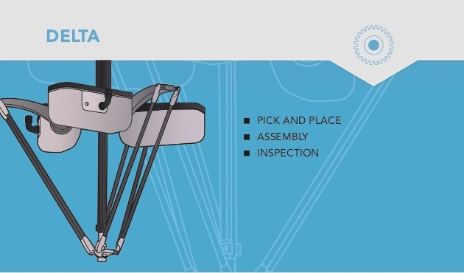

**Fig no.04: Delta Robot**

Let us study working of the Articulated Robot

**Main Parts of the Articulated Robot are:**

* Manipulator
* Controller
* Servomotor
* Servo drive
* PLC (Programmable Logic Controller)

1. **Manipulator**

A 6-axis manipulator, also known as a robotic arm or robot arm. Each axis represents a rotational that allows the arm to move freely in 3-dimensional space. Here's a detailed description of each axis:

* **Base Rotation (Axis 1):** This axis allows the robot arm to rotate horizontally at its base. It enables the arm to move from side to side, essentially turning the robot left or right.
* **Shoulder Rotation (Axis 2):** The second axis provides vertical movement at the shoulder joint. It allows the arm to raise or lower, providing up and down motion.
* **Elbow Rotation (Axis 3):** Axis 3 enables the forearm to bend at the elbow joint. This movement allows the arm to extend forward or retract backward.
* **Wrist Pitch (Axis 4):** The fourth axis allows the wrist to pitch up or down, providing tilting movement to the gripper or tool attached to the end effector.
* **Wrist Roll (Axis 5):** This axis enables the wrist to roll or twist, providing rotational movement around its own axis. It allows the end effector to have orientation control.
* **Wrist Yaw (Axis 6):** The sixth and final axis permits the wrist to yaw or rotate side to side. This rotation allows the end effector to point in different directions.

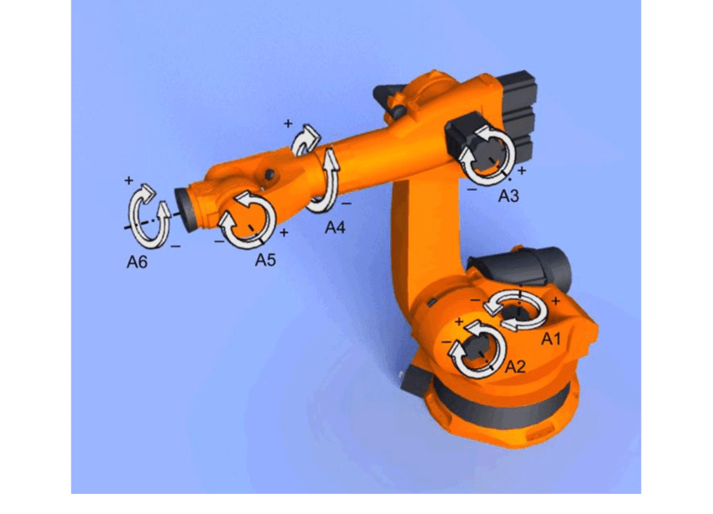By combining the motion of these six axes, a 6-axis manipulator can reach and manipulate objects in various positions and orientations in three-dimensional space, making it highly versatile for a wide range of industrial and research applications. The control of these axes is usually achieved through a combination of motors, encoders, and sensors, allowing precise and coordinated movement of the robot arm

**Fig no.05: 6-axis Manipulator**

1. **Controller**

Controllers used in robots are essential components responsible for governing the robot's behavior, movement, and interactions with its environment. Different types of robots may employ various controllers based on their complexity, application, and capabilities. Here are some commonly used controllers in robots

**Microcontroller**: Microcontrollers are the simplest type of controller used in small and less complex robots. They integrate a processor, memory, and input/output peripherals on a single chip. Microcontrollers are suitable for basic robotic tasks like simple navigation, obstacle avoidance, and sensor interfacing.

**Single-Board Computer (SBC):** Single-board computers like Raspberry Pi or Arduino are more powerful than microcontrollers. They run complete operating systems and can handle more sophisticated tasks. SBCs are commonly used in educational robots, DIY projects, and small-scale automation.

**Programmable Logic Controller (PLC):** PLCs are widely used in industrial robots and automation systems. They are designed for robustness, reliability, and real-time control of manufacturing processes. PLCs can handle complex tasks and are well-suited for industrial applications.

**PID Controller:** Proportional-Integral-Derivative (PID) controllers are a type of feedback control system used in robots to maintain stability and accuracy in various tasks. They are frequently employed in robotic arms, self-balancing robots, and other control-intensive applications.

**Motion Controller:** Motion controllers focus on precisely controlling the movement of robot joints or actuators. They ensure smooth trajectories and accurate positioning of the robot, especially in tasks like pick-and-place operations, welding, or machining.

**Robot Operating System (ROS):** ROS is not a physical controller but rather a software framework used to develop robot applications. It provides a collection of tools, libraries, and communication protocols for building complex robot systems. ROS is popular in research, industrial, and service robotics due to its modularity and flexibility.

Controllers in robots can vary significantly depending on the robot's purpose, design

and complexity. The goal is to have a reliable, efficient, and responsive control system that enables the robot to perform its intended tasks accurately and safely. Advances in technology continue to drive improvements in robotic controllers, allowing robots to tackle more complex and challenging tasks across various industries

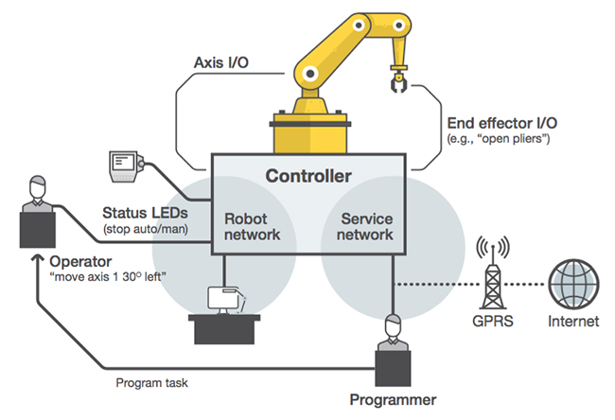

**Fig no.06: Controller**

1. **Servo Motor**

A servomotor, often referred to simply as a servo, is a type of rotary actuator used in robotics and automation applications. It is a self-contained system that consists of a motor, feedback control system, and gears, all housed in a single compact unit. Servomotors are widely used in robots due to their precision, accuracy, and ease of control.

**Motor:** The heart of the servomotor is an electric motor, which can be either a brushed DC motor or a brushless DC (BLDC) motor. The motor provides the rotational movement and torque required to actuate various robotic joints or mechanisms.

**Feedback Device:** Servomotors include a feedback device, typically an encoder or a resolver, that continuously monitors the motor's position and velocity. This feedback information is crucial for the control system to achieve accurate and precise positioning.

**Control System:** The control system of the servomotor uses the feedback data to adjust the motor's movement. It compares the desired position (set point) with the actual position (feedback) and calculates the error. The control system then sends appropriate commands to the motor to minimize this error and reach the desired position. This closed-loop control ensures accurate and stable positioning.

**Gearing**: Servomotors often have gears built into their design to reduce the motor's high-speed, low-torque output to a lower-speed, higher-torque output. Gearing increases, the motor's torque capability, allowing it to handle more substantial loads and providing finer control over the robot's movements.

**Driver/Controller:** Servomotors require a driver or controller to interface with the robot's main control system. The driver amplifies and converts the control signals from the robot's central processing unit into the appropriate current or voltage commands for the motor.

**Power and Signal Connections:** Servomotors are typically equipped with power and signal connectors that facilitate easy integration into robotic systems. The power connection provides electrical power to the motor and control electronics, while the signal connection allows communication between the servomotor and the robot's control system.

**Torque and Speed Ratings**: Servomotors come in various sizes and power ratings, with different torque and speed capabilities. The specifications of a servomotor must be chosen based on the requirements of the robot's specific application, such as the payload, speed, and precision needed.

**Feedback Resolution:** The resolution of the feedback device, often measured in counts per revolution (CPR), determines the precision of the servomotor's position control. Higher resolution encoders offer finer control and more accurate positioning.

**Positioning Modes:** Servomotors usually offer different positioning modes, such as position control, velocity control, and torque control. This flexibility allows robots to perform various tasks, from precise position holding to smooth motion profiles.

Servomotors are prevalent in robotic applications such as industrial automation, robotic arms, drones, humanoid robots, and many other fields. Their ability to provide accurate and controllable motion makes them indispensable for achieving the necessary precision and performance in modern robotic systems.

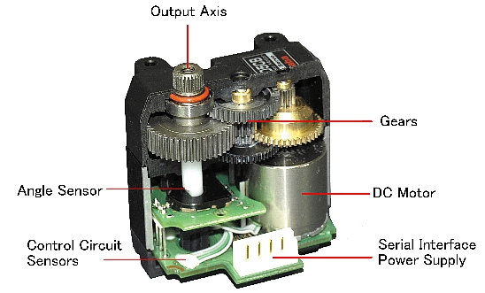

**Fig no.07: Servomotor**

1. **Servo drive**

A servo drive is a crucial component used in robotics to control the motion of servo motors. Servo motors are specialized motors capable of precise control over their angular position, speed, and torque. The servo drive provides the necessary electrical signals to the servo motor, allowing the robot to accurately move to a desired position.

**Control Signals:** The servo drive receives control signals from the robot's central controller or microcontroller. These signals typically come in the form of pulse-width modulation (PWM) or analog voltage signals.

**Feedback Loop:** The servo drive incorporates a feedback mechanism to constantly monitor the actual position of the servo motor. This feedback is often achieved through encoders or resolvers installed on the motor shaft

**Error Correction:** By comparing the desired position (input) with the actual position (feedback), the servo drive calculates an error value. It then adjusts the electrical signals provided to the motor to minimize this error and bring the motor closer to the desired position.

**Closed-Loop System:** The combination of the servo motor, servo drive, and feedback mechanism forms a closed-loop control system. This closed-loop system ensures that the motor maintains accurate positioning and speed even when external forces or loads are acting on it.

**Precision and Accuracy:** Servo drives are designed to provide precise control over the servo motor's movement, enabling the robot to perform intricate tasks with high accuracy.

Overall, the servo drive plays a vital role in enabling robots to achieve the level of accuracy and control required for tasks that demand precise movement and positioning

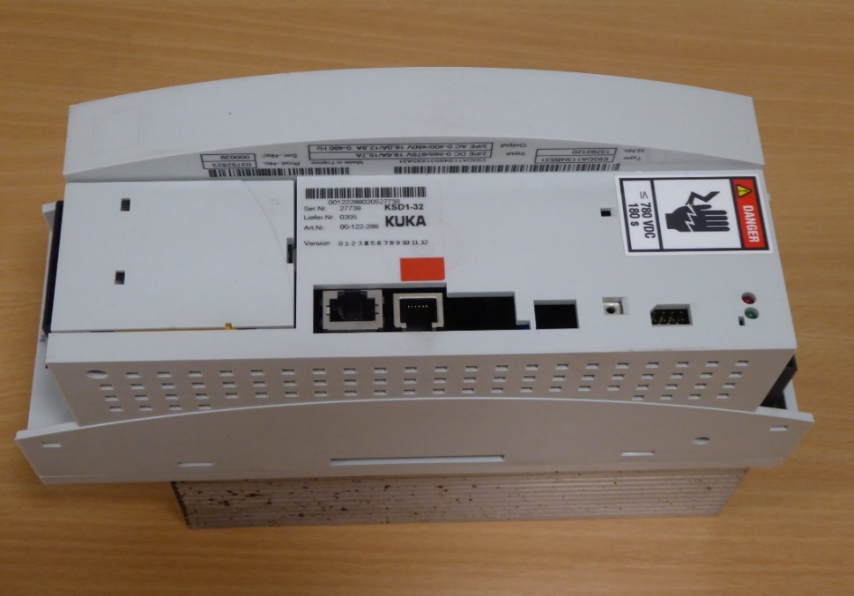

**Fig no.08: Servo drive**

1. **PLC (Programmable Logic Controller)**

PLC (Programmable Logic Controller) programming is a crucial aspect of controlling robots in industrial automation. It involves writing software code that governs the robot's behavior, enabling it to perform specific tasks efficiently and accurately. Here's a detailed description of PLC programming used in robots:

PLC programs are typically written in ladder logic, which resembles electrical relay logic diagrams, making it easy for engineers familiar with electrical circuits to understand and create the programs. Additionally, some PLCs support other programming languages like Structured Text (ST), Function Block Diagram (FBD), Instruction List (IL), and Sequential Function Charts (SFC).

**I/O Modules**: PLCs interface with various input and output modules to connect with sensors and actuators. For robot control, sensors provide feedback on the robot's position, speed, and orientation, while actuators control the robot's motors and grippers.

**Sequential Logic:** The PLC program executes in a sequential manner, scanning the program continuously and updating the output states based on the inputs. It follows the "scan cycle" process, where it reads inputs, processes the logic, and updates the outputs repeatedly.

**Motion Control:** PLCs integrated with motion control capabilities can execute complex robot movements. For example, controlling a robot arm to follow precise trajectories, controlling speed and acceleration, and synchronizing multiple axes for coordinated motion.

**Error Handling:** PLC programs include error-handling routines to deal with unexpected situations, such as collision detection, sensor faults, or communication errors, ensuring the robot operates safely and efficiently.

**Interfacing with HMI:** Human-Machine Interface (HMI) allows operators to interact with the robot system. PLC programming enables the HMI to display relevant information, provide control options, and monitor the robot's performance.

**Program Organization:** PLC programs are organized into subroutines, functions, or modules to enhance readability, maintainability, and code reusability. This modular approach streamlines the development process and facilitates troubleshooting.

**Safety Features:** Safety is of utmost importance when programming robots. PLCs can incorporate safety relays, safety PLCs, or safety modules to implement safety functions like emergency stops, interlocks, and safety monitoring.

**Communication Protocols:** PLCs communicate with other devices and systems through various protocols, such as Ethernet/IP, Profinet, Modbus, or OPC UA. These protocols allow seamless integration with supervisory systems and industrial networks.

**Simulation and Testing:** Before deploying the PLC program on the actual robot, engineers often use simulation software to validate the code's functionality and avoid potential errors or collisions during real-world operation.

By leveraging PLC programming in robots, industries can achieve precise and reliable automation, leading to increased productivity, improved quality, and reduced human intervention in repetitive tasks.

**Designing of the Articulated Robot:**

Articulated robots comprise several interconnected segments called links, which are connected through joints. These joints are designed to allow the robot to move with a high degree of flexibility, precision, and dexterity. The links of articulated robots can range from two to six or more, with each link providing a degree of freedom (DOF) that enables the robot to move in various directions.

The joints used in articulated robots can be classified into two types: revolute and prismatic. Revolute joints are rotary joints that allow the robot to rotate along an axis. Prismatic joints, on the other hand, are linear joints that enable the robot to move in a straight line. Articulated robots are designed to have multiple degrees of freedom (DOF), which is the number of independent parameters that determine the robot's position and orientation. This allows the robot to move in a wide range of directions and positions, making it highly versatile. The DOF of articulated robots can range from two to six or more, with each DOF representing a degree of movement or rotation. The most common DOF configurations for articulated robots are 4-DOF and 6-DOF. 4-DOF robots typically have three revolute joints and one prismatic joint, while 6-DOF robots have three revolute joints and three prismatic joints. The additional degrees of freedom in 6-DOF robots allow for greater flexibility and precision in their movements. In addition to the links and joints, articulated robots also have end-effectors, which are the devices attached to the articulated robot arm that allow it to perform specific tasks. End-effectors can include grippers, suction cups, and other specialized tools that are designed to manipulate objects with precision and accuracy. The robot’s servo motors are used to power the movement of each axis, allowing for precision and speed.

**Control System of the Articulated Robot:**

The control systems of articulated robots are crucial in determining the robot's movements, actions, and overall performance. The robot control systems are responsible for monitoring the robot's position, speed, and orientation and making adjustments as needed to ensure that the robot moves accurately and precisely.

There are two main types of control systems used in articulated robots: open-loop and closed-loop control systems. Open-loop control systems are used in simple, repetitive tasks where the robot's movement can be pre-programmed and does not require real-time feedback. Closed-loop control systems, on the other hand, use sensors to monitor the robot's movements and make adjustments in real-time to ensure precise and accurate movements. Sensors are an essential component of the control systems in articulated robots. They are used to monitor the robot's movements, track its position and orientation, and detect any errors or deviations from the intended path. Common sensors used in articulated robots include encoders, accelerometers, and proximity sensors. Actuators are another critical component of the control systems in articulated robots. Actuators are responsible for moving the robot's joints and links, enabling it to move with precision and accuracy. The most commonly used actuators in articulated robots are electric motors (such as the servo motor), hydraulic cylinders, and pneumatic cylinders. The control systems of articulated robots are typically operated through a computer interface. The operator can program the robot's movements, set its parameters, and monitor its performance through a graphical user interface (GUI). The GUI provides real-time feedback on the robot's movements, allowing the operator to make adjustments as needed to ensure that the robot moves accurately and precisely. In recent years, there have been significant advancements in the control systems of articulated robots, with the integration of artificial intelligence (AI) and machine learning (ML) technologies. These technologies enable the robot to learn and adapt to its environment, improving its performance and increasing its flexibility in performing tasks.

**Advantages:**

* Extensive range of motion.
* Incredible linear reach they have.
* Ability to move with great precision.
* Capability to reach virtually anywhere within the workspace due to their numerous axis points.
* Reputation as one of the most versatile, flexible, and valuable tools available

**Disadvantages:**

Key disadvantages of articulated robots: Complex: Robots with rotary joints have to be made with a more complicated process than those that perform linear or lateral movements.

**Applications:**

1. **Manufacturing:**Articulated robots are widely used in manufacturing industries for tasks such as assembly, welding, painting, packaging, and material handling. These robots can perform these tasks with high precision and speed, resulting in increased productivity and efficiency.
2. **Healthcare:**Articulated robots are increasingly being used in healthcare applications, such as surgery and rehabilitation. They can perform surgical procedures with greater precision and accuracy than human surgeons, reducing recovery times and improving patient outcomes.
3. **Agriculture:**Articulated robots are used in agriculture for tasks such as harvesting, planting, and spraying. By operating in difficult and dangerous environments, articulated robots reduce the risk of injury to human workers and improve the efficiency of the agricultural process.
4. **Military and Defense:**Articulated robots are used in military and defense applications for tasks such as bomb disposal and reconnaissance. These robots can operate in hazardous environments, reducing the risk of injury to military personnel and improving the safety and effectiveness of military operations.

**CONCLUSION**

In conclusion, robots have revolutionized the industrial landscape, playing a pivotal role in modern manufacturing and production processes. Their widespread adoption in industries has led to numerous benefits, driving increased efficiency, precision, and safety. Some key points to consider about robots used in industry are:

**Enhanced Productivity:** Robots can tirelessly perform repetitive tasks with high accuracy and speed, leading to increased productivity and reduced production time.

**Improved Quality**: With precise movements and consistent performance, robots help maintain product quality, minimizing defects and variations.

**Cost Savings**: While initial investment costs can be significant, robots ultimately lead to long-term cost savings due to reduced labor expenses and increased efficiency.

**Safety Advantages**: Robots can handle hazardous or dangerous tasks, protecting human workers from potential risks and improving workplace safety.

**Flexibility:** Advanced robotic systems can be reprogrammed or reconfigured to adapt to changing production needs and different tasks, providing flexibility in manufacturing.

**High Accuracy and Repeatability**: Robots can achieve consistent results, making them suitable for tasks that demand precision, such as welding, assembly, and quality inspection.

**24/7 Operation**: Robots can operate continuously without the need for breaks, contributing to continuous production cycles.

**Data and Analytics**: Robots integrated with sensors can collect valuable data, enabling real-time monitoring, predictive maintenance, and process optimization.

**Collaborative Robots (Cobots):** The emergence of cobots allows for safe human-robot collaboration, promoting teamwork and efficiency in industrial settings.

**Job Evolution:** While robots may replace some jobs, they also create new opportunities in fields like robot programming, maintenance, and system integration.

However, it's essential to recognize that the integration of robots in industry also presents challenges, such as the need for specialized training for the workforce and potential job displacement. Striking a balance between automation and human labor remains a critical consideration.

Overall, robots have proven to be indispensable assets in industry, propelling manufacturing capabilities to new heights and opening doors to more innovative and competitive practices. Continued advancements in robotics technology will undoubtedly lead to further improvements, making robots an even more integral part of industrial processes in the future