Project Thesis on

**Performance Analysis of Solar Dryer Installed at BEC Energy Park**Abstract

The purpose of this project is to analyze the performance of existing solar dryer present in BEC renewable energy park. The solar drying system utilizes solar energy to heat up air and to dry any food substance loaded, which is beneficial in increasing shelf life of food product thereby reducing the wastage of agricultural product and helps in preservation of agricultural product.

Drying is an eminent way to preserve the food and solar energy food drying is an approximate food preservation mechanism for a sustainable real world. This fixed solar dryer has the capacity of 5 kg which is used for the preservation, drying of grapes, potatoes, chilies, peas, ground nut, coconut, sweet corn, sun flower seeds, tur dal etc., more than 10 kinds have been dried using this solar dryer. Drying will generally refer to the removal of moisture content by evaporation rather than by pressure or other physical parameters. Our country is blessed with ample of solar energy round the year. The principle of this dryer is that, hot air is lighter than the cool air and its raises up the altitude. While raising this warm air comes in contact with food slices and draws the moisture from it. The repeated cycle of this process makes it a low cost, very healthy, long term investment. Generally, the sun’s power of heat is used to dry up the moisture content of the fruits or vegetables.

The challenge is to modify the dryer utilizing the abundant solar radiation, provided the efficiency of the dryer is not compromised. Also it should have better temperature regulation and extended operational hours. With this intent, we are proposing a study of the performance of Tray Dryer.

ii.

**Table of Contents**

**Content Details Page No.**

|  |  |  |
| --- | --- | --- |
| **Acknowledgements** | | i |
| **Abstract** | | ii |
| **List of Figures** | | iii |
| **List of Tables** | | iii |
|  |  |  |
| **Chapter 1** | **Introduction** | 1-5 |
| **1.1** | **Introduction** | 1-3 |
| **1.2** | **Problem Statement of the Thesis** | 4 |
| **1.3** | **Objectives of the Thesis** | 5 |
| **1.4** | **Organization of the Thesis** | 5 |
|  |  |  |
| **Chapter 2** | **Literature Survey** | 6-7 |
| **2.1** | **Introduction** |  |
|  | 2.1.1 Solar Dryer | 6-7 |
|  |  |  |
| **Chapter 3** | **Materials and Experimental Techniques/Methodology** | 8-12 |
| **3.1** | **Introduction** | 8-11 |
| **3.2** | **Summary** | 12 |
|  |  |  |
| **Chapter 4** | **Results and Discussions of Solar dryer** | 13-22 |
| 4.1 | Observation table and graph for various food product |  |
| 4.2 | Calculation of efficiency of Solar dryer |  |
| **Chapter 5** | **Conclusions and Future Scope** | 23-24 |
| **5.1** | **Conclusions** | 23 |
| **5.2** | **Future Scope of the Work** | 24 |
|  | **References** | 25 |

List of Figures

|  |  |  |
| --- | --- | --- |
| Fig No. | Figure caption | Page No. |
| 1.1 | Spoiled food products | 02 |
| 3.1 | Controller | 09 |
| 3.2 | Thermostat Sensor | 09 |
| 3.3 | Solar panel for power supply | 10 |
| 3.4 | Flow chart of drying process | 11 |
| 4.1 | Grapes before drying | 14 |
| 4.2 | Grapes after drying | 14 |
| 4.3 | Chilly before drying | 16 |
| 4.4 | Chilly after drying | 16 |
| 4.5 | Potato before drying | 18 |
| 4.6 | Potato after drying | 18 |
| 4.7 | Peas before drying | 20 |
| 4.8 | Peas after drying | 20 |
| 4.9 | Groundnut before drying | 22 |
| 4.10 | Groundnut after drying | 22 |

# 

# List of tables

|  |  |  |
| --- | --- | --- |
| Fig No. | Table caption | Page No. |
| 4.1.1 | Temperature and weight of Grapes in different condition | 13 |
| 4.1.5 | Temperature and weight of Chilly in different condition | 15 |
| 4.1.9 | Temperature and weight of Potato in different condition | 17 |
| 4.1.13 | Temperature and weight of Peas in different condition | 19 |
| 4.1.17 | Temperature and weight of Groundnut in different condition | 21 |
| 5.1.2 | The concluded data while performing experimental analysis | 23 |

iii.

# CHAPTER 1

# INTRODUCTION

# *This chapter consists of brief information about mini project and its problem statement, objectives of the thesis, organization of thesis.*

# INTRODUCTION

# Solar dryer

According to 2011 Agricultural Census of India an estimate of 61.5% of people depend on agriculture and produce variety of food products. In country like India where 300 days out of 365 are sunny have a huge amount of solar energy. Government is also promoting the use of sources of energy like solar energy by providing subsides on solar pumps, solar water heater, solar panels, solar lights etc. Use of solar energy requires minimum expenditure sunlight is free of cost and is renewable source of energy.

By the end of 2050, the world population may reach 9 billion. To feed this population the food production should increase by 70% which is difficult task. Difficulty in increasing food production is due to the reduction in agricultural land, increasing urban population, declining natural resources like fertile land, water etc. As per current status, nearly 12% of the global population does not meet their dietary energy requirement. At the same time around 40 to 50% of the food produced is lost before it reaches consumers. This loss is due to food spoilage and infestation. Food storage technology is energy and cost intensive and have restrictions like storage capacity, easy accessibility for all consumers, difficulty in construction in all regions etc. Therefore, food processing is a better choice which can help in reducing the food losses. Solar drying is one such processing method by which food grains can be stored for longer duration.

1.

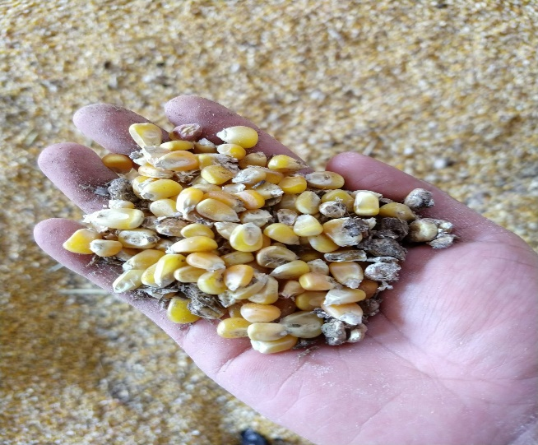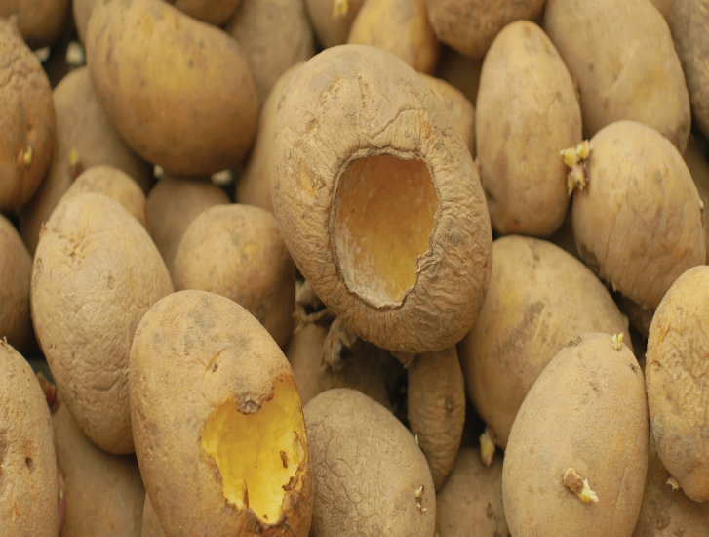

**Fig .1.1** Spoiled food products

Drying is the process of removal of water from the food to inhibit biochemical processes and microbial growth. It increases the shelf life of the product, so that it can be available during off seasons. The open air sun drying is one of the oldest and well known processes for preserving agricultural product for a long time. But this method has many drawbacks. There are certain new techniques are introduced for efficient drying process such as hot air drying or dielectric heating. A solar dryer integrated with a thermal energy storage system is reasonably efficient for continuous and uniform drying of agricultural products in the temperature range of 40–75°C which is the requisite for drying most of the products [3]

2.

**The advantages of the solar drying are –**

* Increased drying temperature.
* Increased drying rate of the product.
* Short drying time.
* Preservation of product quality.
* Product color is also preserved.
* Less contamination by dust, rain and insects.

**The disadvantages of solar dryer are –**

* The working of a solar dryer is limited to the daytime only. It fails to work without sunlight.
* During cloudy days, the working of dryer is limited due to its inability to attain the requisite drying temperature at the day time.
* The temperature attained by the dryer during the daytime is too high which also destroys the drying product quality. Drying temperature cannot be controlled

# 3.

# 1.2 PROBLEM STATEMENT OF THE THESIS

Food scientists have found that by reducing the moisture content of food to between 10 and 20%, bacteria, yeast, mold and enzymes are prevented from spoiling it. The flavor and most of the nutritional value is preserved and concentrated.

Drying and preservation of agricultural products have been one of the oldest uses of solar energy. The traditional method, still widely used throughout the world, is open sun drying where diverse crops, such as fruits, vegetables, cereals, grains, tobacco, etc. are spread on the ground and turned regularly until sufficiently dried so that they can be stored safely. However, there exist many problems associated with open sun drying. It has been seen that open sun drying has the following disadvantages. It requires both large amount of space and long drying time. The disadvantages of open sun drying need an appropriate technology that can help in improving the quality of the dried products and in reducing the wastage. This led to the application of various types of drying devices like solar dryer, electric dryers, wood fuel driers and oil-burned driers. However, the high cost of oil and electricity and their scarcity in the rural areas of most third world countries have made some of these driers very unattractive. Therefore, interest has been focused mainly on the development of solar driers.

Solar dryers are usually classified accordi-ng to the mode of air flow into natural convection and forced convection dryers. Natural convection dryers do not require a fan to pump the air through the dryer. The low air flow rate and the long drying time, however, result in low drying capacity. Therefore, hot air pumped solar air dryer can be used to increase the drying efficiency.

4.

**1.3 Objectives of the Thesis**

* To dry different variety of food grains.
* To analyze amount of time needed to dry different variety of food grains.
* To compare and test the quality of food grains processed by direct drying method and by using solar dryer method.

**1.4 Organization of the Thesis**

# This thesis consists of 5 chapters. Chapter 1 consists of brief information about mini project and its problem statement, objectives of the thesis, organization of thesis. Chapter 2 consists of introduction of literature survey. Chapter 3 chapter consists of description about the materials used in solar dryer, methodology of solar dryer. Chapter 4 focuses on Observation table and graph for various food product and calculation of efficiency of Solar dryer. Chapter 5 concludes about the study and observations of the mini project and the future scope of the model.

5.

**CHAPTER 2**

# Literature Survey

# *This chapter consists of introduction of literature survey, detailed description and types of solar dryer and solar still, future scope of the mini project.*

# 2.1 Introduction

# 2.1.1 Solar Dryer

1. **Bukola Olalenkan Bolaji, “Performance Evaluation of simple Solar Dryer for food preservation”, International Journal on Engineering and Engineering Technology, ISSN:2663-837, Volume 2, no.1, June 2005.**

* This paper gives the performance analysis on yum chips of average thickness of 4mm and its weight was measure before starting of the analysis and measured the weight for every 1-hour interval of time
* By knowing the initial mass and the final mass at the point where no further loss of chips mass was attained. This data is used to calculate the moisture removed in kWh/kg
* The dryer performance was evaluated using the drying rate and the system drying efficiency. The drying rate which is the quantity of moisture removed from the food item in a given time

1. **Yonesh B. Chauhan& Pravin P. Rathod, “A comprehensive view of the Solar dryer”, International Journal of Ambient Energy, ISSN:0143-0750,12 April, 2018.**

* A detailed review on solar dryer in practice over different parts of the world is presented here.
* The paper states that maximum average thermal efficiency of 45.9% can be achieved in solar air heater/dryer having aluminum fins at exit air velocity of 4.20 m/s, as aluminium fins increases the heat transfer area.
* Dryingexperiment were performed at an airflow rate of 3.197 kg/s,moisture reductionfrom 80% to 10.6% in 22.6 hours was achieved with moisture extraction rate of 0.87 kg/kwh. Drying efficiency was estimated to be 20.92 %. 6.

**Limitation:**

* Drying efficiency is low
* More expensive

1. **Sandeep lakhera, Rahul Bahuguna, Sudeep Singh Rawat,** “**Review Paper on Comparative Analysis on Solar Crop Dryer”,** **International Journal for Research in Engineering Application & Management (IJREAM), ISSN :2454-9150, Vol-04, Issue 2, May 2018.**

* This research paper is mainly concentrated on drying of food crops and different types of dryers.
* This paper concludes that forced convection solar dryer can increase the efficiency. (It uses mechanical devices like blower or fan so that the movement of air gets high and take the moisture away from the product at high rate)
* Thermal efficiency of around 21% in terms of drying rate is achieved.

1. **K. Narendra Babu, P. Sudheer Kumar, D. Yamuna, “A Research on Development of a Fixed Solar Dryer with a Practicle Research”, International Journal of Innovative Technology and Exploring Engineering (IJITEE), ISSN: 2278-3075, Volume-8, Issue- 9S2, July 2019.**

* This paper gives a detailed information and performance analysis on Direct type of Solar Dryer
* This research paper mainly concentrated on drying of potato and grapes
* From this research it has been proved that the developed solar thermal energy dryer gives more than 3-4 times heat inside the chamber than the ambient temperature

**Limitations:**

* This set up gives an average dryer productivity for one complete sunny day was around 15% only.
* This method requires more drying time

# 

# 7.

# CHAPTER 3

**Materials and Experimental Techniques/Methodology**

*This chapter consists of description about the materials used in solar dryer, methodology of solar dryer.*

**3.1 Materials used in solar dryer**

**3.1.1 Heat collector**

The function of the heat collector is to intake the atmospheric air with the help of the fans or pumps and increases its temperature using solar radiation till it’s capable to dry the food products. The upper surface of the collector is made of glass of 1m2.

**3.1.2 Black metal sheaths**

In this model of solar dryer there are metal sheets fitted inside the heat collector. The function of these metal sheets is to absorb and release the heat energy in presence of solar radiation.

**3.1.3 Air intake fans**

These are 12V DC fans with rated speed of 0-3800rpm

Which are powered by the solar panel. There are two fans fitted at lower end of the heat collector.

**3.1.4 Air ducts**

These are the simple connecting ducts between the heat collector and drying chamber which are made of hard rubber making it a heat transfer air tight.

8.

**3.1.5 Drying chamber**

It is chamber consisting of 3 trays which are loaded with food products to be dried. Dryed and heated air enters the chambers through air ducts and is circulated to all the trays.

**3.1.6 Trays**

There are three numbers of trays in this type of solar dryer each of different dimensions. The trays are made porous for an efficient air circulation.

**3.1.7 Controller and thermostat sensor**

The controller used here is consisting of 3 digits seven segment led display to display the temperature sensed by the thermostat sensor connected to it. It also consists relay and 4 terminals (T1, T2, 12V, GND) to control the fans connected to it according to the temperature set as required. The below mentioned fig.3.1 & fig.3.2 depict the controllers and sensors used in the model.

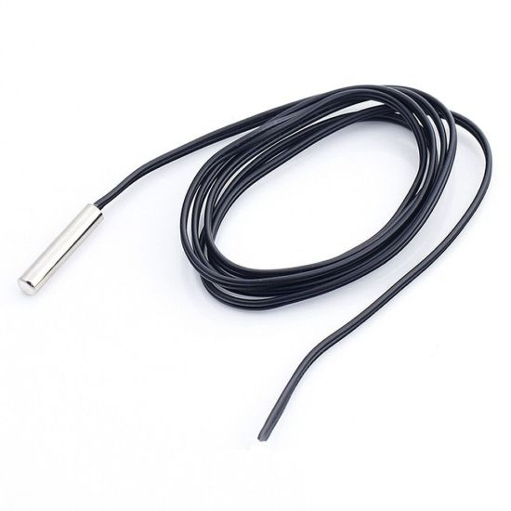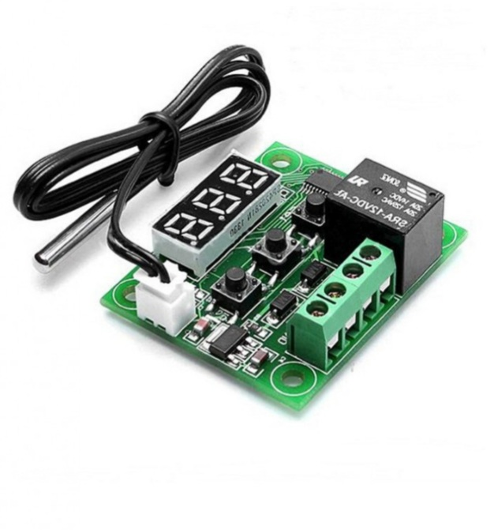

**Fig.3.1** Controller **Fig.3.2** Thermostat sensor

9.

**3.1.8 Solar panel**

It is photovoltaic solar panel with ratings of VMP of 18V and Imp of 1.2Ampere. The purpose of this solar panel is to supply the power to fans and controllers.

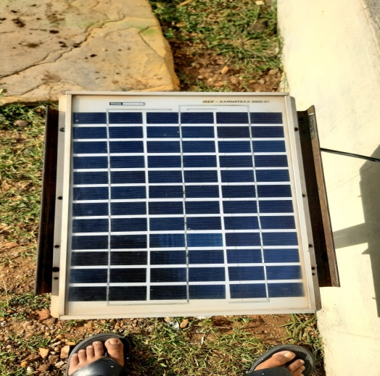

**Fig.3.3 Solar panel for power supply**

10**.**

**3.2 Methodology of Solar dryer**

**Dehydration process**

The process of dehydration consists of removal of moisture from the produce by heat usually in the presence of a controlled flow of air. Initially, the produce to be dried is washed, peeled and prepared (if necessary), and placed on flat-bottomed trays that are placed into the dryer. The solar rays enter the cabinet through the cover material.

Upon reaching the solar collector or the tray surface, they are converted into heat energy, raising the inside temperature. The heat energy is transferred to the produce to be dried. The heated produce gives out water vapor and dries up. Gradually the heated moist air goes up and leaves the drying chamber through the air outlet.

**Fig.3.4** The flow-chart of dehydration process

11.

**Drying process**

1. Cold dry air enters the drying chamber through the air inlet.
2. The solar radiation enters the cabinet through the transparent cover material.
3. The solar radiation is converted into heat energy.
4. Gradually, the heated moist air goes up and circulates throughout drying chamber.
5. Thereby increasing the temperature inside. The heated food gives out water vapor and dries up.

**3.3 Summary**

In this chapter, we come to know about the materials involved in the working model of solar dryer. Temperature controllers are newly incorporated to solar dryer whereas all other materials are already existed. Methodology used in the project are also discussed in this chapter, where the methodology of the solar dryer -dehydrating process, drying process.

Performance analysis of a solar dryer involves evaluating and assessing the efficiency and effectiveness of the drying system in utilizing solar energy to dry materials. The analysis typically includes measuring and analyzing parameters such as temperature, humidity, solar radiation, drying time, and moisture content. Through data collection, analysis, and interpretation, the performance analysis aims to understand the relationship between these variables and the drying process. Graphs, statistical methods, and experimental results are used to derive insights into optimizing the dryer's efficiency, energy consumption, drying rate, and product quality. The analysis provides valuable information for further optimization, improvement, and decision-making in solar dryer design and operation

12.

**CHAPTER 4**

**Results and Discussions**

* 1. **Observation and Graphs**

**Table 4.1.1: Temperature & weight of grapes in different conditions**

|  |  |  |  |  |  |  |
| --- | --- | --- | --- | --- | --- | --- |
| **Sl.no** | **Date** | **Item** | **Time** | **Tray Number** | **Temp in  oC** | **Weight(gm)** |
| **01.** | **03.05.2023** | **Grape** | **12:15 PM** | **Tray 1** | **51** | **110** |
| **Tray 2** | **46** | **110** |
| **Tray 3** | **37** | **110** |
| **Open sun drying** | **33** | **110** |
| **2:00 PM** | **Tray 1** | **66.4** | **51** |
| **Tray 2** | **52** | **69** |
| **Tray 3** | **48.7** | **73** |
| **Open sun drying** | **39** | **98** |
| **3:30 PM** | **Tray 1** | **52.6** | **48** |
| **Tray 2** | **48** | **49** |
| **Tray 3** | **43.2** | **55** |
| **Open sun drying** | **33** | **57** |

13.

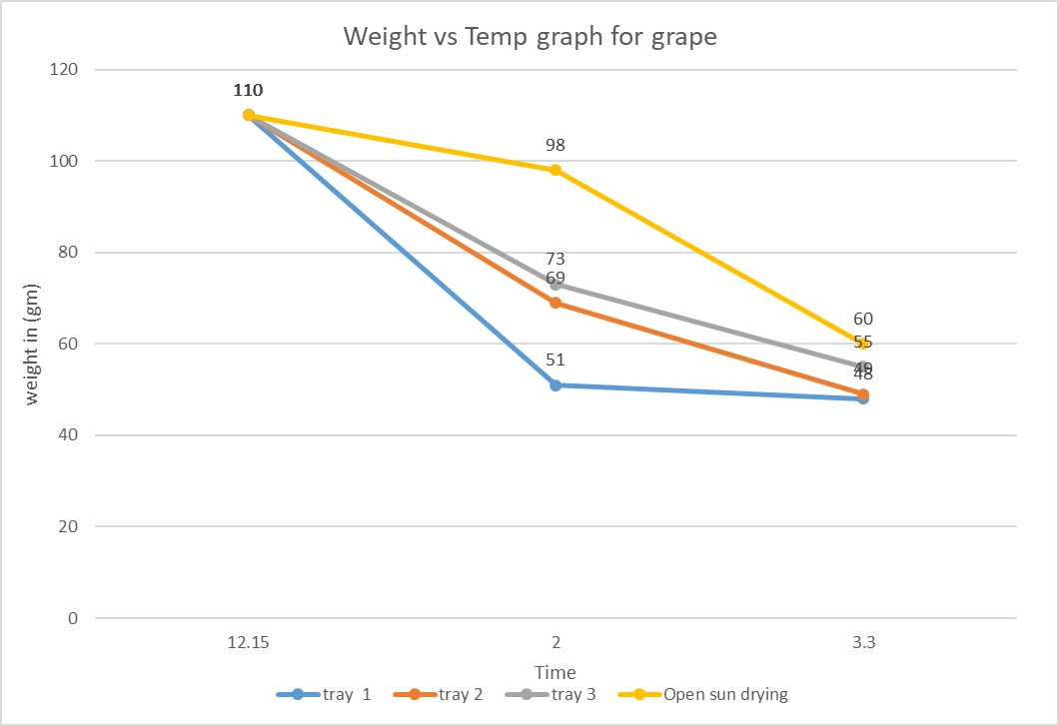**4.1.2: Graphical representation of drying of grape**

**4.1.3 Physical appearance of Grape before and after drying**

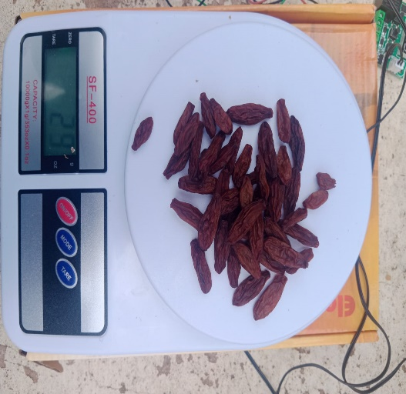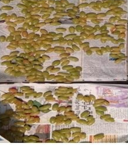

**Fig 4.1:** Grapes before drying **Fig 4.2**: Grapes after drying

**4.1.4 Drying efficiency**

Efficiency = (output/input) *100 [2.1,4]

Here we calculate efficiency in terms of weight.

Dryer Efficiency= (56.66/110) *100

= 46.06%

14.

**Table 4.1.5: Temperature & weight of Chilly in different conditions**

|  |  |  |  |  |  |  |
| --- | --- | --- | --- | --- | --- | --- |
| **Sl.no** | **Date** | **Item** | **Time** | **Tray Number** | **Temp in  oC** | **Weight(gm)** |
| **01.** | **06.05.2023** | **Chilly** | **10.15 AM** | **Tray 1** | **35.2** | **120** |
| **Tray 2** | **32** | **120** |
| **Tray 3** | **29** | **120** |
| **Open sun drying** | **33** | **120** |
| **2.10 PM** | **Tray 1** | **73.3** | **89** |
| **Tray 2** | **50.2** | **101** |
| **Tray 3** | **43.3** | **117** |
| **Open sun drying** | **35.7** | **118** |
| **3.45 PM** | **Tray 1** | **48** | **73** |
| **Tray 2** | **35.9** | **95** |
| **Tray 3** | **29** | **108** |
| **Open sun drying** | **29.5** | **113** |

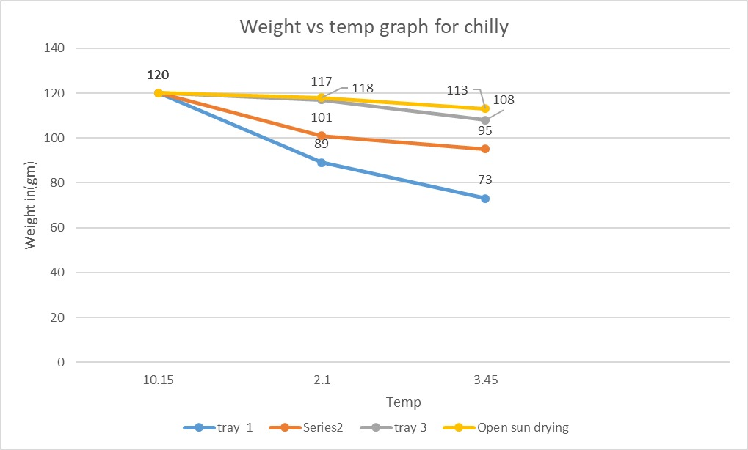**4.1.6: Graphical representation of drying of chilly**

15.

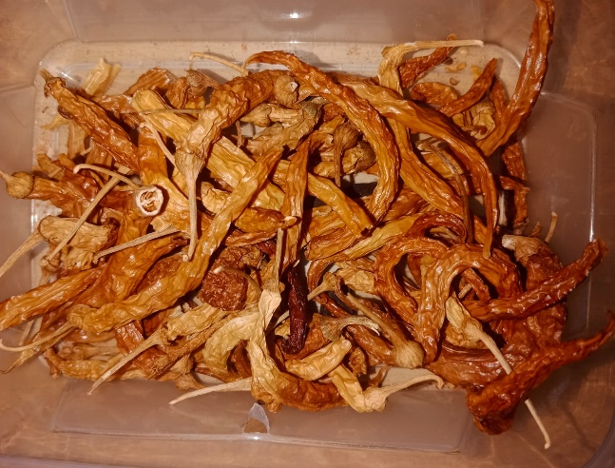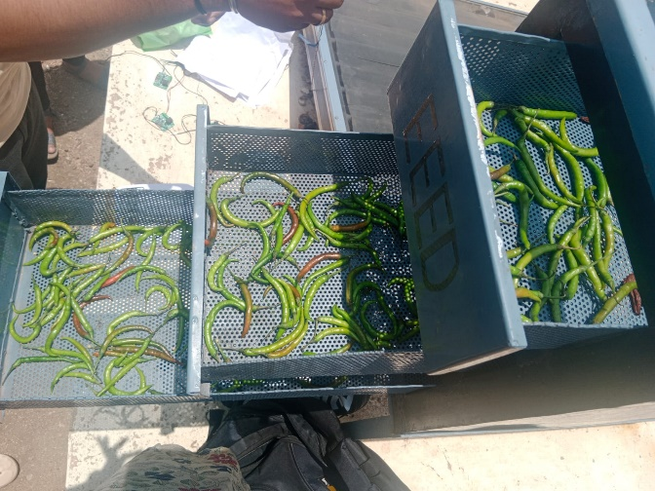**4.1.7 Physical appearance of Chilly before and after drying**

**Fig 4.3:** Chilly before drying **Fig 4.4:** Chilly after drying

**4.1.8** **Drying efficiency**

Efficiency = (output/input) *100 [2.1,4]

Here we calculate efficiency in terms of weight.

Dryer Efficiency= (92/120) *100

=76.6%

16.

**Table 4.1.9: Temperature & weight of Potato in different conditions**

|  |  |  |  |  |  |  |
| --- | --- | --- | --- | --- | --- | --- |
| **Sl.no** | **Date** | **Item** | **Time** | **Tray Number** | **Temp in  oC** | **Weight(gm)** |
| **01.** | **15.05.2023** | **Potato** | **12.15 PM** | **Tray 1** | **53.2** | **80** |
| **Tray 2** | **48** | **80** |
| **Tray 3** | **41** | **80** |
| **Open sun drying** | **39.6** | **80** |
| **3:00 PM** | **Tray 1** | **68** | **65** |
| **Tray 2** | **57** | **69** |
| **Tray 3** | **45** | **75** |
| **Open sun drying** | **42** | **76** |
| **4:10 PM** | **Tray 1** | **40** | **51** |
| **Tray 2** | **38** | **62** |
| **Tray 3** | **32** | **65** |
| **Open sun drying** | **29** | **69** |

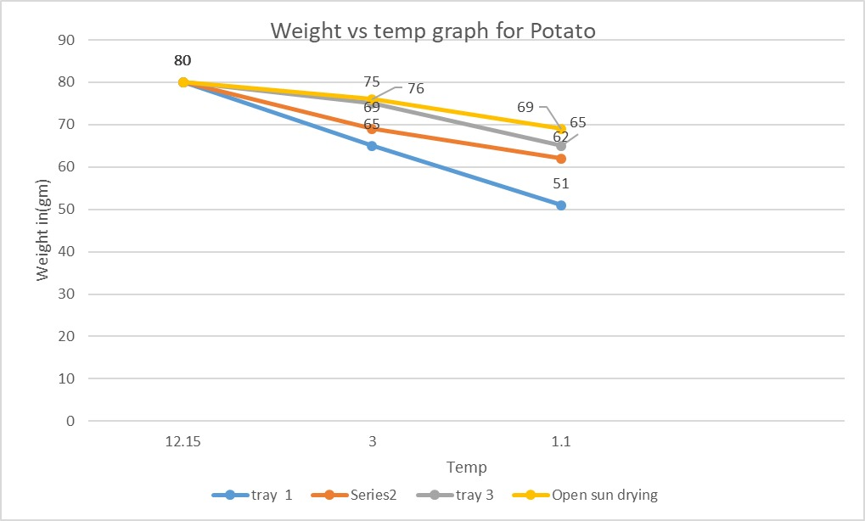**4.1.10: Graphical representation of drying of Potato**

17.

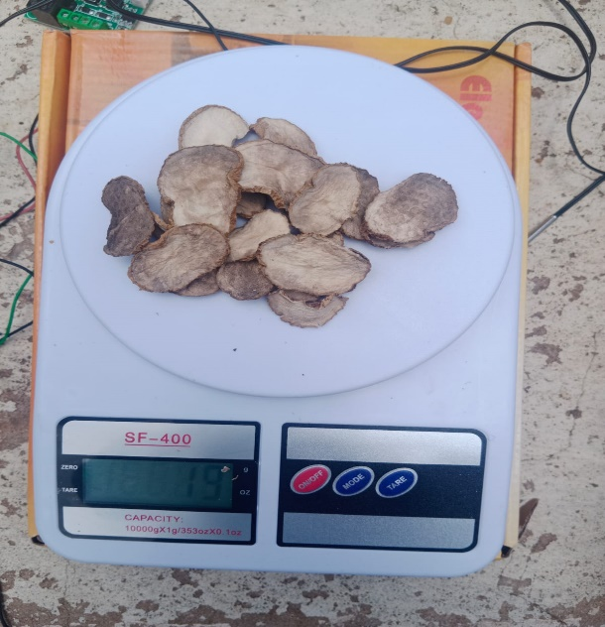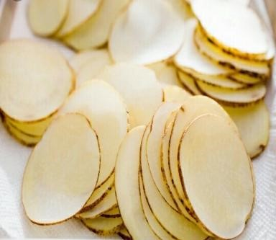**4.1.11 Physical appearances of before and after drying Potato**

# Fig 4.5: Potatoes before drying Fig 4.6: Potatoes after drying

**4.1.12** **Drying efficiency**

Efficiency = (output/input) *100 [2.1,4]

Here we calculate efficiency in terms of weight.

Dryer Efficiency= (59.33/80) *100

=74.16%

18.

**Table 4.1.13: Temperature & weight of Peas in different conditions**

|  |  |  |  |  |  |  |
| --- | --- | --- | --- | --- | --- | --- |
| **Sl.no** | **Date** | **Item** | **Time** | **Tray Number** | **Temp in  oC** | **Weight(gm)** |
| **01.** | **26.05.2023** | **Peas** | **10.15 AM** | **Tray 1** | **45** | **130** |
| **Tray 2** | **42** | **130** |
| **Tray 3** | **32** | **130** |
| **Open sun drying** | **29** | **130** |
| **2.10 PM** | **Tray 1** | **62** | **110** |
| **Tray 2** | **58** | **118** |
| **Tray 3** | **49** | **122** |
| **Open sun drying** | **37** | **124** |
| **3.45 PM** | **Tray 1** | **52** | **93** |
| **Tray 2** | **46** | **102** |
| **Tray 3** | **42** | **109** |
| **Open sun drying** | **41** | **112** |

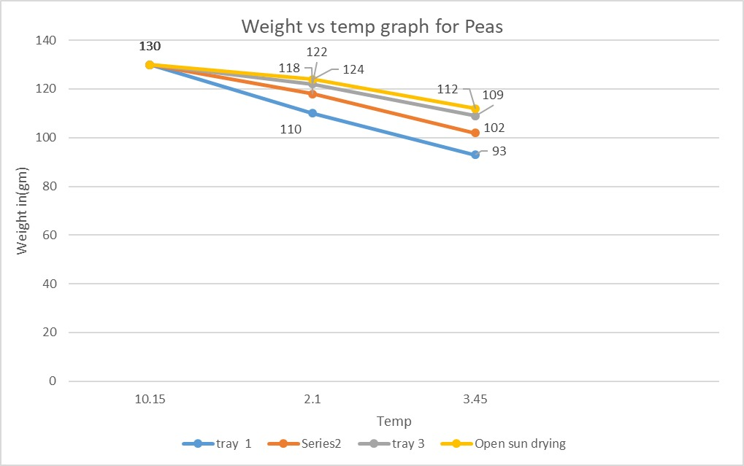**4.1.14: Graphical representation of drying of Peas**

19.

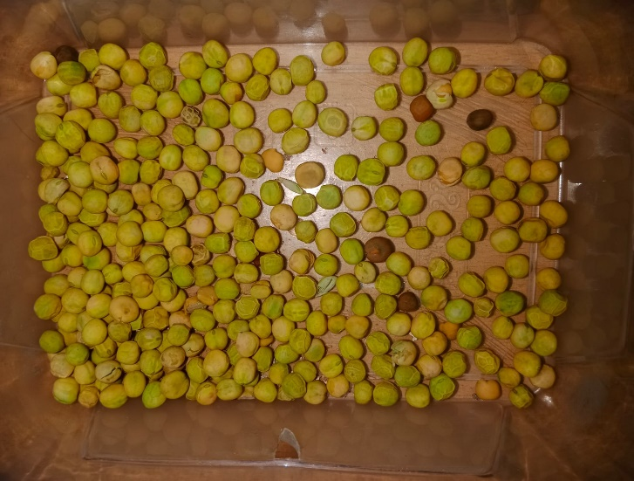**4.1.15Physical appearances of before and after drying Peas**

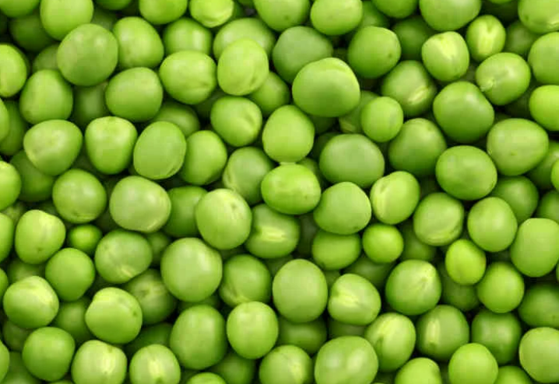

**Fig.4.7:** Peas before drying **Fig4.8**: Peas after drying

**4.1.16** **Drying efficiency**

Efficiency = (output/input) *100 [2.1,4]

Here we calculate efficiency in terms of weight.

Dryer Efficiency= (101.33/130) *100

=77.9%

20.

|  |  |  |  |  |  |  |
| --- | --- | --- | --- | --- | --- | --- |
| **Sl.no** | **Date** | **Item** | **Time** | **Tray Number** | **Temp in  oC** | **Weight(gm)** |
| **01.** | **26.05.2023** | **Peas** | **10.15 AM** | **Tray 1** | **45** | **80** |
| **Tray 2** | **42** | **80** |
| **Tray 3** | **32** | **80** |
| **Open sun drying** | **29** | **80** |
| **2.10 PM** | **Tray 1** | **62** | **62** |
| **Tray 2** | **58** | **69** |
| **Tray 3** | **49** | **74** |
| **Open sun drying** | **37** | **76** |
| **3.45 PM** | **Tray 1** | **52** | **48** |
| **Tray 2** | **46** | **54** |
| **Tray 3** | **42** | **65** |
| **Open sun drying** | **41** | **66** |

**Table 4.1.17: Temperature & weight of Groundnut in different conditions**

**4.1.18: Graphical representation of drying of groundnut**

21.

**4.1.19 Physical appearances of before and after drying groundnut**

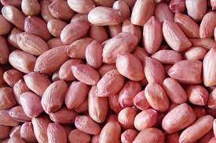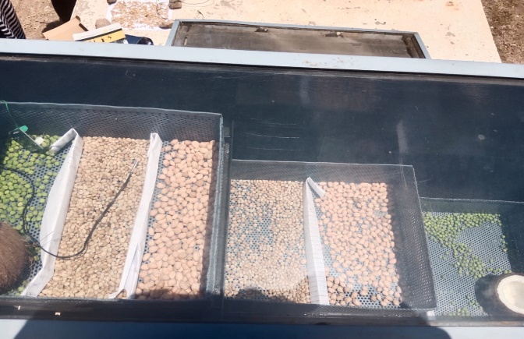

**Fig.4.9:** groundnuts before drying **Fig.4.9:** groundnuts after drying

**4.1.20** **Drying efficiency**

Efficiency = (output/input) *100 [2.1,4]

Here we calculate efficiency in terms of weight.

Dryer Efficiency= (55.66/80) *100

= 69.58 %

22.

**CHAPTER 5**

# Conclusions and Future Scope

# *This chapter concludes about the study and observations of the mini project and the future scope of the models.*

# 5.1 Conclusions

# 5.1.1 Solar Dryer

# Solar drying has proved to be technically and economically valuable for several crops. It is, however, necessary to develop large-scale dryers that may be used throughout the year for different products to make them attractive to the farmers.

# The hourly variation of temperatures inside the dryer compared to the ambient temperature is always above ambient temperature by an average of 15-20ºC throughout the daylight hours.

# The system efficiency was found to be around 65to 80%.

# The Dryer exhibited sufficient ability to dry food items rapidly to a safe moisture level and also it ensures a superior quality of the dried product.

# Protection against UV radiation, dust, insects, mold, and other sources of contamination.

# Table 5.1.2The concluded data while performing the experimental analysis is shown

|  |  |
| --- | --- |
| Sample | Drying Efficiency |
| Grape | 46.06% |
| Chilly | 76.6% |
| Potato | 74.16% |
| Peas | 77.9% |
| Groundnut | 69.58% |

23.

**5.2 Future Scope of the Work**

**5.2.1**

* Designing of the solar dryer, minimizing the shortcomings associated with low efficiency.
* It can be modified to use it during night time by adding air heater.
* To control the speed of dc fans based on the temperature inside the dryer.
* It can be used for waste management.

24.

**References**

1. K. Narendra Babu, P. Sudheer Kumar, D. Yamuna, “A Research on Development of a Fixed Solar Dryer with a Practical Research”, International Journal of Innovative Technology and Exploring Engineering (IJITEE), ISSN:2278-3075, Volume-8, Issue- 9S2, July 2019.
2. Sandeep lakhera, Rahul Bahuguna, Sudeep Singh Rawat, “Review Paper on Comparative Analysis on Solar Crop Dryer”, International Journal for Research in Engineering Application & Management (IJREAM), ISSN :2454-9150, Vol-04, Issue 2, May 2018.
3. Yonesh B. Chauhan& Pravin P. Rathod, “A comprehensive view of the Solar dryer”, International Journal of Ambient Energy, ISSN:0143-0750,12 April, 2018.
4. Bukola. O. Bolaji, “Performance Evaluation of simple Solar Dryer for food preservation”, International Journal on Engineering and Engineering Technology, ISSN:2663-8373, Volume 2, No.1, June 2005

25.