Deviation Firmware
for Devo10
User’s Manual
Version 2.0

Table of Contents
Overview 4
Installation 5
USB & File-system 6
Main Page 7
Navigating 8
Menu Layout 8
Emulator 9
About Deviation Page 9
USB Page 9
Transmitter Configuration Page 10
General Settings 10
LCD Settings 10
Timer Settings 10
Telemetry Settings 10
Main Page Configuration 11
Preview 11
Trim Positions 11
Boxes 11
Switch Display 11
Quick-page Selection 11
Mixer 12
Simple Template 13
Expo & Dual-Rate Template 14
Complex Template 15
Reordering Mixers 17
Available Curves 18
Curve Editing 18
Channel configuration 19
Trims and Virtual Inputs 20
Model Setup Page 21
Protocols 21
Protocol: DEVO 21
Protocol: WK2801 21
Protocol: WK2601 22
Protocol: WK2401 22
Protocol: DSM2 22
Protocol: J6Pro 23
Protocol: Flysky 23
Protocol: Hubsan4 23
Protocol: PPM 23
Predefined Templates 24
Timer Page 25
Telemetry Configuration Page 26

Overview
Deviation is a replacement firmware for the Walkera Devo© series transmitters. The primary goal is to add support for multiple protocols, opening the full potential of this platform.
The core of the Deviation firmware is the mixer system, which is modeled after the system used in the Er9X firmware for the Turnigy/Flysky9x© transmitters.

Deviation also brings a USB file-system support, making it easy to manage the transmitter from any PC without the need for specialized upload/download tools.

Deviation has been designed for ultimate configurability. All model and transmitter configuration is controlled through text files which the firmware (or user) can read and write. It is easy to know exactly what is configured, as well as to modify the configuration either through the transmitter or with a text editor. The main screen is very configurable; any mix of inputs, switches, channel data, or timers can be displayed, and configured per-model. Deviation also supports customizable themes with full control over the images, fonts, and colors.

Deviation can store up to 255 different models, and uses a portable syntax that allows sharing models between any transmitter supported by Deviation.

Deviation has been internationalized. New language support can be added by simply copying a translation file into the appropriate directory on the transmitter.

Installation
Installation of Deviation is done just like upgrading the Walkera firmware.
Note that Deviation will NOT overwrite Walkera models stored on the Tx. While they cannot be accessed by Deviation, they will be safely preserved should the Walkera firmware ever need to be reinstalled.

First install the deviation-devoXX-x.y.z.zip firmware using the Walkera ‘DfuSe USB Upgrade’ tool. You will need the ‘Devention DfuSe USB Upgrade Tool’from Walkera: http://www.walkera.com/cn/soft_up/soft_file_1340783602848_null.zip. Do NOT attempt to use the DfuSe tool from STMicroelectronics! It is recommended to test that this tool works by upgrading to a different Walkera firmware. Several users have had compatibility issues with the DfuSe tool.

Plug the transmitter into the PC via USB, and turn on the transmitter while holding ‘EXT’ to enter programming mode.

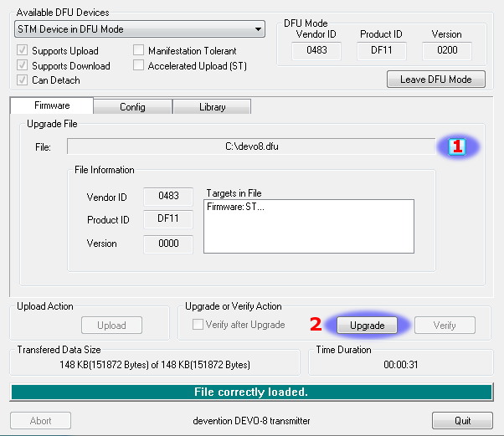
- Press the ‘...’ button and select the dfu file to install
- Select ‘Upgrade’ to install the firmware. This will be greyed-out if your Tx is not detected. Do NOT use ‘Upload’ as this will destroy the dfu file on your PC. There have been reports of it corrupting the model settings on the TX as well.
Turn off the transmitter, and turn back on while holding ‘ENT’. There should be a USB logo on the screen.

If this is an upgrade from a previous Deviation release, it is strongly recommended to back-up the ‘models’ directory from the transmitter as well as the tx.ini file to ensure you don’t lose any model or transmitter configuration. Next unzip the deviation-fs-devoXX-x.y.z.zip to the PC and copy all directories EXCEPT for the ‘models’ directory and the tx.ini file to the transmitter. Optionally, copy the ‘models’ directory to the transmitter except for the currently configured model files. This last step will ensure that the defaults for newly created models have the latest options set. If the tx.ini file is overwritten, the transmitter calibration must be repeated.

If this is an upgrade from the Walkera firmware, the PC should prompt to format the drive. Format using default options. Next unzip the deviation-fs-devoXX-x.y.z.zip to the Tx USB drive.

USB & File-system
Deviation stores all configuration, bitmaps, and models as regular files on the USB file-system.
USB can be most easily enabled by holding down the ‘ENT’ button while powering up the transmitter. Files can then be easily copied to or from the Tx.

The directory structure is as follows:
\tx.ini | Transmitter config. Includes trim settings, calibration data, and the last-used model number
\media\config.ini | The color scheme and fonts for the transmitter
\media\sound.ini | Contains notes to play for various alarms
\media\*.bmp | Images used for the current Tx theme
\media\*.fon | Font files
\models\default.ini | The default model, loaded whenever a model is cleared
\models\model*.ini | Configuration files for each model. Due to a limitation in the firmware, Deviation cannot create new files. It is therefore necessary to have a modelxx.ini for each model regardless of whether it is currently in use.
\modelico\*.bmp | All available model icons (must be 52x36 pixels)
\templates\*.ini | Configuration files used when loading predefined templates. These are nearly identical to the model configuration files, however they do not necessarily define all parameters
\language\lang*.* | Language translation files. These are UTF-8 text files containing the English string and the respective translated string

Main Page
Raw input (stick/switch values)

Transmitter Power

Current Model

Battery voltage

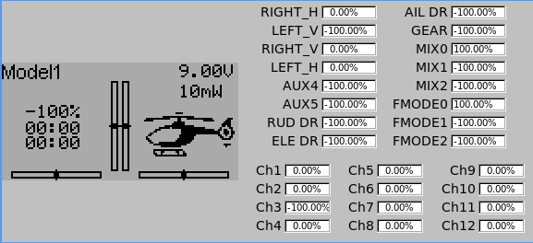
Configurable displays

Model
Icon

Channel Output values

Trims

Current Model: The name of the current model. It is configured from the Model Configuration page.
Transmitter Power: This indicates the currently selected transmitter power. It is configured from the Model Configuration page.
Battery Voltage: Numerical representation of current Tx battery state
Configurable Displays: These can be text-boxes contacting input, channel, telemetry, or timer data; bar graphs displaying channel data; or icons displaying specific states (e.g. gear, flaps,…)
Model Icon: An image representing the current model. It is configured from the Model Configuration page.
Trims: The trim display can be configured to show either 4 or 6trims

Navigating

The transmitter menus can be navigated via the physical buttons (Up, Down, Left, Right, Ent, Ext).
The Menu is entered by pressing ‘ENT’ on the main menu
On all menu pages, ‘UP’ and ‘DN’ are used to navigate to the previous/next item.
The ‘R+’ and ‘L-’ buttons are used on spin-box widgets to increase or decrease the selected value. In some cases holding down the button will use larger step values to move more quickly to the desired value.
For Buttons and rounded-spin-boxes, pressing ENT’ will press the button
Pressing ‘EXT’ will exit 1 menu level.

Menu Layout
Main page
Main menu
‘ENT’
Telemetry
Timer
Channel
Monitor
Transmitter Menu
Main Page Config
Model
Mixer
Transmitter
Config
Trim
Telemetry
Monitor
Transmitter menu
Model menu
USB
About Deviation
Main Menu
Model Menu

Emulator
The emulator provides a side-screen displaying the current virtual-stick/switch states as well as the Channel output that would be received by the servos
The emulator controls are as follows:

q/a | Throttle (Mode 2)
Q/A | Left-Vertical trim
w/s | Rudder (Mode 2)
W/S | Left-Horizontal trim
e/d | Elevator(Mode 2)
E/D | Right-Vertical trim
r/f | Aileron (Mode 2)
R/F | Right-Horizontal trim
z | Gear
x | Rudder Dual-Rate switch
c | Elevator Dual-Rate switch
v | Aileron Dual-Rate switch
b | Mix 0/1/2 switch
n | FMode 0/1/2 switch
\ | Power off
Left-arrow | Left
Right-arrow | Right
Up-arrow | Up
Down-arrow | Down
Enter | Ent
Escape | Exit

About Deviation Page

The Deviation release version can be accessed by selecting ‘About Deviation’ from the main menu. If it is ever necessary to report bugs with the Deviation firmware, include the version string found here with your report.

USB Page

The USB page cab be accessed by selecting ‘USB’ from the main menu. USB mode can then be toggled on/off to enable access to the transmitter’s file-system. Note that doing so should never be done while the model is bound, as USB will disrupt signal transmission!

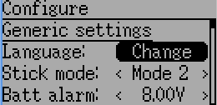
Transmitter Configuration Page

The Configuration page defines various transmitter functions. It is entered from the main menu via ‘Transmitter Menu’ followed by ‘Transmitter Config’.

General Settings
Language: Select an appropriate language for all text
Stick mode: Select one of Mode 1-4.
- Mode 1 is common in Europe. Elevator and Rudder on left, Throttle and Aileron on right.
- Mode 2 is common in North America. Throttle and Rudder on left, Elevator and Aileron on right.
- Mode 3 has Elevator and Aileron on left, Throttle and Rudder on right
- Mode 4 has Throttle and Aileron on left, Elevator and Rudder on right
Batt alarm: Set battery voltage at which alarm will sound
Sticks: Calibrate the range of all analog sticks and dials
Buzz volume: Set buzzer volume
Vibration: Turn haptic feedback on/off

LCD Settings
Backlight: Set screen brightness
Contrast: Set screen contrast
Dimmer time: Set delay before screen dims
Dimmer target: Set screen brightness when dimmed

Timer Settings
Prealert time: Time before timer reaches zero to start beeping
Prealert intvl: How often to beep before timer reaches zero
Timeup intvl: How often to beep once timer has expired

Telemetry Settings
Temperature: Set units to display temperature for telemetry
Length: Set units to display length for telemetry

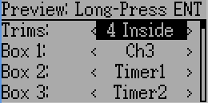
Main Page Configuration

The Main Page Configuration page provides customized control of the main-page layout. The display of boxes, bars, icons, and trims along with their contents can all be controlled from here. This page is accessed from the main-menu via 'Model menu' followed by 'Main page config'.

Preview
Entering preview by a long 'ENT' press will allow quickly visualizing any changes made via the configuration page. Press 'EXT' to return to the configuration.

Trim Positions
There are 3 options for the Trim Positions:
- 4 outside: Only 4 trims are shown, and they will be placed at the screen edges
- 4 inside: Only 4 trims are shown, and they are placed at the middle of the screen
- 6 Trims: 6 trims are shown, all placed towards the inside

Boxes
Boxes are used to display interesting text values. There are 8 available boxes. Boxes 1 through 4 are drawn on the left, and boxes 5 through 8 are drawn on the right. Currently a box can display one of the timers, one of the output channels, or telemetry data.

Switch Display
Switches are used to display the state of an input or output channel. A switch is either on (value > 0) or off (value <= 0). Up to 4 switches can be displayed. When a switch is enabled, a small indicator box will be displayed on the main page corresponding to the appropriate switch.

Quick-page Selection
Quick-pages allow quick access to other pages from the main page via Long-UP or LONG-DN buttons. Up to four quick-pages can be configured.

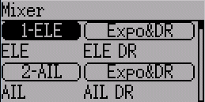
Mixer

The Mixer page controls how inputs (sticks/switches) are assigned to output channels. The mixer page is accessed from the main menu via 'Model menu' followed by 'Mixer'.

The Deviation mixer is modeled after the Er9x implementation. Each output channel is composed of a series of one or more mixers each of which consists of a single input, an activation switch, and a function/curve that modifies the mixer output. This is a very powerful capability, but it is requires a lot of understanding to make full use of. In order to simplify implementation, there are 3 templates that have been defined to make defining channels easier.

The number of channels available is dependent on the number of channels selected on the Model Setup Page. Additionally there are 10 Virtual channels that can be used as an intermediate step for complex setups.

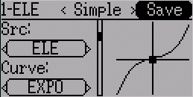
Simple Template
The simple template is the simplest manner of defining a channel. It allows defining a primary-input (stick, switch, or other channel), and applying a curve or function to that input. The result can also be scaled or have an alternate zero-offset.

A ‘Long-ENT’ press will update the current mixer settings, making it possible to test them on the transmitter.
Src: The input source controlling this mixer
Curve: The function applied to the input to generate the output. See the Curve section for more info. Selecting the ‘Curve’ spin-box will allow configuring the Curve in the case that a multi-point curve or Expo-rate are chosen.
Scale: A multiplicative scalar that is applied after the Curve to control the output range
Offset: an additive offset that is applied after the scaling.

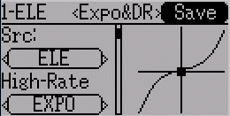
Expo & Dual-Rate Template
The Expo/Dual-Rate template is a more sophisticated template designed to allow use of toggle or 3-way switches to manipulate an input. The primary-input (stick, switch, or other channel), can have a different curve/function and scaling for each toggle-switch position.

Selecting a value for Switch1 or Switch2 will activate the corresponding section. Each section can either have a 'linked' curve (curve is the same as the 'High-Rate' curve) in which case only the scalar can be modified, or alternatively can have an independent curve definition. Pressing the 'Mid-Rate' or 'Low-Rate' button for a given switch will toggle between linked and independent curves.

A ‘Long-ENT’ press will update the current mixer settings, making it possible to test them on the transmitter.

Src: The input source controlling this mixer
Curve: The function applied to the input to generate the output. See the Curve section for more info. Selecting the ‘Curve’ spin-box will allow configuring the Curve in the case that a multi-point curve or Expo-rate are chosen.
Switch: Specify a switch to enable Medium or Low rates.
Scale: A multiplicative scalar that is applied after the Curve to control the output range

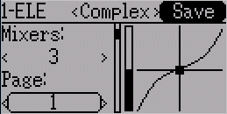
Complex Template
The Complex template unlocks the full power of the mixer system. For a given channel, any number of mixers can be applied to affect the final result. Each mixer is applied based on whether the specified switch is active, and can either replace, add to, or multiply to the previous mixers for this channel. Using this system it should be possible to define an output channel as a combination of any number of inputs.

A ‘Long-ENT’ press will update the current mixer settings, making it possible to test them on the transmitter.

The Complex Mixer page has the following options:
Mixers: Specify the number of mixers for this channel
Page: Specify the current mixer page being edited. Pressing the spin-box will allow reordering the pages of the current channel.
Switch: Specify an optional switch which determines whether the current mixer is active.
Mux: Defines how the current mixer is applied to the previously defined mixers for this channel. Options are:
- Replace: If this mixer is active, all previous mixers are ignored
- Add: Add the value of this mixer to the previous mixers
- Mult: Multiply the value of this mixer with the previous mixers
- Max: The output will be the greater of the current mixer vs the previous mixers
- Min: The output will be the lesser of the current mixer vs the previous mixers
Src: The input source controlling this mixer
Curve: The function applied to the input to generate the output. See the Curve section for more info. Selecting the ‘Curve’ spin-box will allow configuring the Curve in the case that a multi-point curve or Expo-rate are chosen.
Scale: A multiplicative scalar that is applied after the Curve to control the output range
Offset: an additive offset that is applied after the scaling.
Trim: Selects whether or not any trims for the selected Source are applied to this mixer

Note that while the scale value is limited to 100%, the mixer may provide a value larger than 100% if an offset is set or if the trim value is non-zero.

A given mixer can be considered to have the general form:
M(x) = if(Switch) { Src * Curve * Scale + Offset} else {0} + Trim

The combination of mixers for a given output channel is defined by the Mux type:

For a ‘Replace’ mux:
Cx = if(Switchn) {Mn} else if (Switchn-1) {Mn-1} … else if (Switch0) {M0}

For a ‘Multiply’ mux:
Cx = if(Switchn) {Mn} else {1} * if (Switchn-1) {Mn-1} else {1} * … *
if (Switch0) { M0} else {1}

For an ‘Add’ mux:
Cx = if(Switchn) {Mn} else {0} + if (Switchn-1) {Mn-1} else {0} + … +
if (Switch0) { M0} else {0}

For a ‘Max’ mux:
Cx = MAX(if(Switchn) {Mn} else {0}, if (Switchn-1) {Mn-1} else {0}, …,
if (Switch0) { M0} else {0})

For a ‘Min’ mux:
Cx = MIN(if(Switchn) {Mn} else {0}, if (Switchn-1) {Mn-1} else {0}, …,
if (Switch0) { M0} else {0})

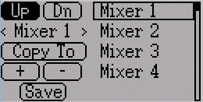
Reordering Mixers
Since the ordering of mixers is important to the output, it is possible to reorder and/or copy mixers in order to facilitate building complex rules. This page is accessed by pressing the ‘Page’ spin-box on the complex mixer page.
Select the respective mixer and use the up/down buttons to move the order of the selected mixer. Note that the mixer name represents its position when the reorder dialog was opened. If the dialog is closed and reopened, all mixers will be shown as numbered sequentially.
The reorder page can add new mixers or delete existing ones using the ‘+’ and ‘-’ buttons respectively. A mixer can also be copied to an existing mixer (overwriting it in the process) by using the ‘Copy To’ functionality

Available Curves
The following curve functions are supported:
1-to-1: Output is equal to the input (not editable).
Fixed: Output is constant regardless of input (not editable).
Min/Max: Output is -100 if input is < 0 and 100 if input is >= 0 (not editable)
Zero/Max: Output is 0 if input is < 0 and 100 if input is >= 0 (not editable)
>0: Output is 0 if input is < 0 and matches the input when >= 0 (not editable)
<0: Output matches the input when < 0 and is 0 if input >= 0 (not editable)
ABSVAL: Output is the absolute-value of the input (not editable)
EXPO: Apply exponential curve to the input for non-linear response (editable)
Deadband: Output will not respond to input values near zero (editable)
Multi-point: Curve is based on 3 to 13user-defined points

Curve Editing
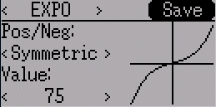
The Curve Editor is accessed by pressing a graph or by pressing the curve spin-box when it is selectable. Some curve types may not be edited (any of the curves preceding the ‘Expo’ curve), and the curve-box will not be selectable if one of these curves is currently active.

The Curve editor page will be difference depending on which curve is selected. It is not possible to change the curve type from the curve editor (except when a multi-point curve is selected)

For the Expo curve, the controls allow independently configuring the shape of the curve for values greater-than or less-than zero.

For the Deadband curve, the controls allow independently configuring the deadband width for values greater-than or less-than zero.

For the Multi-point curves, Each point can be individually set. Points are set by choosing the point number and then choosing a value. Touching the graph will allow quickly setting the value to the touched y-coordinate.

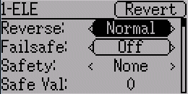
Channel configuration
The Channel configuration provides the ability to configure the final channel outputs. Capabilities such as channel reverse and failsafe-values are applied here. Also available are controls for end-points, scaling, sub-trim, and a safety switch (which could be used to ensure that a motor cannot spin-up while working on a model)

Changes to this page will immediately effect the channel output. Pressing 'Revert' will restore the shown values to their saved state.

Reverse: Reverse the direction of servo rotation
Failsafe: Specifies a value that the Rx should use when it loses signal from the transmitter. Not all receivers support this capability.
Safety: Specifies a switch that will override all mixers and force the channel output to ‘Value’ when flipped.
Min/Max: These values define the minimum and maximum values that the transmitter will ever send to the receiver (after all scaling and trims are applied). If a calculated value is outside the min/max range, it will be clipped to either the min or max value as appropriate.
Scale: This is a final scalar to adjust the servo throw.
Sub-trim: Adjust servo zero position
Speed: Adjust maximum servo speed. Zero is disabled (fastest), 1 is slowest, 100 is fastest rate.

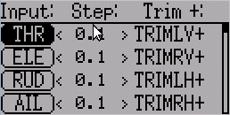
Trims and Virtual Inputs

The trim page allows assigning the trim buttons and trim step, as well as configuring buttons to work as virtual inputs. It s accessed from the main menu via 'Model menu' followed by 'Trims'.

If the ‘Input’ field is set to an input stick, then the trim is applied as part of the mixer, and will operate as a typical trim control. If the ‘Input’ field is set as a channel or virtual-channel output, the value is applied directly to the channel output. In this case, the selected ‘Pos’ and ‘Neg’ buttons can operate as a virtual stick to control an output channel.

The Trim-step defines how sensitive the trims are to input. The maximum number of trim steps is +/-100. So a step size of 0.1 will allow a full +/- 10% of trim adjustment on the servo.

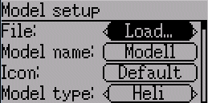
Model Setup Page

The model page provides various model configuration options. It s accessed from the main menu via 'Model menu' followed by 'Model setup'.

File: The File spin-box allows loading a new model, copying the existing model to a new location, resetting the current model to the default (all configuration is lost), and loading templates (see Predefined Templates)
Model Name: Set the model’s name
Icon: Choose the model’s icon
Model Type: Set the model type. Some models (e.g. helicopter) have additional configuration options that can be accessed by clicking the Model type.
Protocol: Set the type of Rx being used. Note that some protocols have additional options that can be accessed by pressing the Protocol spin-box when it is active. See the Protocol section for more on specific protocols. Note that a protocol change will not take effect until the transmitter is power-cycled, or the Bind/Re-Init button is pressed (see below)
Number of channels: Sets the number of channels to transmit (the maximum number of channels is dependent on the selected protocol).
Tx Power: Specify the radio output power when applicable.
Fixed ID: The Fixed ID sets a unique code to ensure that the Tx will only bind to a specific model. This is useful to ensure that the Tx is not accidentally bound to the wrong model.
Bind/Re-Init: Depending on the protocol and Fixed-ID setting, the Tx may bind with the model on start-up, or may need to be manually bound once. See the Protocol section for more on specific protocols. If the protocol does not support binding, the button will show ‘Re-Init’, which can be used to switch protocols without power-cycling the transmitter.

Protocols
Some protocols have additional customization or limits. Each of the protocols is described below

Protocol: DEVO
The DEVO protocol is used to maintain compatibility with the Walkera DEVO receivers/models. This protocol supports up to 12 channels. The DEVO protocol supports both auto-binding and manual-binding. If FixedID is set to ‘None’ the transmitter will attempt to auto-bind with the receiver every time it is powered n. If a value is set for FixedID, the receiver must be bound manually one-time using the ‘Bind’ button, after which it should stay bound. Note that the FixedID is only part of the binding procedure. Two transmitters with the Same ID cannot control the same model.

Protocol: WK2801
The WK2801 protocol is used to control older Walkera models. The previous Walkera models were segmented into 3 similar but not identical protocols: WK2801, WK2601, WK2401. This roughly corresponds to the number of channels supported, but many of the newer 6-channel receivers actually support the WK2801 protocol. It is recommended to try the WK2801 protocol 1st when working with older Walkera models before attempting the WK2601 or WK2401 mode, as the WK2801 is a superior protocol. The WK2801 protocol supports up to 8 channels, and both auto-binding and manual-binding. If FixedID is set to ‘None’ the transmitter will attempt to auto-bind with the receiver every time it is powered on. If a value is set for FixedID, the receiver must be bound manually one-time using the ‘Bind’ button, after which it should stay bound.

Protocol: WK2601
The WK2601 protocol is used to control older Walkera models. The previous Walkera models were segmented into 3 similar but not identical protocols: WK2801, WK2601, WK2401. This roughly corresponds to the number of channels supported, but many of the newer 6-channel receivers actually support the WK2801 protocol. It is recommended to try the WK2801 protocol 1st when working with older Walkera models before attempting the WK2601 or WK2401 mode, as the WK2801 is a superior protocol. The WK2601 protocol supports up to 7 channels, and only supports auto-binding. The fixed ID can be used, but does not prevent auto-binding during power-on.

The WK2601 protocol also supports additional options. These are accessed by pressing the Protocol spin-box when Wk2601 is shown:
Chan mode: Sets how channels are processed:
- 5+1: AIL, ELE, THR, RUD, GYRO (ch 7) are proportional. Gear (ch 5) is binary. Ch 6 is disabled
- Heli: AIL, ELE, THR, RUD, GYRO are proportional. Gear (ch 5) is binary. COL (ch 6) is linked to Thr. If Ch6 >= 0, the Rx will apply a 3D curve to the Thr. If Ch6 < 0, the Rx will apply normal curves to the Thr. The value of Ch6 defines the ratio of COL to THR.
- 6+1: AIL, ELE, THR, RUD, COL (ch 6), GYRO (ch 7) are proportional. Gear (ch 5) is binary. This mode is highly experimental.
COL Inv: Invert COL servo
COL Limit: Set maximum range of COL servo

Protocol: WK2401
The WK2401 protocol is used to control older Walkera models. The previous Walkera models were segmented into 3 similar but not identical protocols: WK2801, WK2601, WK2401. This roughly corresponds to the number of channels supported, but many of the newer 6-channel receivers actually support the WK2801 protocol. It is recommended to try the WK2801 protocol 1st when working with older Walkera models before attempting the WK2601 or WK2401 mode, as the WK2801 is a superior protocol. The WK2401 protocol supports up to 4 channels, and only supports auto-binding. The fixed ID can be used, but does not prevent auto-binding during power-on.

Protocol: DSM2
The DSM2 protocol is used to control many Spektrum© and JR©, as well as other models using this protocol. While the DSM2 protocol can support up to 14 channels, Deviation is currently limited to a maximum of 9. Note that many receivers with less than 8 channels require the Transmitter to send 7 or less channels. Make sure the # of channels is set appropriately for the receiver. DSM2 does not support auto-binding. If FixedID is set to None, a transmitter-specific ID is used instead. It is necessary to manually bind each model before the first use.

Protocol: J6Pro
The J6Pro protocol is used to support Nine Eagles© models. Only models compatible with the J6Pro transmitter can be used. Many older 4-channel Nine Eagles models used a different protocol that is unsupported. The J6Pro protocol supports up to 12 channels, although only models with 6 channels have been tested. J6Pro does not support auto-binding. If FixedID is set to None, a transmitter-specific ID is used instead. It is necessary to manually bind each model before the first use.

Protocol: Flysky
The Flysky protocol is used to control Turnigy/Flysky receivers as well as a few other models using the same protocol (WL V911, Xieda 9958, etc). NOTE: This protocol requires the addition of a hardware module to function. See the following document for more information:
http://www.deviationtx.com/repository/Documentation/Flysky-to-Devo.pdf/

The Flysky protocol supports up to 8 channels, and both auto-binding and manual-binding. If FixedID is set to ‘None’ the transmitter will attempt to auto-bind with the receiver every time it is powered on. If a value is set for FixedID, the receiver must be bound manually one-time using the ‘Bind’ button, after which it should stay bound.

Protocol: Hubsan4
The Hubsan4 protocol supports the Hubsan-X4 quadracopter. No other models have been tested with this protocol. NOTE: This protocol requires the addition of a hardware module to function. See the following document for more information:
http://www.deviationtx.com/repository/Documentation/Flysky-to-Devo.pdf/

The Hubsan4 protocol supports 4 channels, and only supports auto-binding. The fixed ID can be used, but does not prevent auto-binding during power-on.

Protocol: PPM
The PPM protocol is used to output PPM on the trainer port. It will disable all radio transmission. The PPM protocol is useful for connecting to simulators, or other radio-modules that plug into the trainer port. The FixedID has no effect, and there is no binding associated with this protocol.

Deviation does not auto-detect when a trainer cord is plugged into the transmitter. To use Deviation with a simulator (such as Phoenix), create a new model, name it apropriately, and select PPM as the protocol. Use the Re-Init button or power-cycle to enable PPM mode.

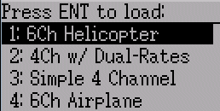
Predefined Templates

The Deviation firmware supports user-customizable predefined templates. By Selecting ‘Template...’ From the Model page, it is possible to select one of these options

Additional templates can be added via USB to the ‘\template’ directory.
A template does not completely replace your existing model, but instead only a portion of it. The currently supported templates will replace the mixer and trim definitions, but will not affect the display layout. In the future Deviation will support templates that only affect the display layout without affecting the mixers as well.

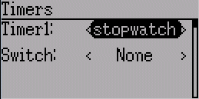
Timer Page

The timer page defines the 2 available timers. Timers can count either up or down, and can be enabled either manually from the main screen or by an input trigger (stick or switch).
This page is accessed from the main menu via 'Model menu' followed by 'Timers'.

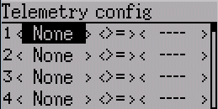
Telemetry Configuration Page

The telemetry configuration page allows specifying alarms when specific telemetry events occur. This page is accessed from the main menu via 'Model menu' followed by 'Telemetry'

Telemetry: Specify the telemetry input to use for alarm control. This can be a temperature probe, voltage probe, or RPM probe.
Equality: Can be '>=' or '<=' indicating whether a value above or below the target causes an alarm.
Target: The target value for the alarm

