Deviation Firmware User’s Manual
Version 0.1

Table of Contents
Overview 3
Installation 4
Filesystem 4
Main Page 5
Emulator 6
Main Page Configuration 7
Preview 8
Trim Postions 8
BarGraphs 8
Boxes 8
Toggle Icons 8
Mixer 9
Simple Template: 10
Expo & Dual-Rate Template: 10
Complex Template: 11
Channel configuration: 12
Trims: 12
Model Page: 13
Timer Page: 13

Overview
Deviation is a replacement firmware for the Walkera Devo© series transmitters. The primary goal is to add support for multiple protocols, opening the full potential of this platform.
The core of the Deviation firmware is the mixer system, which is modeled after the system used in the Er9X firmward for the Turnigy/Flysky9x© transmitters.

Deviation also brings USB filesystem support, making it easy to manage the transmitter from any PC without the need for specialized upload/download tools.

Deviation has been designed for ultimate configurability. All model and transmitter configuration is controlled through text files which the firmware (or user) can read and write. It is easy to know exactly what is configured, as well as to modify the configuration either through the transmitter or with a text editor. The main screen is very configurable; any mix of channel data, timers or telemetry can be displayed, and configured per-model. Deviation also supports easy theming with full control over the images, fonts, and colors.

Deviation can store up to 255 different models, and uses a portable syntax that should allow sharing models between any transmitter supported by Deviation in the future.

Installation
Installation of Deviation is done just like upgrading the Walkera firmware.
Note that Deviation will NOT overwrite Walkera models stored on the Tx. While they cannot be accessed by Deviation, they will be safely preserved should the Walkera firmware ever ned to be reinstalled.

First install the deviation-x.yy.dfu using the Walkera ‘DfuSe USB Upgrade’ tool.
There are 2 options on how to install the libraries.

If previously the Walkera firmware was installed, the fastest solution is to use the ‘DfuSe’ tool to install the deviation library.

Alternatively (or if this is an upgrade from a previous Deviation version) power off the Tx, and power back on holding the ‘Ent’ button (with the USB cable still plugged in). This will start the Tx in USB mode. Windows will now detect the transmitter as a USB drive. If the deviation lib was not installed, Windows will ask to format the drive. Format using the default options. Next unzip the deviation-lib-x.yy.zip to the Tx USB drive.

Filesystem
Deviation stores all configuration, bitmaps, and models as regular files on the USB filesystem.The directory structure is as follows:

\tx.ini | Transmitter config. Includes trim settings, calibration data, and the last-used model number
\media\config.ini | The color scheme and fonts for the transmitter
\media\*.bmp | Images used for the current Tx theme
\models\default.ini | The default model, loaded whenever a model is cleared
\models\model*.ini | Configuration files for each model. Due to a limitation in the firmware, Deviation cnanot create new files. It is therefore necessary to have a modelxx.ini for each model regardless of whether it is currently in use.
\templates\tmpl*.ini | Configuration files used when loading predefined templates. These are nearly identical to the model configuration files, however they do not necessarily define all parameters

Main Page
Transmitter Power

Raw input (stick/switch values)

Battery voltage

Current Model

Tx Option Pages

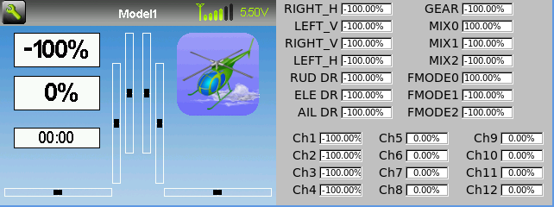
Channel Output values

Model Configuration Pages

Trims

Configurable displays

Tx Option Pages: Selecting this icon provides access to the main-page configuration screen; the Channel-Test screen; the frequency scanner; and USB mode
Current Model: Selecting the model-name provides access to the Load-Model screen for quick-model switching
Transmitter Power: This indicates the currently selected transmitter power. It is configured from the Model Configuration page
Battery Voltage: Either a numeric or graphical representation of current Tx battery state
Configurable Displays: These can be text-boxes contacting channel, timer, or telemetry data; bar graphs displaying channel data; or icons displaying specific states (e.g. gear, flaps,…)
Trims: The trim display can be configured to show either 4 or 6trims
Model Configuration Pages: Selecting the model icon provides access to the model configuration pages

Emulator
The emulator provides a side-screen displaying the current virtual-stick/switch states as well as the Channel output that would be received by the servos
The emulator controls are as follows:

q/a | Throttle (Mode 2)
Q/A | Left-Vertical trim
w/s | Rudder (Mode 2)
W/S | Left-Horizontal trim
e/d | Elevator(Mode 2)
E/D | Right-Vertical trim
r/f | Aileron (Mode 2)
R/F | Right-Horizonatl trim
z | Gear
x | Rudder Dual-Rate switch
c | Elevator Dual-Rate switch
v | Aileron Dual-Rate switch
b | Mix 0/1/2 switch
n | FMode 0/1/2 switch
\ | Power off
Left-arrow | Left
Right-arrow | Right
Up-arrow | Up
Down-arrow | Down
Enter | Ent
Escape | Exit
Table 1: Emulator Controls

Main Page Configuration

Next Page

Return to main screen

Number of channel bar-graphs to show

Text box enable
and contents

Main Screen Preview

Prev Page

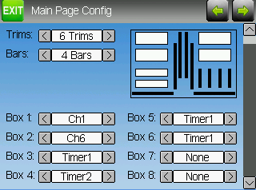
Number of Trims/
Trim Position

Next Page

Prev Page

Return to main screen

Main Screen Preview

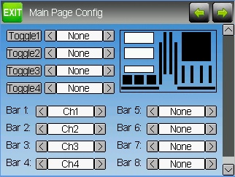
Toggle enable and Icon chooser

Bar graph channel configuration

The Main Page Configuration page provides full control of the main-page layout. The number of boxes, their size and location, and their contents can all be controlled from here. Additionally bar-graphs, toggle-icons, and trims can be configured as well.

Preview
The preview box portrays an approximation of the current configuration, and can be used as a reference to see how changing options will effect the main screen.

Trim Postions
There are 3 options for the Trim Positions:
- 4 outside: Only 4 trims are shown, and they will be placed at the screen edges
- 4 inside: Only 4 trims are shown, and they are placeat the middle of the screen
- 6 Trims: 6 trims are shown., all placed towards the inside

BarGraphs
Bargraphs are used to visualize the state of up to 8 output channels. There are 3 possible configurations:
- None: Bargraphs are disabled and will not be displayed
- 4 bars: Up to 4 bars will be displayed using one side of the screen
- 8 bars: up to 8 bars will be displayed using both sides of the screen
Bargraphs will only be displayed if there is room for them. For ‘4 bars’ mode, either boxes 3&4 or 7&8 need to be disabled. For ‘8 bars’, four boxes: 3, 4, 7 and 8 all ned to be disabled.

Boxes
Boxes are used to display interesting text values Boxes 1, 2, 5, and 6 are large boxes with a big font. Boxes 3, 4, 7, and 8 are smaller and use a smaller font. Currently a box can display one of the timers or one of the output channels.

Toggle Icons
Toggle icons are used to display the state of an input or output channel. A toggle is either on (value > 0) or off (value <= 0). Each toggle can have a different icon shown when it is active. Up to 4 toggles can be displayed. If only 4 trims are shown, the 4 toggles will replace the area used by trims 5&6. If 6 trims are shown, only 3 toggles can be shown and they will be placed either in place of box 4 or box 8. The toggles will only be shown if there is room for them (no box or bar-graph is using that space).

Mixer

Next Page

Prev Page

Show Chantest page

Return to main screen

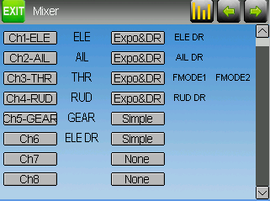
Switches that effect the channel

Mixer template in use

Primary input effecting channel

Channel Output
(and label on Rx)

The Deviation mixer is modeled after the Er9x implementation. Each output channel is composed of a series of one or more mixers each of which consists of a single input, an activation switch, and a function/curve that modifies the mixer output. This is a very powerful capability, but it is requires a lot of understanding to make full use of. In order to simplify implementation, there are 3 templates that have been defined to make defining channels easier.

Simple Template:
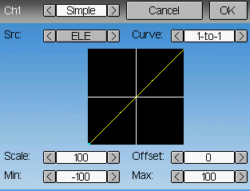

The simple template is the simplest manner of defining a channel. It allows defining a primary-input (stick, switch, or other channel), and applying a curve or function to that input. The result can also be scaled or have an alternate zero-offset
Selecting the ‘Curve’ spinbox or the graph will allow configuring the Curve in the case that a multi-point curve or Expo-rate are chosen.

Expo & Dual-Rate Template:
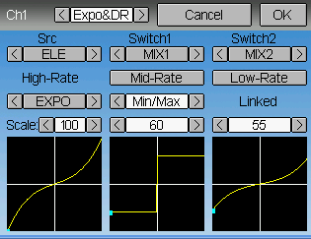

The Expo/Dual-Rate template is a more sophisticated template designed to allow use of toggle or 3-way switches to manipulate an input. The primary-input (stick, switch, or other channel), can have a different curve/function and scaling for each toggle-switch position

Complex Template:
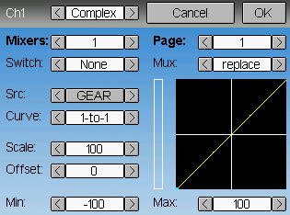

The Complex template unlocks the full power of the mixer system. For a given channel, any number of mixers can be applied to affect the final result. Each mixer is applied based on whether the specified switch is active, and can either replace, add to, or multiply to the previous mixers for this channel. Using this system it should be possible to define an output channel as a combination of any number of inputs.

A given mixer can be considered to have the general form:
M(x) = if(Switch) { Src * Curve * Scale + Offset} else {0}

The combination of mixers for a given output channel is defined by the Mux type:
For a ‘Replace’ mux:
Cx = if(Switchn) {Mn} else if (Switchn-1) {Mn-1} … else if (Switch0) {M0}

For a ‘Multiply’ mux:
Cx = if(Switchn) {Mn} else {1} * if (Switchn-1) {Mn-1} else {1} * … *
if (Switch0) { M0} else {1}

For an ‘Add’ mux:
Cx = if(Switchn) {Mn} else {0} + if (Switchn-1) {Mn-1} else {0} + … +
if (Switch0) { M0} else {0}

Channel configuration:
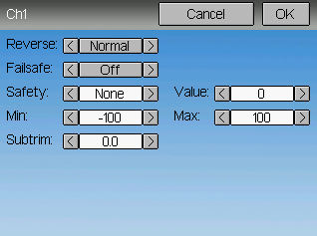

The Channel configuration provides the ability to configure the final channel outputs. Capabilities such as channel reverse and failsafe-values are applied here. Also available are controls for end-points, subtrim, and a safety switch (which could be used to ensure that a motor cannot spin-up while working on a model)

Trims:
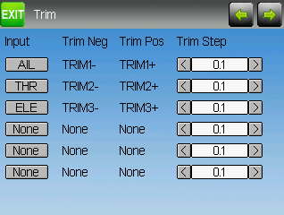
The trim page allows assigning the trim buttons an trim step. Under normal circumstances it should not be necessary to modify the trim configuration, however in some cases it may be desireable to repurpose unused trims. The Trim-step defines how sensitive the trims are to input. The maximum number of trim steps is +/-100. So a step size of 0.1 will allow a full +/- 10% of trim adjustment on the servo.

Model Page:
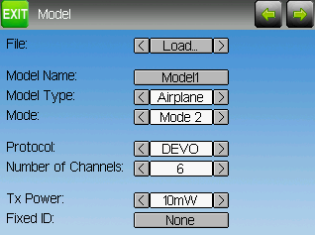

The model page allows loading and copying models, as well as loading predefined model templates. It also provides configuration options for the current model, including the Model name; Helicopter/Airplane specific configurations; Transmit Protocol; Number of channels to send to the receiver; Transmit Power; and whether a FixedID is enabled.

Timer Page:
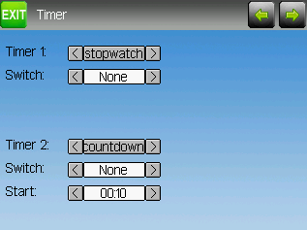
The timer page defines the 2 available timers. Timers can count either up or down, and can be enabled either manually from the main screen or by an input trigger (stick or switch)

