**Exercise 1: Setting Up JUnit**

**Scenario**:

You need to set up JUnit in your Java project to start writing unit tests.

**Steps**:

1. Create a new Java project in your IDE (e.g., IntelliJ IDEA, Eclipse).

2. Add JUnit dependency to your project. If you are using Maven, add the following to your pom.xml:

<dependency>  
 <groupId>junit</groupId>  
 <artifactId>junit</artifactId>  
 <version>4.13.2</version>  
 <scope>test</scope>  
</dependency>

3. Create a new test class in your project.

**Answer:**

1. Create a new Java project in IntelliJ IDEA .

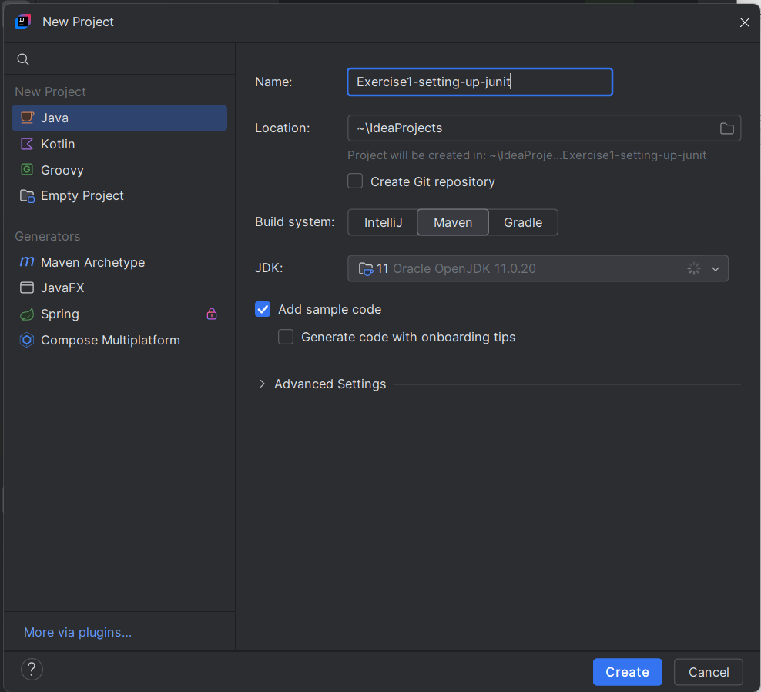

1. Add JUnit dependency to your project

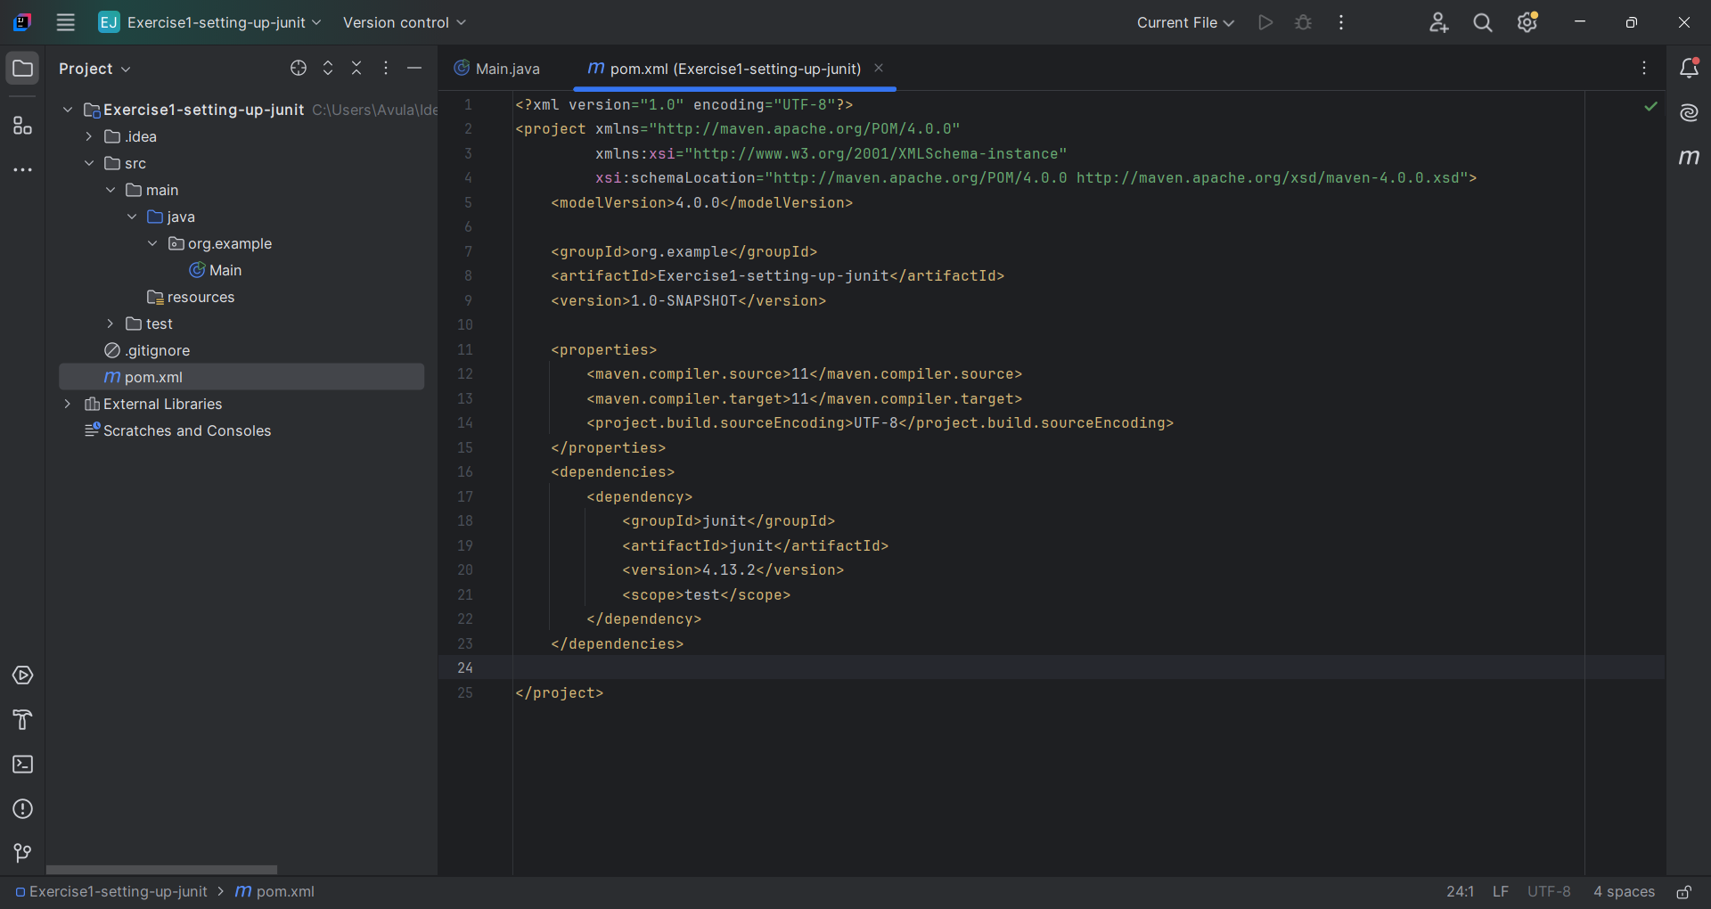

1. Create a new test class in your project

