**Exercise 1: Control Structures**

**Scenario 1:** The bank wants to apply a discount to loan interest rates for customers above 60 years old.

* + **Question:** Write a PL/SQL block that loops through all customers, checks their age, and if they are above 60, apply a 1% discount to their current loan interest rates.

**Scenario 2:** A customer can be promoted to VIP status based on their balance.

* + **Question:** Write a PL/SQL block that iterates through all customers and sets a flag IsVIP to TRUE for those with a balance over $10,000.

**Scenario 3:** The bank wants to send reminders to customers whose loans are due within the next 30 days.

**Question:** Write a PL/SQL block that fetches all loans due in the next 30 days and prints a reminder message for each customer

**Answer:**

**Environment: Oracle 11xe**

**Creation and insertion of tables:**

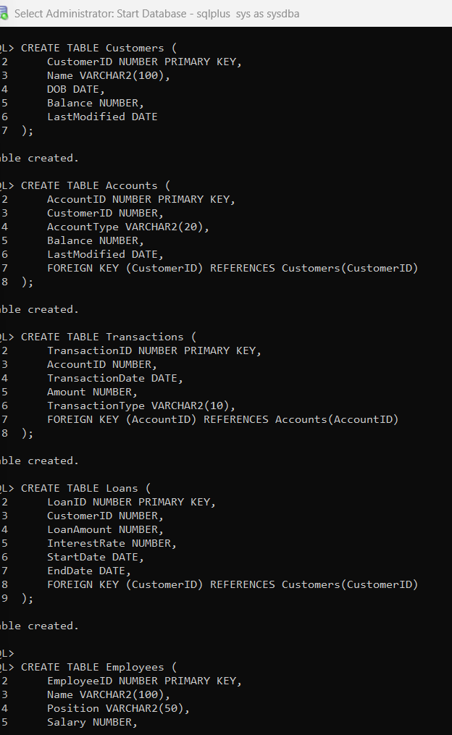

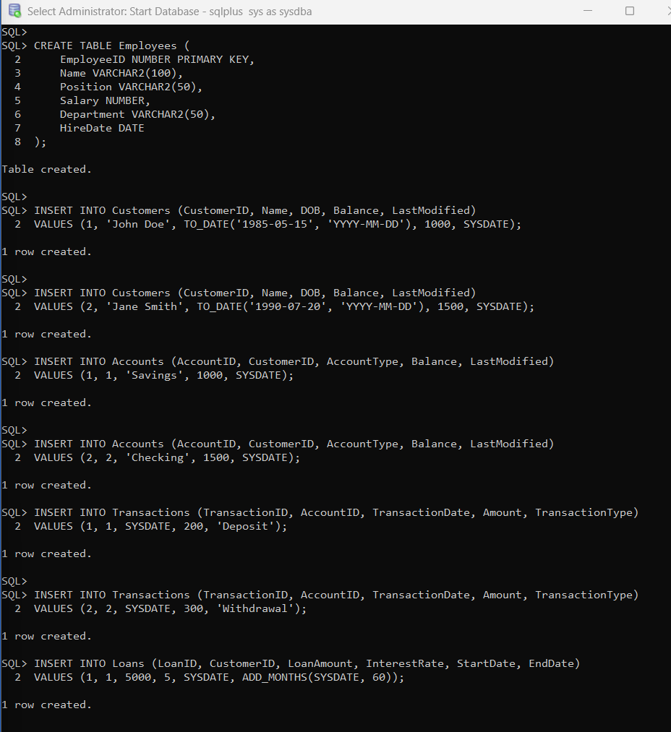

**Adding extra rows to get the output for the questions:**

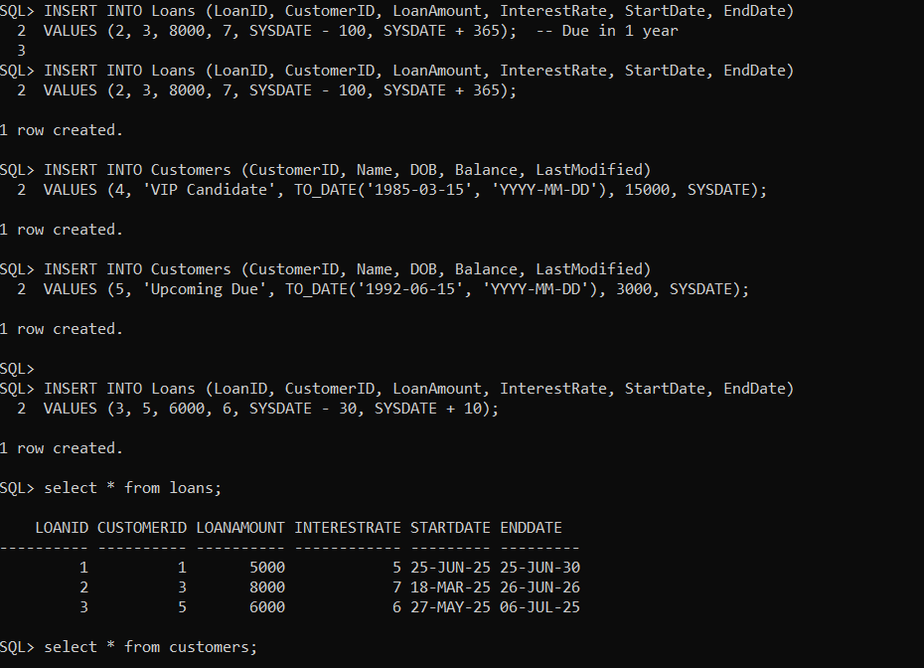

**PL/SQL code:**

SET SERVEROUTPUT ON;

BEGIN

-- Scenario 1: Apply 1% discount to loan interest rate for customers above 60

UPDATE Customers

SET loan_interest_rate = loan_interest_rate - 1

WHERE age > 60;

-- Scenario 2: Set IsVIP flag to TRUE for customers with balance over $10,000

UPDATE customers

SET IsVIP = 'TRUE'

WHERE balance > 10000;

-- Scenario 3: Send reminders for loans due in the next 30 days

FOR rec IN (

SELECT l.loan_id, l.customer_id, l.due_date, c.name

FROM loans l

JOIN customers c ON l.customer_id = c.customer_id

WHERE l.due_date BETWEEN SYSDATE AND SYSDATE + 30

) LOOP

DBMS_OUTPUT.PUT_LINE('Reminder: Loan ID ' || rec.loan_id ||

' for customer ' || rec.name ||

' is due on ' || TO_CHAR(rec.due_date, 'DD-MON-YYYY'));

END LOOP;

COMMIT;

END;

/

**Output:**

