**Exercise 3: Stored Procedures**

**Scenario 1:** The bank needs to process monthly interest for all savings accounts.

* + **Question:** Write a stored procedure **ProcessMonthlyInterest** that calculates and updates the balance of all savings accounts by applying an interest rate of 1% to the current balance.

**Scenario 2:** The bank wants to implement a bonus scheme for employees based on their performance.

* + **Question:** Write a stored procedure **UpdateEmployeeBonus** that updates the salary of employees in a given department by adding a bonus percentage passed as a parameter.

**Scenario 3:** Customers should be able to transfer funds between their accounts.

* + **Question:** Write a stored procedure **TransferFunds** that transfers a specified amount from one account to another, checking that the source account has sufficient balance before making the transfer.

**Answer:**

**Environment: Oracle 11xe**

**PL/SQL code:**

-- Scenario 1: ProcessMonthlyInterest

CREATE OR REPLACE PROCEDURE ProcessMonthlyInterest AS

BEGIN

UPDATE Accounts

SET Balance = Balance + (Balance * 0.01)

WHERE AccountType = 'Savings';

COMMIT;

END;

/

-- Scenario 2: UpdateEmployeeBonus

CREATE OR REPLACE PROCEDURE UpdateEmployeeBonus(

p_Department IN VARCHAR2,

p_BonusPercent IN NUMBER

) AS

BEGIN

UPDATE Employees

SET Salary = Salary + (Salary * (p_BonusPercent / 100))

WHERE Department = p_Department;

COMMIT;

END;

/

-- Scenario 3: TransferFunds

CREATE OR REPLACE PROCEDURE TransferFunds(

p_FromAccountID IN NUMBER,

p_ToAccountID IN NUMBER,

p_Amount IN NUMBER

) AS

v_FromBalance NUMBER;

BEGIN

SELECT Balance INTO v_FromBalance FROM Accounts WHERE AccountID = p_FromAccountID FOR UPDATE;

IF v_FromBalance < p_Amount THEN

RAISE_APPLICATION_ERROR(-20001, 'Insufficient balance.');

END IF;

UPDATE Accounts

SET Balance = Balance - p_Amount

WHERE AccountID = p_FromAccountID;

UPDATE Accounts

SET Balance = Balance + p_Amount

WHERE AccountID = p_ToAccountID;

COMMIT;

END;

/

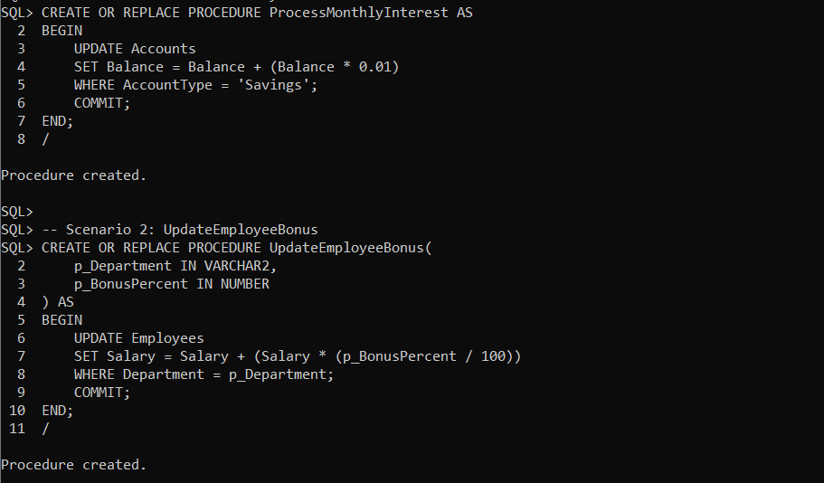

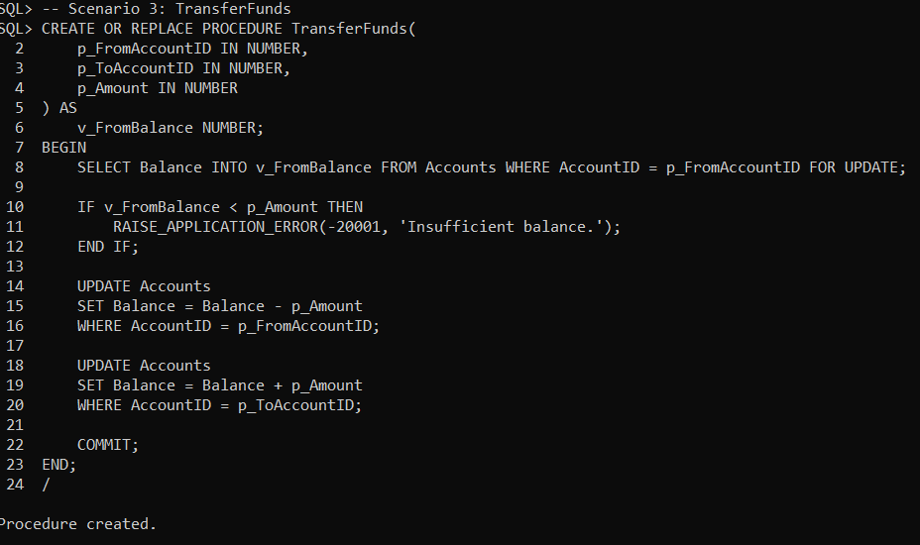

**Output**:

