**Exercise 1: Configuring a Basic Spring Application**

**Scenario:**

Your company is developing a web application for managing a library. You need to use the Spring Framework to handle the backend operations.

**Steps:**

1. **Set Up a Spring Project:**
   * Create a Maven project named **LibraryManagement**.
   * Add Spring Core dependencies in the **pom.xml** file.
2. **Configure the Application Context:**
   * Create an XML configuration file named **applicationContext.xml** in the **src/main/resources** directory.
   * Define beans for **BookService** and **BookRepository** in the XML file.
3. **Define Service and Repository Classes:**
   * Create a package **com.library.service** and add a class **BookService**.
   * Create a package **com.library.repository** and add a class **BookRepository**.
4. **Run the Application:**
   * Create a main class to load the Spring context and test the configuration.

**Solution:**

**1.Set Up a Spring Project:**

* Created a maven project and named it as **LibraryManagement**.

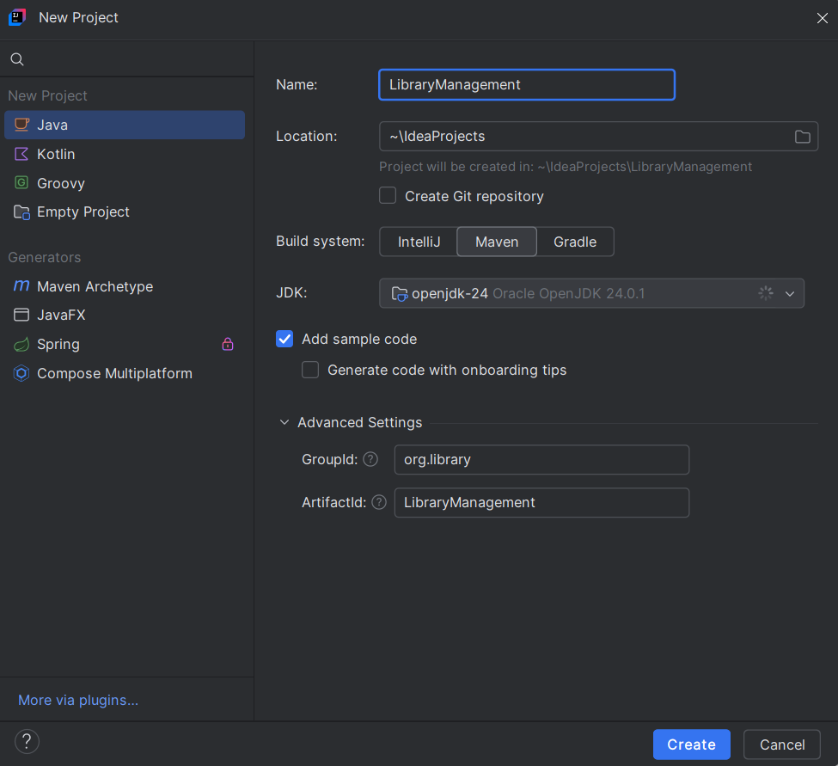

* Added Spring Core dependencies in the **pom.xml** file.

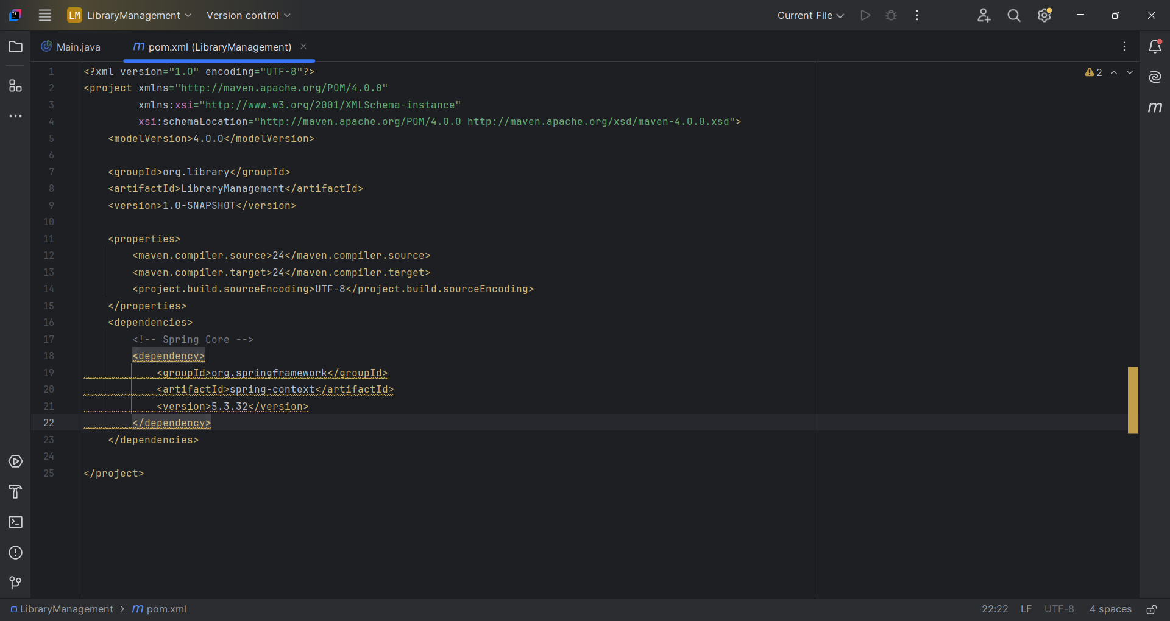

**2. Configure the Application Context:**

* Created an XML configuration file named **applicationContext.xml** in the **src/main/resources** directory.

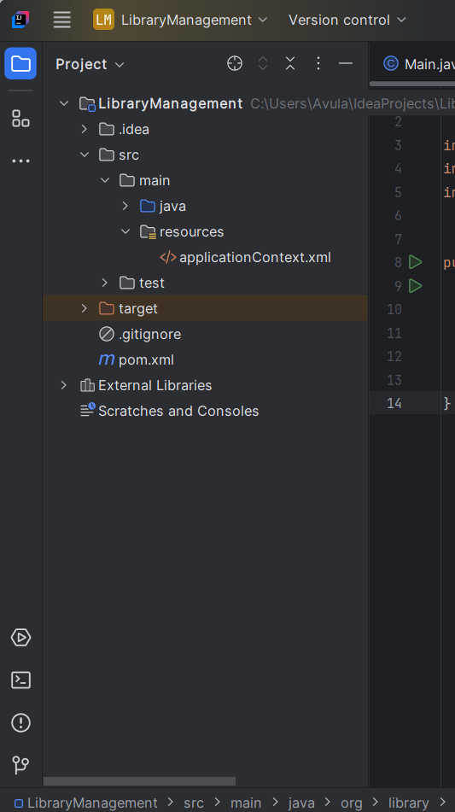

* Define beans for **BookService** and **BookRepository** in the XML file.

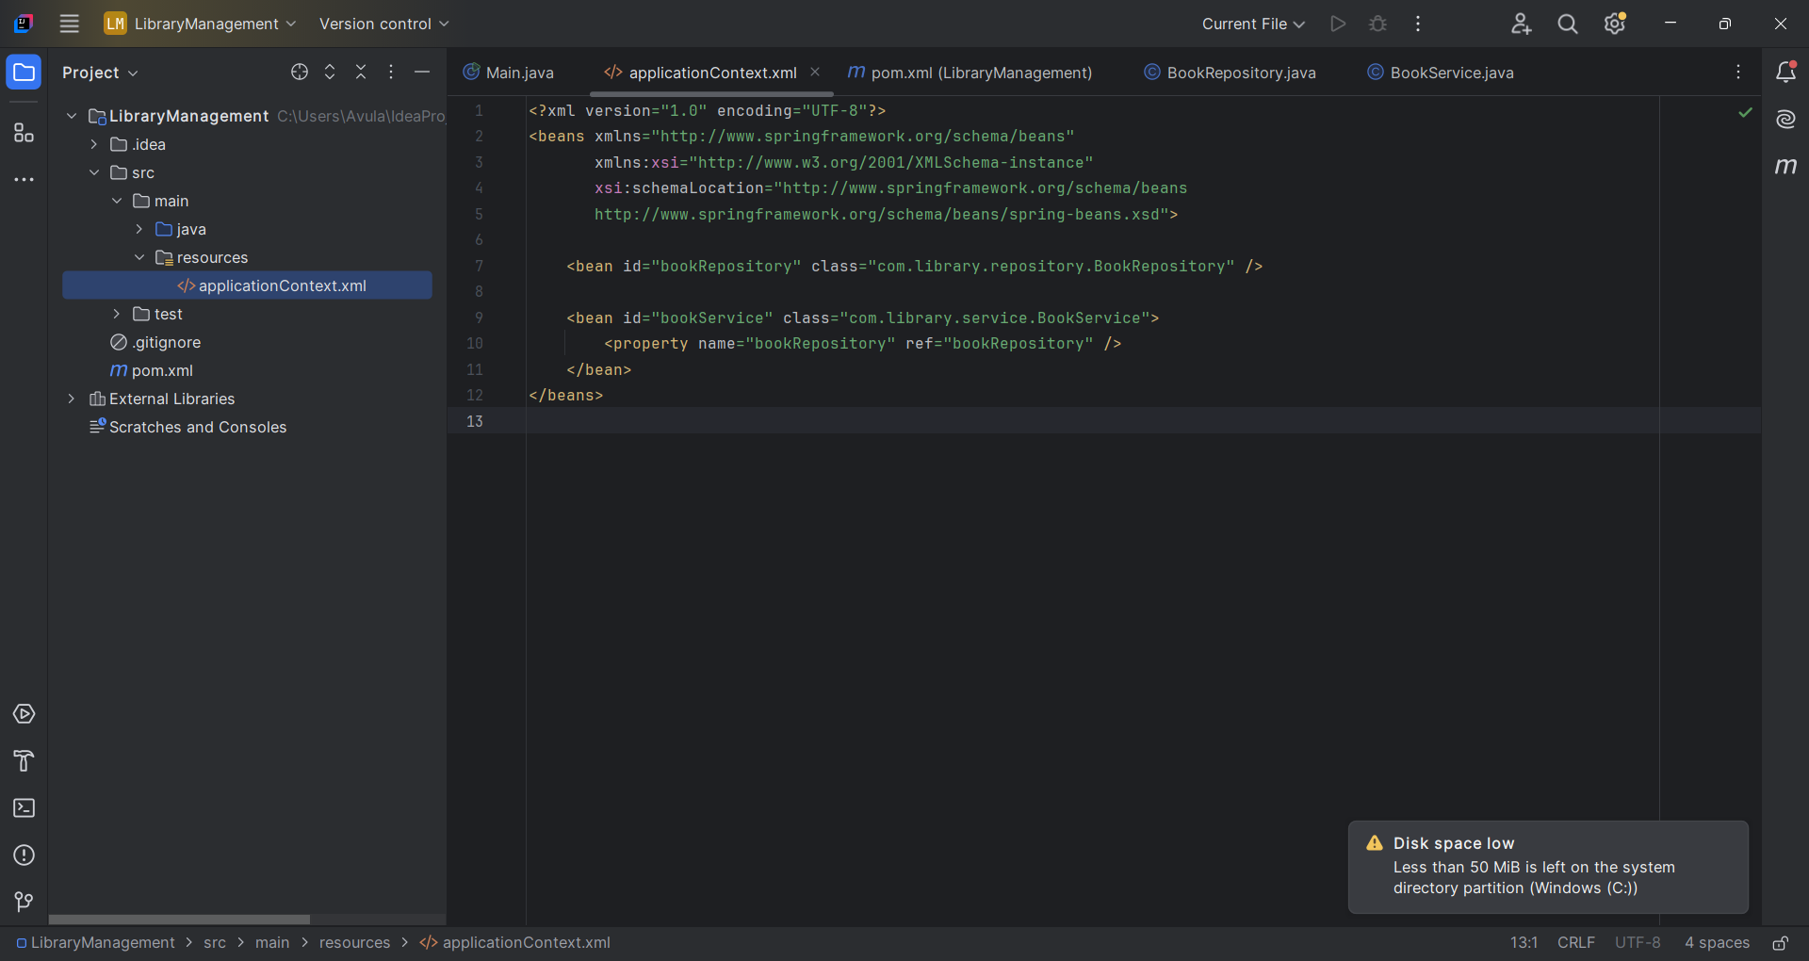

**3. Define Service and Repository Classes**:

* Create a package **com.library.service** and add a class **BookService**.

package com.library.service;

import com.library.repository.BookRepository;

public class BookService {

private BookRepository bookRepository;

public void setBookRepository(BookRepository bookRepository) {

this.bookRepository = bookRepository;

}

public void listBooks() {

System.out.println("Calling BookRepository from BookService...");

bookRepository.displayBooks();

}

}

* Create a package **com.library.repository** and add a class **BookRepository**.

package com.library.repository;

public class BookRepository {

public void displayBooks() {

System.out.println("Displaying list of books from the repository.");

}

}

1. **Run the Application:**

* Created a main class.

package com.library;

import com.library.service.BookService;

import org.springframework.context.ApplicationContext;

import org.springframework.context.support.ClassPathXmlApplicationContext;

public class Main {

public static void main(String[] args) {

ApplicationContext context = new ClassPathXmlApplicationContext("applicationContext.xml");

BookService bookService = context.getBean("bookService", BookService.class);

bookService.listBooks();

}

}

**Output:**

