# Hands-On 1: Create a Spring Web Project using Maven

## Instructions:

1. Go to https://start.spring.io/

2. Change Group as “com.cognizant”

3. Change Artifact Id as “spring-learn”

4. Select Spring Boot DevTools and Spring Web

5. Create and download the project as zip

6. Extract the zip in root folder to Eclipse Workspace or IntelliJ IDEA

7. Build the project using:

mvn clean package -Dhttp.proxyHost=proxy.cognizant.com -Dhttp.proxyPort=6050 -Dhttps.proxyHost=proxy.cognizant.com -Dhttps.proxyPort=6050 -Dhttp.proxyUser=123456

8. Import the project in IDE (Eclipse: File > Import > Maven > Existing Maven Projects, IntelliJ: File > Open Project > Select pom.xml)

9. Include logs to verify if main() method of SpringLearnApplication runs.

10. Run the SpringLearnApplication class.

## Walkthrough for SME:

1. src/main/java - Folder with application code

2. src/main/resources - Folder for application configuration

3. src/test/java - Folder with code for testing the application

4. SpringLearnApplication.java - Walkthrough the main() method.

5. Purpose of @SpringBootApplication annotation

6. pom.xml - Walkthrough all the configuration defined in XML file

- Open 'Dependency Hierarchy' and show the dependency tree.

## SpringLearnApplication.java

package com.cognizant.spring_learn;  
  
import org.springframework.boot.SpringApplication;  
import org.springframework.boot.autoconfigure.SpringBootApplication;  
  
@SpringBootApplication  
public class SpringLearnApplication {  
 public static void main(String[] args) {  
 System.out.println("SpringLearnApplication started...");  
 SpringApplication.run(SpringLearnApplication.class, args);  
 }  
}

**project file:**

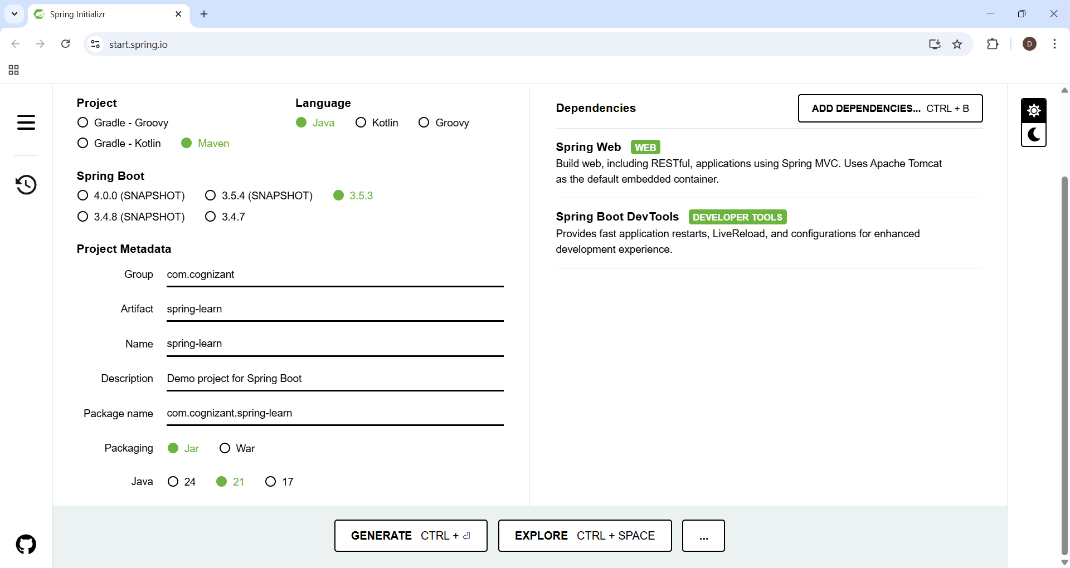

**Pom.xml file:**

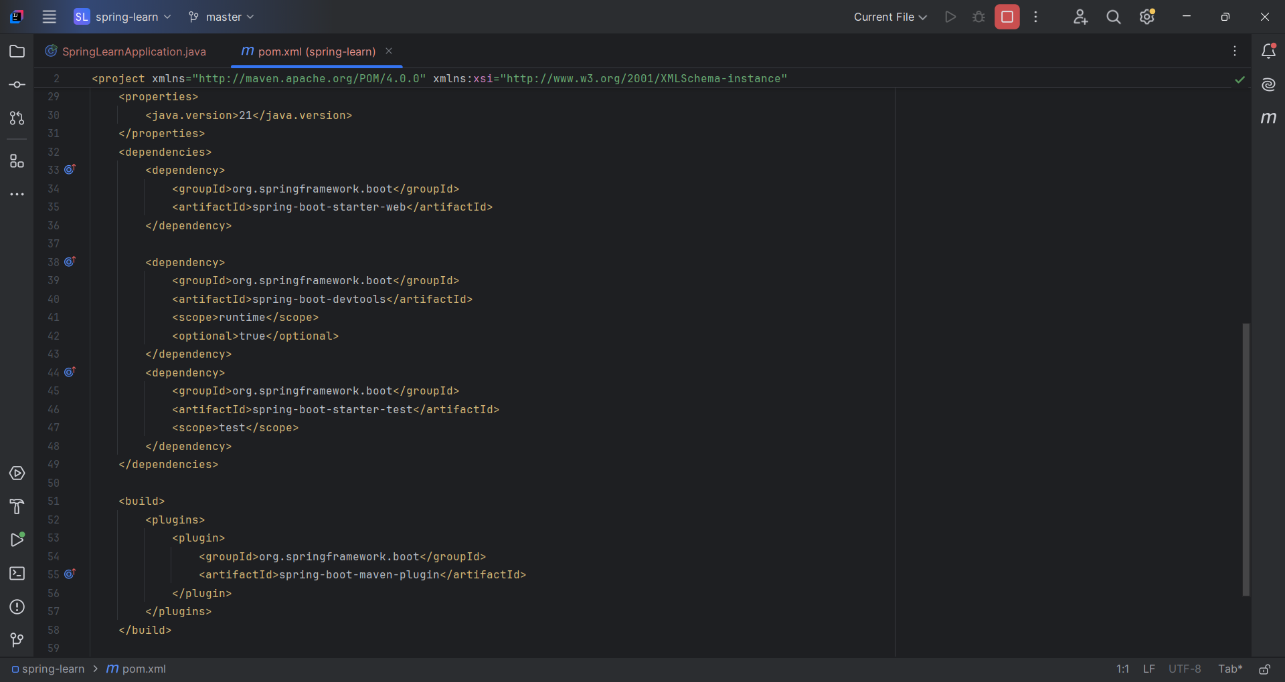

**Output:**

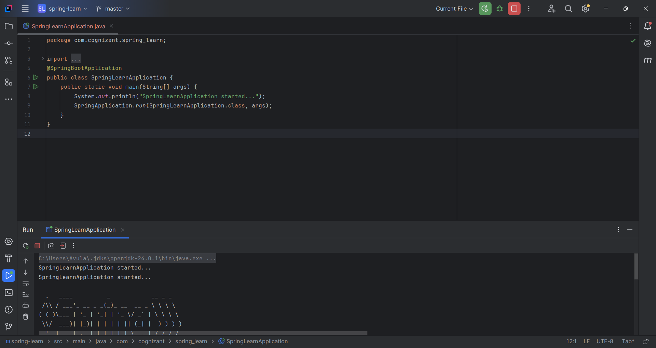

**Maven:**

