**Hands on 2: REST - Country Web Service**   
  
Write a REST service that returns India country details in the earlier created spring learn application.  
  
**URL**: /country  
**Controller**: com.cognizant.spring-learn.controller.CountryController  
**Method Annotation**: @RequestMapping  
**Method Name**: getCountryIndia()  
**Method Implementation**: Load India bean from spring xml configuration and return  
**Sample Request**: http://localhost:8083/country  
**Sample Response**:

{

  "code": "IN",

  "name": "India"

}

SME to explain the following aspects:

* What happens in the controller method?
* How the bean is converted into JSON reponse?
* In network tab of developer tools show the HTTP header details received
* In postman click on "Headers" tab to view the HTTP header details received

**Country.java:**

package com.cognizant.spring_learn.model;

public class Country {

private String code;

private String name;

// Getters and Setters

public String getCode() {

return code;

}

public void setCode(String code) {

this.code = code;

}

public String getName() {

return name;

}

public void setName(String name) {

this.name = name;

}

}

**CountryConfig.java:**

package com.cognizant.spring_learn.config;

import com.cognizant.spring_learn.model.Country;

import org.springframework.context.annotation.Bean;

import org.springframework.context.annotation.Configuration;

@Configuration

public class CountryConfig {

@Bean(name = "in")

public Country getCountryIndia() {

Country country = new Country();

country.setCode("IN");

country.setName("India");

return country;

}

}

**CountryController.java:**

package com.cognizant.spring_learn.controller;

import com.cognizant.spring_learn.model.Country;

import org.slf4j.Logger;

import org.slf4j.LoggerFactory;

import org.springframework.beans.factory.annotation.Autowired;

import org.springframework.context.ApplicationContext;

import org.springframework.web.bind.annotation.RequestMapping;

import org.springframework.web.bind.annotation.RestController;

@RestController

public class CountryController {

private static final Logger LOGGER = LoggerFactory.getLogger(CountryController.class);

@Autowired

private ApplicationContext context;

@RequestMapping("/country")

public Country getCountryIndia() {

LOGGER.info("START getCountryIndia()");

Country country = (Country) context.getBean("in");

LOGGER.info("END getCountryIndia()");

return country;

}

}

**OUTPUT:**

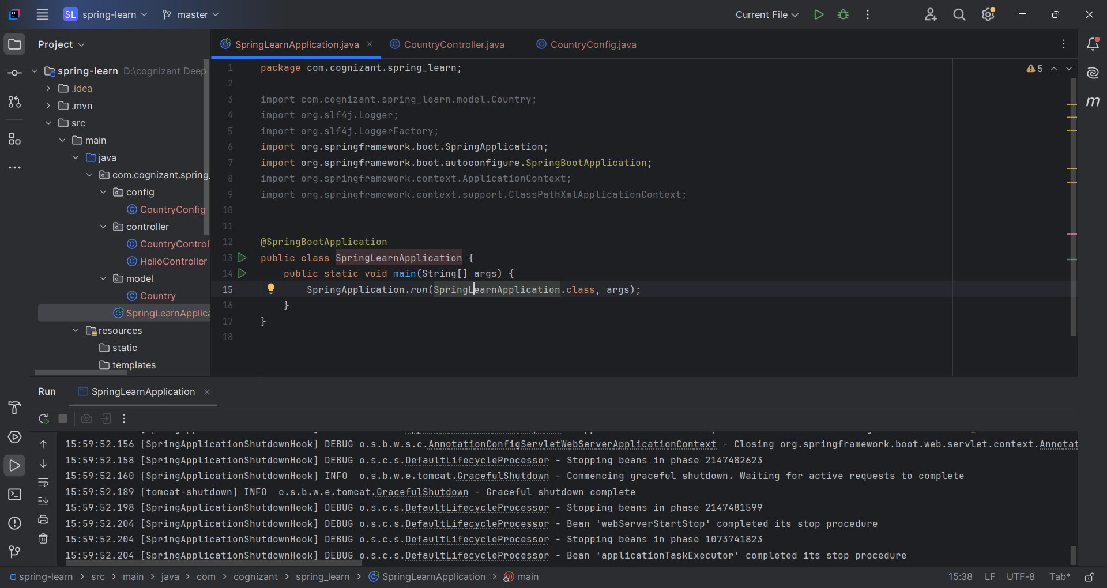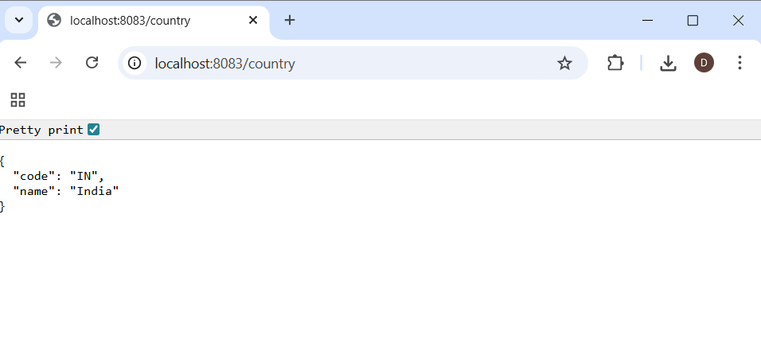

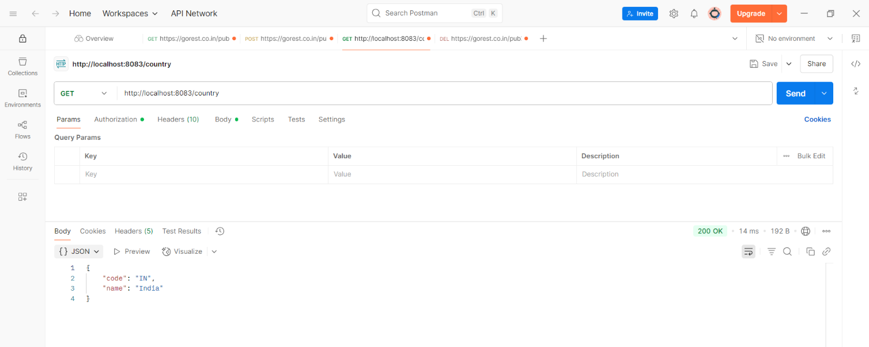

**What happens in the controller method?**The method handles a GET request to /country, loads the "India" bean from Spring context, and returns it.

**🔹 How is the bean converted into JSON response?**Spring Boot uses the Jackson library to automatically convert the returned Java object into JSON.

**🔹 In network tab of developer tools – HTTP headers received:** headers like Content-Type: application/json, Content-Length, and Date**.**

**🔹 In Postman – Headers tab:**Headers such as Content-Type, Content-Length, Server, and Date appear under the response section.