**Create Eureka Discovery Server and register microservices**

Eureka Discovery Server holds a registry of all the services that are available

for immediate consumption. Anybody whom wants to consume a RESTful

Web Service can come to the discovery server and find out what is available

and ready for consumption. Eureka Discovery Server is part of spring cloud

module.

Follow steps below to implement:

**Create and Launch Eureka Discovery Server**

* + - * Using https://start.spring.io generate a project with following
      * configuration:
      * Group: com.cognizant
      * Artifact: eureka-discovery-server
      * Module: Spring Cloud Discovery > Eureka Server
* Download the project, build it using maven in command line
* Import the project in Eclipse
* Include @EnableEurekaServer in
* class EurekaDiscoveryServerApplication
* Include the following configurations in application.properties:
* server.port=8761
* eureka.client.register-with-eureka=false
* eureka.client.fetch-registry=false
* logging.level.com.netflix.eureka=OFF
* logging.level.com.netflix.discovery=OFF
* The above configuration runs the discovery service in port 8761
* The eureka properties prohibits direct registration of services, instead
* discovery server will find available services and register them.
* Launch the service by running the application class
* The discovery service can be view by launching http://locahost:8761 in
* the browser.
* This will display the discover server details.
* Look into the section "Instances currently registered with Eureka", which will have an empty list

**Solution Code:**

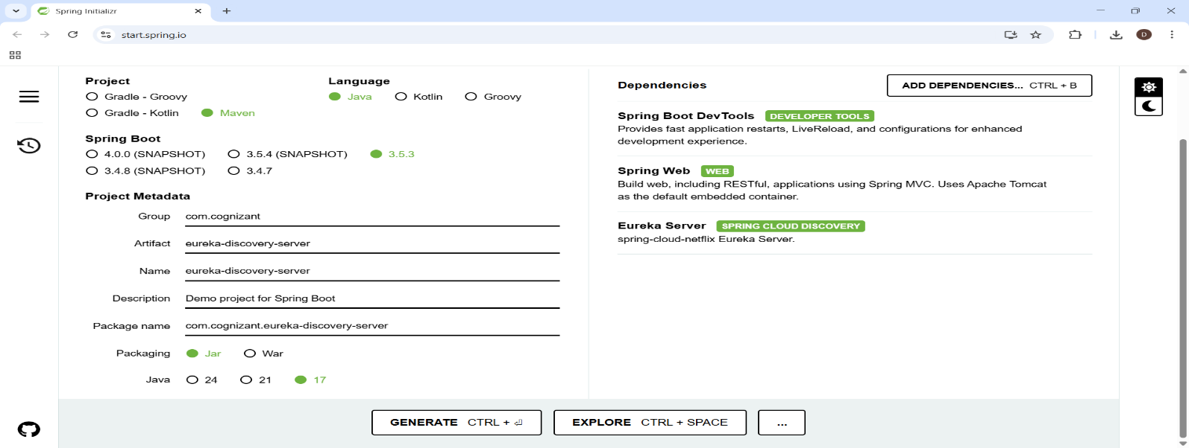

**//application.properties**

server.port=8761

eureka.client.register-with-eureka=false

eureka.client.fetch-registry=false

logging.level.com.netflix.eureka=OFF

logging.level.com.netflix.discovery=OFF

**// EurekaDiscoveryServerApplication.java**

package com.cognizant.eureka_discovery_server;

import org.springframework.boot.SpringApplication;

import org.springframework.boot.autoconfigure.SpringBootApplication;

import org.springframework.cloud.netflix.eureka.server.EnableEurekaServer;

**@SpringBootApplication**

**@EnableEurekaServer**

public class EurekaDiscoveryServerApplication {

    public static void main(String[] args) {

        SpringApplication.run(EurekaDiscoveryServerApplication.class, args);

    }

}

**OUTPUT:**



