**Hands-on 1:**

**Create a new React Application with the name “myfirstreact”, Run the application to print “welcome to the first session of React” as heading of that page.**

**Solution:**

1. To create a new React app, Install Nodejs and Npm from the following link:

**ANS**: I already installed the Nodejs and Npm in my System.

1. Install Create-react-app by running the following command in the command prompt:

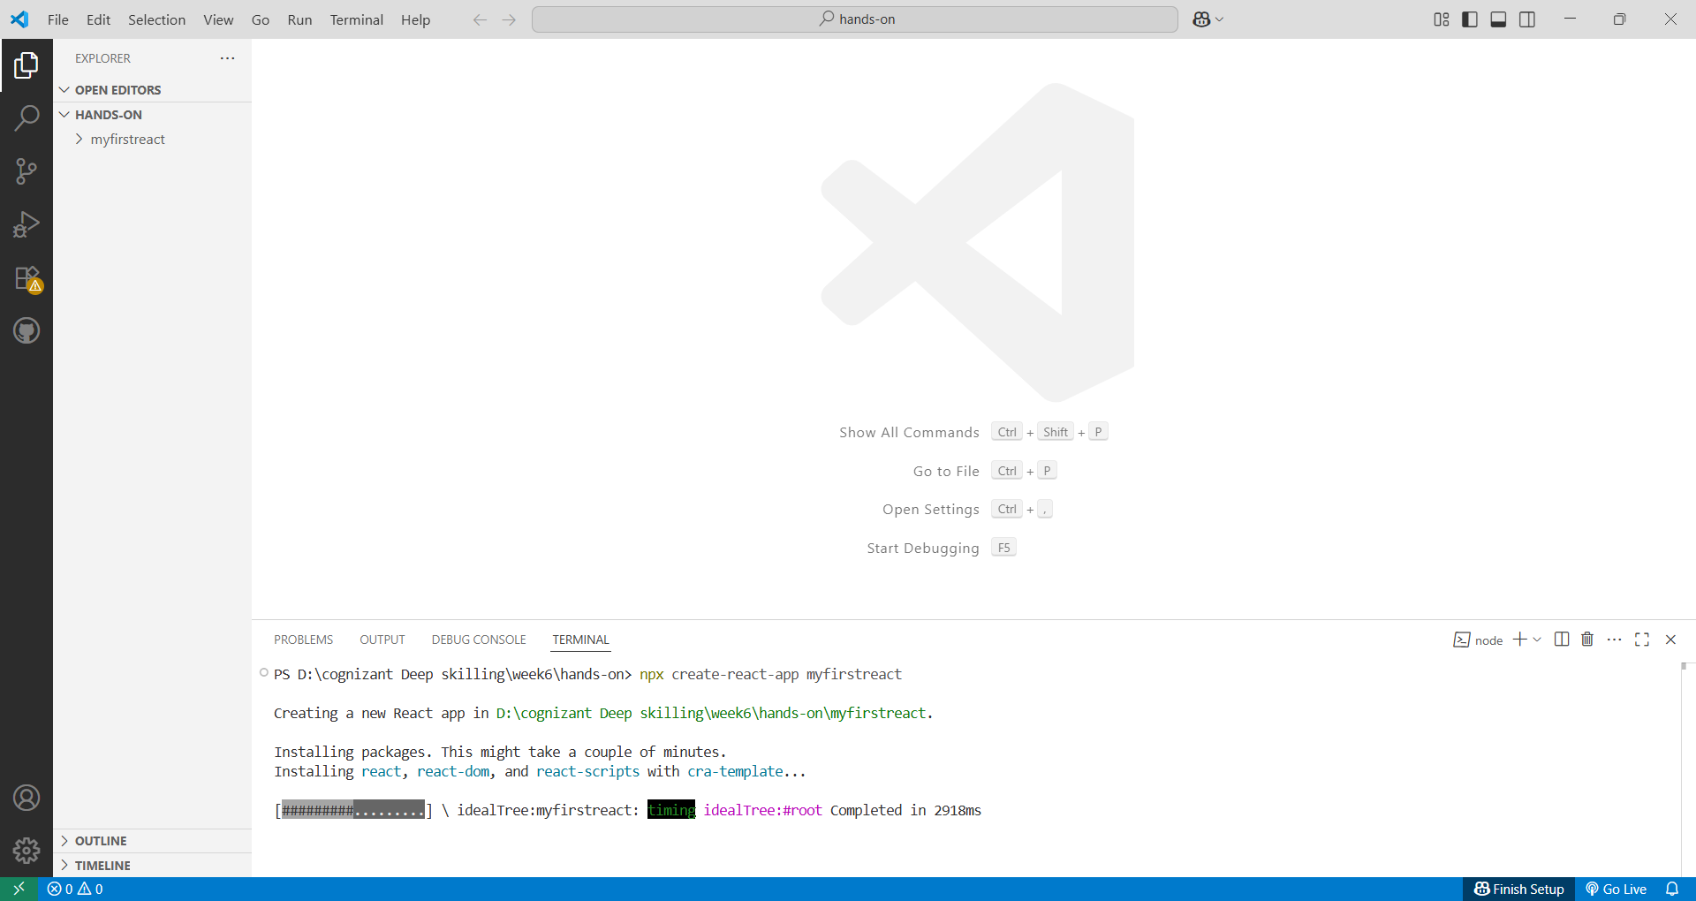

1. Once the App is created, navigate into the folder of myfirstreact by typing the following command:



1. Open the folder of myfirstreact in Visual Studio Code
2. Open the App.js file in Src Folder of myfirstreact
3. Remove the current content of “App.js”

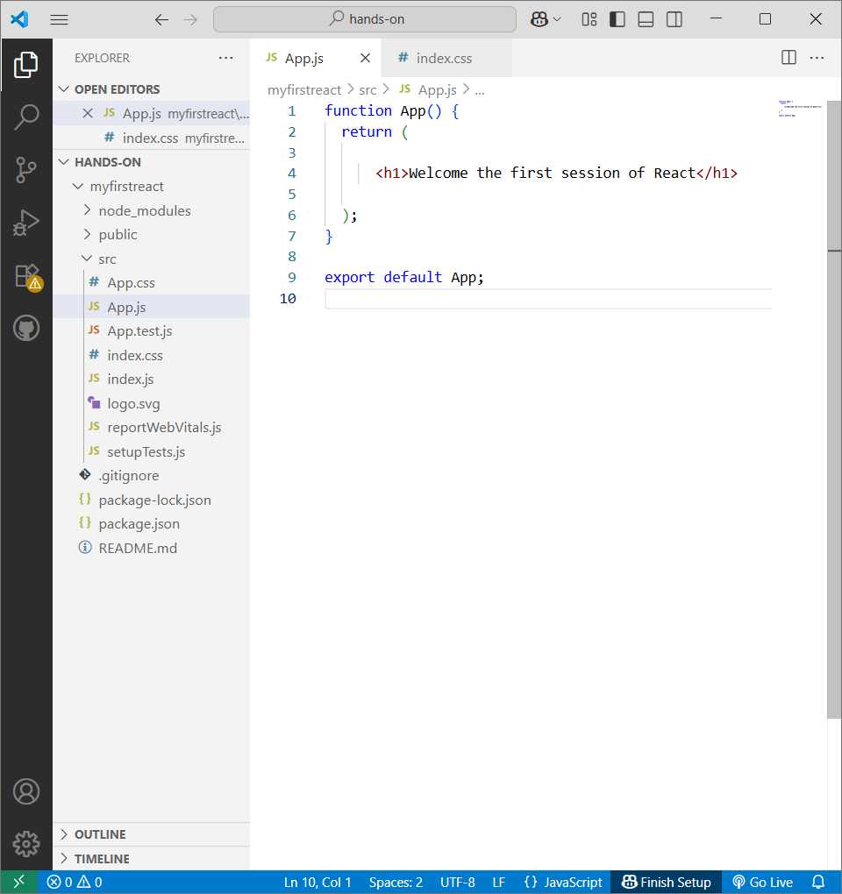

1. Run the following command to execute the React application:

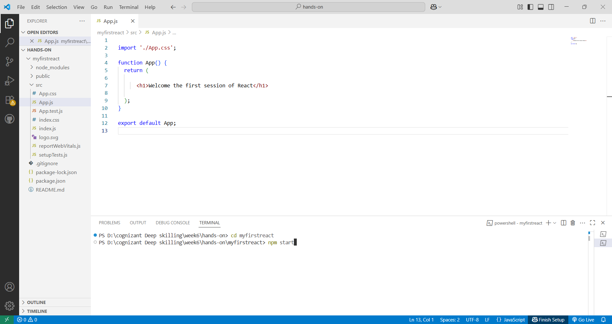

**OUTPUT:**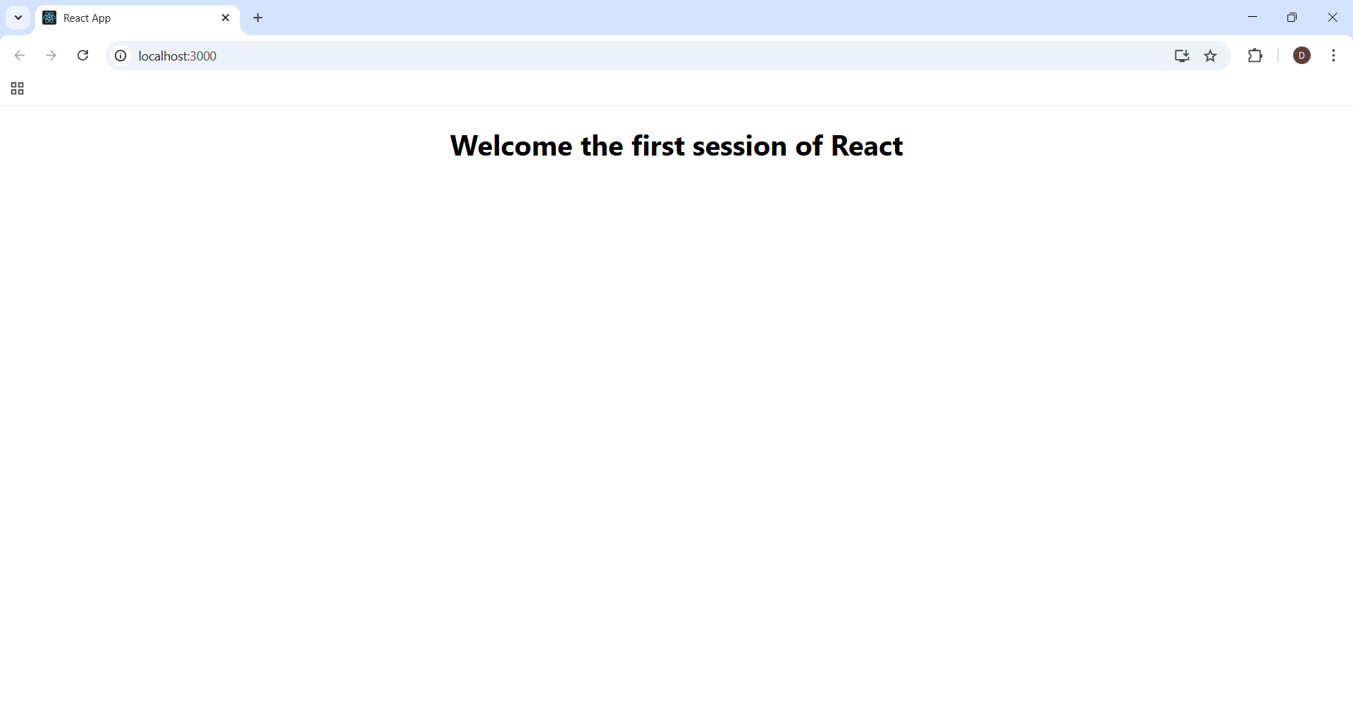

**1. Define SPA and its benefits**

SPA (Single-Page Application) is a web app that loads a single HTML page and dynamically updates the content without reloading the entire page.

Benefits:

* Fast navigation (no page reload)
* Better user experience
* Less server load
* Feels like a mobile app

**2. Define React and identify its working**

React is a JavaScript library used to build user interfaces, especially for SPAs.

How it works:

* Uses components to build UI
* Uses a virtual DOM to update only the changed parts
* Fast and efficient rendering

**3. Identify the differences between SPA and MPA**

|  |  |  |
| --- | --- | --- |
| Feature | SPA | MPA |
| Page reload | No full page reload | Full page reloads needed |
| Speed | Faster | Slower |
| Development | More JavaScript logic | More server-side logic |
| SEO | Harder to optimize | Easier to optimize |

**4. Explain Pros & Cons of Single-Page Application**

Pros:

* Fast loading after first visit
* Smooth user experience
* Easy to turn into mobile app

Cons:

* SEO can be difficult
* Initial load time may be longer
* Needs JavaScript to work

**5. Explain about React**

React is a front-end JavaScript library developed by Facebook. It helps developers build interactive and fast UIs using reusable components.

**6. Define virtual DOM**

Virtual DOM is a lightweight copy of the real DOM. React uses it to detect changes and update only the changed parts in the real DOM, making updates faster.

**7. Explain Features of React**

* Component-based: Build UI in reusable parts
* Virtual DOM: Fast updates
* Declarative: Easy to understand and manage UI
* JSX: HTML-like syntax inside JavaScript
* One-way data flow: Easy to track data changes