**Hands on 1:**

Cognizant Academy teams want to maintain a list of trainers along with their expertise in a SPA using React as the technology. You are assigned the task of creating this React app.

The following trainers’ data application will deal.

1. T-ID
2. Name
3. Phone
4. Email
5. Stream
6. Skills

**Solution code for each step:**

1. Create a new React app using *create-react-app* tool with the as “TrainersApp”



1. Open the application using the VS Code
2. Add a new file called *trainer.js* inside the **src folder** and define a class named as “Trainer” with the following properties
   1. TrainerId
   2. Name
   3. Email
   4. Phone
   5. Technology
   6. Skills

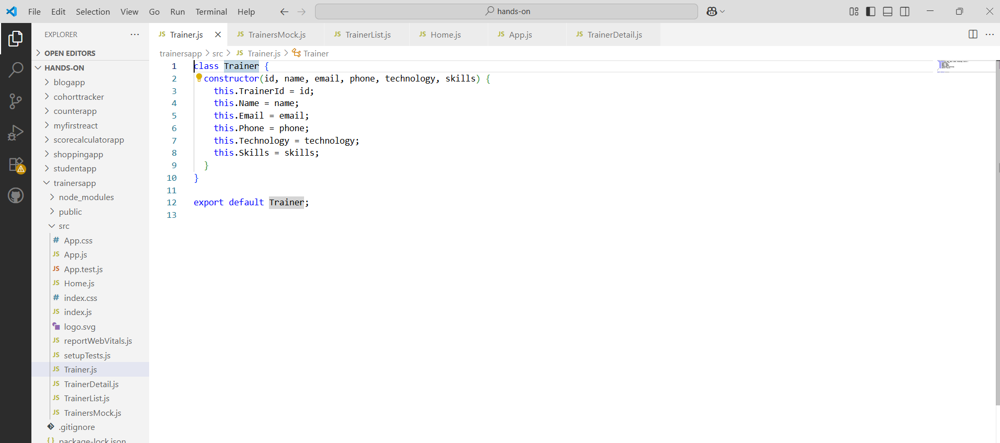

1. Create a new TrainersMock.js file which will contain the mock trainer data. Refer the following screenshot for mock data

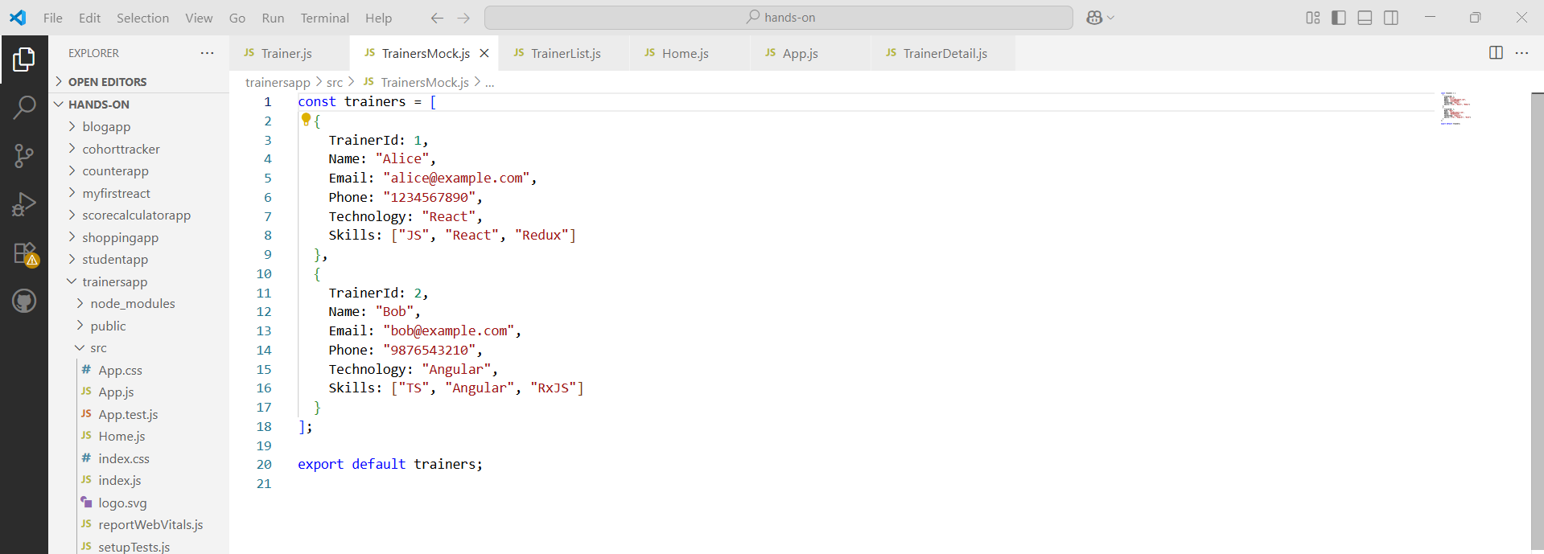

1. Install the support for React router for the dom. Execute the following command.



1. Create new component named as **TrainersList** inside *Trainerlist.js* file. The component should accept the trainer’s data as parameter and render it as a list. The list should display names of each trainers which must be clickable like a hyper link. Refer the following screenshot for the component layout.

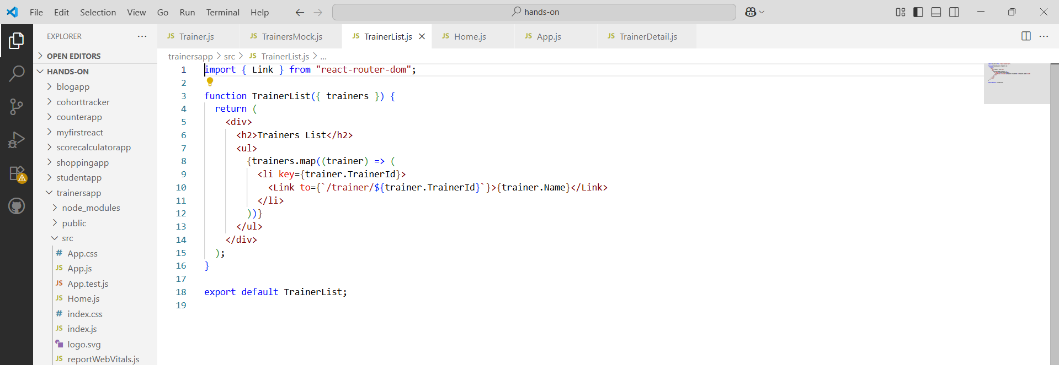

1. Create a new component named as Home inside Home.js which will be responsible for displaying the following

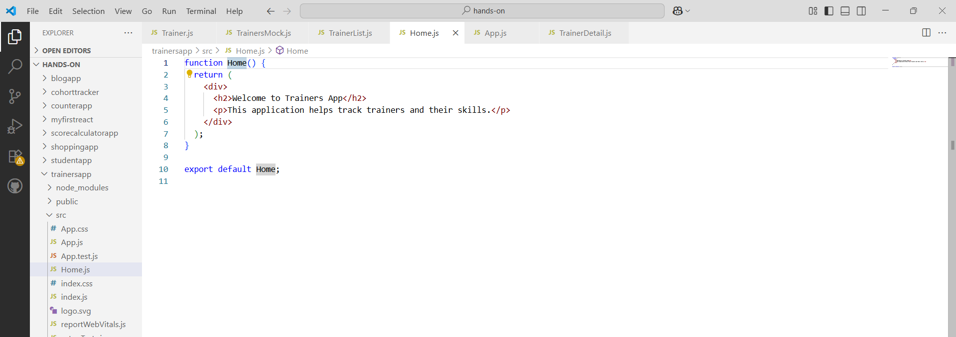

1. Modify the App component to add support for routing and defining the navigation links to Home component and TrainersList component. Use BrowserRouter, Routes, Route and Link components from the react-router-dom library.

Define the following URL

1. / - must redirect to home component
2. /trainers – must redirect to trainers list component.

The layout of the page must be similar to the following

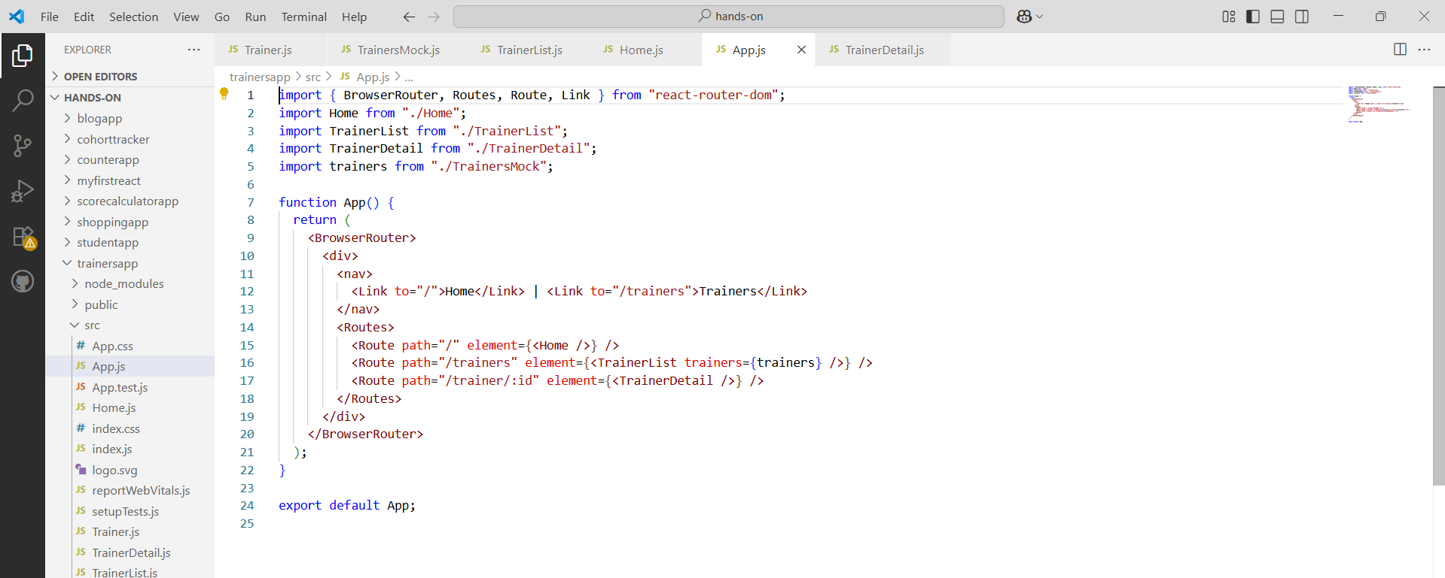

1. Create a new component named **TrainerDetail** in *TrainerDetails.js* file.

The component should retrieve a parameter named id from the URL with the help of “useParams” hook from the React router DOM library.

It should query the mock trainer data using the id and display the trainer details as show in screenshot.

Modify the TrainersList component to add Links to TrainerDetail component while passing the ID. Define a route in App component for the same.

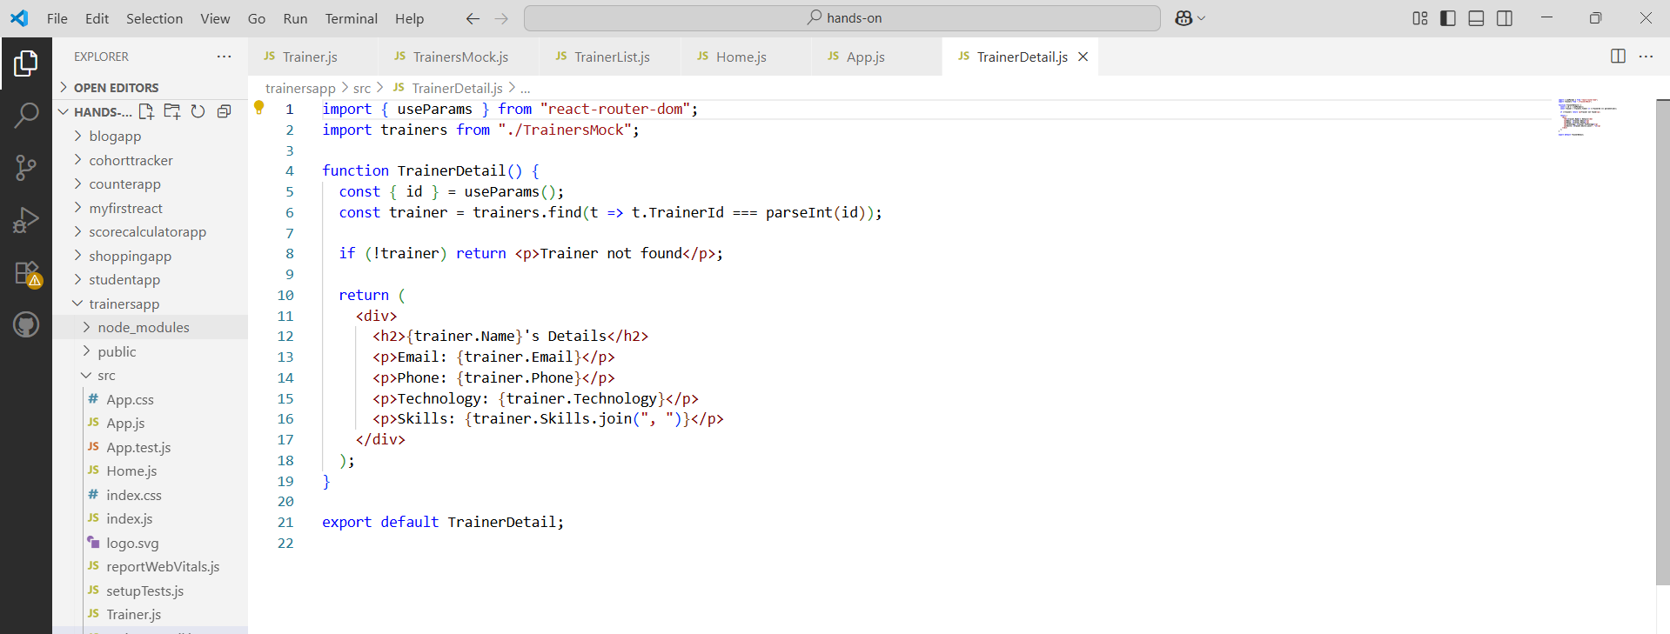

**Run the Command:**

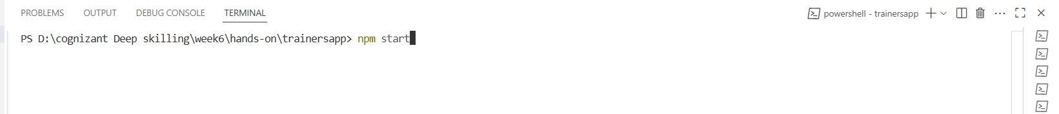

**Output:**

**Home page**

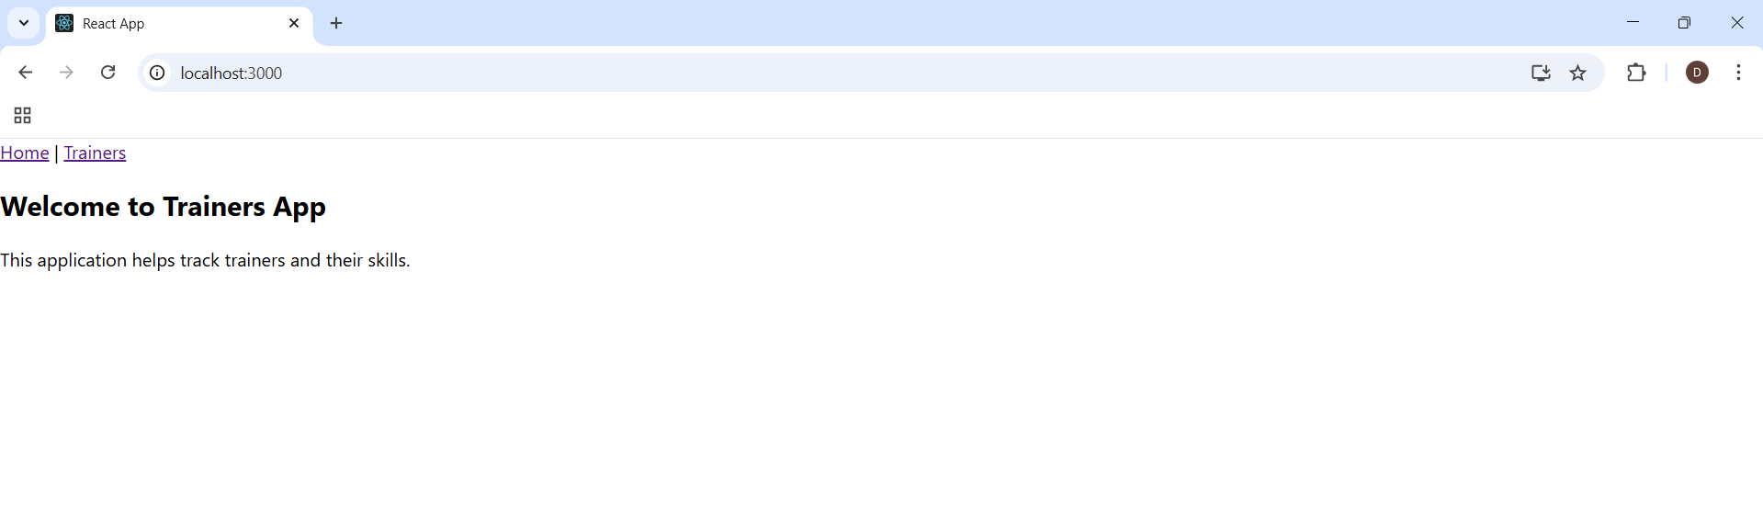

**Trainer’s page**

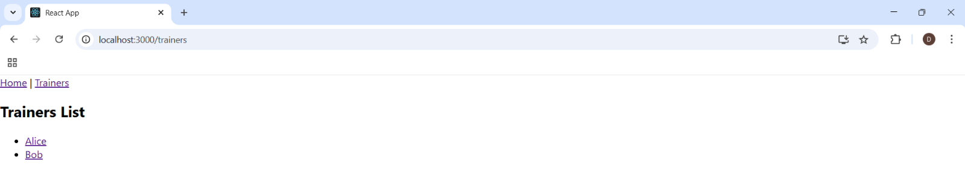

**Trainer page based on given ID**

