**Hands on 1:**

**Create a React Application named “shoppingapp” with a class component named “OnlineShopping” and “Cart”.**

**Solution for each Step:**

1. In Cart class, create 2 properties as mentioned below:

* Itemname
* Price

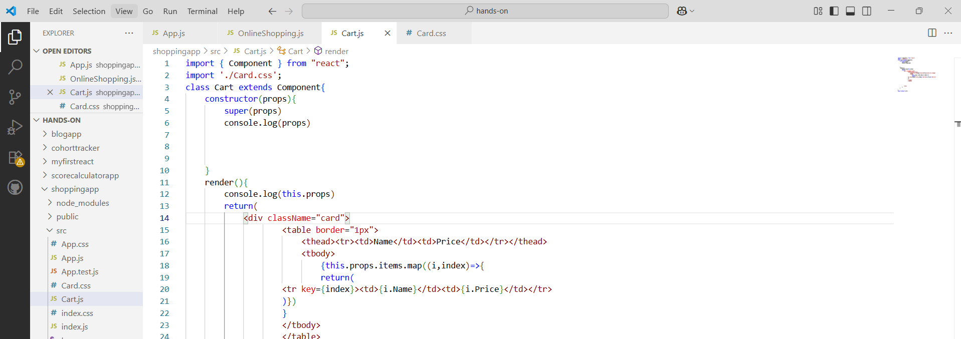

**Card.css file**

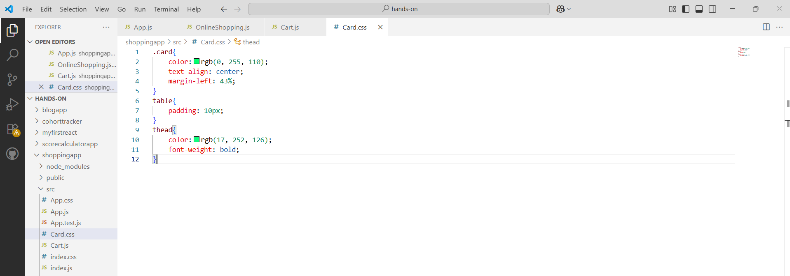

1. In OnlineShopping class, create an array of Cart and initialize 5 items.

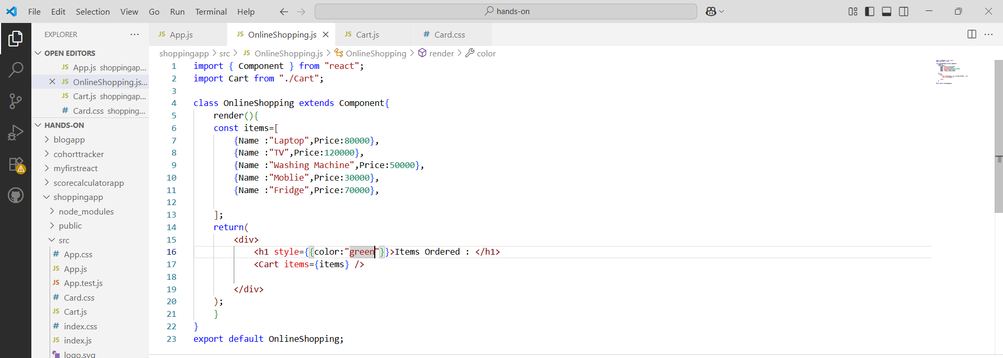

**App.js file**

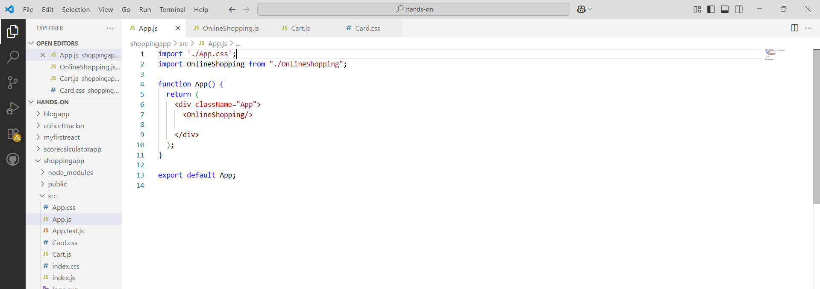

**Run the command:**

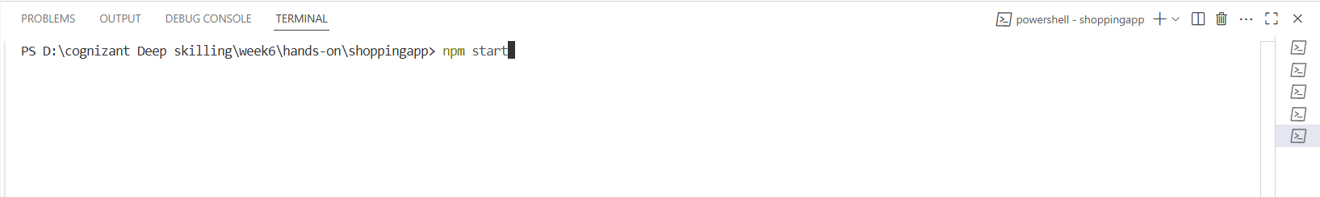

**Output:**

