**Hands on 1:**

Create a React App “counterapp” which will have a component named “CountPeople” which will have 2 methods.

UpdateEntry() 🡪 which will display the number of people who entered the mall.

UpdateExit() 🡪 which will display the number of people who exited the mall.

Use Constructor and state to Store the entrycount and exitcount.

The component has 2 buttons

1. Login 🡪 when clicked, the entrycount should get incremented by 1
2. Exit 🡪 when clicked, the exitcount should get incremented by 1

**Solution Code:**

**CountPeople.js file**

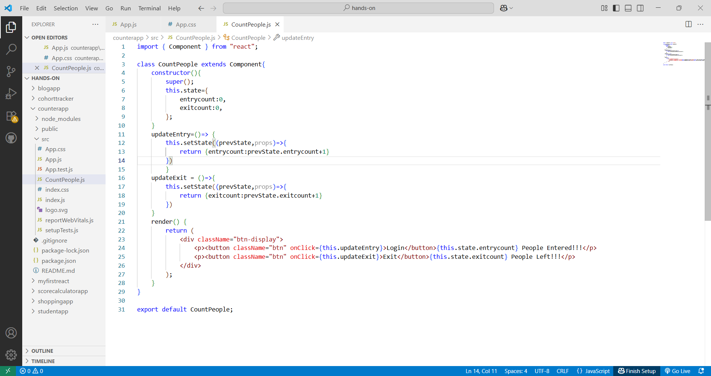

**App.css file**

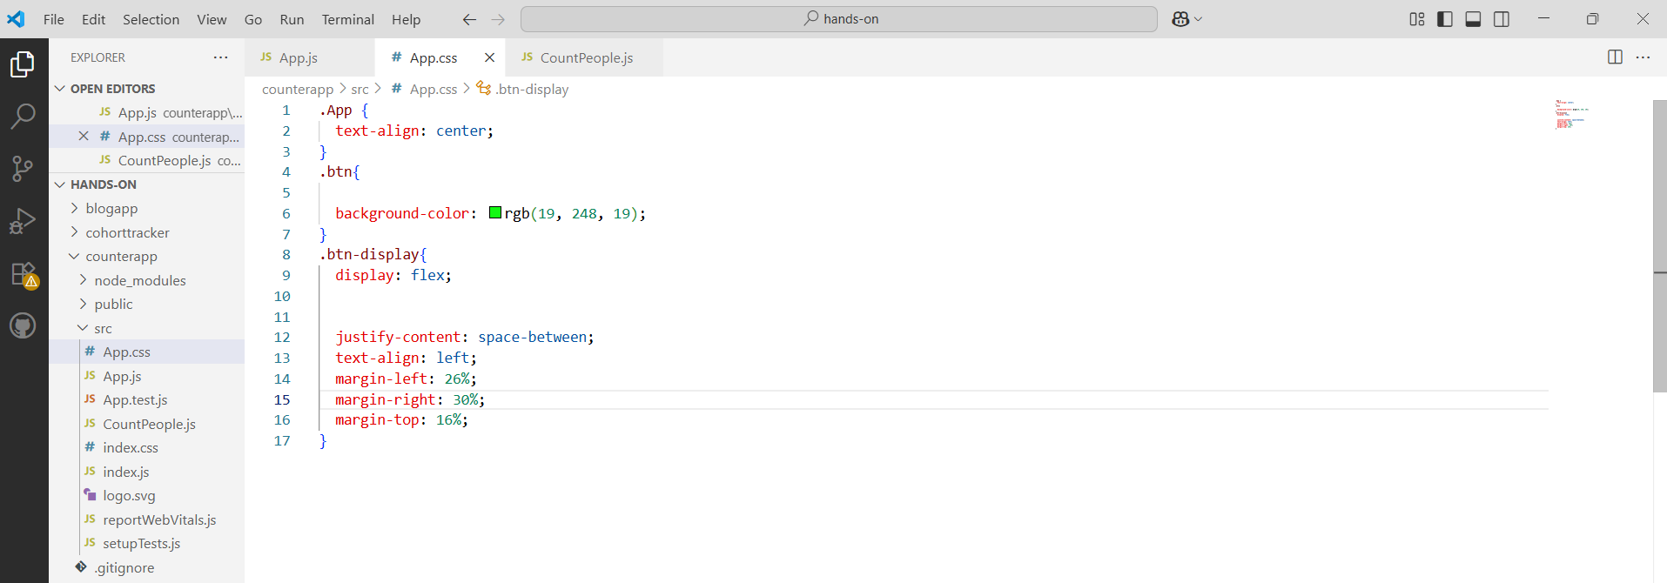

**App.js file**

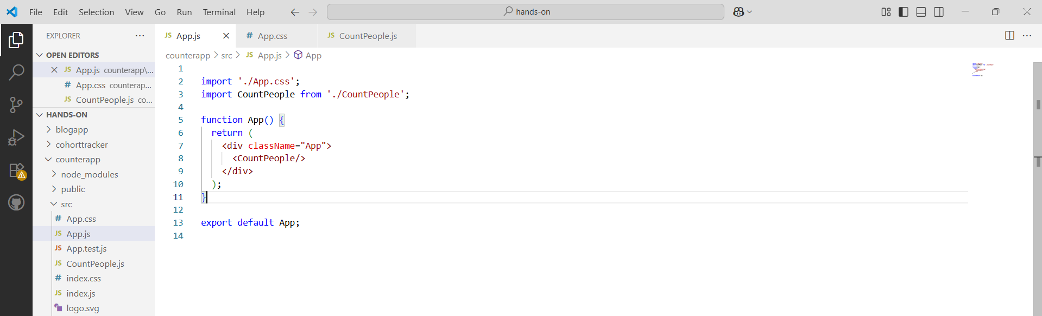

**Run the Command:**

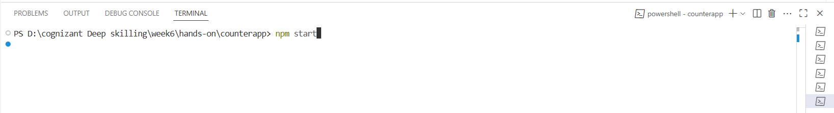

**Output:**

