CricketIQ
IPL Analytics & Predictive Intelligence Platform

Project Documentation
Requirement Gathering · User Stories · UI Design · UML Diagrams · Table Design & Normalisation
Submitted to | [Guide Name], [Designation]
Submitted by | [Student Name(s)] · [Register / Roll Number]
Department | [Department Name]
Institution | [Institution / College Name]
Academic Year | [Academic Year]
Repository | https://github.com/arjuntp-397/Mini-Project-2

Table of Contents
1. Requirement Gathering
2. User Story Creation
3. UI Design
4. UML Diagrams
5. Table Design
6. Design: Customisation on Templates
7. Table Normalisation

1. Requirement Gathering

1.1 Purpose
CricketIQ is a web analytics platform for the IPL: one place to browse team, player and match records, view season analytics, and run four prediction tools — win probability, player form forecast, playing-XI suggestion, and player similarity.

1.2 Scope
In scope:
- Team, player and match directories with detail pages.
- Analytics dashboard: win trends, run and wicket leaderboards.
- Four intelligence tools: win probability, form forecast, playing-XI, similarity.
- Dark/light themes, responsive from mobile to desktop.
Out of scope: live ball-by-ball ingestion, user accounts/login, payments.

1.3 Functional Requirements
ID | Requirement | Route
FR-01 | Browse teams (paginated, searchable). | GET /teams
FR-02 | Team profile: squad + latest season record. | GET /teams/<id>
FR-03 | Browse players, filter by role. | GET /players
FR-04 | Player profile: career totals + full record. | GET /players/<id>
FR-05 | Browse matches, filter by season. | GET /matches
FR-06 | Match result + full scorecard. | GET /matches/<id>
FR-07 | Win-trend charts + leaderboards. | GET /analytics
FR-08 | Simulate a matchup, view win probability. | GET /api/predict/match
FR-09 | Forecast a player’s next-innings runs. | GET /api/predict/player
FR-10 | Suggested playing XI for a matchup. | GET /api/assistant/team_selection
FR-11 | Find statistically similar players. | GET /api/players/similarity
FR-12 | Client-side filter, search, sort on any list. | client JS
FR-13 | Persisted dark / light theme. | client JS

1.4 Non-Functional Requirements
Category | Requirement
Performance | ML models cached in-process; eager-loaded joins avoid N+1 queries.
Usability | One component set across all pages; inline errors + toasts, no alert().
Accessibility | Contrast ≥ 4.5:1 body / ≥ 3:1 large text; visible focus ring; ARIA-live regions.
Responsiveness | Sidebar ≥ 1200px, drawer below; verified 390px–1440px.
Maintainability | Template inheritance + shared macros; one CSS token layer.
Reliability | Defined empty/error state on every list and API call.

2. User Story Creation
Written from the perspective of an Analyst — the system’s single actor; CricketIQ has no login or roles.
ID | User story | Acceptance criteria
US-01 | Browse all teams to see franchise details at a glance. | Paginated, filterable directory; each card links to a team page.
US-02 | View a team’s squad and season record to assess form. | Sortable squad table + season stat tiles.
US-03 | Filter players by role to focus on a position. | Role dropdown + instant on-page search.
US-04 | View a player’s career totals and match record. | Career tiles + batting/bowling tables; empty state if none.
US-05 | Browse matches for a season to review fixtures. | Season filter; sortable, links to each scorecard.
US-06 | View a match scorecard for the full breakdown. | Both innings’ tables; empty state if no scorecard.
US-07 | See win trends and leaderboards to spot form. | Trend chart (or ranked bars for one season) + two leaderboards.
US-08 | Simulate a matchup for a win-probability estimate. | Rejects invalid pairs inline; doughnut chart + factors on success.
US-09 | Forecast a player’s next-innings runs. | Recent form, projected runs, confidence label.
US-10 | Get a suggested playing XI for a matchup. | 11 players with role breakdown + reasoning.
US-11 | Find players statistically similar to one chosen. | Cluster ID + up to 5 similar players.
US-12 | Switch dark / light theme to match my environment. | Choice persists; no flash of wrong theme.

3. UI Design
The interface uses a custom design system, "Floodlight" — one CSS token layer (static/css/style.css) over the Bootstrap 5 grid, colour in OKLCH throughout. Dark is default; light mode is fully supported, both verified for contrast rather than assumed. Pitch-green and analytics-blue — the reflex choices for a cricket dashboard — were deliberately avoided in favour of a cool graphite surface with a single amber accent.
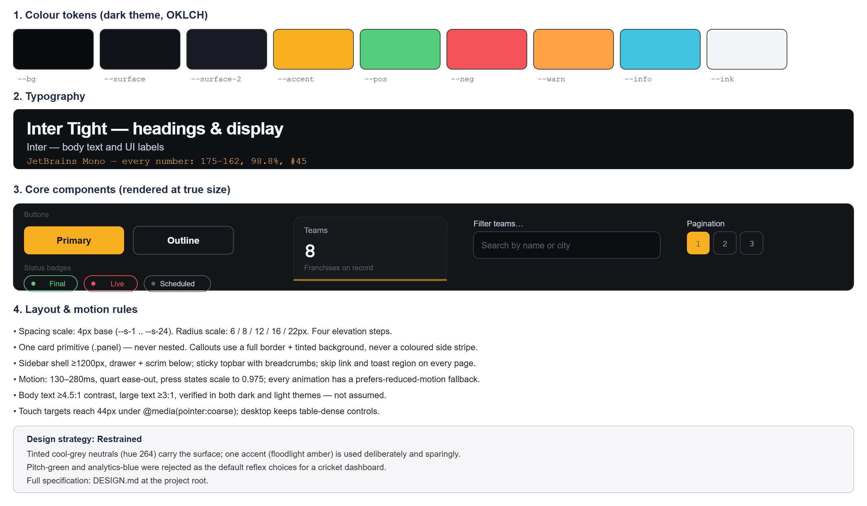
Figure 3.1 — Colour tokens, typography and core components, rendered at true size.
Type pairs three families: Inter Tight (headings), Inter (body), JetBrains Mono (every number, so table figures never jitter). Full spec in DESIGN.md.

4. UML Diagrams

4.1 Use Case Diagram
One actor — an unauthenticated analyst — grouped into four service areas. The three directory use cases share a single "Filter, Search & Sort" behaviour via <<include>>.
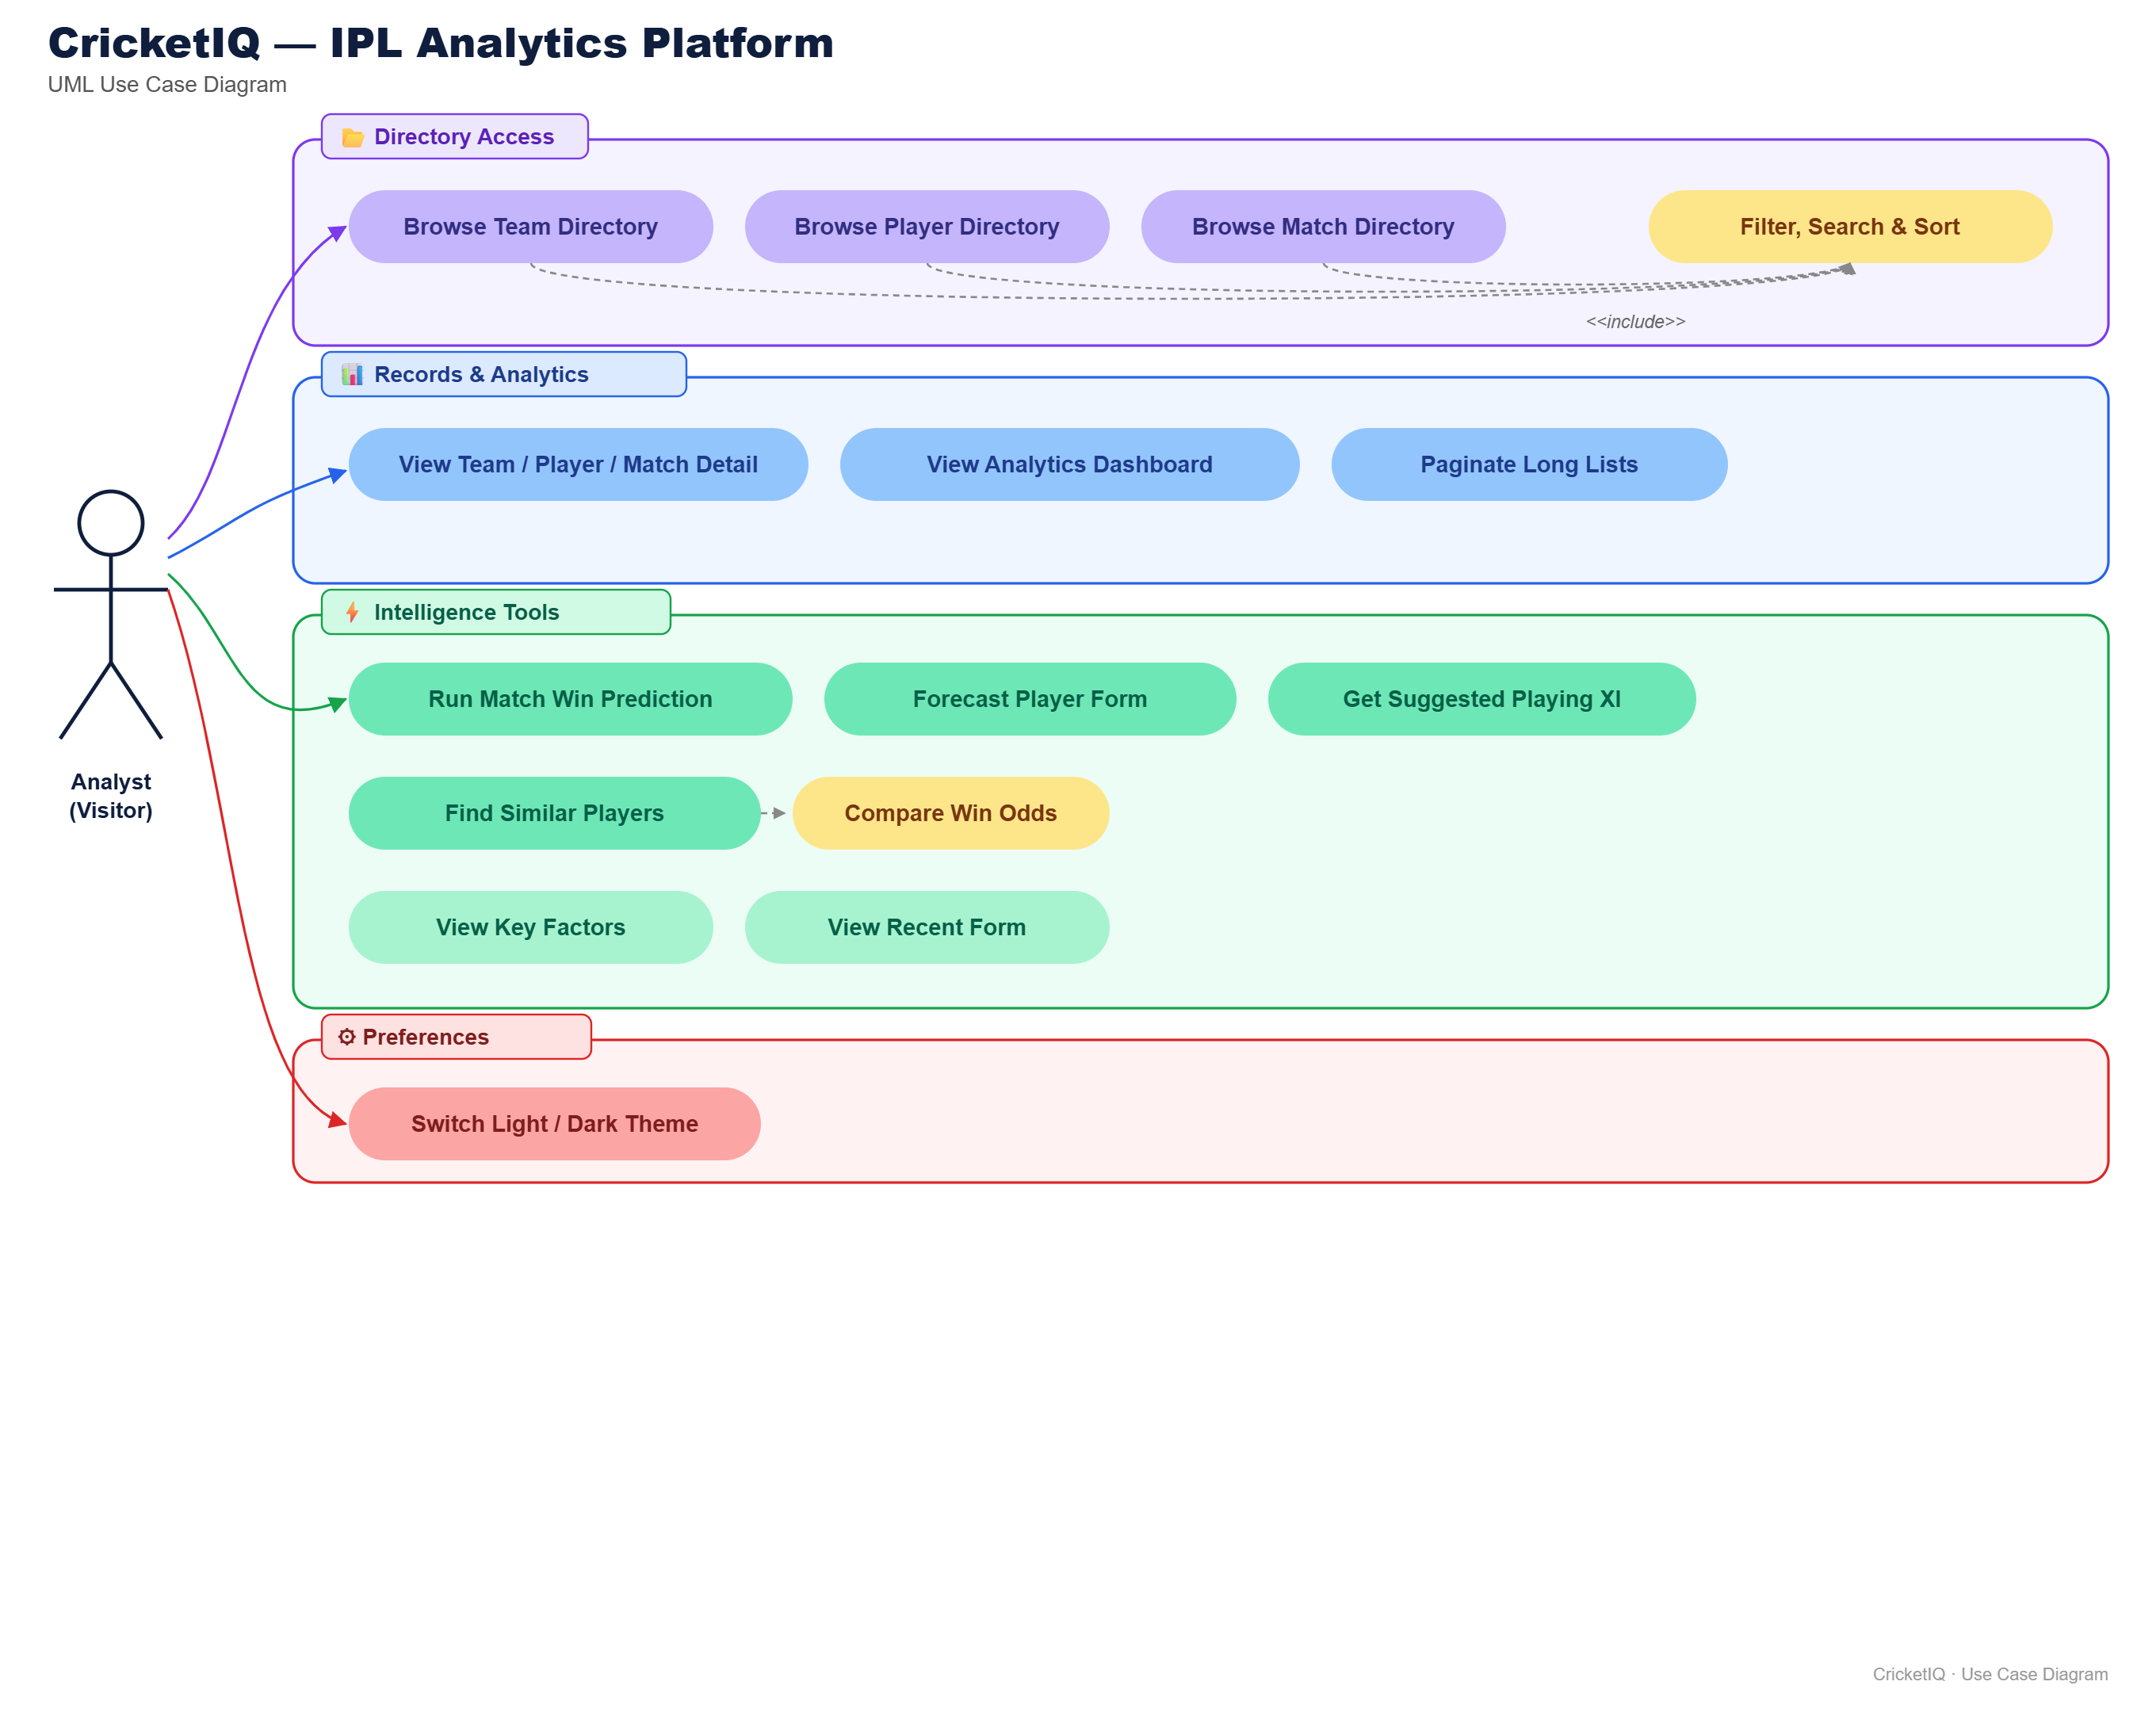
Figure 4.1 — Use case diagram.

4.2 Class Diagram
Condensed view of the six SQLAlchemy models. Team is the hub, referenced by Player and by Match in four FK roles (home, away, winner, toss winner). Batting and bowling figures live in their own tables rather than as columns on Player — see Section 7.
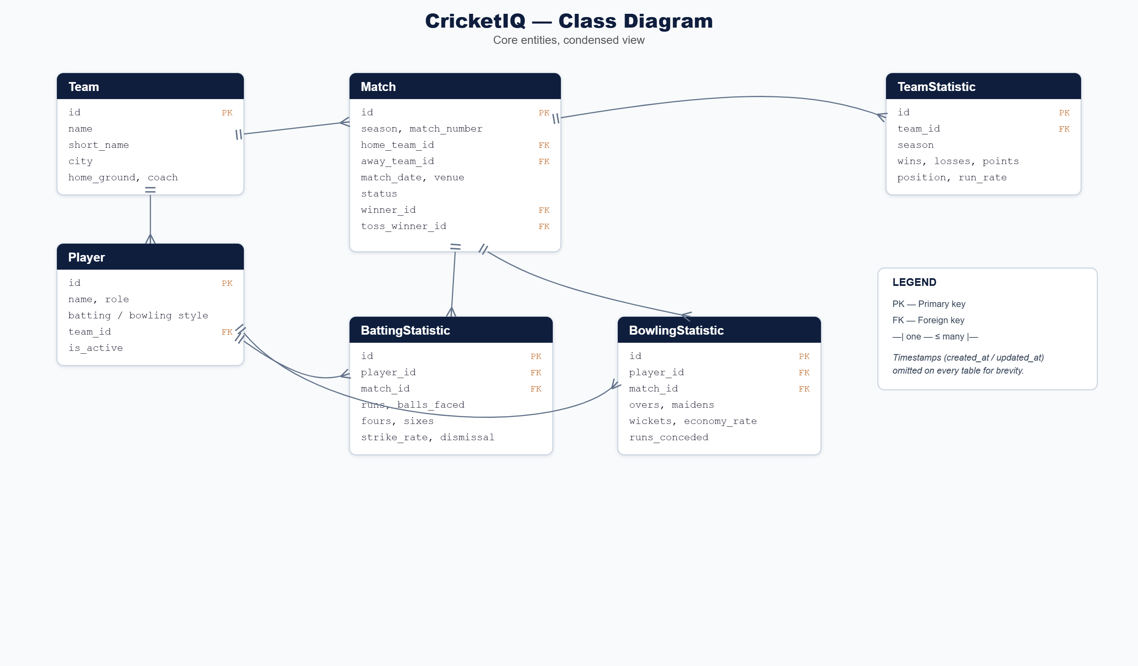
Figure 4.2 — Class diagram.

4.3 Process Flow — Match Win Prediction
End-to-end flow for the win-probability use case, across Browser, Flask API and Model/Data. Errors return inline plus a toast, never a blocking alert().
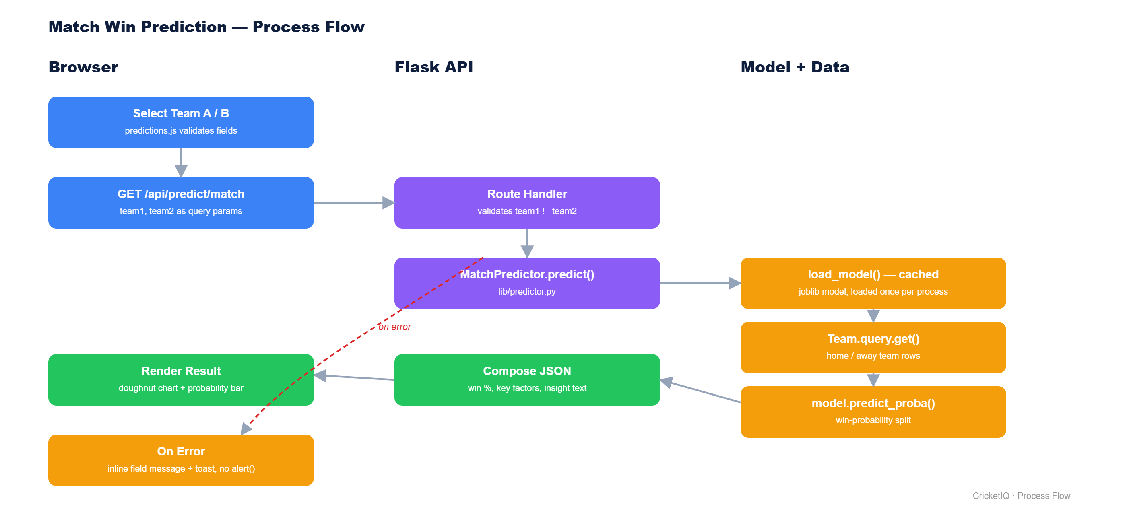
Figure 4.3 — Match prediction process flow.

5. Table Design
Six tables, implemented with Flask-SQLAlchemy. Full field list, types and keys below; every table also carries created_at / updated_at, omitted here for brevity.
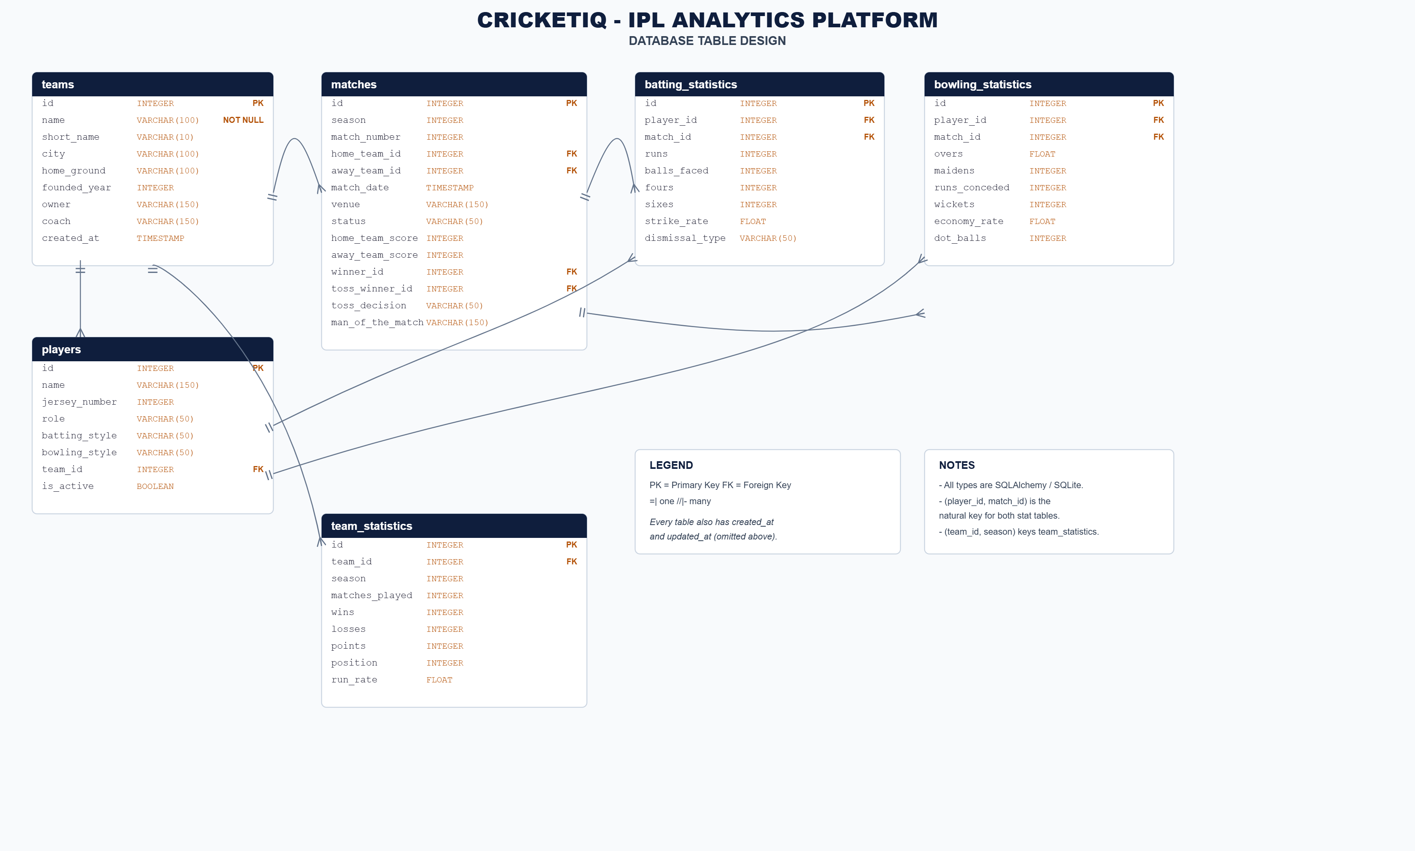
Figure 5.1 — Database table design.
Team is the reference point for Player (squad) and Match (home/away/winner/toss, four FK roles). BattingStatistic and BowlingStatistic each key off (player_id, match_id); TeamStatistic keys off (team_id, season).

6. Design: Customisation on Templates
All 13 pages extend one base layout (templates/base.html), which owns the sidebar, topbar, footer, toast region and five Jinja2 blocks. Each child template overrides only the blocks it needs.
Two macro files remove repetition further: _icons.html (one SVG sprite, no Font Awesome dependency) and _components.html (pagination, empty states, badges, filter search — shared by every listing page).
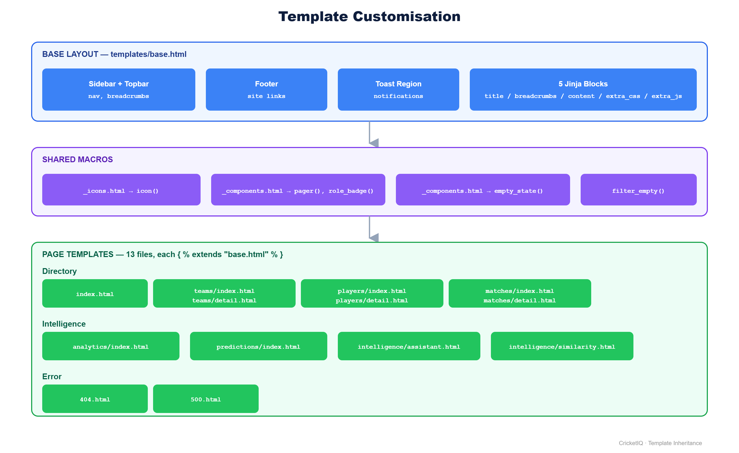
Figure 6.1 — Template inheritance.
Example child template:
{% extends "base.html" %}
{% block title %}Teams — CricketIQ{% endblock %}
{% block content %}
... page markup, using the icon() and role_badge() macros ...
{% endblock %}

7. Table Normalisation

7.1 1NF
Every column is atomic; no repeating groups. A player’s many innings become rows in batting_statistics / bowling_statistics, not numbered columns on players.

7.2 2NF
All six tables key on a single-column id, so 2NF holds automatically. The real business keys — (player_id, match_id) and (team_id, season) — have every other column depend on the full pair, never on one half.

7.3 3NF
No column depends on another non-key column. A player’s team name is never copied onto players — only team_id, resolved via FK. Season aggregates (wins, points, run_rate) live in team_statistics, not on teams, since they describe a (team, season) pair and would otherwise be overwritten every season.

7.4 Summary
Table | 1NF | 2NF | 3NF | Notes
teams | Yes | Yes | Yes | No repeating groups; no transitive dependency.
players | Yes | Yes | Yes | team_id is an FK, not a copied team name.
matches | Yes | Yes | Yes | Four team roles are FKs.
batting_statistics | Yes | Yes | Yes | One row per (player, match).
bowling_statistics | Yes | Yes | Yes | One row per (player, match).
team_statistics | Yes | Yes | Yes | Keyed by (team, season), off teams.

Further detail: README.md, PROJECT_OVERVIEW.md, DESIGN.md at the project root; source at https://github.com/arjuntp-397/Mini-Project-2.

