//FCFS
#include<stdio.h>
int main()
{
int p[20],bt[20],wt[20],tt[20],n,i;
float avg_wt,avg_tt;
printf("enter the number of processes");
scanf("%d",&n);
printf("enter the and process id:");
for(i=0;i<n;i++)
{
scanf("%d",&p[i]);

}
printf("enter the burst time: ");
for(i=0;i<n;i++)
{

scanf("%d",&bt[i]);
}
wt[0]=0;
for(i=0;i<n;i++)
{
wt[i]=wt[i-1]+bt[i-1];
avg_wt+=wt[i];
}
avg_wt=avg_wt/n;
for(i=0;i<n;i++)
{
tt[i]=wt[i]+bt[i];
avg_tt+=tt[i];
}
avg_tt=avg_tt/n;
printf("PID\tBT\tWT\tTT\n");
for(i=0;i<n;i++)
{
printf("%d\t%d\t%d\t%d\n",p[i],bt[i],wt[i],tt[i]);
}
printf("GANT CHART");
printf("\n-------------------------------------------------------\n");
for(i=0;i<n;i++)
{
printf("|P%d|\t",p[i]);

}
printf("\n-----------------------------------------------------\n");
printf("%d\t",wt[0]);
for(i=0;i<n;i++)
{
printf("%d\t",tt[i]);
}
printf("\n");
printf("the average waiting time is:%f\n",avg_wt);
printf("the average turn around time is:%f\n",avg_tt);
}

OUTPUT
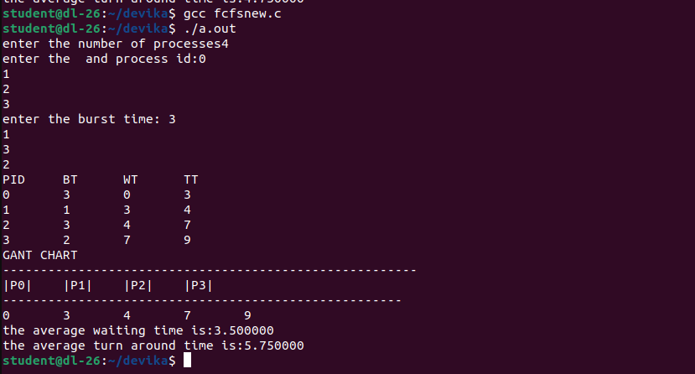

//SJF
#include<stdio.h>
int main()
{
int p[20],bt[20],wt[20],tt[20],n,i,j,temp;
float avg_wt,avg_tt;
printf("enter the number of processes");
scanf("%d",&n);
printf("enter the and process id:");
for(i=0;i<n;i++)
{
scanf("%d",&p[i]);

}
printf("enter the burst time: ");
for(i=0;i<n;i++)
{

scanf("%d",&bt[i]);
}
for(i=0;i<n-1;i++)
{
for(j=0;j<n-i-1;j++)
{
if(bt[j]>bt[j+1])
{
temp=bt[j];
bt[j]=bt[j+1];
bt[j+1]=temp;
temp=p[j];
p[j]=p[j+1];
p[j+1]=temp;
}
}
}
wt[0]=0;
for(i=0;i<n;i++)
{
wt[i]=wt[i-1]+bt[i-1];
avg_wt+=wt[i];
}
avg_wt=avg_wt/n;
for(i=0;i<n;i++)
{
tt[i]=wt[i]+bt[i];
avg_tt+=tt[i];
}
avg_tt=avg_tt/n;
printf("PID\tBT\tWT\tTT\n");
for(i=0;i<n;i++)
{
printf("%d\t%d\t%d\t%d\n",p[i],bt[i],wt[i],tt[i]);
}
printf("GANT CHART");
printf("\n-------------------------------------------------------\n");
for(i=0;i<n;i++)
{
printf("|P%d|\t",p[i]);

}
printf("\n-----------------------------------------------------\n");
printf("%d\t",wt[0]);
for(i=0;i<n;i++)
{
/*printf("%d\t",wt[i]);*/
printf("%d\t",tt[i]);
}
printf("\n");
printf("the average waiting time is:%f\n",avg_wt);
printf("the average turn around time is:%f\n",avg_tt);

}

OUTPUT
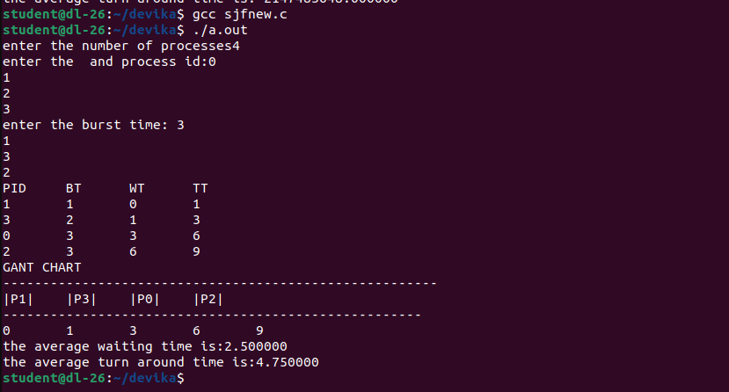

//PRIORITY
#include<stdio.h>
int main()
{
int p[20],bt[20],wt[20],tt[20],n,i,j,temp=0,priority[20];
float avg_wt,avg_tt;
printf("enter the number of processes:");
scanf("%d",&n);
printf("enter the and process id:");
for(i=0;i<n;i++)
{
scanf("%d",&p[i]);

}
printf("enter the burst time: ");
for(i=0;i<n;i++)
{
scanf("%d",&bt[i]);
}
printf("enter the priority:");
for(i=0;i<n;i++)
{
scanf("%d",&priority[i]);
}
for(i=0;i<n-1;i++)
{
for(j=0;j<n-i-1;j++)
{
if(priority[j]>priority[j+1])
{
temp=priority[j];
priority[j]=priority[j+1];
priority[j+1]=temp;
temp=p[j];
p[j]=p[j+1];
p[j+1]=temp;
temp=bt[j];
bt[j]=bt[j+1];
bt[j+1]=temp;
}
}
}
wt[0]=0;
for(i=0;i<n;i++)
{
wt[i]=wt[i-1]+bt[i-1];
avg_wt+=wt[i];
}
avg_wt=avg_wt/n;
for(i=0;i<n;i++)
{
tt[i]=wt[i]+bt[i];
avg_tt+=tt[i];
}
avg_tt=avg_tt/n;
printf("PID\tBT\tPRIO\tWT\tTT\n");
for(i=0;i<n;i++)
{
printf("%d\t%d\t%d\t%d\t%d\n",p[i],bt[i],priority[i],wt[i],tt[i]);
}
printf("GANT CHART");
printf("\n-------------------------------------------------------\n");
for(i=0;i<n;i++)
{
printf("|P%d|\t",p[i]);

}
printf("\n-----------------------------------------------------\n");
printf("%d\t",wt[0]);
for(i=0;i<n;i++)
{
/*printf("%d\t",wt[i]);*/
printf("%d\t",tt[i]);
}
printf("\n");
printf("the average waiting time is:%f\n",avg_wt);
printf("the average turn around time is:%f\n",avg_tt);
}

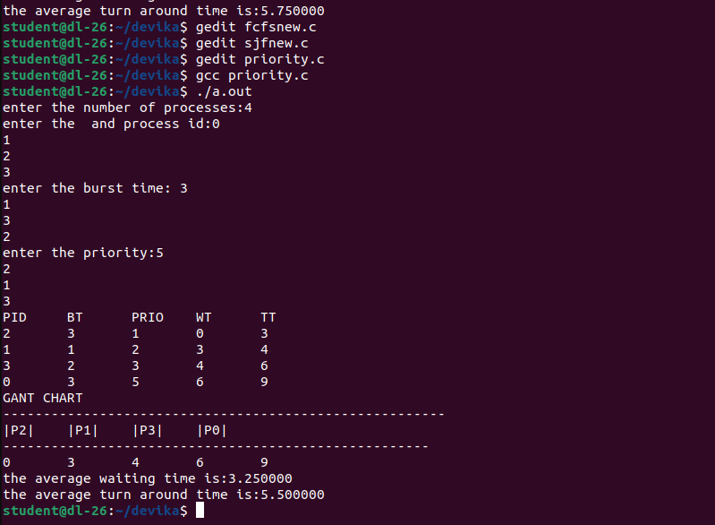
OUTPUT

