**Software Development Lifecycle (SDLC) for IBM Sterling Order Management System(OMS) in Reliance Digital**

**Devika P Shetty**

**NNM23IS045**

|  |  |
| --- | --- |
| **Keywords:** | Software Development Life Cycle (SDLC), IBM Sterling Order Management System(OMS) in Reliance Digital,Incremental Development, Spiral Model, Waterfall Model, Requirements Engineering, Risk Management, Change Management, Functional Requirements, Non-Functional Requirements, Deployment, Validation Strategy, Cost and Time Constraints. |
|  |  |
| **Abstract:** | IBM Sterling Order Management is a product with unprecedented order-processing and stock-management and multi-channel fulfillment capabilities for larger enterprises. As a leader in electronics retail, Reliance Digital relies on IBM Sterling OMS for high-volume transactions to get real-time inventory updates, stock allocation optimizations, and speedier deliveries. Being a complex system, it requires adherence to the SDLC and proper implementation with both scalability and adaptability in mind.  The case studies address, analyze, explore, and compare Waterfall, Incremental, and Spiral Models to find a suitable candidate for working onto and delivering IBM Sterling OMS along with Reliance Digital. All of these were analyzed for functional and non-functional requirements, risk and change management, and time and cost constraints. They also provided insights into requirements engineering processes, validation strategies, and challenges that may appear during deployment.  Among this comparative description, the Incremental Development Model appears the most suitable given its phased release of features, short feedback cycles with stakeholders, and ease of integration with already functional retail systems. This will further ensure a smooth and minimally disruptive advance in the case of the order management process for Reliance Digital, now and in the future. |
| **Publishing:** | This paper was submitted to *Dr. Jason Elroy Martis, Associate Professor, Department of Information Science and Engineering, NMAM Institute of Technology. Nitte Karnataka, India.* This paper is also hosted on a GitHub repository, along with the material used for preparing this research. The link to the GitHub Repository is given in the endnote. |
|  |  |

# **Table of Contents**

# **Introduction 1-2**

# 1.1 Overview of IBM Sterling OMS 1

# 1.2 Objective of the Study 2

# **The Problem of the Case Study 3-10**

# 2.1 Problem Identification 3-5

# 2.2 The necessity for a high-performing Order Management System 5-7

# **Explicit Comparison of Software Development Models 11-12**

# 3.1 Waterfall Mode 11 3.2 Incremental Development Model 11 3.3 Spiral Model 11-12

# **The Requirements Engineering Process 3**

# **References 14**

**1.Introduction:**

IBM Sterling Order Management System (OMS) is a robust medium-sized free order management solution that allows businesses to manage inventory tracking, order, and warehouse operations over multiple sales channels. It provides real-time visibility into inventory and intelligent order management and works with third-party logistics providers to ensure efficient scale order processing.

* 1. **Overview of IBM Sterling OMS**

Reliance Digital - one of India's largest consumer electronics retailers-using IBM Sterling OMS to ramp up operational activity within supply chains. Considering the large number of transactions processed daily, Reliance Digital must also ensure an acceptable volume of huge order processing is within reasonable turn-around time. IBM Sterling OMS mostly facilitates on-time order deliveries by smartly directing inventory allocation for the delivery of highest customer service through removal of overselling and delayed deliveries.

* 1. **Objective of the Study**

This research aims to analyze the Software Development Life Cycle (SDLC) for deploying IBM Sterling OMS at Reliance Digital. The analysis examines a comparison between three SDLC models:

- **Waterfall Model**: a rigid and structured way of development, dividing the work into different steps one after the other;

- **Incremental Development Model:** development where iterations occur until the product reaches sufficient stability for a release;

- **Spiral Model**: risk-driven development or risk-based and continues refinements.

Evaluation will consider:

- Functional and non-functional attributes.

- Management of risk and changes.

- Constraining conditions concerning time and cost.

In addition, IBM Sterling OMS's requirements engineering process explains System Requirements Specification/Requirement Document, validation approach, and difficulties in the implementation.

**2. The Problem of the Case Study**

**2.1 Problem Identification.**

Reliance Digital sells thousands of items through their physical stores and e-commerce platforms on a daily basis. Efficiency in stock availability, order fulfillment, and processing of returns is the only way to manage this volume of transactions and orders successfully. However, they were faced with a variety of challenges in these operations during: Inventory inconsistency: The delays occurring in updating inventories had sometimes led to overselling or shortages; Order processing time delays: This attends to the complications that arise from slack coordination in transitioning orders from the processing area to the warehouse that eventually slows down the entire activity from the placement of an order until it is fulfilled; Returns and refunds handling: These deal with the problems faced by the organization in respect to timely processing of cancellations, exchanges, and returns/refunds; Integration of Logistics and Payments: Integration into third-party logistics and payment gateway refers basically to the integration of the application with an automated application developed on a third-party platform. Scalability and performance will provide a way for the application to scale as needed for continued business performance checks.

**2.2 The necessity for a high-performing Order Management System**

Reliance Digital is working towards these solutions; a scalable and effective order management system is being considered. IBM Sterling OMS is capable of providing: Real-time Inventory Visibility gives a live view of stock throughout the sales channels.Intelligent Order Orchestration. This optimizes order fulfillment by more rational routing of shipments through the nearest warehouse. Automated Workflow Management modernizing order processing, returns, and the payment process. Integrating with the supply chain service providers will easily execute accurate and timely supply chain processes. Scalability and reliability can support high transaction volumes with less downtime.

The wise choice of an SDLC model that helps in the implementation of the IBM Sterling OMS would assure effective and risk-free implementation of the system in line with the business needs and in meeting customer expectations.

**3. Explicit Comparison of Software Development Models**

A final and exhaustive model of the software development life cycle, implementation of the IBM Sterling OMS in Reliance Digital reasonably mirrors implementation across business scenarios, risk management, scalability, and thoughtful consideration on them. Thus, this evaluation of suitability for IBM's OMS deployments examines the three leading software development models in the world today-Waterfall Model, Incremental Model, and Spiral Model-in great detail.

**3.1 Waterfall Model**

Waterfall Model is old style. It is linear and sequential. Each phase has to be completed before the next phase can commence. This fits very well for projects that have well-defined and stable requirements. It is a linear and sequential approach to software development that consists of several phases. It must be completed in a specific order. This classical waterfall model is simple and idealistic. It is often used for large-scale projects with long timelines, where there is little room for error and the project stakeholders need to have a high level of confidence in the outcome. Arising as one of the cascaded approaches of linear software development, the Waterfall model does not allow what is realized in one stage to proportionally affect what is expected to follow it. The combination of requirements design-development-and-testing under this model suits projects where requirements are perfectly known and finite.

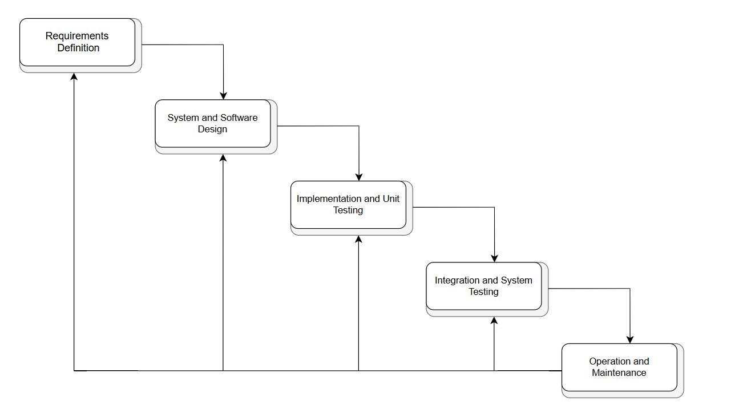

*Fig1.Waterfall Model*

**Phases of IMB Sterling OMS installation**

**1. Requirements analysis** -Expected during the order processing, inventory tracking, and fulfillment workflows. Research needed on-technical and business requirements to be established.

**2. Design**-Architecture planning, database design, API integrations, and warehouse automation rules.

**3. Implementation**-Development and configuration of the order management modules (order validation, stock updates, coordination of warehouses).

**4. Testing**-Unit, integration, and acceptance testing with the user.

**5. Deployment and maintenance**-Comprises the development and implementation of the system and thereafter, support.

Suitability for the IBM Sterling OMS-Ideal for projects where requirements have been fixed and well articulated and envisaged only to pose slight changes to their scope.

Not applicable-The dynamic business environment that seeks continuous revisions.

**Pros and cons**

**Pros**

* A more structured phase where things became more manageable-a lot more clarity.
* Extensive documentation for all phases of the actual software development are necessary.
* Ideal for the industry, definitely on the regulatory side for retail and finance.

**Cons**

* Diametrically opposed to modification fitting after one stage has been established.
* Testing further on invites expensive rework of what could be built.

**3.2 Incremental Development Model**

Incremental model also known as the successive version model is a process of software development where requirements divided into multiple standalone modules of the software development cycle. An indecisive user development model is a stepwise concept where a system is build incrementally through various smaller, manageable increments that add functionality at each step. The incremental development model helps to ensure that features are released early for user feedback before final release, and thus, provides an opportunity to get any feedback on the added increments before finalizing the deployment of the software.

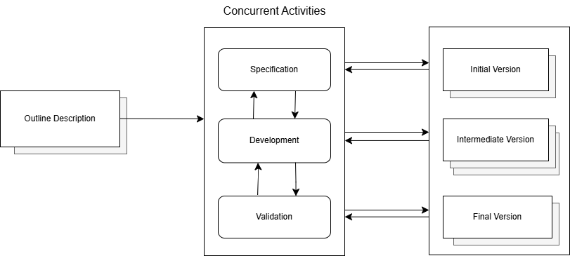

*Fig. 2. Incremental Model*

**IBM Sterling OMS implementation phase**

**1. Planning phase**- This involves implementing core order processing and inventory tracking functionality first.

**2. Incremental releases-** Gradual implementation of returns management, fraud detection, analytics, and automation.

**3. Testing and feedback-** Testing is done at all stages of increments along with feedback from the business side

**4. Final integration and deployment-**Involves integrating all sub-modules into final working IBM Sterling OMS.

**Suitability-fits IBM Sterling OMS**

**Best suited for:** Large systems that need phased deployment and continuous improvement.

**Flexibility:** Provides chances for business teams to give feedback and ask for changes in between the increments.

**Pros and cons**

**Pros**

* Good early operational feature, without waiting for complete.
* Adaptability-close follow-up of business-side change requests.
* Less risk because of division of complete software development into small sub-parts.

**Cons**

* Requires very careful version control and integration management.
* The later increment might generate unforeseen complexity for system integration.

**3.3 Spiral Model**

The Spiral Model is a risk-driven software development approach that combines iterative development with organised risk management.The Spiral Model is a revolving development method that incorporates constant monitoring and evaluation of potential risks. This is primarily advantageous for programs that are bound to face lots of risk and uncertainty, due to its ability to make continuous refinements.

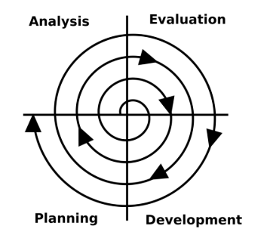

*Fig. 3. Spiral Model*

**Step in Implementation of IBM Sterling OMS**

**1. Risk Assessment –** Determine level of danger posed by unknown system updates, operational efficiency, and possible breaches.

**2. Prototyping –** Building the working models of the most dangerous traits like warehouse automation and inventory management in real time.

**3. Development & Refinement –** Development through modification of the effect module combined with extensive manual testing and gradual multi-pass refining.

**4. Final Deployment –** Final version of IBM Sterling OMS, refined but not suspected to contain severe bugs.

**Suitability for IBM Sterling OMS**

**Best:** A refinement-rich, high-security demanding project, which needs strict validation from impartial users in order for the measures taken to be effective.

**Pros & Cons**

**Pros**

* Limits the scope of project failure by attempting to mitigate risks identified in the plan.
* Improvement of the system from feedback stems eases usage of the system by stakeholders.
* System gained higher scalability and system performance because of the iterative method.

**Cons**

* Drags on the time frame and bumps up the cost of the program due to having to re-do processes.
* Greater risk leads to the greater need of having an experienced team to help with risk management.

**3.4 Best SDLC Model for IBM Sterling OMS**

Reliance Digital has goals and targets in place for the efficient implementation of IBM Sterling OMS which include the optimal balance of a flexible, reliable and efficient model and structure. The implementation is best served through the Incremental SDLC model, while Incremental Model entails elements of flexible and reliable structures, the Waterfall model is far too rigid and inflexible to meet the goals. Likewise, The Spiral Model is too poorly structured causing heavy cost restraints. Furthermore, it is evident that The Waterfall SDLC model stands out amongst the rest in the Inflexibility domain as it exhibits a very controlled system.

Proposed Model: Developmental Incremental. Earned user feedback aids users in modifying business performance strategy to yield optimal results, which come at a reduced cost due to lower risk, all retained through the Al Reliance system.

The Spiral Model techniques can be applied to the high-risk fraud detection and security validation system through the use of refined and compartmentalized structures that help reduce potential risk without lacking in the overall time frame for the system deployment.

**4. Requirements Engineering Process**

The Requirements Engineering Process ensures IBM Sterling OMS is aligned well not only with the business needs that justify it but also with organizational efficiency and technical standards. This entails defining functional and non-functional requirements, forming a strategy for validating them, and logging issues related to their implementation.

**4.1Functional Requirements (What the system must do):**

Functional requirements outline key characteristics that IBM Sterling OMS should provide for Reliance Digital:

* Order Processing & Fulfillment – Order creation, validation, modification, and tracking.
* Real-Time Inventory Management – Syncing inventory levels across multiple warehouses and sales channels.
* Warehouse Automation – Allocating stock, picking, packing, and shipping optimally.
* Payment & Refund Management – Integrate secure payment gateways and automate refund processing.
* Returns & Exchange Handling – A smooth flow of product returns, exchanges, and restocking.
* Multi-Channel Integration – Seamless connectivity between online stores, physical stores, and supplier networks.

**4.2 Non-Functional Requirements (How the system should perform)**

These are ensuring the performance in terms of efficiency, security, and scalability of IBM Sterling OMS:

* Scalability – Capability to manage thousands of concurrent transactions at peak sales times.
* Performance –Order processing and inventory updation should take less than 2 seconds.
* Security – Multi-factor authentication, encryption, and fraud detection measures.
* Reliability and uptime – 99.9% uptime with automatic failover and disaster recovery.
* Regulatory Compliance – Adherence to GDPR, PCI DSS, and financial transaction security protocols.

**4.3 Requirements Validation Strategy**

Validation by itself ensures that requirements of IBM Sterling OMS are appropriate from the business point of view, technically feasible, and easy to implement when deployed for their operations.

**Techniques of Validation Based on SDLC Models**

**Waterfall Model**

* Extensive document reviews – Ensure each requirement is defined upfront.
* Lastly, no testing was conducted until the entire development was completed, and this was what increased the risk involved.

**Incremental Development Model**

* Based on user's prototyping and feedback – Early functional validations by business teams through small releases of features.
* Testing at the increments – This has led to the early discovery of issues and less reworking as a result.

**5. Conclusion and References**

**Conclusion**

For IBM Sterling OMS implementation in Reliance Digital, a streamlined SDLC approach must be fully brought into play to fast-track order processing, real-time inventory updates, and multichannel integrations.From the comparative analyses that were done between the Waterfall, Incremental, and Spiral methods :The Waterfall Model is too rigid for a dynamic retail environment since it is entirely a sequential and unyielding model. The Incremental Development Model appears to offer the best compromise for business software. It allows for the delivery of certain functional areas in phases, thus continuously gathering feedback from the business and enhancing the system. Though the Spiral Model works quite well in risk control, it is very tedious and costly, which counters its appropriateness for implementations that must be accelerated within the retail environment. Several functional and non-functional requirements, validation techniques, and impediments within requirements engineering are also analyzed. It was further stated that early testing, furrowing feedback cycles, and strong integration management were of utmost importance in establishing a good fit between IBM Sterling OMS and Reliance Digital's business needs.

**References**

1. [Software Engineering](https://www.pearson.com/en-us/subject-catalog/p/software-engineering/P200000003258/9780137503148) (Sommerville, Ian. Software Engineering, 10th Edition, Pearson.)

2. Pressman, Roger S. Software Engineering: A Practitioner’s Approach, McGraw Hill.

3. [IBM Sterling Order Management System documentation - IBM Documentation](https://www.ibm.com/docs/en/order-management?topic=SSGTJF/landing/welcome.htm).

This whole process guarantees that the optimal SDLC practices are followed to make the IBM Sterling OMS into a truly capable and powerful tool for Reliance Digital with improved order management, increased efficiency, and experience for the customer.