SIMATS ENGINEERING
Department of Information Technology
CSA15 – CLOUD COMPUTING AND BIG DATA ANALYTICS
ASSESSMENT TOOL 3 – APPLICATION BASED QUESTIONS (ANSWERS)
CO2: Analyze virtualization architectures to identify performance and security issues in cloud computing environments. | Document 1: e-commerce, streaming and banking case focus
Student Name | G.Devika | Register Number | 192371086
Department / Section | CSE(AI) | Academic Year / Semester | 4TH YEAR
Course Outcome | CO2 (BL3) | Total Marks | 25

Question 1: Auto-Scaling and Load Balancing for Seasonal Sales
Scenario: A company experiences unpredictable traffic spikes during seasonal sales. Explain how auto-scaling and load balancing handle this demand, how they reduce downtime and improve user experience, the role of monitoring tools, and relate it to a real-world e-commerce scenario.
1. How auto-scaling and load balancing handle the demand
A fixed set of servers is either too small on sale day or wastefully large for the rest of the year. Cloud elasticity solves this by splitting the work between two cooperating services. The load balancer is the single public entry point: it accepts every request and passes it to a healthy server using a rule such as round robin or least connections. Auto-scaling controls how many servers exist behind it: it adds servers when demand rises (scale out) and removes them when demand falls (scale in).
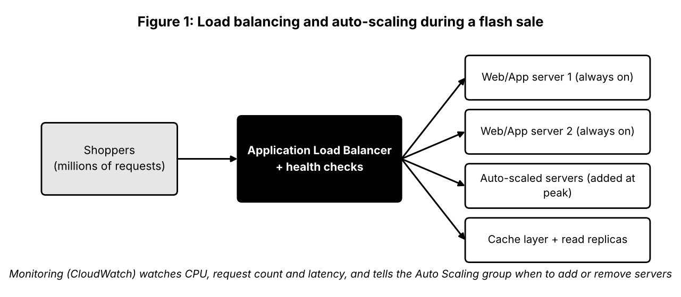
- Horizontal scaling: many identical, stateless web servers are cloned from one machine image, so any server can serve any shopper.
- Policies: target tracking (keep average CPU near 60%), step scaling (add 4 servers if requests exceed a limit) and scheduled scaling (pre-warm capacity 30 minutes before a known sale start).
- Session handling: shopping carts are stored in a shared cache or database, not on one server, so removing a server never loses a cart.
2. Reducing downtime and improving user experience
Health checks are the key to availability. The load balancer probes each server every few seconds; if one stops responding it is taken out of rotation and traffic continues to flow to the rest, so a hardware or software fault does not become an outage. Spreading servers over several availability zones means that even the failure of an entire data centre leaves the shop running. Users notice only the benefits: pages load in about the same time at 10,000 visitors as at 10 million.
Aspect | Fixed on-premises capacity | Cloud auto-scaling + load balancer
Sale-day peak | Servers overload; pages time out | New servers added within minutes
Server failure | Customers see errors until repair | Faulty node removed automatically
Cost in quiet months | Full hardware cost, mostly idle | Pay only for servers actually running
Planning effort | Months of forecasting and purchasing | Rules and templates defined once
User experience | Slow checkout, abandoned carts | Consistent response times

3. Role of monitoring tools
Monitoring supplies the numbers that scaling rules act on. Tools such as Amazon CloudWatch collect metrics (CPU, memory, requests per second, response time, error rate) and logs, raise alarms when a threshold is crossed, and display dashboards for the operations team. They also support after-the-event analysis: if scaling was too slow, the graphs show whether the threshold or the instance start-up time needs adjusting. Synthetic checks that simulate a customer completing a purchase detect problems before real shoppers do.
4. Real-world example: big festival sale on an Indian e-commerce site
During a festive sale such as Flipkart's Big Billion Days or Amazon's Great Indian Festival, traffic can jump many times within minutes of a midnight launch. The retailer pre-scales using scheduled policies, places an application load balancer in front of product, cart and checkout services, and lets dynamic policies add servers as shoppers arrive. A cache layer serves product pages, protecting the database. As the sale ends, scale-in removes the extra capacity. The result is that the site stays available at the busiest moment and the company does not carry that capacity all year.
Question 2: Secure, Durable and Economical Cloud Backup
Scenario: An organisation wants to store large volumes of backup data securely in the cloud. Discuss durability and redundancy, encryption and access control, cost advantages over traditional storage, and a disaster recovery use case.
1. Durability and data redundancy
Object storage services such as Amazon S3, Azure Blob Storage and Google Cloud Storage break each object into pieces and keep multiple copies on separate disks and in separate facilities, with continuous integrity checks and automatic repair. Providers advertise very high durability (for example, 99.999999999%, or eleven nines, for S3), meaning that losing an object is extremely unlikely. Redundancy can be widened further by choice: copies across availability zones protect against a data-centre failure, and cross-region replication protects against a regional disaster.
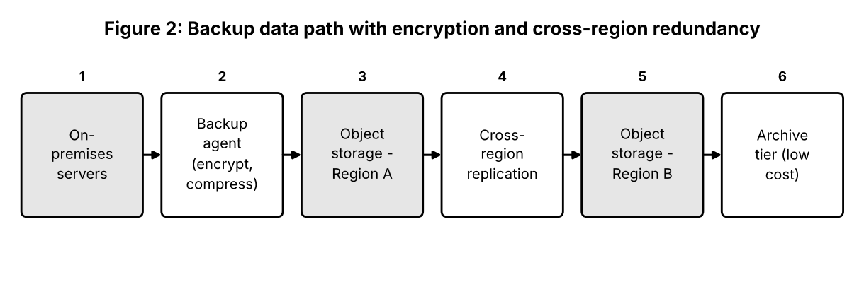
2. Encryption and access control for sensitive backups
- Encryption in transit: backup agents upload over TLS or a private line, so data cannot be read on the network.
- Encryption at rest: server-side AES-256 encryption with keys held in a key management service; for highly sensitive data, the organisation encrypts before upload and keeps its own keys.
- Access control: least-privilege roles, separate accounts for backup administrators, multi-factor authentication, bucket policies that block public access, and time-limited credentials.
- Tamper protection: versioning and object-lock (write-once) prevent deletion or encryption of backups by malware or a careless administrator.
- Audit: every access is logged for review.
3. Cost advantages compared to traditional storage
Cost factor | Traditional tape / SAN backup | Cloud object storage
Up-front investment | Buy hardware, tape libraries, software licences | None; pay per GB per month
Capacity planning | Over-buy for growth | Grows on demand
Off-site copy | Courier tapes to second site | Replication built in
Operations | Staff, power, cooling, space, refresh every 4-5 years | Managed by provider
Ageing data | Stays on expensive media | Lifecycle rules move it to archive tiers at a fraction of the price

The trade-offs are retrieval and data-transfer charges for archive tiers and the need for sufficient bandwidth for the first full backup; many providers offer physical transfer appliances (for example AWS Snowball) for very large initial loads.
4. Disaster recovery use case
A regional bank runs its core systems in Chennai and replicates encrypted backups every hour to object storage in Mumbai, with older copies moving to an archive tier. When a flood disables the Chennai data centre, the bank launches virtual machines in Mumbai from the replicated images and restores the latest database backup. Service resumes within hours, with at most about an hour of transactions to re-enter. Meeting such a recovery time and recovery point would be expensive with a privately owned second site.
Question 3: CDNs and Global Availability for a Mobile App
Scenario: A mobile app company plans to deploy its application globally. Explain how CDNs improve performance and reduce latency, how edge servers enhance user experience, how providers support global availability, and relate this to real-time streaming or gaming.
1. How CDNs improve performance and reduce latency
Latency grows with physical distance and the number of network hops. A content delivery network keeps copies of content on servers placed in many cities. A user in Mumbai is routed to a Mumbai server instead of a data centre in Virginia, so the round trip falls from hundreds of milliseconds to a few tens. Because most requests are answered from cache, the origin server carries far less load and bandwidth costs drop.
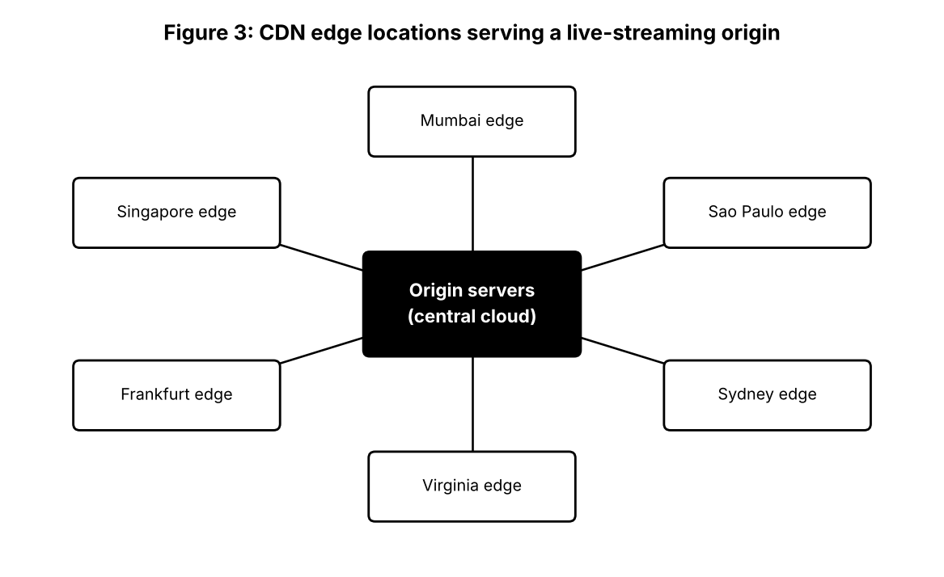
- Caching: images, scripts, app updates and video segments are stored at the edge, with time-to-live rules controlling freshness.
- Connection optimisation: the edge keeps persistent, optimised connections back to the origin and terminates TLS close to the user.
- Traffic protection: edge servers absorb DDoS attacks and filter malicious requests before they reach the origin.
2. How edge servers enhance user experience across regions
Edge servers (points of presence) make an app feel local everywhere. Downloads start sooner, images appear quickly, and video begins playing with less buffering. Edge platforms such as CloudFront Functions or Cloudflare Workers can also run small pieces of code near the user to personalise content, resize images, check authentication tokens or redirect by country. On poor mobile networks, fewer long-distance round trips mean fewer failures and retries.
3. How cloud providers support global availability
Capability | What it provides | Example benefit
Regions and availability zones | Independent data-centre groups in many countries | Deploy near users and survive a site failure
Global DNS / traffic routing | Directs users to the nearest or healthiest region | Automatic failover during an outage
Global load balancing | One address that spreads traffic over regions | Even load and fast routing
Data replication | Multi-region databases and storage | Same data available everywhere
Private backbone network | Provider-owned fibre between regions | Lower, steadier latency than the public internet

4. Real-time streaming example
For a live cricket match streamed to millions of mobile users, the video is cut into a few seconds long segments. The origin publishes each segment once; the CDN copies it to edge servers, and each viewer fetches it from the nearest one. Adaptive bitrate streaming lets the player switch quality as the connection changes. Without a CDN the origin would have to send each segment millions of times; with it, the origin sends it only to the edge locations, so playback stays smooth even when the audience surges.
Question 4: Compliance and Data Security for a Financial Institution
Scenario: A financial institution requires strict compliance and data security in the cloud. Explain how providers support regulatory compliance and auditing, the role of logging, monitoring and encryption, how data sovereignty is met, and give an example involving sensitive financial transactions.
1. Regulatory compliance and auditing support
Security in the cloud is a shared responsibility: the provider secures the physical data centres, hardware and the virtualisation layer, while the customer secures its own configuration, identities and data. Providers support the customer by obtaining independent certifications and audit reports (ISO 27001, SOC 1/2, PCI DSS, and local financial-sector requirements) that the institution can show to regulators. Compliance dashboards, configuration rules and automated evidence reports help demonstrate that controls are working, and providers sign contractual commitments on data handling and breach notification.
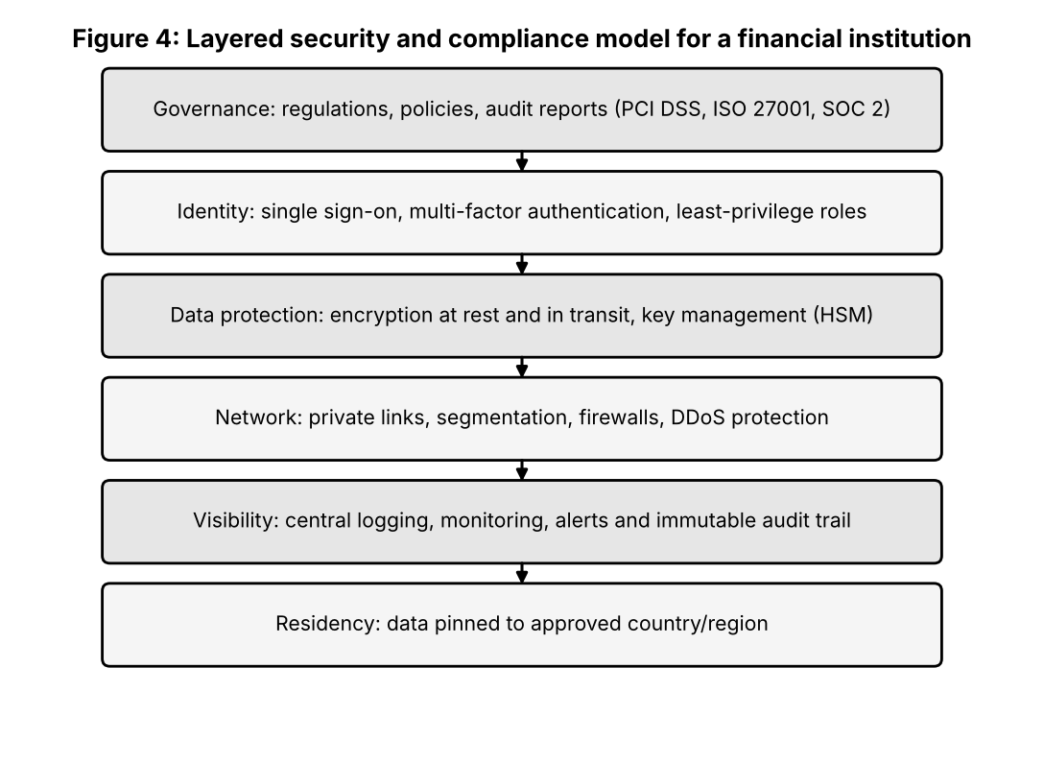
2. Role of logging, monitoring and encryption
Control | Purpose | Typical tool
Logging | Records who did what, when and from where; evidence for auditors | CloudTrail, Azure Activity Log, Cloud Audit Logs
Monitoring and alerting | Detects unusual behaviour such as large downloads or logins from new countries | CloudWatch, Security Hub, SIEM platform
Encryption in transit | Stops interception between client, services and data centres | TLS 1.2+, IPsec VPN
Encryption at rest | Makes stolen disks or snapshots unreadable | AES-256 with KMS or HSM-protected keys
Key management | Controls who can create, use and rotate keys | Customer-managed keys, rotation policies

Together these controls form detection and prevention: encryption limits what an attacker obtains, while logs and alerts show that an attack is happening and provide evidence afterwards.
3. Meeting data sovereignty requirements
- Choose approved regions: deploy only in regions inside the required country (for example, India for payment data under RBI storage rules).
- Enforce by policy: organisation-level rules that block creating resources in other regions.
- Control replication: keep backups and disaster-recovery copies in a second in-country region.
- Own the keys: customer-managed or externally held keys so that data cannot be decrypted without the institution's approval.
- Contract and audit: confirm in agreements where data and support staff are located, and review access logs for cross-border access.
4. Example: processing sensitive financial transactions
When a customer makes a UPI or card payment, the request passes a web application firewall, the card number is replaced by a token, and the transaction is processed by services that run only in the Indian region. Database records and backups are encrypted with keys held in a hardware security module, and each access is written to an immutable log. If a staff account suddenly queries thousands of customer records, the monitoring system alerts the security team, who can revoke access immediately and use the logs for investigation and regulator reporting.
Question 5: Containers, Orchestration and Portability
Scenario: A development team wants to adopt containerisation. Explain how containers differ from virtual machines in performance and resource usage, how orchestration such as Kubernetes simplifies deployment and scaling, the portability benefits, and give a microservices example.
1. Containers versus virtual machines
A virtual machine includes a full guest operating system on top of a hypervisor, so each VM carries gigabytes of operating-system files and boots in minutes. A container packages only the application and its libraries and shares the host's kernel, so it is typically tens of megabytes in size and starts in seconds.
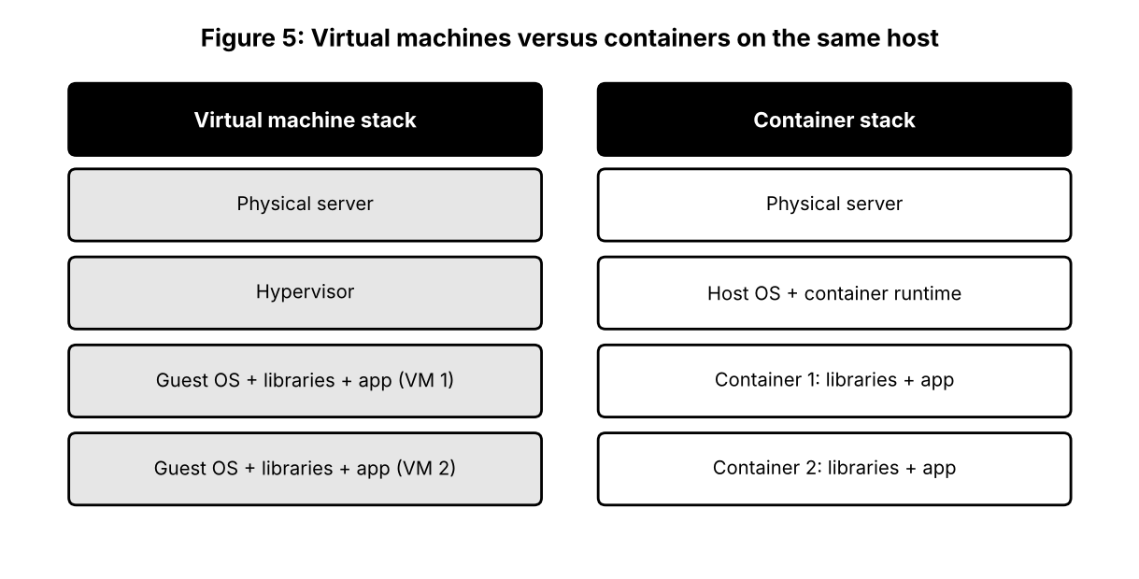
Factor | Virtual machine | Container
Size | Gigabytes | Megabytes
Start-up time | Minutes | Seconds or less
Resource overhead | Each VM reserves CPU and memory for its own OS | Shared kernel; far less overhead
Density per server | Tens of VMs | Hundreds of containers
Isolation | Strong, separate kernels | Process-level; weaker unless hardened
Best for | Different operating systems, strong tenant isolation | Fast-scaling microservices and CI/CD

2. How orchestration (Kubernetes) simplifies deployment and scaling
Running a few containers by hand is easy; running hundreds is not. Kubernetes automates the work. The team describes the desired state in a configuration file (for example, 'run five copies of the cart service') and Kubernetes keeps it true: it schedules containers on nodes with free capacity, restarts failed ones, performs rolling updates without downtime, rolls back bad releases, and exposes services through stable internal addresses and load balancing.
- Horizontal Pod Autoscaler: adds or removes container copies based on CPU or custom metrics.
- Cluster Autoscaler: adds or removes worker nodes when the cluster needs more or less capacity.
- Self-healing: replaces crashed or unresponsive containers automatically.
- Configuration and secrets: kept outside the image so the same image runs in all environments.
3. Portability across cloud environments
A container image contains everything the application needs, so it behaves the same on a developer laptop, a test server, and any provider's cloud. Kubernetes is offered as a managed service by all major providers (EKS, AKS, GKE) and can also run on-premises, so teams can move or spread workloads between clouds with few changes and reduce lock-in. The remaining differences usually lie in storage, networking and identity integration, which should be kept behind configuration.
4. Example: microservices-based e-commerce application
Microservice | Responsibility | Scaling behaviour
Catalogue | Product listing and search | Scales up during browsing peaks
Cart | Maintains the basket (state in Redis) | Scales with active shoppers
Order | Creates and tracks orders | Moderate; uses a queue to handle bursts
Payment | Talks to payment gateway | Scaled separately with stricter security
Notification | Sends e-mail and SMS | Event-driven; scales with order events

Each service has its own container image, release cycle and database. The cart service can be updated or scaled without touching payments, and a failure in notifications does not stop customers from ordering.

