SIMATS ENGINEERING
Department of Information Technology
CSA15 – CLOUD COMPUTING AND BIG DATA ANALYTICS
ASSIGNMENT 3 – CO3: DESIGN A CLOUD-BASED COLLABORATIVE SOLUTION (ANSWERS)
CO3: Implement cloud-based solutions using cloud storage, web APIs, and platform services for real-world applications. | Pair work (Student A and Student B) | Document 2: Amazon S3, AWS and Zoho platforms, REST posts API, assignment submission and placement coordination
Student A Name | G.Devika | Register Number | 192371086
Department / Section | CSE(BIO SCI) | Academic Year / Semester | 4TH YEAR
Faculty Name | DR.R.Latha | Nature of Assignment | Pair work
Duration | 1 Week | Total Marks | 50

Question 1: Accessing Cloud Services through Different Methods (6 Marks)
Scenario: Classify cloud access methods, draw the client-network-cloud architecture, demonstrate access to one cloud service and record observations and a limitation.
Shared group work
The pair compared how one cloud service can be reached in different ways and how the Internet connects the user to the provider. Amazon Simple Storage Service (S3), an object-storage service, was selected for the demonstration because it can be reached from a browser console, a phone app and program code, and the free tier allows safe experimentation with small files.
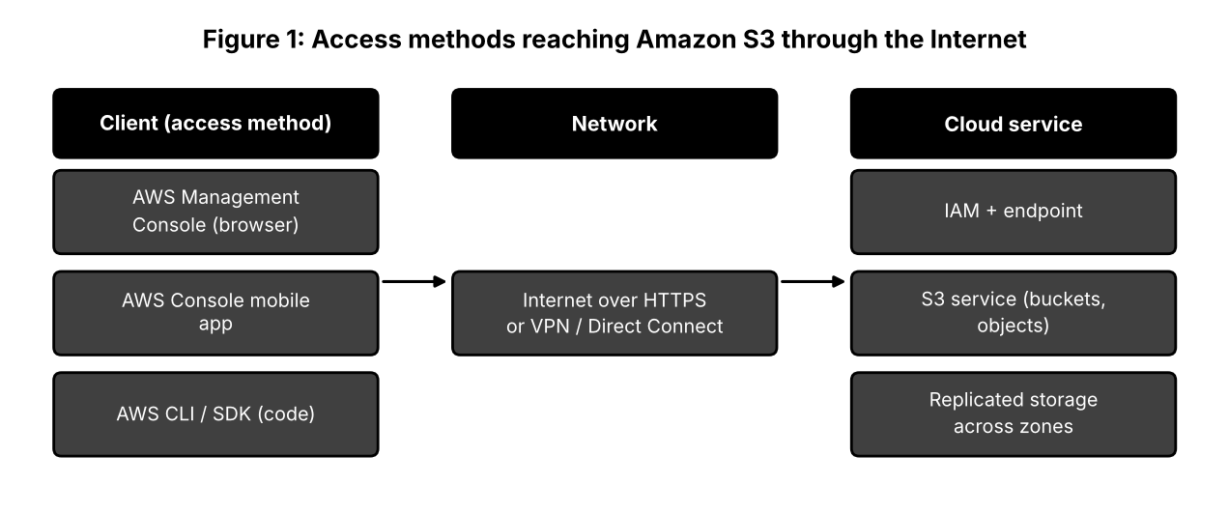
Student A: access method design
Access method | Typical user | Requirements | Strength | Weakness
Management console (browser) | Beginner, administrator | Browser, Internet, IAM user with MFA | Visual, easy to learn | Slow for repeated tasks
Mobile application | Operations staff on the move | Phone, app, secure login | Quick monitoring and alerts | Limited functions
CLI / SDK / REST API | Developer, DevOps engineer | Access keys or role, AWS CLI or SDK, code | Automation and repeatability | Needs programming knowledge; key protection

Explanation of access: the client sends a signed HTTPS request across the Internet (or a private VPN/Direct Connect link) to a regional S3 endpoint. The identity service checks the credentials and permissions; if they are valid, S3 reads or writes the object, which is stored redundantly across several data centres, and the response travels back. The client needs hardware and software to create the request and display the result; the network gives reach and bandwidth, and its delay affects speed.
Most suitable method for the selected application (storing and sharing course files): the browser console for the lab demonstration and the CLI for repeated uploads, because the console needs no installation and the CLI can be scripted. Mobile access is kept for monitoring only.
Student B: practical evidence
- Step 1: signed in to the AWS console using an IAM user with MFA (root account not used).
- Step 2: created a bucket with 'Block all public access' enabled, in the region nearest to Chennai.
- Step 3: uploaded a PDF and an image and opened the object's properties.
- Step 4: performed the same listing from the AWS CLI with the command 'aws s3 ls s3://bucket-name' and compared the result.
- Step 5: viewed the bucket from the mobile console app.
Evidence slot: attach your own original screenshot of the S3 bucket page, the CLI listing and the mobile app view.
Criterion | Console | CLI | Mobile app
Accessibility | Any browser | Needs installation and configuration | Needs app and login
Response | Visual feedback; several clicks | Immediate text result | Fast for viewing
Usability | Good for beginners | Efficient for repeated work | Limited but convenient

Limitation encountered: the first CLI command failed with an access-denied message because the IAM user had no permission to list the bucket. Effect on cloud usage: access depends not only on connectivity but also on correct permissions; wrong settings stop work, while overly wide settings create security risk. The solution was to attach a policy that allowed only the required S3 actions on that bucket.
Cross-verification
Each student can explain the other's work: Student A can describe why the CLI call failed (identity and permissions), and Student B can trace a request along the Client → Network → Cloud path in Figure 1.
Question 2: Cloud Platforms and Web Applications (7 Marks)
Scenario: Compare two platforms, map a user request to cloud services, demonstrate a cloud web application and evaluate it against local operation.
Shared group work: two platforms
Criterion | Amazon Web Services (AWS) | Zoho Cloud (Zoho Workplace / Creator)
Platform type | Infrastructure and platform (IaaS/PaaS) for building applications | Software-as-a-service suite with low-code platform
Web applications | Applications hosted by customers on EC2, S3, Elastic Beanstalk; WorkMail | Writer, Sheet, Show, Mail, Projects, CRM, Creator
Who builds the app | The customer designs and deploys it | The provider supplies ready applications; customer configures
User interaction | Through the customer's website or the console | Browser and mobile apps with built-in sharing
Cost model | Pay per use of resources | Per-user subscription, free plan available
Control | High; full control of servers and network | Lower; limited to application settings

Conclusion of the comparison: AWS suits teams that must build and operate their own applications, while Zoho suits organisations that want ready-made collaboration applications with little administration.
Student A: platform analysis
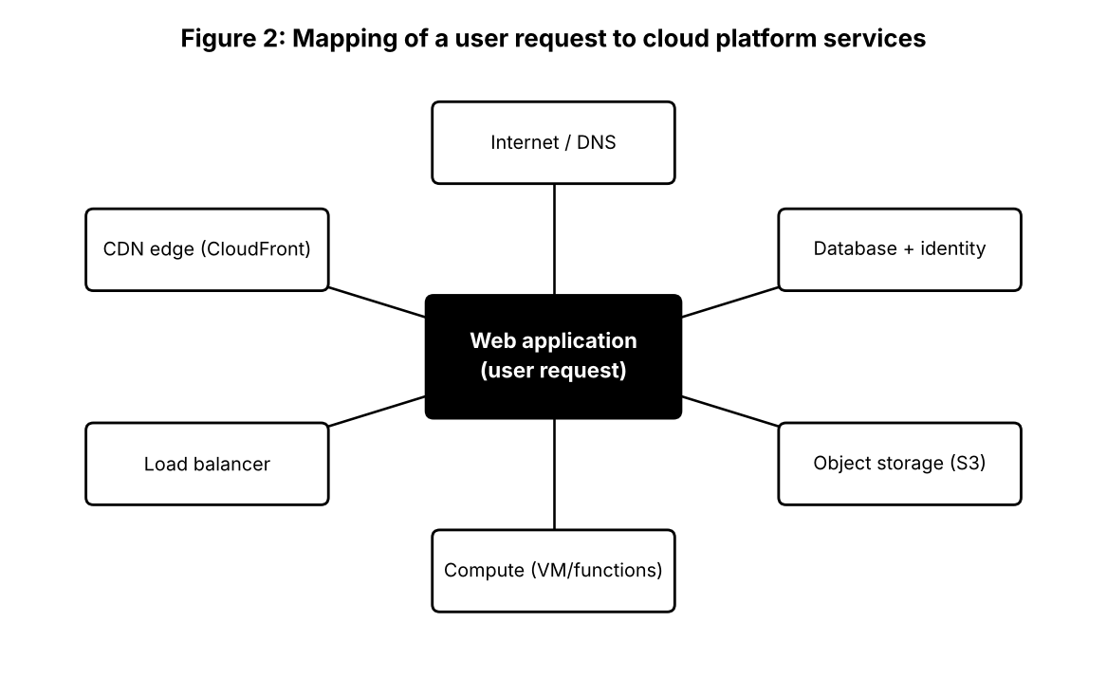
Platform component (AWS) | Function | Support for a web application
Route 53 (DNS) | Resolves the website name | Directs the user to the application
CloudFront (CDN) | Caches content at edge locations | Faster page loading
Elastic Load Balancing | Spreads requests | Avoids overload and failure of one server
EC2 / Lambda (compute) | Runs application code | Processes the user's request
S3 (storage) | Stores files and static pages | Holds images, documents, uploaded files
RDS / DynamoDB, IAM | Database and identity | Stores records; controls who can do what

Role of the Internet: carries the HTTPS request and the response. Role of the cloud infrastructure: provides elastic compute, storage and security without the user owning hardware. Role of the application: implements the features and business rules the user sees.
Student B: application investigation (Zoho Writer)
Selected application: Zoho Writer, a cloud word processor, used to prepare a lab report jointly.
Sequence | User action | Cloud access involved
1 | Open writer.zoho.com and log in | Authentication by Zoho account service
2 | Create a new document from a template | Document object created in cloud storage
3 | Type, format and insert an image | Autosave of changes to the server
4 | Share with partner using 'Share' option | Permission recorded in cloud
5 | Export as PDF | Server generates the PDF; downloaded by browser

Evidence slot: attach your own original screenshot of Zoho Writer showing the document, sharing option and export.
Benefits: nothing to install, work is saved automatically, accessible from phone or laptop, templates and spell-check are provided, and the document can be shared or exported instantly.
Joint evaluation: local computer only
Aspect | Application installed only on one computer | Same application accessed through the cloud
Access | Only from that computer | Any device with a browser
Data safety | Lost if disk fails or computer stolen | Stored and replicated by provider
Sharing | Files sent by e-mail or pen drive | Link or permission-based sharing
Updates and licence | Manual installation per machine | Automatic and central
Resources | Needs strong local hardware | Uses provider's servers
Offline use | Works without Internet | Limited unless offline mode exists

Question 3: Web APIs for Cloud Access (7 Marks)
Scenario: Study Web APIs and communicate with a public API using a program that sends different requests and records responses.
Shared group work
A Web API allows software to use a remote service by sending messages over HTTP. REST APIs treat data as resources identified by URLs and use standard methods: GET to read, POST to create, PUT or PATCH to update and DELETE to remove. The group chose JSONPlaceholder, a free public REST API intended for testing, which offers sample 'posts', 'comments' and 'users' resources and requires no key.
Student A: API design and understanding
Purpose of the API: to provide a safe, fake back end for learning how clients read and create data.
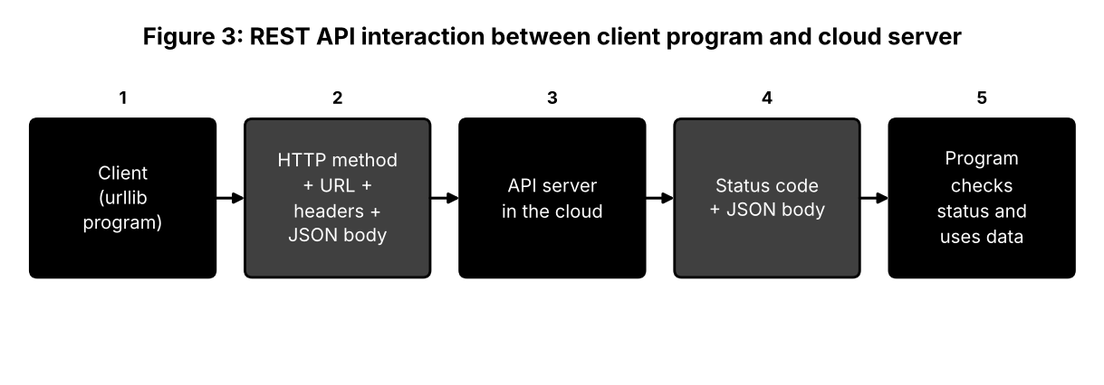
Part | Description | Example
Request line | Method + resource URL | GET /posts/1
Request headers | Metadata such as content type | Content-Type: application/json
Request body | Data sent when creating a resource (POST) | {'title': 'Cloud lab', 'body': 'API test', 'userId': 7}
Response status | Outcome of the request | 200 OK, 201 Created, 404 Not Found
Response body | Returned data in JSON | {'userId': 1, 'id': 1, 'title': ...}

- Client: the Python program built with the standard urllib library.
- API request: method, URL and optional body prepared by the client.
- Cloud/server: the hosted service that finds or creates the resource.
- API response: status plus JSON content that the client checks and uses.
- Programmatic access: a program can read and modify cloud data automatically using only HTTP, without a user interface.
Student B: implementation and evidence
The program uses only Python's standard library, so no installation is needed. It sends three requests: a GET for one item, a filtered GET and a POST that creates an item.
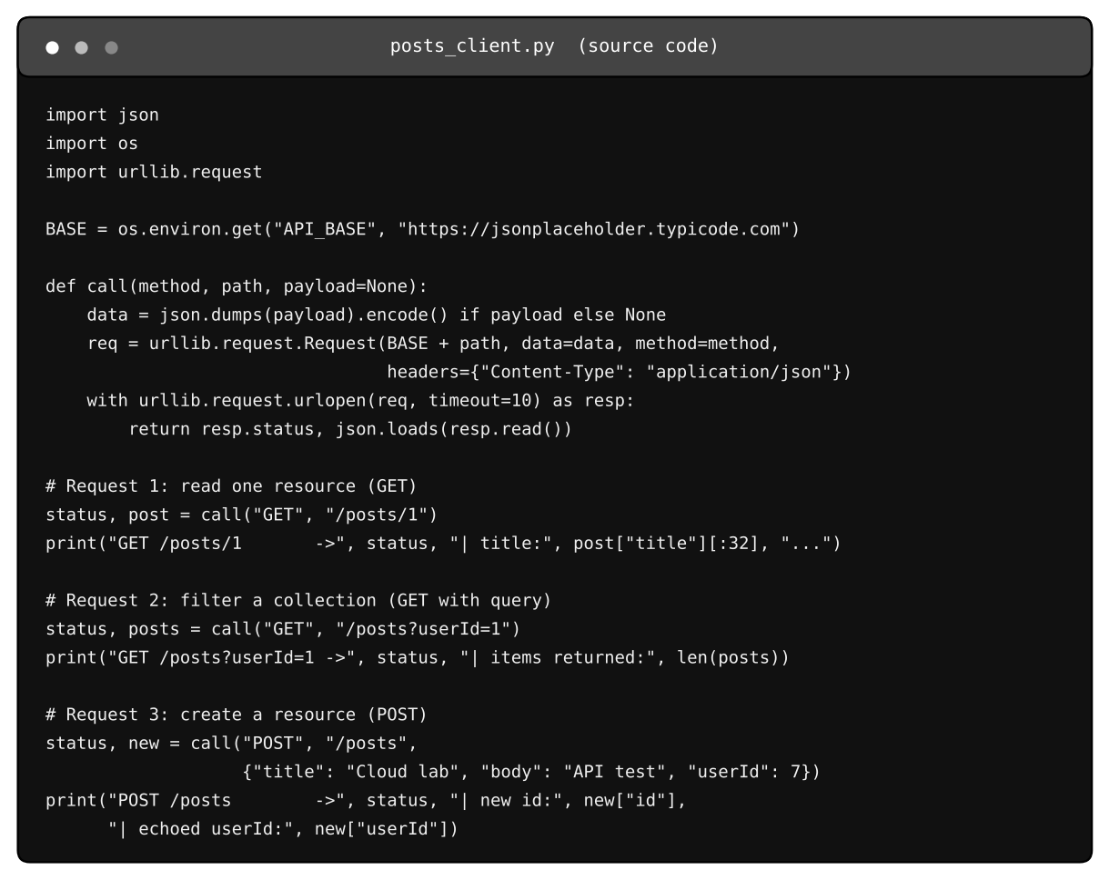
Figure 4: Program listing (posts_client.py) and its execution output below.
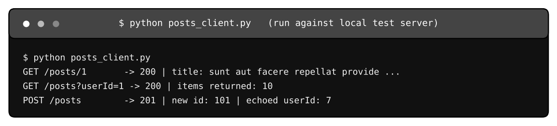
Execution output from a local test server that mimics the response format of the public API, because the build environment has no Internet. Re-run against the live API and attach your own screenshot.
Request | Input | Response observed | Meaning
GET /posts/1 | Resource id 1 | Status 200; one post with title | Resource found
GET /posts?userId=1 | Filter by user | Status 200; list of 10 posts | Query parameter filters a collection
POST /posts | JSON body with title, body, userId | Status 201; new id 101; fields echoed | Resource created

Analysis: status codes were the main evidence of success (200 for reads, 201 for creation); the same endpoint ('/posts') handles reading and creating depending on the method; and the server returned the identifier of the new record. The public test service does not actually store the new record, so a later GET for id 101 would not find it, a reminder that API behaviour must be read from its documentation.
Joint analysis: benefit when many users and applications communicate automatically
- Automation: thousands of programs can call the same API without manual steps.
- Standardisation: HTTP and JSON work with any language and platform.
- Scalability: stateless requests can be spread over many servers behind a load balancer.
- Control: API keys, quotas and throttling manage and protect usage.
- Loose coupling: the provider can change its internal systems without breaking clients if the interface is unchanged.
- Integration: different services (payment, maps, storage) are combined into one application.
Question 4: Cloud Security and Network Access (7 Marks)
Scenario: Study authentication, authorization, secure communication, threats and mitigations in cloud access.
Shared group work
Cloud access is open to the Internet by design, so every layer between the user and the data must be protected. The group used the idea of defence in depth: if one layer fails, others still protect the resource.
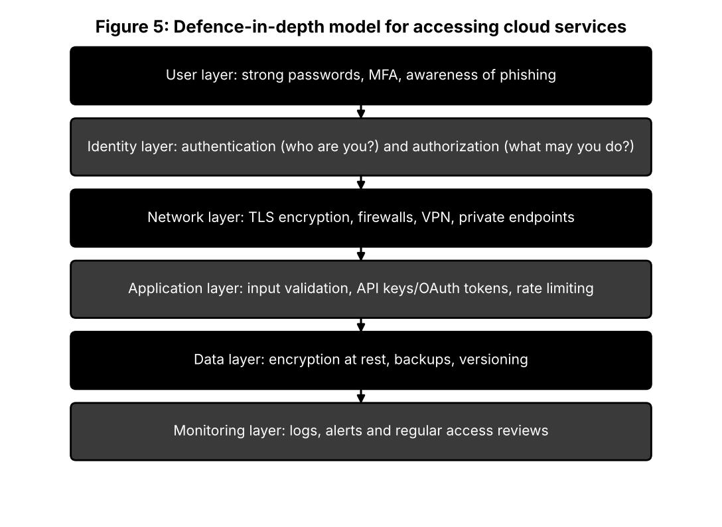
Student B: security design
Consideration | Why it matters | Example measure
Identity verification | Only genuine users should enter | Password + one-time code (MFA)
Authorization | Users must not exceed their role | IAM roles, least privilege
Secure communication | Prevents eavesdropping and tampering | HTTPS/TLS, VPN
Data protection | Limits damage if storage is exposed | Encryption at rest, backups, versioning
Monitoring | Detects misuse early | Access logs and alerts

Authentication confirms the identity of the person or program; authorization decides which resources and actions that identity may use. Secure communication ensures that the credentials and data cannot be read or modified while travelling across the network.
Secure access flow: User → Authentication (login + MFA) → Network (HTTPS/TLS tunnel) → Cloud Service (API gateway or application) → Authorization (policy check on role) → Resource (file or record). Possible points of attack: the user (phishing), the login step (password guessing), the network (interception on public Wi-Fi), the service (misconfiguration, vulnerable code), the authorization step (excess privileges) and the resource (exposed public bucket).
Student A: security investigation
Scenario investigated: an S3 bucket used for course files, first with public access and a wide policy, then with 'Block public access' and a least-privilege policy. The scenario was examined conceptually and through the settings pages without uploading sensitive data.
Threat | Where it occurs | Mitigation | Effect if ignored
Phishing | User | Training, MFA | Stolen credentials
Brute-force login | Authentication | Lockout, rate limits, strong passwords | Account takeover
Man-in-the-middle | Network | TLS certificates, VPN | Data read or changed in transit
Public bucket / open link | Cloud service | Block public access, policy review | Data leak
Over-privileged account | Authorization | Least privilege, role reviews | Accidental or malicious deletion
Leaked access key in code | Application | Secrets manager, key rotation | Unauthorised API use and bills

Evidence slot: attach your own original screenshot of the authentication (MFA) setup and the bucket's public-access settings.
Effect on users: poor practices can expose personal information, cause data loss or ransom demands, produce unexpected charges (for example from misused keys) and damage trust in the organisation.
Joint evaluation
A local application is usually protected by the building, the local network and the user's computer login. A cloud application is reachable by anyone on the Internet, so additional measures are necessary: multi-factor authentication, encryption of all traffic, strict permissions with regular review, protection against automated attacks (rate limits, firewalls), centralised logging and alerting, secure storage of keys and tokens, and continuous configuration checks. Users must also understand the shared-responsibility model: the provider secures the data centre, while the customer secures accounts and settings.
Question 5: Collaboration Using Cloud-Based Services (6 Marks)
Scenario: Create a shared workspace, configure permissions, perform collaborative activities and record observations.
Shared group work
The pair used Microsoft OneDrive with Word for the web. Student B created a shared folder 'Cloud_Assignment_Team' and a document inside it. Student A was added as an editor, a faculty mentor as a commenter and a lab assistant as a viewer.
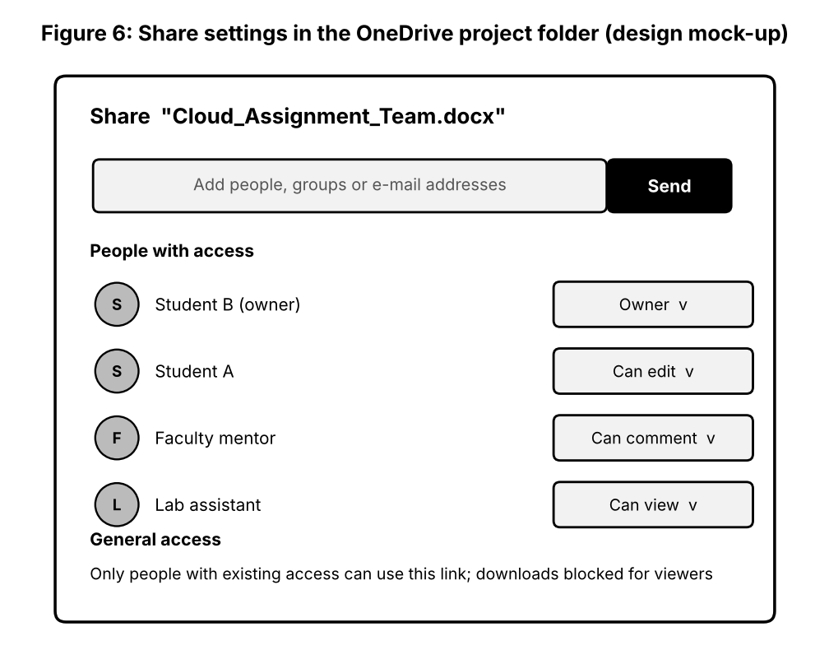
Student A: collaboration design
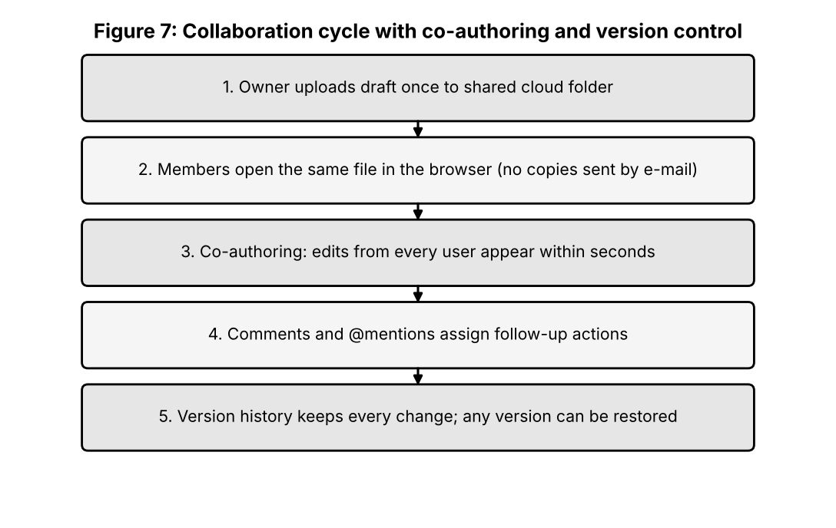
Topic | Explanation for this workspace
Sharing | The folder, not individual files, is shared, so new files follow the same rules.
Concurrent access | Word for the web allows co-authoring; each user's cursor and edits appear within seconds.
Version control | Version history stores earlier states with author and time and allows restore.
Permission management | Roles: owner, editor, commenter, viewer; reviewed before submission and removed afterwards.

User | Role | Reason for permission
Student B | Owner | Creates structure and controls sharing
Student A | Can edit | Writes and revises content
Faculty mentor | Can comment | Guides without altering the text
Lab assistant | Can view | Checks progress only; download blocked

Student B: collaborative implementation
- Activity 1: Student A and Student B co-authored the report, working on different headings at the same time.
- Activity 2: used comments with @mentions to assign a correction, and resolved it after the edit.
- Permission demonstration: changed the lab assistant from edit to view and confirmed the editing buttons disappeared for that user.
- Observation: changes by one user appeared on the other's screen within a few seconds, with coloured cursors showing who was typing.
Evidence slot: attach your own original screenshot of co-authoring in Word for the web, the sharing settings and the version history.
Issue identified: a comment thread was resolved by mistake before the change was made. Solution: agree that only the person who raised a comment may close it, and use version history to restore the missing text.
Cross-understanding answers
Student B: with cloud collaboration, everyone works on the same file reached by a link, so there is no need to send attachments or merge versions; changes are saved centrally, the latest version is always known, and mailbox and storage are not filled with copies.
Student A: with incorrect permissions, unauthorised persons may read private content, editors may delete or overwrite work, a shared link may spread outside the group, evaluators may be unable to comment, and responsibility for a change becomes unclear. The result can be data leakage, loss of work and academic integrity problems.
Question 6: Integrated Cloud Access and Collaboration Mini Investigation (7 Marks)
Scenario: Scenario selected: Cloud-Based Assignment Submission and Evaluation.
Student A: system design
- Problem: paper and e-mail submission cause lost files, late-submission disputes, unequal feedback and slow marking.
- Users: students, subject faculty, department coordinator, lab assistant.
- Access methods: web portal (primary), mobile browser or app for status, API for linking with the college record system.
- Cloud services: identity service, object storage for submissions, database for marks and status, notification service, document-checking service.
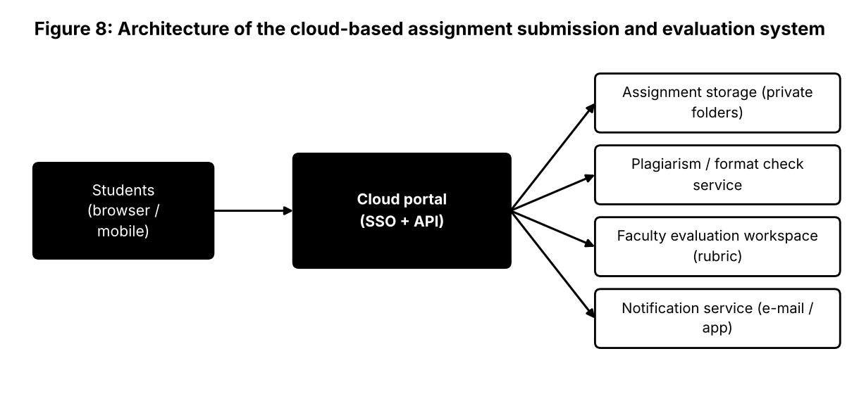
Function | How users access | How users collaborate
Submit | Students log in with college account and upload a file before the deadline | Team assignments: group members co-edit before one submission
Evaluate | Faculty open the submission in the browser | Rubric comments added directly on the file; second evaluator can view
Feedback | Students see marks and comments in the portal | Discussion through comment threads
Monitor | Coordinator views status reports through the portal | Reports shared with faculty

Student B: prototype, testing and evaluation
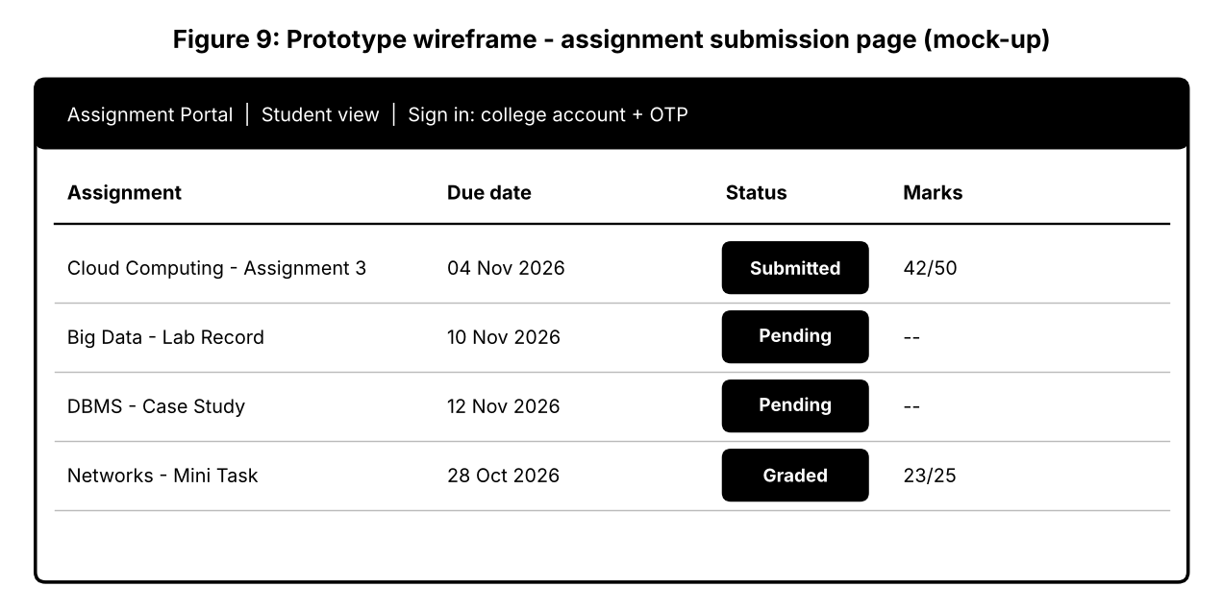
Prototype: a shared cloud folder structure (one private sub-folder per student, one evaluation folder for faculty) and an online form for submissions, supported by the wireframe above. Cloud access demonstrated: login with college account and one-time code. Collaboration demonstrated: faculty comments on a submitted document that the student can read.
Evidence slot: attach your own original screenshot of the submission folder and the faculty comment on a document.
Scenario | Test | Expected | Observed (record)
User scenario 1: student | Uploads PDF before deadline from mobile | Status 'Submitted'; time stamp stored | Screenshot and time
User scenario 2: faculty | Opens submission, adds rubric comment | Student sees comment; other students cannot open the file | Screenshot of permission result

Results analysis: the prototype shows that central storage removes lost files and that time stamps settle deadline disputes. Limitations: manual marks entry in the prototype, dependence on Internet during the deadline hour, no automatic plagiarism check. Improvements: automatic reminders, similarity-check service, backup copies in a second region, and integration with the college's mark database through an API.
Joint evaluation
Cloud access means submission is possible anywhere and at any time before the deadline, while collaboration allows evaluators and students to exchange feedback on the same document. Together they shorten the evaluation cycle, remove manual collection and returning of files, provide transparent records and allow the coordinator to monitor progress for the whole class.
Question 7: Day-4 Design Challenge: Cloud-Based Collaborative Solution (10 Marks)
Scenario: Joint design of a cloud-based college placement coordination solution.
Stage 1: independent proposals (retained as evidence)
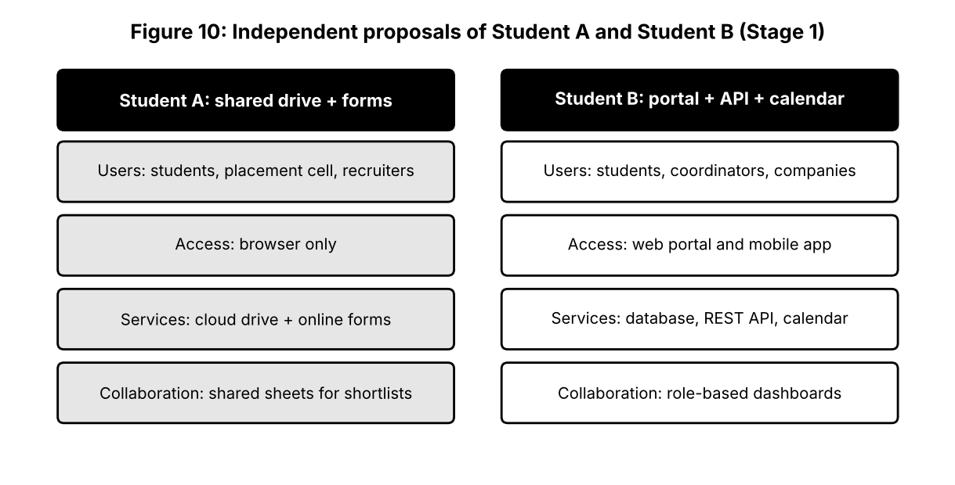
Common problem: placement information, student profiles, company schedules and results are handled in separate spreadsheets and messages, causing missed interviews and duplicated work.
Stage 2: design comparison record
Point | Student A | Student B | Outcome
Where they agree | Cloud storage for profiles | Cloud storage for profiles | Retain
Where they differ | Browser only; online forms | Portal, mobile app, API | Portal plus mobile app
Strength of A | Simple and quick to set up |  | Use forms for initial data collection
Strength of B |  | Role-based dashboards and calendar | Adopt dashboards and calendar
Weakness of A | Shared sheets expose all student data to all editors |  | Replace by role-based access
Weakness of B |  | More complex and costly to build | Build in phases
Missing | Notifications; audit log | Offline access to schedule | Add notifications and logs

Stage 3: joint final design
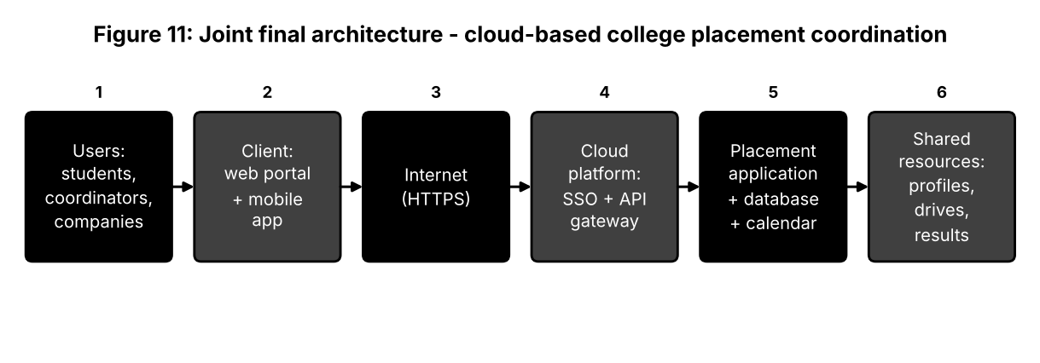
Element | Final decision
Problem | Uncoordinated, error-prone placement management
Users | Students, placement coordinators, company recruiters, faculty
Cloud access method | Web portal and mobile app; API to the college information system
Network requirements | Internet over HTTPS; low-bandwidth friendly pages for hostel networks
Cloud platform / service | Managed single sign-on, API gateway, managed database, object storage, calendar and notification services
Web application / API | Portal for profiles, drives and results; REST API for sharing eligible student lists with companies
Collaboration mechanism | Shared drive calendar, role-based dashboards, comments on shortlists
Authentication / security | SSO with MFA, role-based access, encryption, audit logs; companies see only consented data
Data / resource sharing | Students edit own profile; coordinators manage drives; recruiters see shortlisted candidates only
Workflow | Student registers → profile verified → drive announced → eligible students notified → applications → shortlist shared with company → results published

Stage 4: validation
Student A (technical validation): the web portal was chosen because it works on every device without installation; the managed platform scales during the busy placement season and provides built-in security; the API gateway allows controlled data exchange with companies; the separation of access, application and data layers simplifies security and maintenance.
Test case | Users / condition | Expected | Observed (record)
T1 Student profile update | Student on mobile network | Change saved, visible to coordinator | Result and screenshot
T2 Recruiter access | Recruiter logs in | Sees only shortlisted students | Permission screenshot
T3 Unauthorised access | Student opens another student's profile | Access denied | Message screenshot
T4 Drive notification | Coordinator announces drive | Eligible students notified quickly | Time to notification
T5 Peak load | Many students apply together | Portal stays responsive | Response time

Evidence slot: attach your own original screenshot of the tested workflows for T1 to T5.
Student B compared expected and observed behaviour for each test; differences (for example slow notification) are listed with corrective actions.
Stage 5: cross-defence
Student A (evidence supporting the design): test T2 and T3 show that role-based access protects private data; T1 and T4 show that updates and notifications reach users quickly; T5 shows acceptable behaviour under load.
Student B (reason for the chosen approach): placement involves many parties in different places who need current information and different levels of access. Cloud access removes location and device barriers, while cloud collaboration gives all parties one trusted set of data and removes repeated manual communication.
Stage 6: joint evaluation
Area | Evaluation
Benefits | Single source of information, fewer missed interviews, transparent records, anywhere access
Access limitations | Needs reliable Internet; students in poor-network areas may be disadvantaged
Collaboration benefits | Shared calendars, comments on shortlists, live status
Security risks | Leak of student data, impersonation, misuse of recruiter accounts
Scalability | Managed services scale for seasonal peaks
Improvements | Offline schedule cache, automatic résumé checks, analytics dashboards
Unsuitable when | Strict rules forbid storing student data outside the institution's own servers, or connectivity is not available

Final question: factors for a system designer
- Purpose and users: who needs the system, from where, on which devices.
- Connectivity: expected network quality and the need for offline access.
- Security and privacy: data sensitivity, identity, regulations and consent.
- Collaboration needs: number of simultaneous users and level of control required.
- Performance and scalability: peak loads and growth.
- Cost: subscription or usage cost compared with the benefit.
- Reliability and support: provider's availability guarantees and backup.
- Integration and portability: APIs, standard formats and ability to move data away.
Contribution Record
Question | Student A: primary contribution | Student B: primary contribution | Joint work
Q1 | Access-method table and architecture | Console, CLI and mobile demonstration; limitation | Selection of S3
Q2 | AWS component analysis and request mapping | Zoho Writer demonstration and evidence | Platform comparison and local-versus-cloud table
Q3 | API structure and flow diagram | urllib program, execution and analysis | API selection; benefit analysis
Q4 | Threat investigation and mitigation table | Security design and secure-access flow | Extra measures for cloud
Q5 | Collaboration design and roles | Co-authoring activities, issue and solution | Workspace creation
Q6 | System design and architecture | Prototype and two user tests | Efficiency evaluation
Q7 | Technical validation and Proposal A | Test cases, experimental validation and Proposal B | Comparison, joint design, evaluation

Viva Preparation: Transfer Questions
Modified condition | Expected reasoning
Internet connectivity becomes unreliable | Requests time out and uploads fail; use retries, resumable uploads, offline copies and a secondary connection.
Everyone is given edit permission on a shared document | Accidental deletions, leakage of content, unclear authorship; apply roles and review sharing settings.
The API is unavailable | Handle exceptions, show a clear message, retry later with back-off, use cached data and log the event.
A user is authenticated but lacks permission | The service returns an access-denied response (403), records the attempt and does not reveal the resource.

Implementation Evidence Chain and Submission Note
Evidence item | Provided in this document | To be added by students
Access methods | Comparison table, Figure 1, steps followed | Console, CLI and mobile screenshots
Platforms and application | AWS and Zoho comparison; request mapping | Zoho Writer screenshots
Web API | Code listing, tests and output of a local test run | Output of the program run against the live API
Security | Defence-in-depth figure, threat and mitigation table | MFA and bucket-setting screenshots
Collaboration | Sharing mock-up and workflow | Real sharing and version-history screenshots
Mini-project and Day-4 design | Architecture, wireframes, test plans | Observed results and screenshots

Note: figures labelled 'mock-up' or 'wireframe' are design illustrations, not screenshots of a live system. Original screenshots from the students' own accounts must be attached where an evidence slot is shown.

