**Display Available Products:**

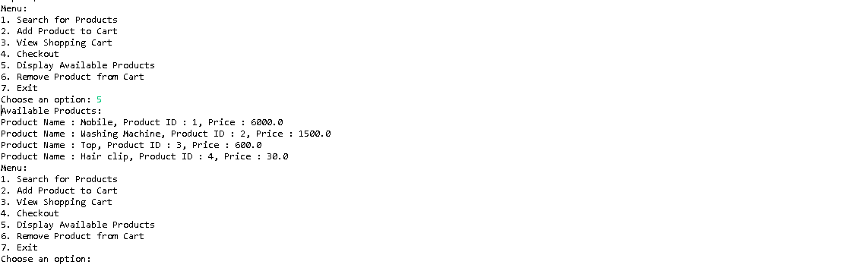

**Search for Products:**

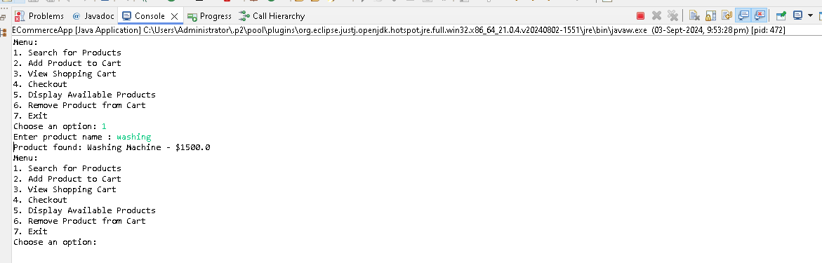

**Add Product to Cart:  
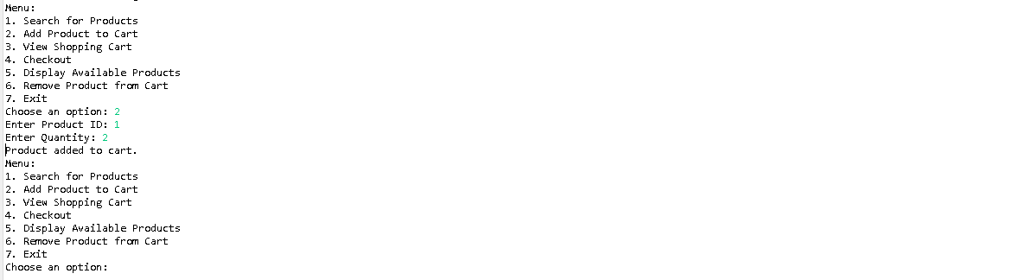**

**Add 2nd Product to Cart:**

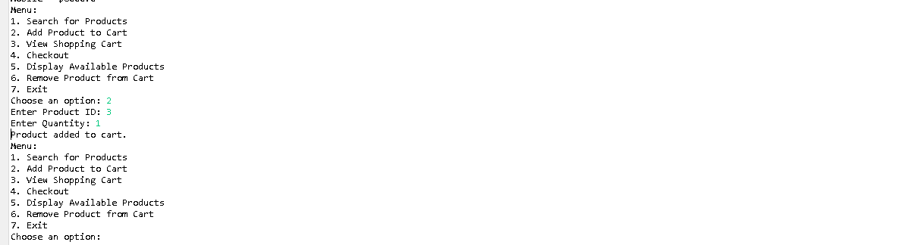

**View Shopping Cart :**

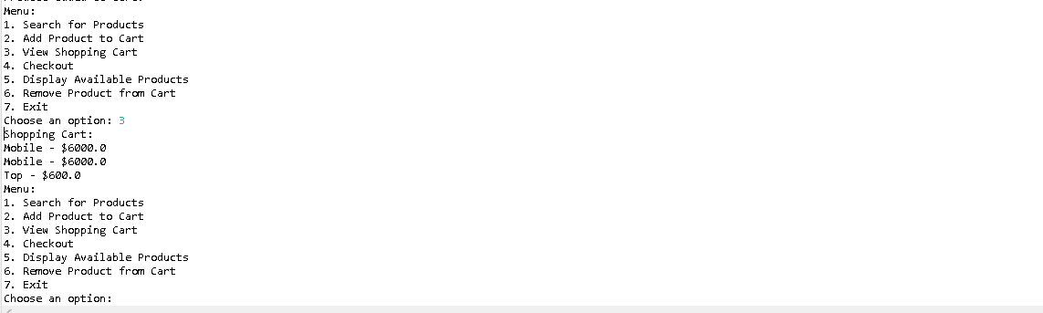

**Remove Product and View Cart :  
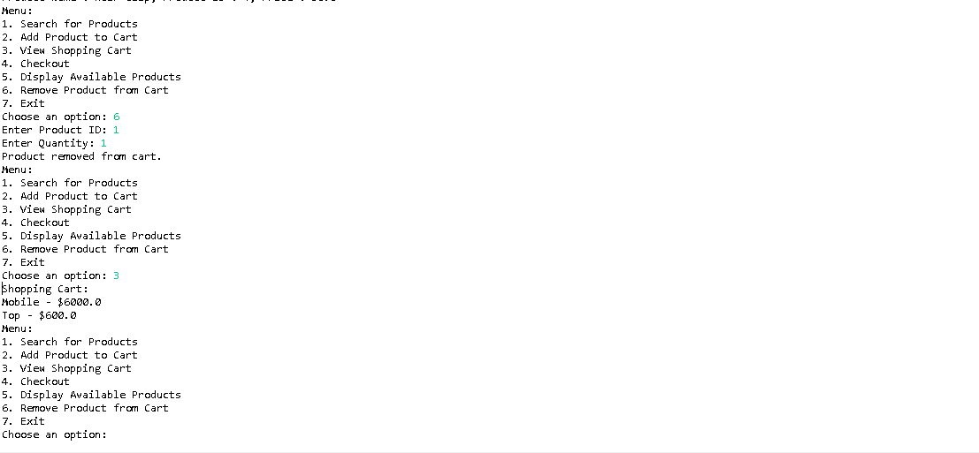**

**Checkout:**

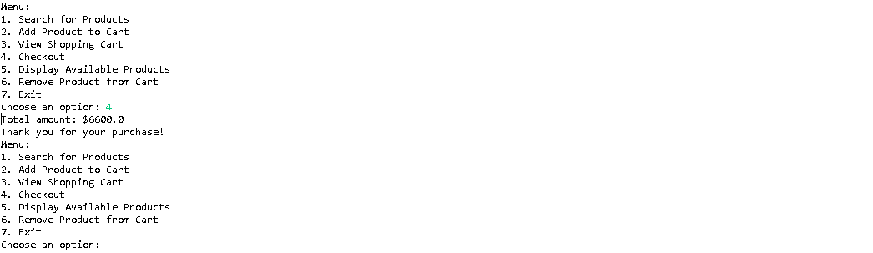

**Exit:**

