Cycle 5

Exp 1

import calendar
year=int(input("enter a year to check:"))
if calendar.isleap(year):
print(f"{year} is a leap year")
else:
print(f"{year} is not a leap year")

Output

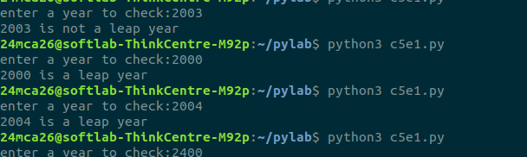

Exp 2

import datetime
now=datetime.datetime.now()
print("a)current date and time:",now)
print("b)current year:",now.year)
print("c)month of the year:",now.month)
print("d)week number of the year: ",now.isocalendar()[1])
print("e)weekday Number:",now.weekday())
print("f)Day of the year:",now.timetuple().tm_yday)
print("g)Day of the month:",now.day)
print("h)Day of week:",now.isoweekday())

output

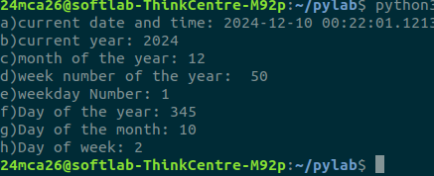

Exp 3

from datetime import date,timedelta
today=date.today()
yesterday=today-timedelta(days=1)
tomorrow=today+timedelta(days=1)
print("Yesterday:",yesterday)
print("Today",today)
print("Tomorrow",tomorrow)

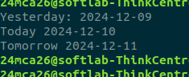

Exp4

from palindrome import is_palindrome

def longest_palindromic_substring(s):

longest = ""
for i in range(len(s)):
for j in range(i + 1, len(s) + 1):
substring = s[i:j]
if is_palindrome(substring) and len(substring) > len(longest):
longest = substring

return longest

input_string = input("Enter the string : ")
print(f"Longest Palindromic Substring: {longest_palindromic_substring(input_string)}")

output

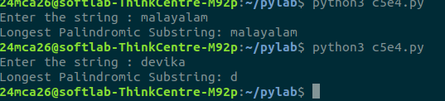

Exp 5

main.py

from Graphics.rectangle import *
from Graphics.circle import *
from Graphics.threeDGraphics.cuboid import *
from Graphics.threeDGraphics.sphere import *

print("Rectangle")
l=int(input("Enter the length:"))
b=int(input("Enter the breadth :"))
print("Area of rectangle:",RectArea(l,b))
print("Area of rectangle:",RectPerimeter(l,b))

print("Circle")
r=int(input("Enter the radius :"))
print("Circle Area:",CircleArea(r))
print("Circle Perimeter:",CirclePerimeter(r))

print("Cuboid")
l=int(input("Enter the length:"))
w=int(input("Enter the width :"))
h=int(input("Enter the height:"))
CuboidArea(l,w,h)
CuboidPerimeter(l,w,h)

print("Sphere")

circle.py

from math import pi

def CircleArea(r):
return (pi*r*r)

def CirclePerimeter(r):
return (2*pi*r)

rectangle.py

def RectArea(l,b):
return (l*b)

def RectPerimeter(l,b):
return (2*(l+b))

cuboid.py

def CuboidArea(l,w,h):
print("Area of cuboid:",(2*l*w)+(2*l*h)+(2*h*w))

def CuboidPerimeter(l,w,h):
print( "Perimeter of cuboid :",(4*(l+w+h)) )

sphere.py

from math import pi

def SphereArea(r):
return (4*pi*r*r)

def SpherePerimeter(r):
return ((4/3)*pi*(r**3))

output

