**CASCADING STYLE SHEET 3**

**Introduction to CSS3**

Cascading Style Sheets (CSS) is a style sheet language describing the **appearance** (formatting) of an HTML document like background images, font styles, and sizes. It is used; to decrease the amount of source code on a page allowing faster download speeds; to improve different web browser compatibility; to enable multiple pages to share the same formatting; an increased range of formatting options and quicker synchronized updating of multiple web pages.

**Cascading Style Sheets Syntax:**

· **Selector:** A selector is an HTML tag in which style will be applied. This could be any tag like <h1> or <table> etc.

· **Property:** A property is a type of attribute of HTML tag. Put simply, all the HTML attributes are converted into CSS properties. They could be *color* or *border* etc.

· **Value:** Values are assigned

**Selector {property: value ;}**

**Embedded CSS - The <style> Element:**

You can put your CSS rules into an HTML document using the **<style>** element. This tag is placed inside **<head>...</head>** tags. Rules defined using this syntax will be applied to all the elements available in the document. Here is the generic syntax:

**<head>**

**<style type="text/css" >**

**Style Rules**

**............**

**</style>**

**</head>**

**CSS selectors**

css selectors are used to find/select HTML elements based on their id,class,type.

**1.Element selectors/tag selectors**

<html>

<head>

<style>

p {

    text-align:center;

    color:red;

    font-size: 60px;

    font-family:Arial, Helvetica, sans-serif;

    }

</style>

</head>

<body>

    <p>good morning</p>

</body>

</html>

**2. Id selector's(#)**

This selectors is used for the style rule below will be applied to the HTML element with id="ID".

eg:

**#para1{**

**text-align:center;**

**color:blue;**

**}**

**<body>**

**<p>goodmorning</p>**

**<p id="para1">how are you </p>**

**</body>**

**3.Class selector's(.)**

In class selector's, all HTML elements with class=" " will be select, and it select the element with a specific class.

eg: **<head>**

**<style>**

**.center{**

**text-align:center;**

**color:green;**

**}**

**</style>**

**</head>**

**<body>**

**<p class="center">hello</p>**

**</body>**

**4. Grouping selectors(, ,)**

Grouping selectors means that we can group the selectors to minimize the code. In group selectors, seperate each element with a comma.

eg: **<head>**

**<style>**

**h1,h2,p{**

**text-align:center;**

**color:red;**

**}**

**</style>**

**</head>**

**<body>**

**<h1>hai</h1>**

**<h2>hello</h2>**

**<p>Good morning</p>**

**</body>**

**5.Descendant selector**

**div p{**

**}**

used to call all p elements of div, i.e, children, grandchildren and so on.

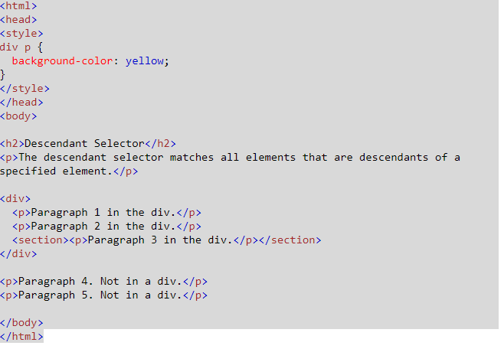

Output

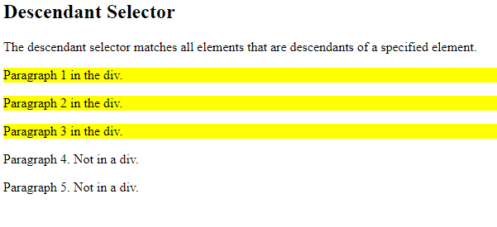

**General Sibling Selector (~)**

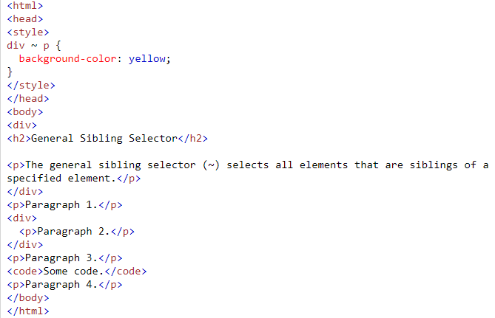

**Output**

