7153CEM - Big Data Analytics and Data Visualisation
7153CEM - Big Data Analytics and Data Visualisation

7153CEM - Big Data Analytics and Data Visualisation

Module Leader: Dr. Anup Pandey
Student Name: Devika Kaladevi
Student ID: 14329793
word count : 3000

Optimizing Efficiency of the Supply chain using
Pyspark and Tableau

ABSTRACT
The importance of optimizing Sales prediction in the supply chain is explored in this paper impacting benefit per order, sales performance, profit distribution across several sites, and the effect of delivery modes on profitability, the study analyses the supply chain dataset by aiming to predict the benefit per order based on the features. By using Apache Spark’s Machine learning and data analysis methods like regression modeling.

Contents
INTRODUCTION 2
BACKGROUND: 2
DATA SECTION 3
METHODOLOGY 4
EXPERIMENTAL SECTION 11
RESULT DISCUSSION 15
CONCLUSION 16
FUTURE WORKS 16
SOCIAL IMPACT 17
Appendix 18
References 24

INTRODUCTION

The methodology begins with data preparation, including the data loading in to Spark and ensuring data quality .The dataset for this assignment from the Kaggle website dataset that is frequently used to examine that how organizations quickly changing world of global trade. This paper is a methodical investigation of a large-scale supply chain dataset, carefully breaking down the various aspects that affect benefit per order, sales results, and profit distribution in various geographic areas. Businesses are increasingly using data-driven strategies to negotiate the intricacies of supply chain dynamics as they pursue sustainability and competitiveness head-on.

using Tableau to Create Visualization that goes deeper into the data. Tableau is an effective application for data visualization that produces interactive charts and dashboards.

Using Pyspark enables to process the large datasets to analyze the data using the Pyspark library to support the effectiveness and efficiency of supply chain operations by delving deeply into the details of this information.

Using Google Collab, Machine learning algorithms has been implemented with linear Regression, Logistic Regression, Random forest and naive Bayes. These models are constructed using sparks pipeline which includes VectorAssesmbler and regression model

This paper is a methodical investigation of a large-scale supply chain dataset, carefully breaking down the various aspects that affect benefit per order, sales results, and profit distribution. We set out to discover the hidden patterns and interdependencies that support the effectiveness and efficiency of supply chain operations by delving deeply into the details of this information.

We cover a wide range of characteristics, including sales information, location markers, and shipping measures. to extract significant knowledge that provides stakeholders with the ability to make well-informed decisions. Our goal is to use the supply chain dynamics by applying and investigating, which will change toward increased operational efficiency.

BACKGROUND:

The effectiveness of supply chain management, which encompasses a range of tasks from locating raw materials to shipping completed goods to end users, is crucial for organizational success in the fast-paced corporate world of today.
Evaluating sales, price, product, and customer satisfaction data will help you understand customer behaviour, market trends, and expansion opportunities. In terms of real-time data analysis for optimization of operations, the digital transformation was able to stay competitive in terms of supply.

Several procedures related to delivery, customer service, and expectations are included in supply chain management. Understanding the benefits associated with each order, such as location, shipping time, and sales per customer, allows organizations to use machine learning models to optimize operations. Relevant data trends can be extracted for use in business decision-making.

DATA SECTION

The dataset is from Kaggle (reference attached with URL), dataset contains 53 columns and 180520 rows attributes, which include Type , Days of shipping , Benefit per order, Sales per customer, Delivery status, Sales per customer, Category id, Customer country, and many more .The analysis was carried out using a supply chain dataset that had been generated by Dataco Global. This dataset serves a purpose in machine learning techniques and Big data analysis which has distribute different products globally.

Figure 1: Dataset Screenshot of Csv file

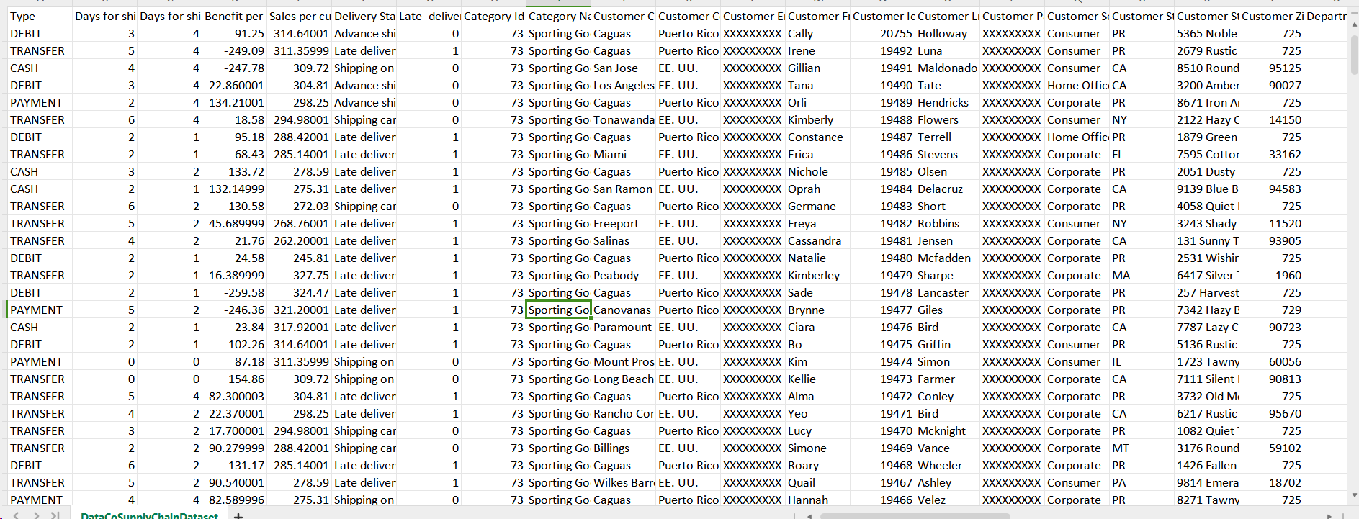

Some of the data types presented in the dataset are represented in table below ,And so, on Attribute and types can be found in the dataset with the csv file given in (reference url)
TABLE I. DATASET FEATURES

ATTRIBUTES |  | TYPES
TYPE |  | String
Days for shipping (real) |  | Integer
Daysfor shipment (scheduled) |  | Integer
Benefit per order |  | Double
Sales per customer |  | Double
Delivery Status |  | String
Late_delivery_risk |  | Integer
Category Id | Integer
Category Name | String
Customer City | String
Customer Country | String
Customer Email | String
Customer Fname | String
Customer Id | Integer
Customer Lname | String
Customer Password | String
Customer Segment | String

METHODOLOGY

Implementation, the methodology adopted in this project is structured and methodical, designed to extract actionable insights from the dataset while ensuring robust model performance. Beginning with exploratory data analysis (EDA), the initial step involved delving into the dataset's nuances to comprehend its underlying patterns and distributions. This informed subsequent decisions regarding feature selection and engineering.

HADOOP INSTALLATION:
Figure 2: Downloaded virtual machine, ubuntu machine installation, Hadoop installation.



figure 3: Below shows the Hadoop version.

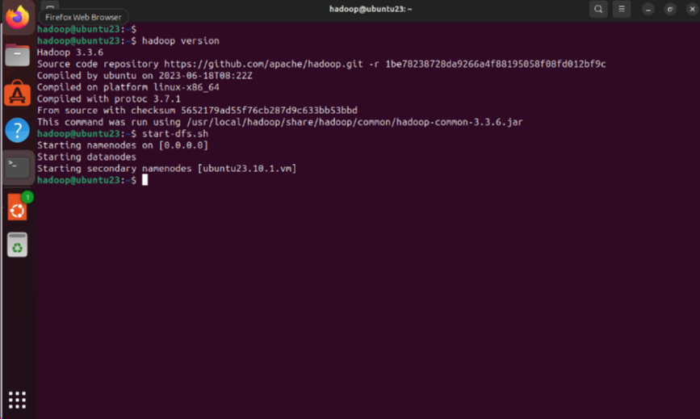

PYSPARK INSTALLATION:

pip install pyspark installing pyspark, which is a Python API for Apache Spark, a popular distributed computing system for big data processing. Once we install pyspark, the machine is ready to write code for spark application using Python. Once we are done with pyspark installation, checking the pyspark version.

Figure 4: Below figure show the pyspark Version.

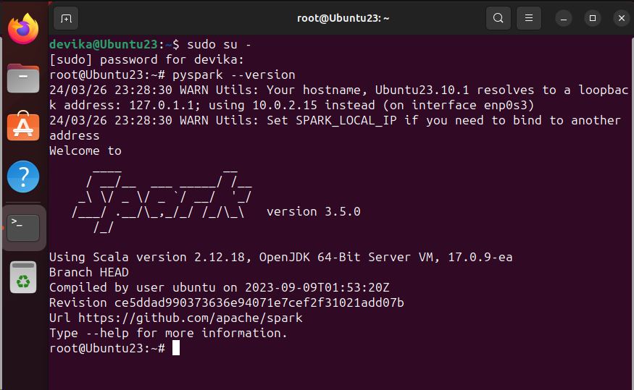
TABLEAU INSTALLATION:
Figure 5: Tableau installation
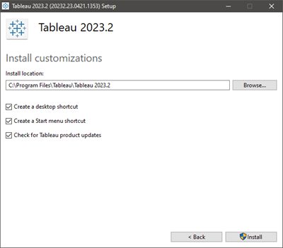

Figure 6 : Tableau registration
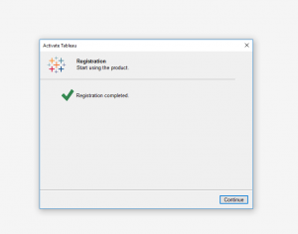

Figure 7 :Snippet of dataset
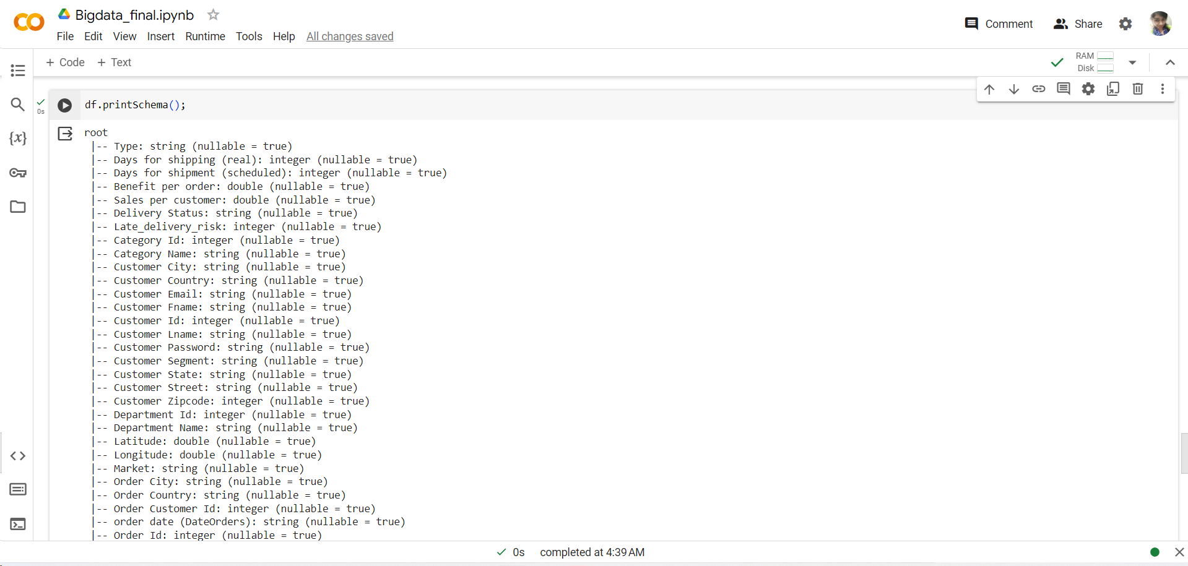

PRE-PROCESSING:

In Pre-Processing stage, The necessary libraries for working with Spark and data analysis are imported. Spark session is created with programming spark with dataset and load the data by reading the Csv file DataCosupplyChain.csv once loading the dataset get in info of the dataset. Check whether the data is having any null value in each column. This is done by converting the Spark data to pandas’ data frame and looping through each column to print the count of null values.

Figure 8: Snippet of the reading the csv file

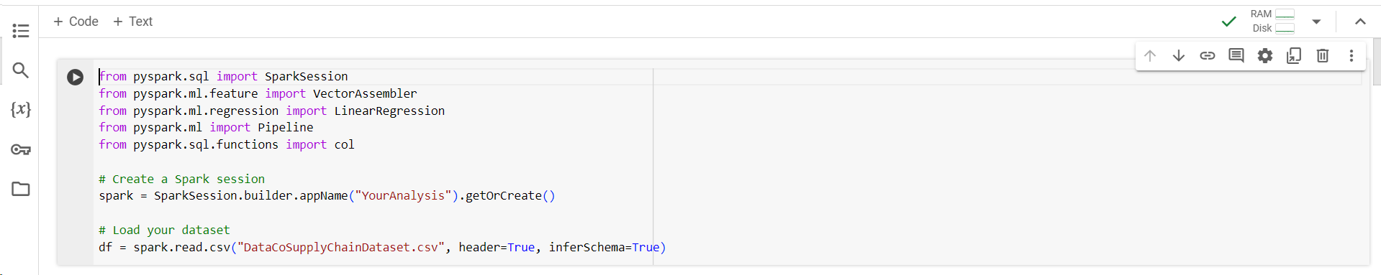

Figure 9: snippet Check null values in Data set

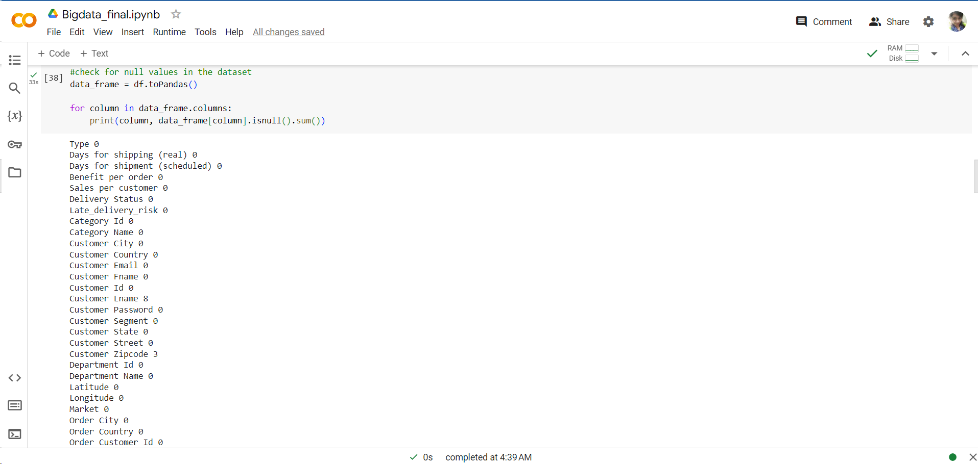
Figure10
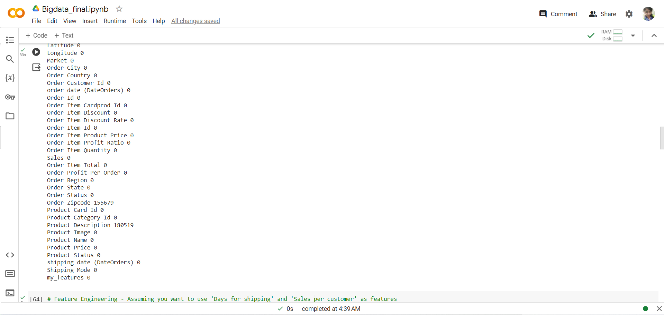

Checking the null value to check or ensure the quality of dataset

MACHINE LEARNING MODEL

The dataset is ready for modeling. Key factors that were discovered to have a significant effect on the prediction of "Benefit per order" including "Days for shipping (real)" and "Sales per customer." To generate a single feature vector, these features have been modified and integrated using Apache Spark's VectorAssembler. Final_data is used to select the ‘Days of shipping(real), sales per customer, Benefit per order.
Here using Machine learning model regression model we are using Linear Regression , Logistic regression , Random forest ,Naïve bayes models to predict the Benefit per order .
Figure11:feature engineering
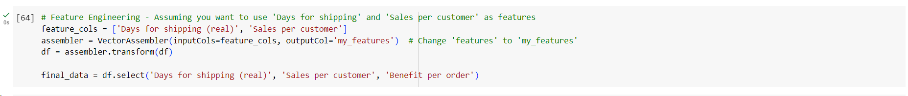
The next step in any machine learning project is to split the data into two sets: training and testing sets. The randomSplit() method from PySpark is used to split the input data frame final_data into two data frames: train and test. The split is done by specifying the percentages of the data to be allocated to each set.

Figure12: Splitting the train and test data

Separating the dataset into training and testing sets allowed for an A pipeline that combined linear regression modeling and feature assembly into an efficient workflow to streamline the modeling process. This enabled it to be possible to train and evaluate the models effectively and ensured the results' scalability and reliability. once the model is trained Make predictions on the test data and the model, the evaluator uses the regression evaluator for Benefit per order and metric as RMSE
To evaluate the trained model's predicted reliability and precision, relevant metrics were utilized, such as Root Mean Squared Error (RMSE). This detailed approach ensured that data analysis occurred systematically and generated insights that could be utilized to optimize supply chain management.
These methodologies were employed to enhance the performance and accuracy of the prediction models.
Linear Regression
Statistical and Machine learning technique relationship between the independent variables and the dependent variable. The linear regression model archives an accuracy of Root Mean Squared Error (RMSE): 101.3405225136131
Figure13: Creating the linear Regression

Figure 14 : getting the RMSE value
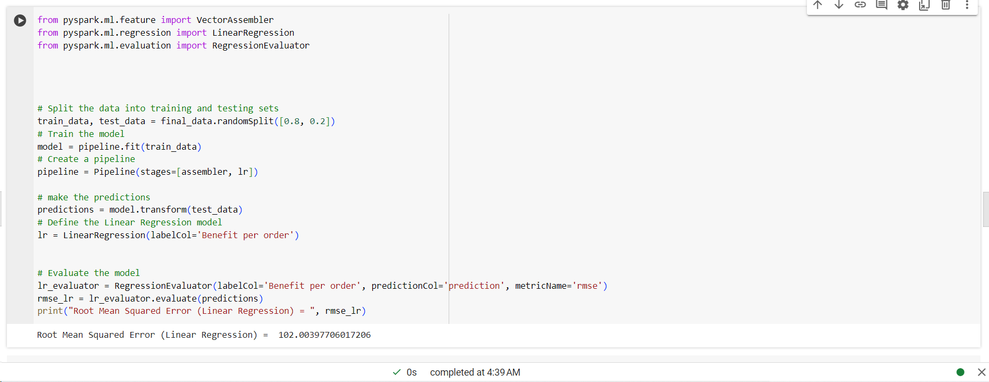

Random Forest

learning technique used in both classification and regression tasks node of the tree, instead of using all features with Root Mean Squared Error (Random Forest Regression) = 102.2848121383135

figure 15 : Random forest
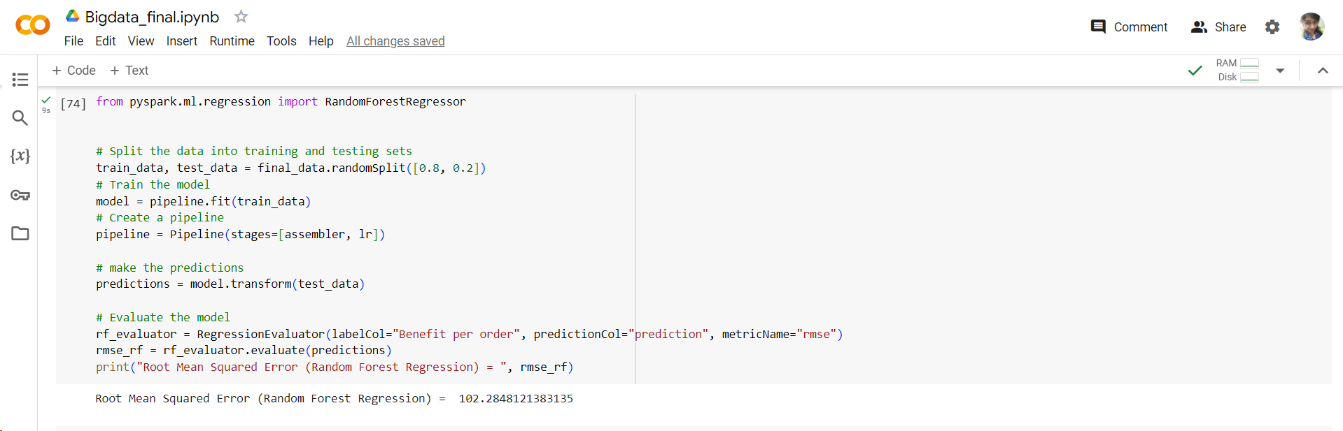

Navie Bayes

Features are completely independent, but it simplifies the calculations but here the value predicted is attached in the screenshot.

Figure 16:Navie Bayes
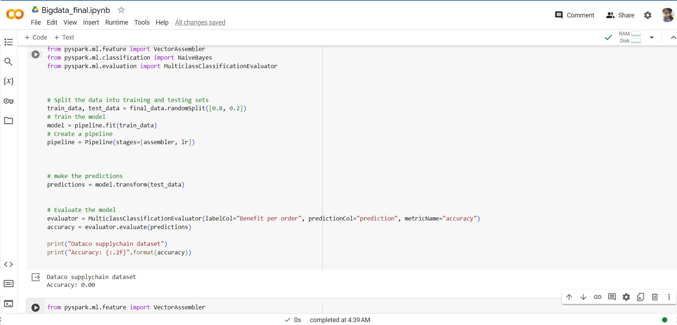

Figure 17: Already trained and evaluated various models, storing their RMSE values
for each model

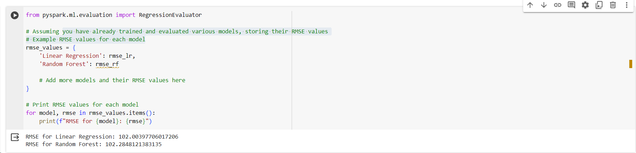

EXPERIMENTAL SECTION

Explorative analysis and visualisations:

Experimental methodology aims to evaluate the effectiveness of utilizing sophisticated data analytics techniques, particularly linear regression modeling, in forecasting the benefit per order in the context of a supply chain. With the dataset, some visualizations created below for the supply chain

Figure :18 sales vs days of shipping
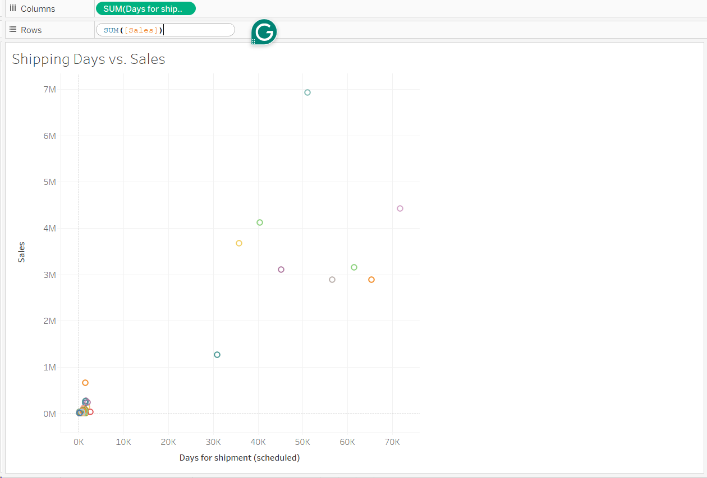

Here this graph created in Tableau, compares the data between sales and shipping over the period. the graph is structured with sales data represted the sales figure corresponding to the specific shipping , we are Taking up the Days of shipping as column and rows as sales .

Figure 19:shows the profit distrubiton per region
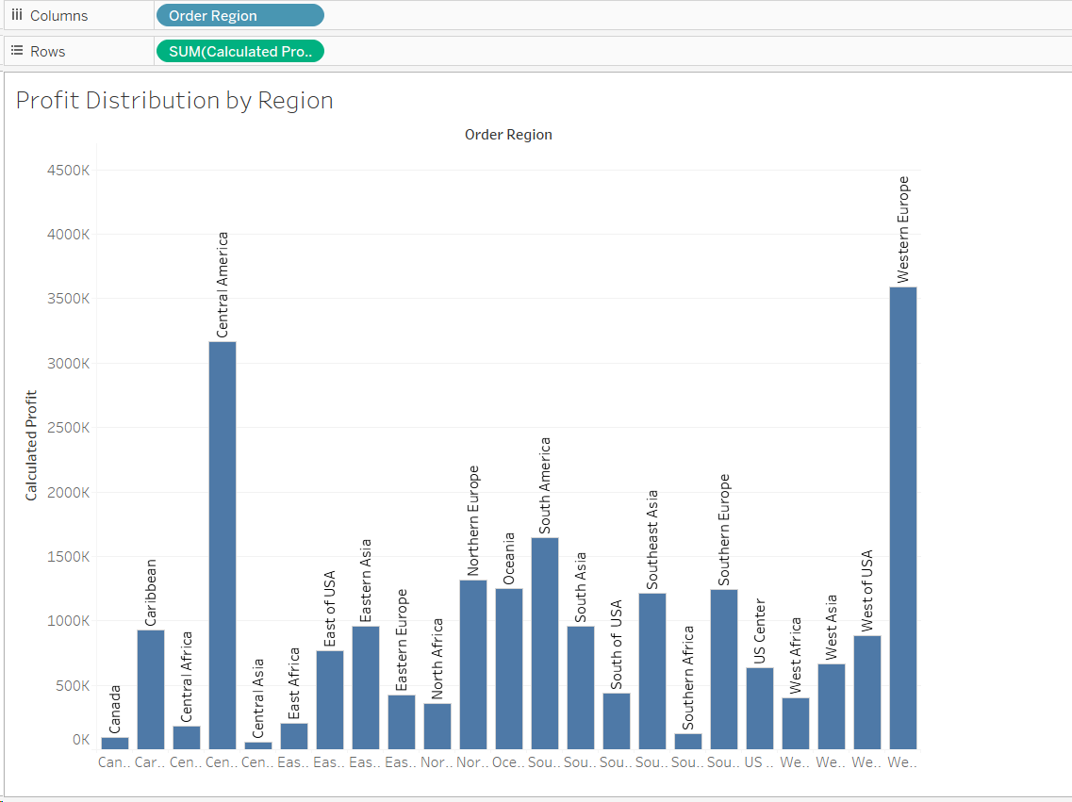

Graph generated for profit by region and order region ,sum of calculated for each order region, the mark are labeled by order /region. The data is filtered on product name , which keeps 118 of 118 members.

Figure 20: Shipping mode and sum of calculated profit.

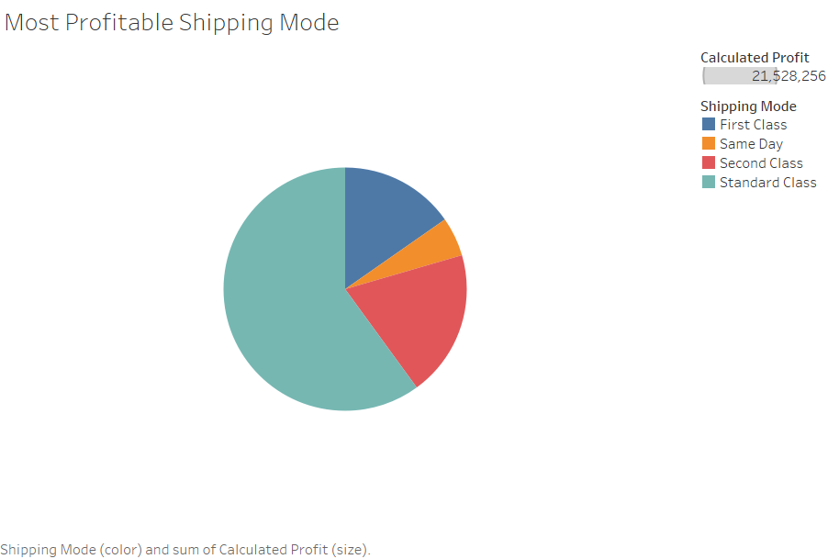

Figure 21 : Sales performance by market

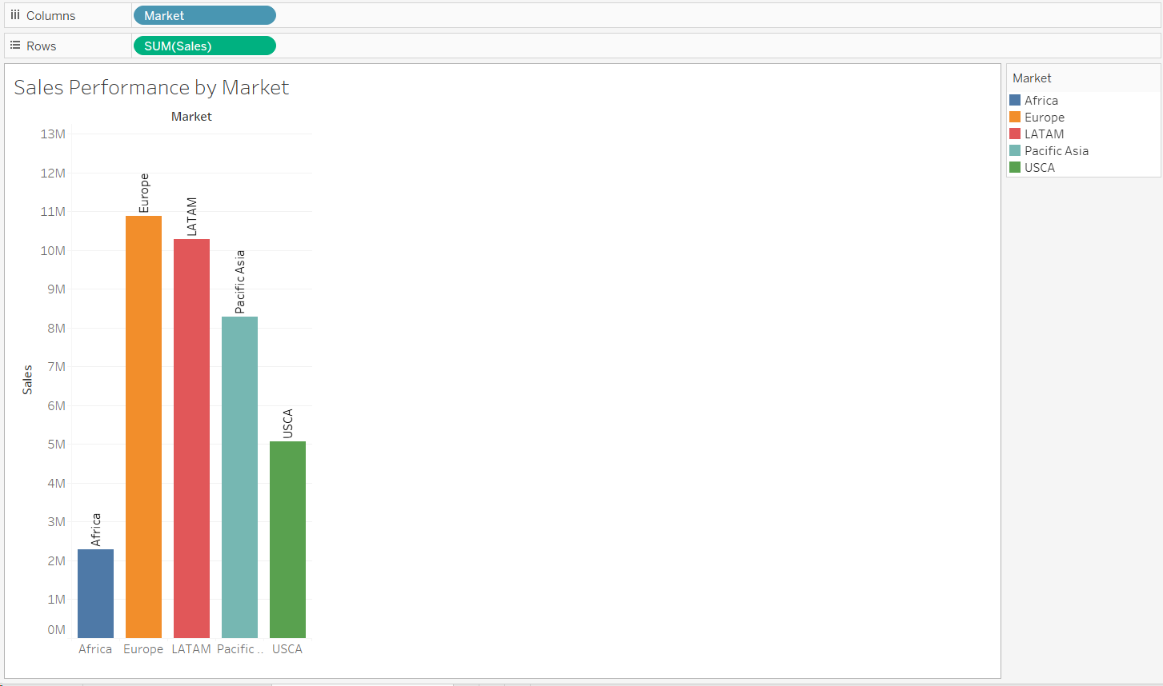

In the past, discussions how important data analytics is for supply chain optimization and improving consumer happiness. Companies can reveal hidden trends and extract useful information to support their strategic and decision making.
This research combines theoretical foundations with real-world application, making it a comprehensive effort to push supply chain analytics boundaries. The core of this operational paradigm is the requirement that companies implement data-driven approaches and use advanced analytics to manage the intricacies of supply chain management.
Academic discussions have emphasized how important data analytics is for supply chain optimization and improving consumer happiness. Research has demonstrated the revolutionary possibilities of big data analytics, providing new perspectives on consumer behavior, industry trends, and operational bottlenecks. Through the utilization of extensive data repositories, companies can reveal hidden trends and extract useful information to support their strategic decision-making.

There are priceless pearls of knowledge hidden in this informational treasure mine that provide insights into the complex interactions between different parts of the supply chain ecosystem. however, this study takes a unique approach by using sophisticated data analysis methods to uncover hidden connections and new patterns.
An essential part of this analytical project is the code that is provided, which makes it easier to convert unprocessed data into insights that can be used. Making use of Apache Spark, a powerful distributed computing platform, the code carries out several tasks to prepare the dataset, train a prediction model, and assess its performance. By employing methods including feature engineering, exploratory data analysis, and linear regression modeling, the code represents a methodical approach to deciphering the complex dynamics included in the supply chain dataset.
Our objective is to provide businesses with the expertise and skills required to effectively navigate the complexities of contemporary supply chain management from the point of view of precise data analysis and methodical precision.

RESULT DISCUSSION

The results clearly show that as it resulted in estimating the benefit per order, the Random Forest Regression model Root Mean Squared Error (Random Forest Regression) = 102.2848121383135 better than the Linear Regression model Root Mean Squared Error (RMSE): 101.3405225136131.
This suggests that the Random Forest model captures the non-linear correlations between the features and the target variable more effectively. implementing these models, organizations might accurately predict the benefits per order and improve the functioning of their supply chains.
After thorough data analysis and model validation, a number of important conclusions were drawn that clarified the advantages and disadvantages of the predictive strategy.
This metric is an accurate means to evaluate how well the model explains the fundamental connections and patterns in the data. It shows the average size of the residuals that are not prediction errors.
A review of the dataset in more detail indicates that multiple elements might have an impact on the model's predictive accuracy. The benefit per order can be greatly impacted by changes in shipping variables, such as sales per customer and shipping days.
Larger sales volumes and optimal delivery efficiency may be linked to the model's accurate estimates of the benefit per order. On the other hand, differences between expected and actual values might result from shipment delays or variations in consumer purchasing patterns.

CONCLUSION
To fully understand the complex structure of supply chain dynamics, this research defines an in-depth work to apply the most modern data analysis methodologies. Using expert data exploration, preprocessing, and predictive modeling, we have been working hard to extract useful data from a big and expanded dataset that covers a variety of supply chain operations.

The primary goal of the project was to clarify the factors impacting benefit per order, sales performance, and profit distribution across different locations. Using modern statistical techniques like linear regression modeling , Random Forest, naïve Bayes we attempted to find hidden patterns and relationships in the data so that organizations could have the information needed to increase their operational efficiency and make intelligent choices.
The calculated Root Mean Squared Error (RMSE) of the linear regression model evaluation showed encouraging predictive performance. The model's ability to predict benefit per order based on delivery parameters and sales data represents a step forward in supply chain forecasting efforts, even though its accuracy varied across distinct instances.

FUTURE WORKS

exploring additional characteristics that might improve the algorithms' capacity for prediction. Optimizing the model's parameters will increase performance. Analysing the dataset in more detail to gain a deeper awareness of supply chain dynamics.

There are several directions for further study and investigation in the field of supply chain analytics, even if this project has given insightful information about supply chain dynamics and established the groundwork for wise decision-making.
Integrating more data sources to improve the models' prediction power is one possible direction for future research. It may be possible to forecast important metrics more precisely and gain a more comprehensive picture of supply chain performance by taking into account external elements like weather patterns, economic indicators, and geopolitical events.
Furthermore, there is potential to increase the precision and resilience of prediction models through the investigation of more sophisticated machine learning algorithms and methodologies. Time series analytic techniques, ensemble methods, and deep learning approaches may be able to provide fresh perspectives and reveal intricate patterns in the data that conventional regression models would have missed.
Lastly, there are many of innovative opportunities when it comes to investigating the use of cutting-edge technologies like blockchain, the Internet of Things (IoT), and artificial intelligence in supply chain management. These technologies have the power to completely transform supply chain automation, traceability, and transparency, opening the door to future supply chains that are more secure, effective, and long-lasting.

SOCIAL IMPACT

A variety of social ethical issues become particularly important when using machine learning techniques on the DataCo Supply Chain Dataset. Let's explore each of these concepts in more detail with reference to the DataCo Supply Chain Dataset

Fairness: Making sure the models are fair and equitable, particularly when it comes to elements like client demographics.

Privacy: Preserving confidential client data that was used for analysis, customer privacy personal data ,data encryptions

Transparency: Clearly explaining the implications of the models' anticipates and explaining the way they work, to stakeholders how the data is handled for the process of both customers and employees.

While the initiative has many social implications, its innovative thinking and capacity to improve supply chain management consumer experiences are what give it the most importance. Beyond only improving operational efficiency, supply chain optimization offers businesses a variety of additional advantages.
The project's optimization efforts primarily promise cost savings, which is essential to guaranteeing that goods and services are affordable and available to customers. Businesses can pass on cost savings to customers by optimizing processes and reducing inefficiencies, which will increase customers' purchasing power and promote economic inclusion.
The project's emphasis on reducing environmental impact via effective supply chain procedures highlights its dedication to sustainability. By streamlining transportation, cutting back on superfluous inventory, and implementing environmentally friendly packaging options, companies may lessen their carbon footprint and support international initiatives to conserve the environment and slow down climate change.

Accountability: Identifying who is accountable for decisions according to the model's predictions, especially if these choices have an effect on individuals or neighbourhoods.
The project's emphasis on guaranteeing clients receive their items on schedule is equally significant.
Convenience and dependability are critical in today's fast-paced world, and effective supply chain management leads to higher customer satisfaction and a higher standard of living. In addition to satisfying client expectations, on-time delivery promotes more efficient logistical processes, which reduces interruptions and improves societal well-being overall.

Figure 22: Attaching the proof of Google collab
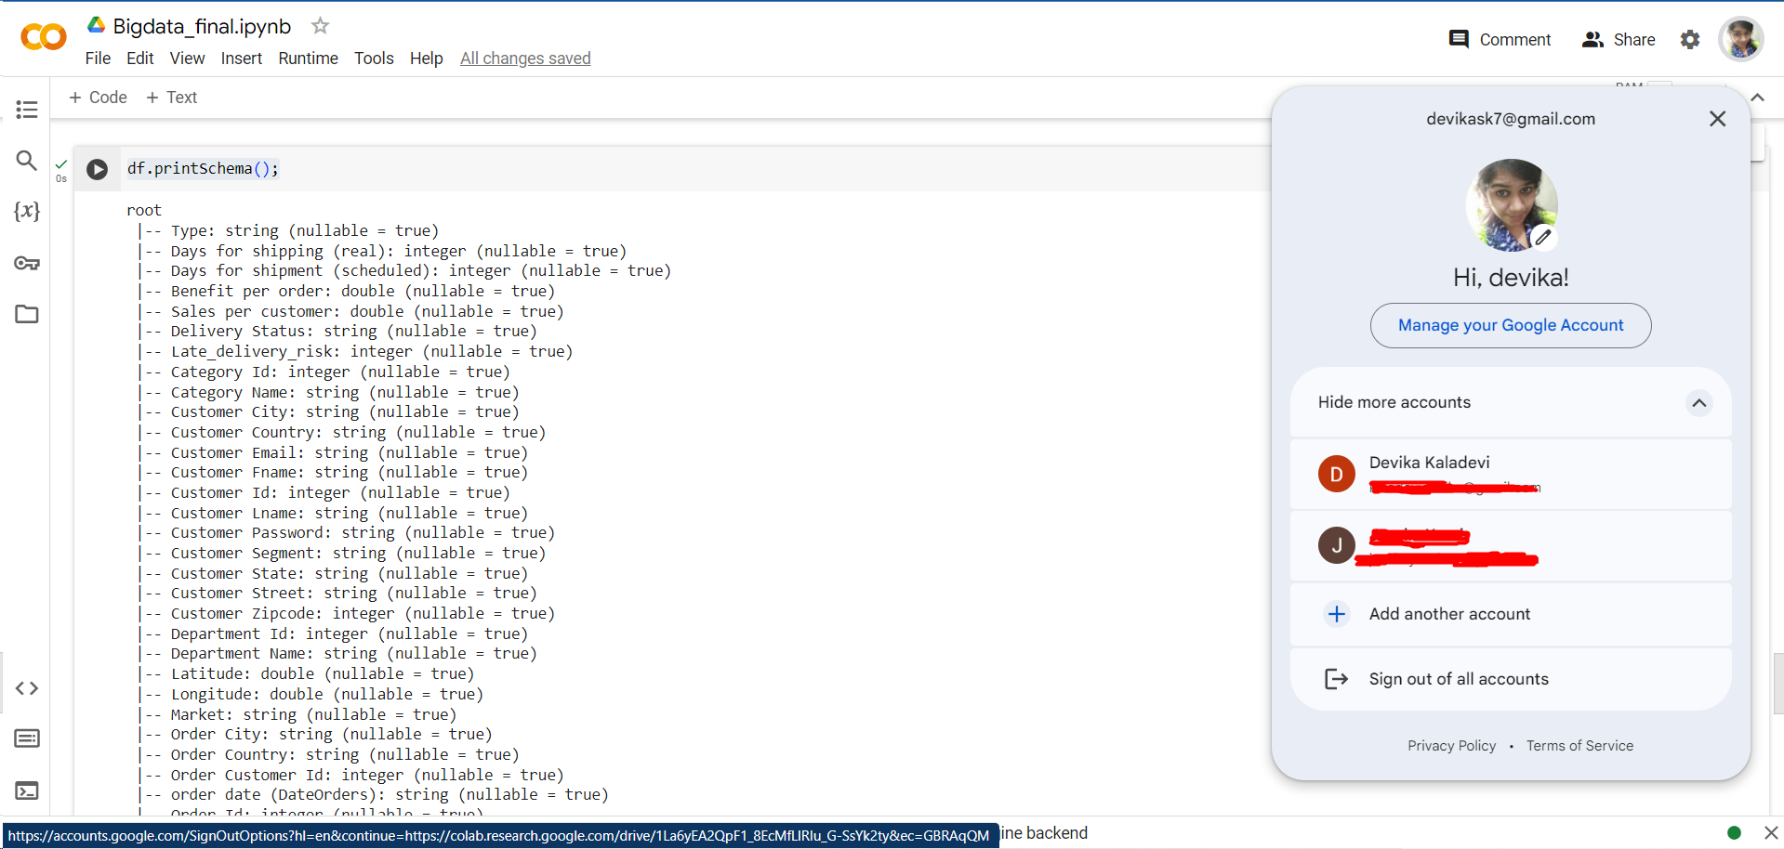

Appendix
Dataset : https://www.kaggle.com/datasets/shashwatwork/dataco-smart-supply-chain-for-big-data-analysis

Program code with google collab:

Installation of pyspark
!pip install pyspark

Reading the CSV FILE

from pyspark.sql import SparkSession
from pyspark.ml.feature import VectorAssembler
from pyspark.ml.regression import LinearRegression
from pyspark.ml import Pipeline
from pyspark.sql.functions import col

# Create a Spark session
spark = SparkSession.builder.appName("YourAnalysis").getOrCreate()

# Load your dataset
df = spark.read.csv("DataCoSupplyChainDataset.csv", header=True, inferSchema=True)

show the dataset details
# Display the first few rows of the DataFrame
df.show(

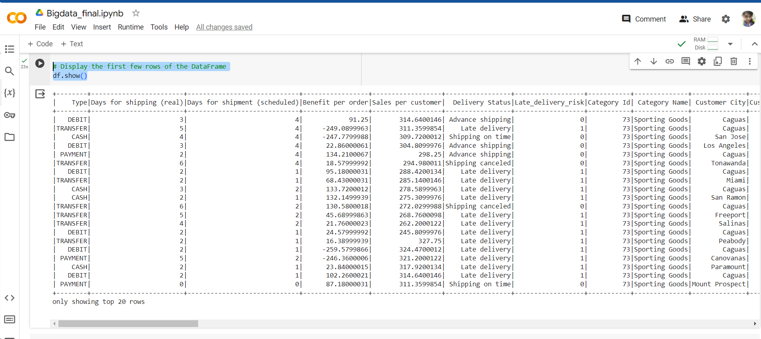

Checking the null values

#check for null values in the dataset
data_frame = df.toPandas()

for column in data_frame.columns:
print(column, data_frame[column].isnull().sum())
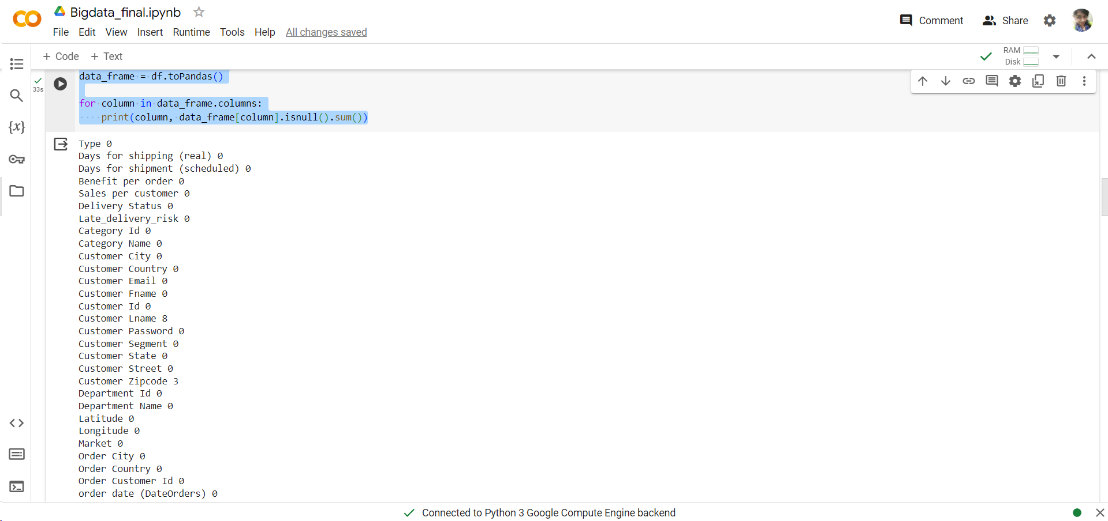

df.printSchema();
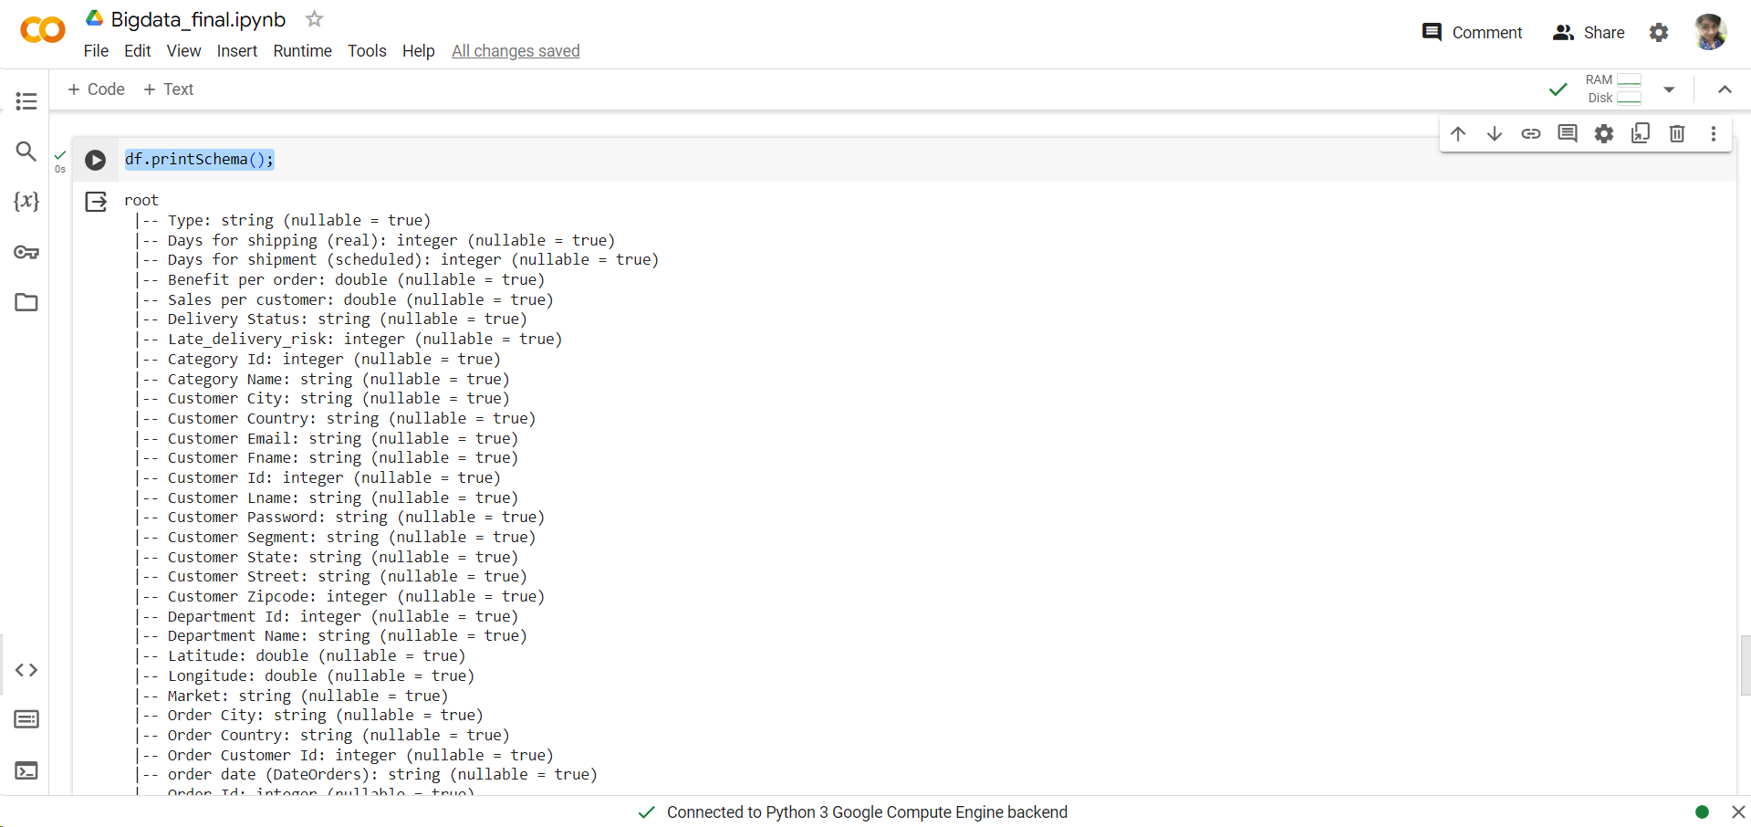

# Feature Engineering - Assuming you want to use 'Days for shipping' and 'Sales per customer' as features
feature_cols = ['Days for shipping (real)', 'Sales per customer']
assembler = VectorAssembler(inputCols=feature_cols, outputCol='my_features') # Change 'features' to 'my_features'
df = assembler.transform(df)

final_data = df.select('Days for shipping (real)', 'Sales per customer', 'Benefit per order')
# Split the data into training and testing sets
train_data, test_data = final_data.randomSplit([0.8, 0.2])
# Create a pipeline
pipeline = Pipeline(stages=[assembler, lr])

Linear Algorithms
from pyspark.ml.feature import VectorAssembler
from pyspark.ml.regression import LinearRegression
from pyspark.ml.evaluation import RegressionEvaluator

# Split the data into training and testing sets
train_data, test_data = final_data.randomSplit([0.8, 0.2])
# Train the model
model = pipeline.fit(train_data)
# Create a pipeline
pipeline = Pipeline(stages=[assembler, lr])

# make the predictions
predictions = model.transform(test_data)
# Define the Linear Regression model
lr = LinearRegression(labelCol='Benefit per order')

# Evaluate the model
lr_evaluator = RegressionEvaluator(labelCol='Benefit per order', predictionCol='prediction', metricName='rmse')
rmse_lr = lr_evaluator.evaluate(predictions)
print("Root Mean Squared Error (Linear Regression) = ", rmse_lr)

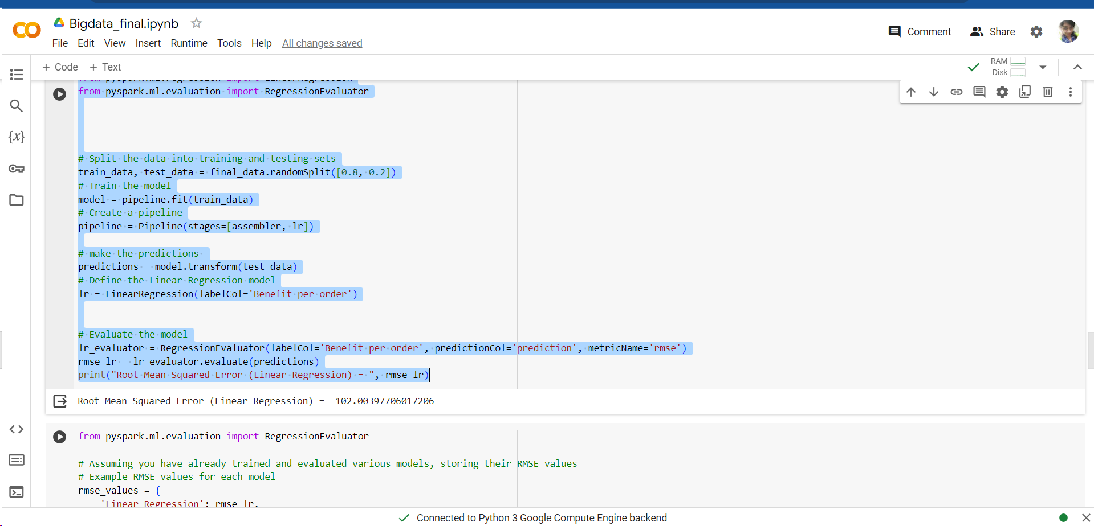

Random Forest
from pyspark.ml.regression import RandomForestRegressor

# Split the data into training and testing sets
train_data, test_data = final_data.randomSplit([0.8, 0.2])
# Train the model
model = pipeline.fit(train_data)
# Create a pipeline
pipeline = Pipeline(stages=[assembler, lr])

# make the predictions
predictions = model.transform(test_data)

# Evaluate the model
rf_evaluator = RegressionEvaluator(labelCol="Benefit per order", predictionCol="prediction", metricName="rmse")
rmse_rf = rf_evaluator.evaluate(predictions)
print("Root Mean Squared Error (Random Forest Regression) = ", rmse_rf)

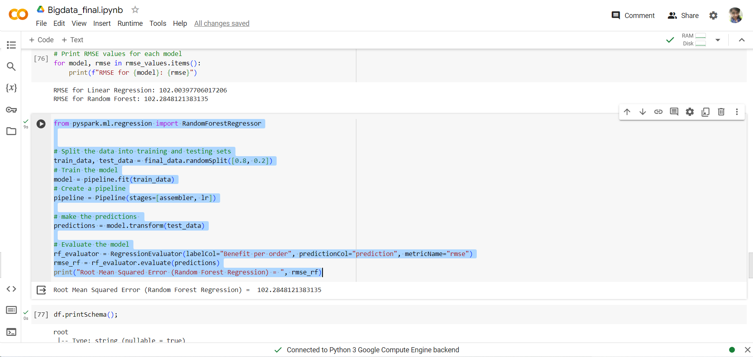

Naivebayes
from pyspark.ml.feature import VectorAssembler
from pyspark.ml.classification import NaiveBayes
from pyspark.ml.evaluation import MulticlassClassificationEvaluator

# Split the data into training and testing sets
train_data, test_data = final_data.randomSplit([0.8, 0.2])
# Train the model
model = pipeline.fit(train_data)
# Create a pipeline
pipeline = Pipeline(stages=[assembler, lr])

# make the predictions
predictions = model.transform(test_data)

# Evaluate the model
evaluator = MulticlassClassificationEvaluator(labelCol="Benefit per order", predictionCol="prediction", metricName="accuracy")
accuracy = evaluator.evaluate(predictions)

print("Dataco supplychain dataset")
print("Accuracy: {:.2f}".format(accuracy))

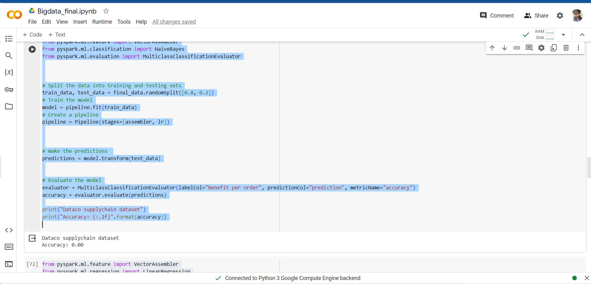

from pyspark.ml.evaluation import RegressionEvaluator

# Assuming you have already trained and evaluated various models, storing their RMSE values
# Example RMSE values for each model
rmse_values = {
'Linear Regression': rmse_lr,
'Random Forest': rmse_rf

# Add more models and their RMSE values here
}

# Print RMSE values for each model
for model, rmse in rmse_values.items():
print(f"RMSE for {model}: {rmse}")

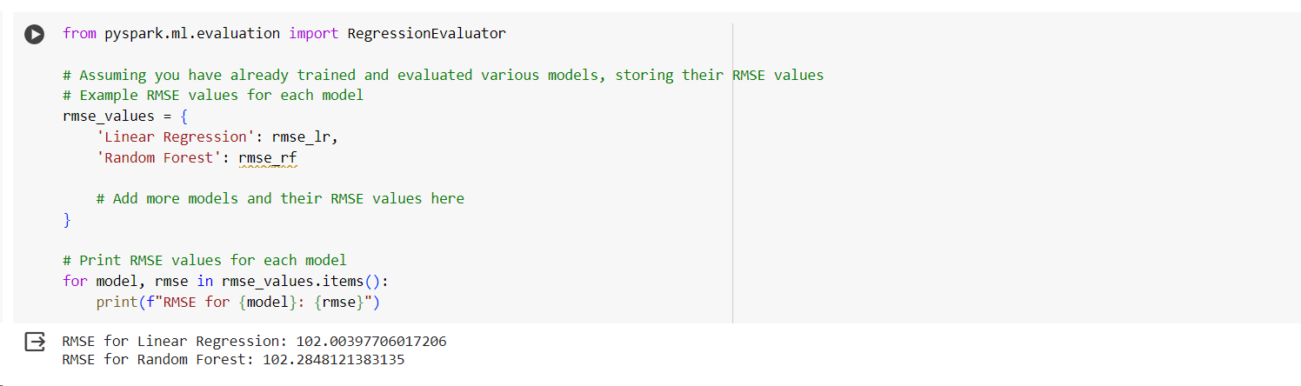

References
[1] Aktas, E. (2024). Big data applications in supply chain management. In The Palgrave Handbook of Supply Chain Management (pp. 1301–1325). Springer International Publishing.
[2] Li, C., Chen, Y., & Shang, Y. (2022). A review of industrial big data for decision making in intelligent manufacturing. Engineering Science and Technology an International Journal, 29(101021), 101021. https://doi.org/10.1016/j.jestch.2021.06.001
[3] Seyedan, M., & Mafakheri, F. (2020). Predictive big data analytics for supply chain demand forecasting: methods, applications, and research opportunities. Journal of Big Data, 7(1). https://doi.org/10.1186/s40537-020-00329-2
[4] Fallucchi, F., Coladangelo, M., Giuliano, R., & William De Luca, E. (2020). Predicting Employee Attrition Using Machine Learning Techniques. Computers, 9(4), 86. https://doi.org/10.3390/computers9040086
[5] Lobo, V., & Correia, A. (2022). Applications of Machine Learning and Deep Learning for Privacy and Cybersecurity. IGI Global.
[6] Nguyen, H., Vu, T., Vo, T. P., & Thai, H.-T. (2021). Efficient machine learning models for prediction of concrete strengths. Construction and Building Materials, 266, 120950. https://doi.org/10.1016/j.conbuildmat.2020.120950
[7] (N.d.-a). Researchgate.net. Retrieved March 3, 2024, from https://www.researchgate.net/publication/371832852_Big_data_optimisation_and_management_in_supply_chain_management_a_systematic_literature_review
[8] (N.d.-b). Researchgate.net. Retrieved March 3, 2024, from https://www.researchgate.net/publication/376577004_Analysis_of_E-Commerce_Purchase_Patterns_Using_Big_Data_An_Integrative_Approach_to_Understanding_Consumer_Behavior
[9] (N.d.-c). Researchgate.net. Retrieved March 3, 2024, from https://www.researchgate.net/publication/371439907_THE_COMPLEXITY_OF_SUPPLY_CHAIN_MANAGEMENT_IN_AN_ORGANISATION_AND_HOW_SUCCESSFUL_IT_CAN_BE_APPLIED_EFFECTIVELY

