Lab experiment 1
Aim: Configuration of IP address and establishing of peer to peer network

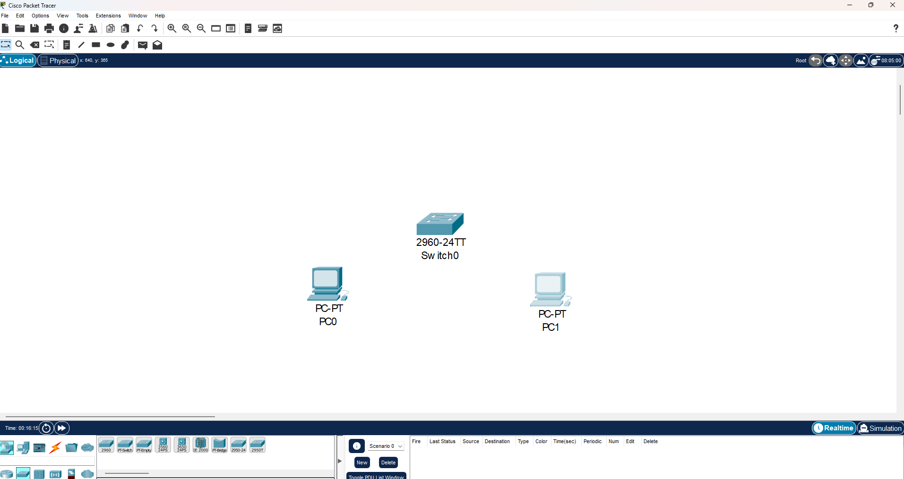
Step 1) Open CISCO PACKET TRACER and add two Devices(PC) and a Switch

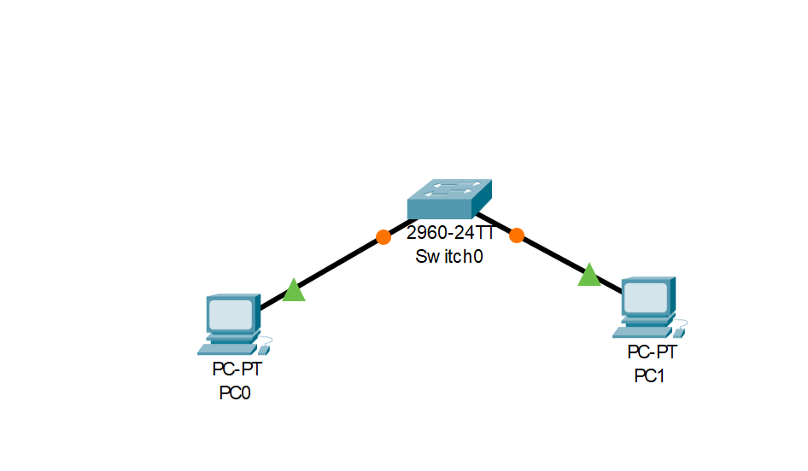
Step 2) Establish a connection between them through Copper Straight through Wire with Ethernet

Step 3) Click PC0, go to Desktop Tab and click IP configuration
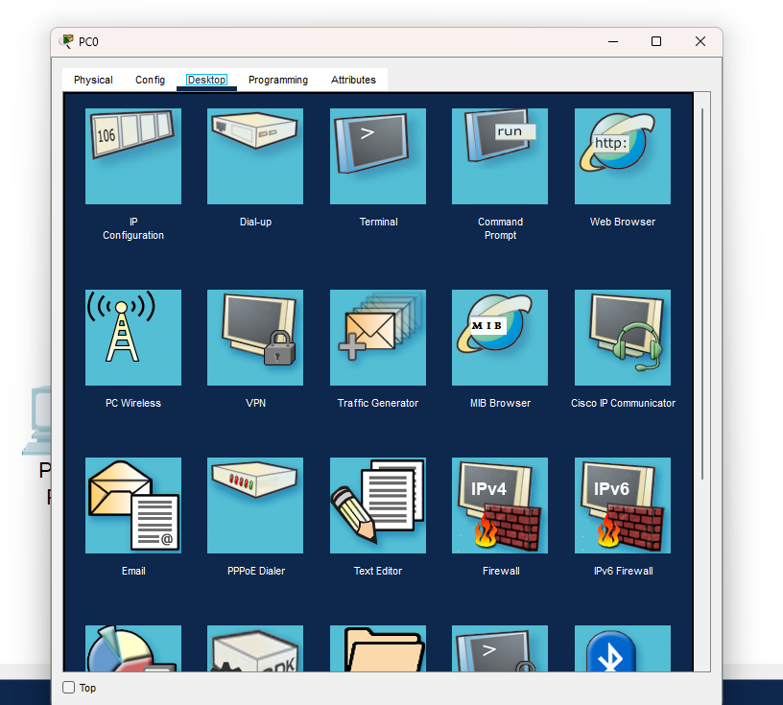

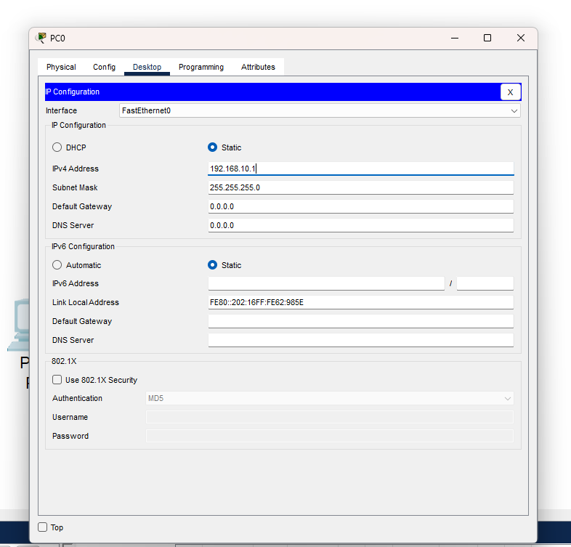
Step 4) Set up the IPV4 Address and Subnet Task

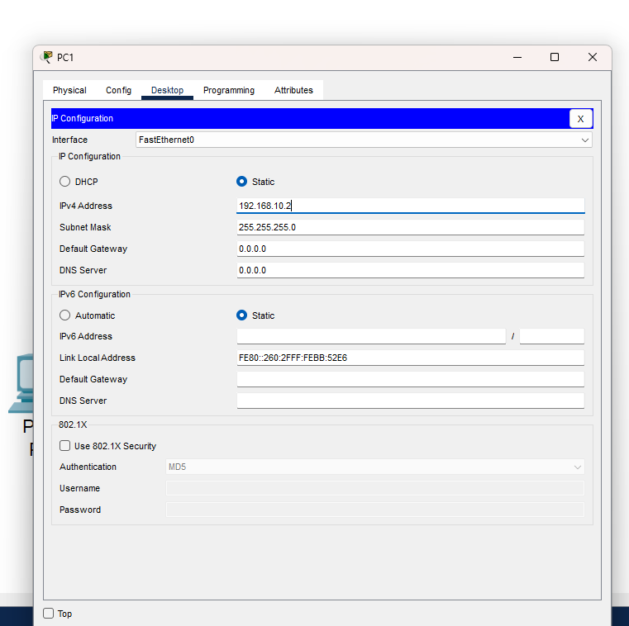
Step 5) Do same for PC1

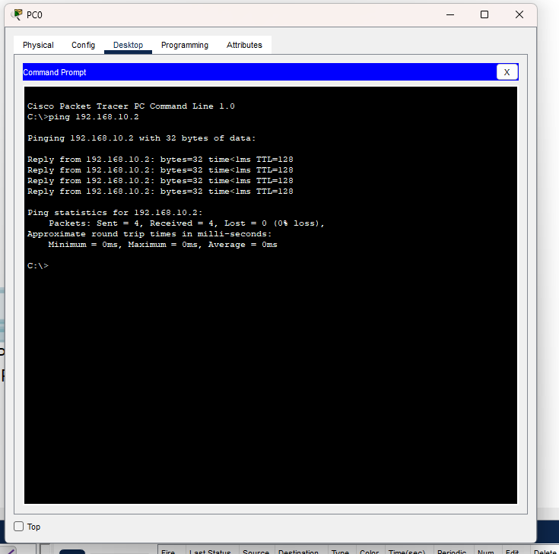
Step 6) The connection has been made. Now we have to check the connection. Click PC0, Open command prompt inside Desktop and ping PC1

Do the same from PC1 to PC0
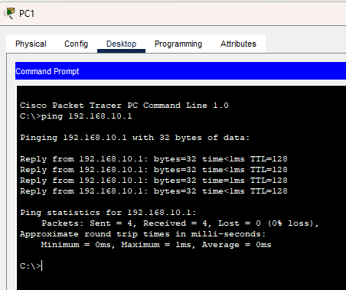

Result: IP Addresses have been configured and a Peer-to-Peer connection has been established between two devices and checked.

Lab Experiment 2
Aim:Implementation of various network topologies

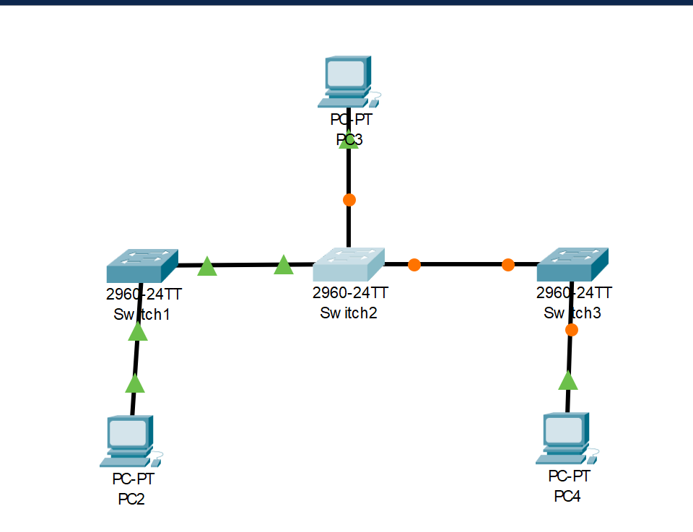
Step 1) Implementation of Bus topology: Make a structure like this using switches, PCS and copper straight through cables using Ethernet and then configure all the IP addresses of all PC’s.

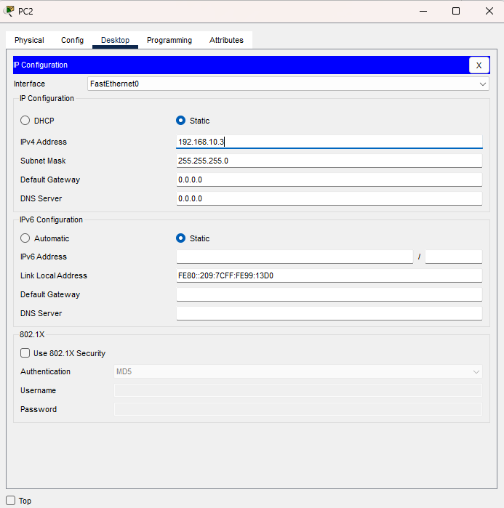

Now check the connection using ping. Here I communicated from PC2 to PC4 through the bus topology
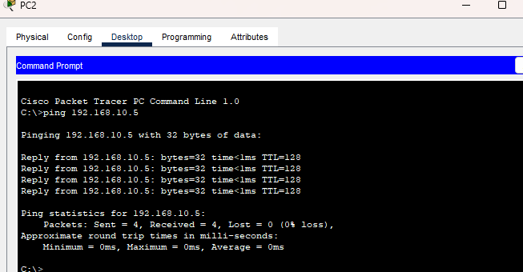

A connection can also be checked this way though the ping is enough.
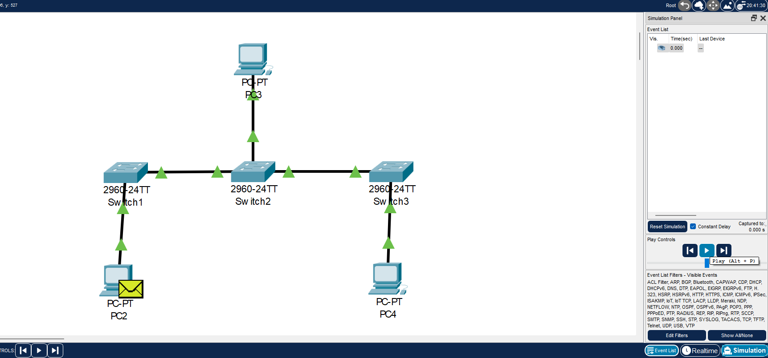

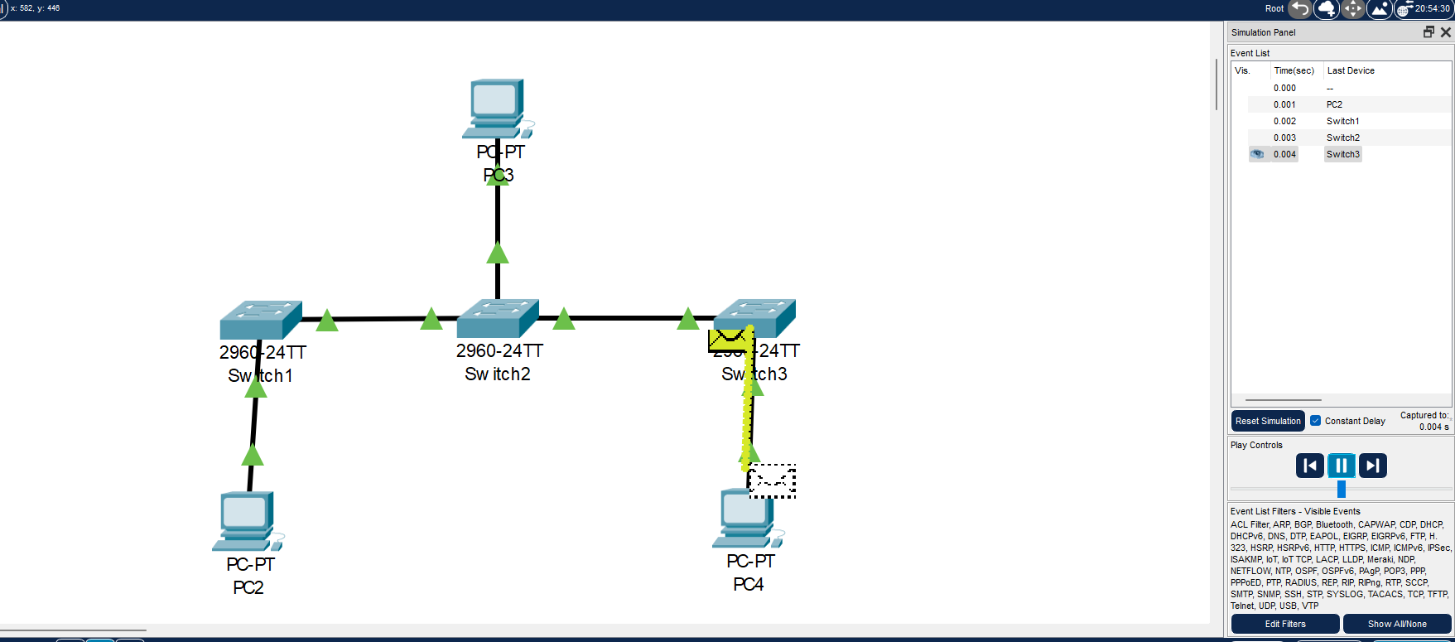

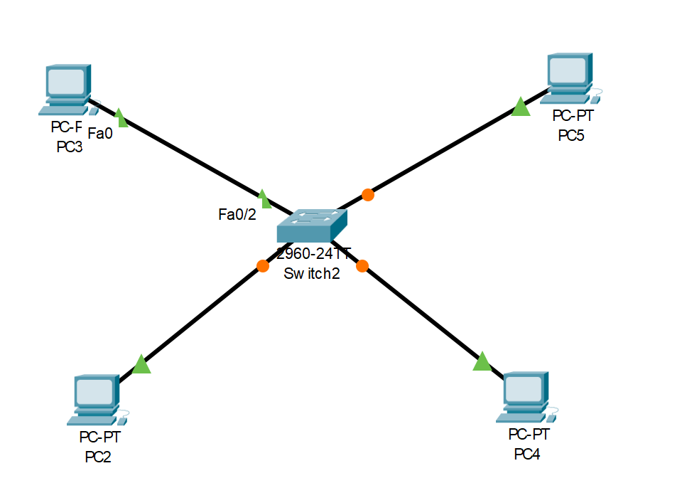
Step 2) Implementation and checking of connection Star Topology in a similar way

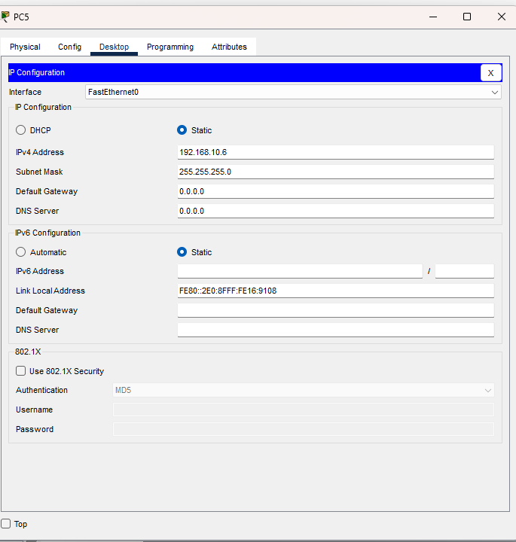

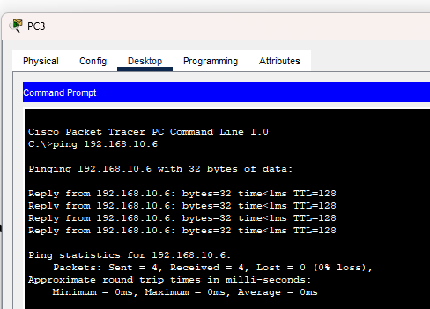

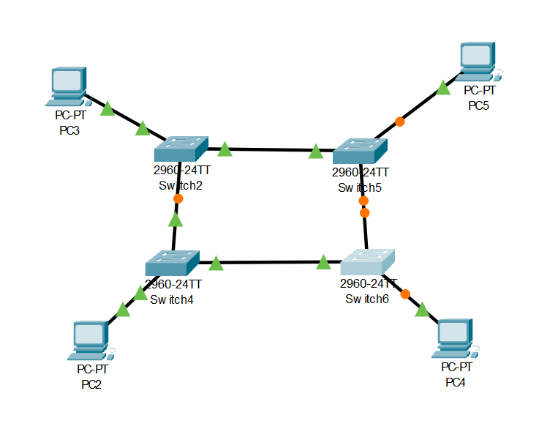
Step 3) Implementation and checking of connection Ring Topology in a similar way

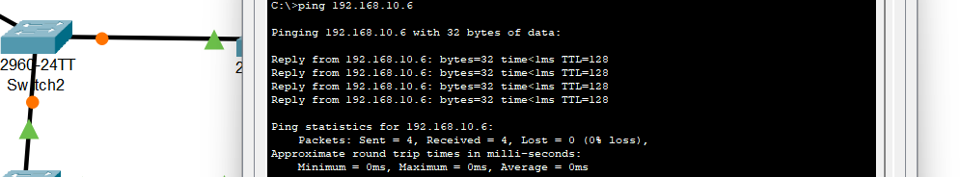

Step 4) Implementation and checking of connection Mesh Topology in a similar way
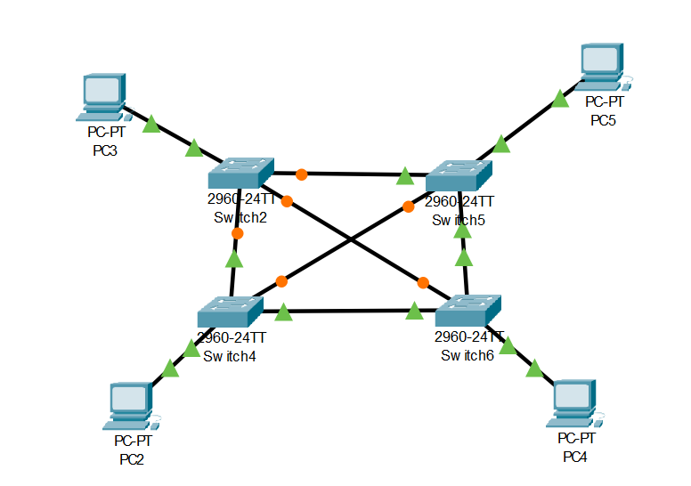

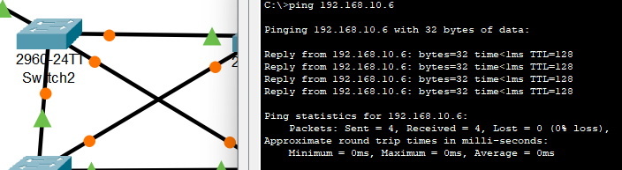

Result:The implementation of all major network topologies have been established and checked.

