IOT ML BOOTCAMP: DAY 1

1)TINKERCAD:

* Tinker cad is an online platform where we can simulate your ideas. By using tinker cad we can be able to learn a micro-controller called Arduino. Arduino was developed in Italy.
* Embedded c++ is a programming language that is used for building applications in Arduino.
* All embedded programming languages are executed by hardware but compiled on laptop.
* Compiler vs cross compiler

->compiler will generate .exe file which is binary file

->cross compiler will generate .hex file

->Arduino is cross compiler platform.

Experiment 1:

Aim :- Making led ‘on’ at pin 13

Program:

//program to blink the LED connected to pin 13

void setup(){

//used to configure the hardware such as sensors

//it will be first executed function

pinMode(13,OUTPUT);//output pheipheral connected at pin 13

}

void loop(){

//runs until the power supply goes off

digitalWrite(13,0); //writes the on or off digital symbol to pin 13

// 1 symbol is equal to 5V

}

Experiment 2:

Toggle LED :

//program to blink the LED connected to pin 13

void setup(){

//used to configure the hardware such as sensors

//it will be first executed function

pinMode(13,OUTPUT);//output pheipheral connected at pin 13

}

void loop(){

//runs until the power supply goes off

digitalWrite(13,1); //writes the on or off digital symbol to pin 13

// 1 symbol is equal to 5V

delay(1000);

digitalWrite(13,0);

delay(1000);

}

Experiment 3:  
 Aim: on the LED when a button is pressed

const int button=8;//connected to the 8th pin in digital side and we connect a button to it

int buttonstate = 0;

void setup(){

//used to configure the hardware such as sensors

//it will be first executed function

pinMode(13,OUTPUT);//output pheipheral connected at pin 13

pinMode(button,INPUT_PULLUP);

}

void loop(){

//runs until the power supply goes off

buttonstate = digitalRead(button);

if(buttonstate == HIGH)

digitalWrite(13,1);

else

digitalWrite(13,0);

}

Button is placed like this on Arduino

Experiment 4:

Aim: program to print hello world

void setup()

{

Serial.begin(9600);//begin should be inside setup

Serial.println("Hello Dude!");

}

void loop(){

Serial.println("hello World");

}

Experiment 5:

Aim : write a program to produce a beep sound continuesly?

->connect buzzer negative to ground

->positive to any pin from 0-13

Source code

void setup()

{

pinMode(9,OUTPUT);

}

void loop(){

for(int i=0;i<10;i++)

{

digitalWrite(9,1);

delay(500);

digitalWrite(9,0);

delay(500);

}

While(1);

}

Image for buzzer sound:

Experiment 6:

Aim : write a program to rotate servo motor form 0 degrees to 90 degrees and 90-0 degrees continuously?

* Servo motor contains 3 input wires

1) brown color – ground

2)red color – power

3)orange color – signal

Source code::

#include<Servo.h>

Servo motor;

void setup(){

motor.attach(3);

}

void loop()

{

for(int i=0;i<90;i++)

{

motor.write(i);

delay(10);

}

for(int i=90;i>=0;i--)

{

motor.write(i);

delay(10);

}

}

Experiment 7:

Aim : write a program to detect motion and trigger led accordingly?

* This sensor contains 3 input wires:

i)signal connect to pin 3

ii) ground connected to GND

iii)power connected to 5V

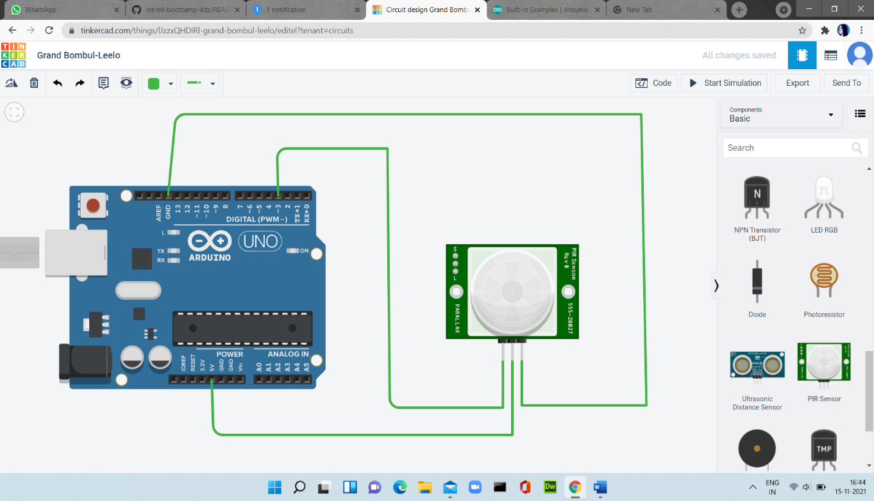

Source code:

void setup(){

pinMode(3,INPUT);

pinMode(13,OUTPUT);

Serial.begin(9600);

}

void loop()

{

int m = digitalRead(3);

Serial.println(m);

if(m==1)

digitalWrite(13,1);

else

digitalWrite(13,0);

}