Node MCU pinpoint::

On MCU

->vin is 5V

->A0 is a only one analog pin.

NOTE : Built in LED for NodeMCU is at GPI016 and GPI02

Experiment 13:

Aim : Toggle GPI016 LED for every 20 ms?

int led = 16;

void setup() {

pinMode(led,OUTPUT);

}

void loop() {

digitalWrite(led,1);

delay(20);

digitalWrite(led,0);

delay(20);

}

Example 14:

Aim : Write a program to read humidity and temperature dhT11 sensor?

->dht11(Digital humidity and temperature) sensor is having internal ADC.

->it has 3 terminals:1)GND 2)VCC ,3)DATA

->connect GND to GND then VCC to VIN and then DATA to D2.

#include "DHT.h"

DHT dht(D2,DHT11);

void setup() {

dht.begin();

Serial.begin(9600);

}

void loop() {

float h = dht.readHumidity();

float t = dht.readTemperature();

Serial.print("h : ");

Serial.print(h);

Serial.print(", T : ");

Serial.println(t);

delay(2000);

}

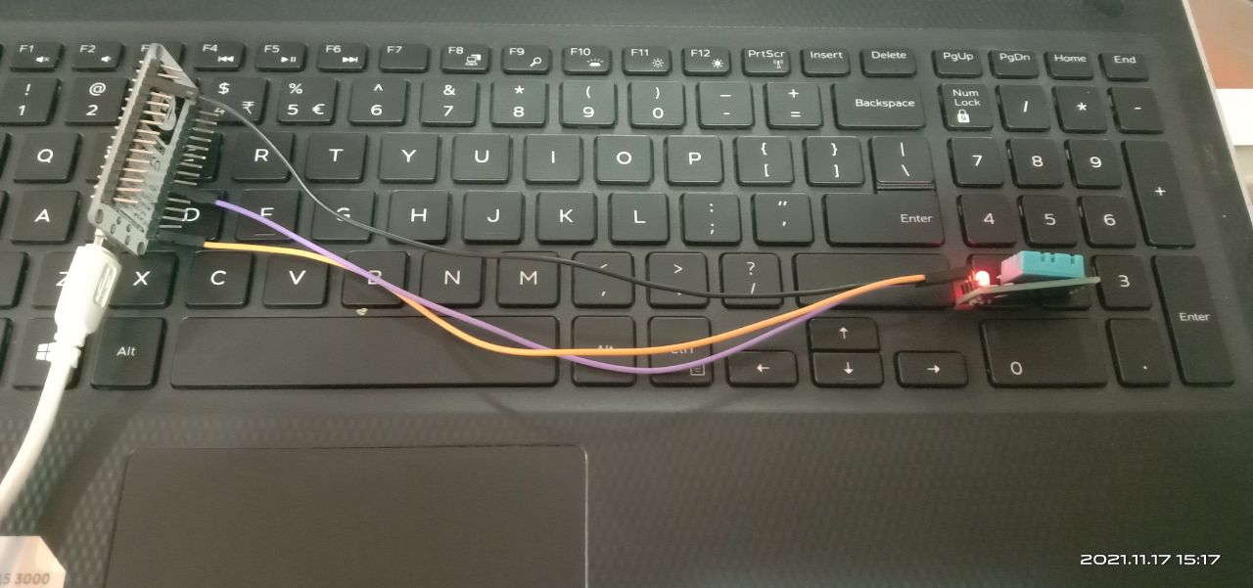

Experiment 15:

Aim: LDR sensor connection

Description:

->connect VCC to VIN, GND to GND , D0 to D2.

->same circuit as the other.

int light = D2;

void setup()

{

pinMode(light,INPUT);

Serial.begin(9600);

}

void loop()

{

int m = digitalRead(light);

//Serial.println(m);

if(m==1)

Serial.println("daark!!!");

else

Serial.println("light detected..");

delay(100);

}

Experiment 16:

Aim : write a program for proximity sensor ?

Code:

int light = D2;

void setup()

{

pinMode(light,INPUT);

Serial.begin(9600);

}

void loop()

{

int m = digitalRead(light);

//Serial.println(m);

if(m==1)

Serial.println("Hand not detected!!!");

else

Serial.println("Hand detected..");

delay(100);

}

Experiment 17:

Aim : program to detect the distance of an object?