Task-1)
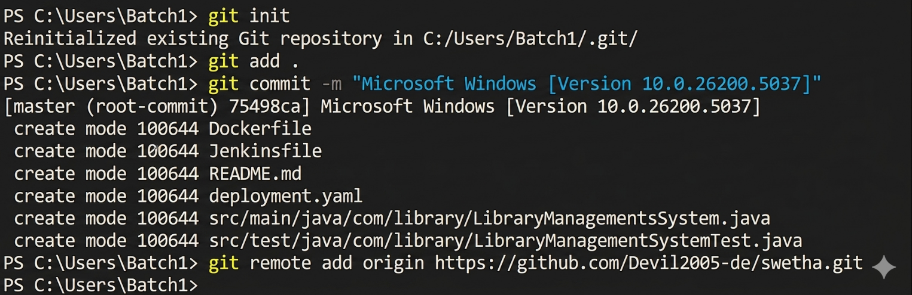
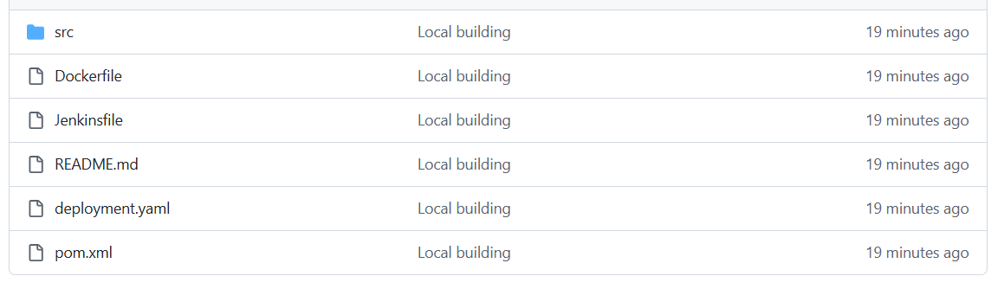
Task-2) Cloning the application into vs code
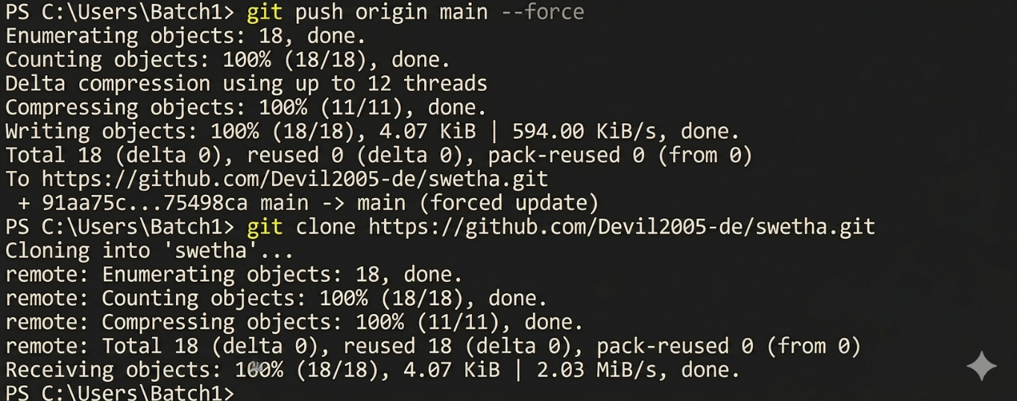

some code changed and committed into git
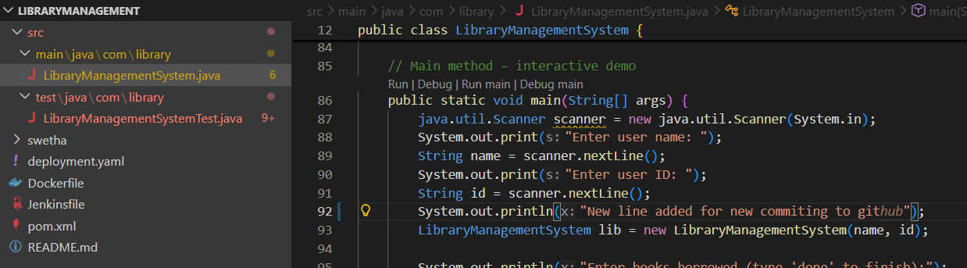

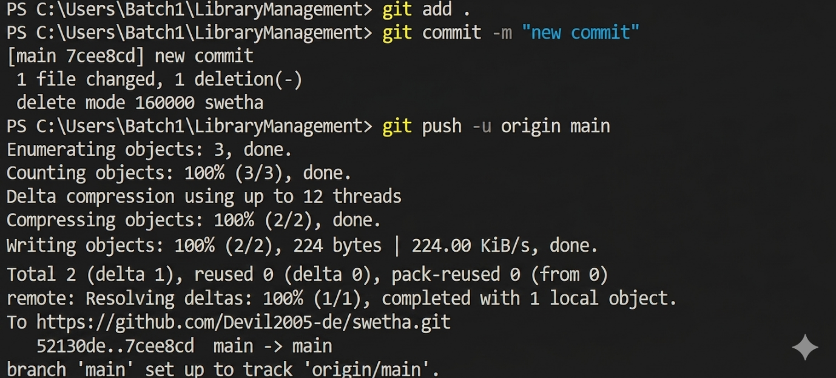

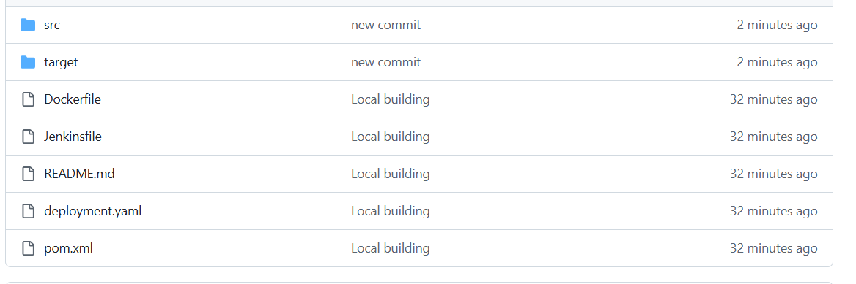

Task-3)
Mvn clean test
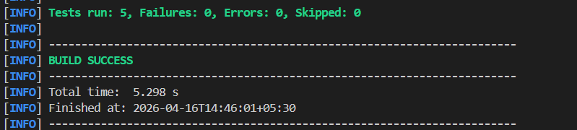
Mvn clean package
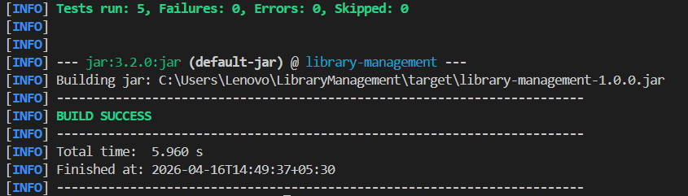

Task-4)
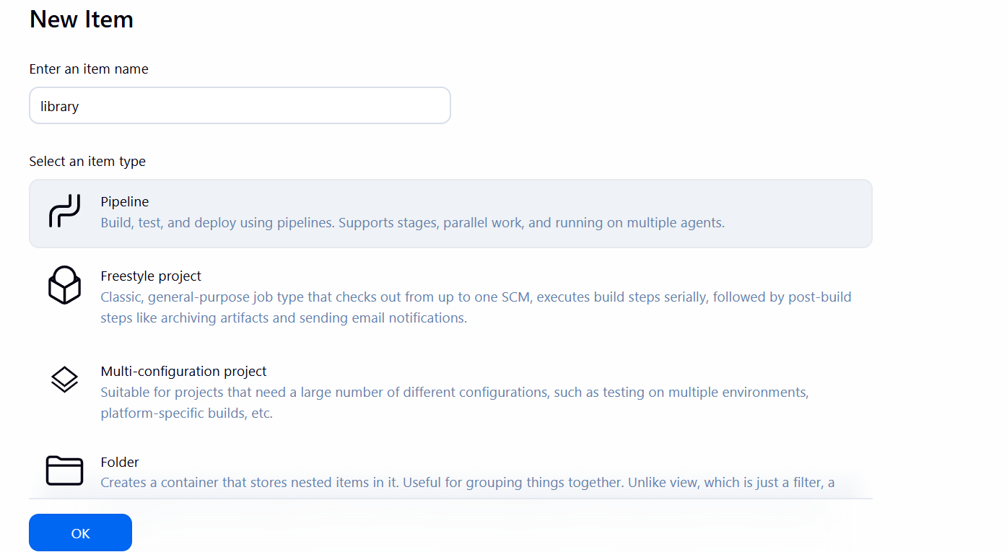

CI/CD Script
pipeline {
agent any

stages {
stage('Checkout') {
steps {
git branch: 'main', url: 'https://github.com/Devil2005-de/swetha.git'
}
}
stage('Compile') {
steps {
sh 'mvn clean compile'
}
}
stage('Test') {
steps {
sh 'mvn test'
}
}
stage('Package') {
steps {
sh 'mvn package -DskipTests'
}
}
}
post {
always {
junit 'target/surefire-reports/*.xml'
}
}
}

