



**Design & Development of web application for Turf Playground Booking.**



Prince Singh

PRN - 123M1H058



Prof. Dr. AVINASH CHORMALE



DEPARTMENT OF MCA

PIMPRI CHINCHWAD COLLEGE OF ENGINEERING SECTOR NO. 26, PRADHIKARAN, NIGDI, PUNE - 44.

(2023-2024)

# Index

## Introduction

1. **Problem Statement:**
   * **Working Of Existing System**
   * **Need Of New System**

## Scope of proposed system

## Objectives of proposed system

1. **Methodology**
2. ***Flow diagram followed by description of working***
3. ***Functional Requirements***
4. ***Non-functional Requirements:***

## Technical Requirements

* ***Software requirement***

## Expected Outcomes

1. **Conclusion**

## Introduction :

Turf playgrounds are used to play various sports like football, tennis, cricket, etc. People enjoy playing on the turf, it has vibrant environment and very safe to play. Many school teams and clubs prefer turf playground for practice and training purpose.

Sometimes it becomes difficult to book turf playground because of timing issue or the slot getting booked previously. This sports ground booking website is proposed for booking the turf in an easy and efficient way.

It has various modules namely, Admin, Owners and User.

Admin can login and can add turf locations, assign manager by creating login credentials for manager, add price details for the particular turf, manages turf and view the details of sports venues booking for all locations.

Owners are different for different Turf playground locations. Owners will get login credentials from admin, he/she can login using credentials, he/she can check the rates, view the request for turf booking for the respective location, can accept booking, generate bill and can view the booking history.

Users can check the availability of the turf, select timings, fill personal details, can pay by providing bank details or card details and he/she can also see view previous turf booking history.

## Problem Statement :

* **Working Of Existing System :**

As of now there are very few online systems like web application and android application to Book Turf Playground online. People/customers usually Contact the respective owners of Turf playground and get a schedule for their booking. Customers usually don’t know at which time the particular Turf is free and what Discount/Offers is available for any Turf.

## Need Of New System :

To overcome this problem, we need to develop an online Web application where users can search nearby Turf playground as per locations and see the timings and availability of Turf and can book the free schedule. Users can also check and avail the Discount or Offers if applicable.

Advantages of the Proposed Project-

* This not only help the players but also the turf owners who want to expand their business through online medium.
* Saves time (availability of all turf at single platform)
* Easy to access the system anywhere and anytime.
* Turf booking can be done just by sitting at home.

## Scope of proposed system :

**Booking Facility:** Users can search the Turf based on location and see the previous booking details and available slots and timing and Discounted Offers. Users can book the Turf and pay the amount at the time of visit by meeting the owner.

**Cancellation Facility:** Users as well as the owner of the Turf can cancel the booking if they want to.

**User Registration:** New users can sign up on the website and use the application after login with their credentials.

**Turf Registration:** The owner of the Turfs can register their turf to expand their business.

## Objectives of proposed system :

1. To Design and Develop online web application for Turf Booking.
2. To obtain a simple interface for webpage which helps Turf owners to expand their business through online.
3. To obtain a bug-free Booking System for users which allow them to search and view the information of Turf.
4. To obtain the system that maintains the List of Turf and their Booking History so it will be easy to access 24 * 7.

**User Login and Logout** Functionality.

**Check Turf:** User can check for turf of nearby location and prices.

**Check Availability:** User can see the availability of the respective turf which is selected by him.

**Check Rates:** User can check rates for the respective location turf.

**Book Turf:** User can provide date, time and other personal details and he can also do payment.

**Booking History:** User can see his previous booking history.

**Cancel Booking:** User can cancel the booking if not required anymore.

## Methodology :

1. **Flow diagram followed by description of working:**

**Zero Level DFD:**

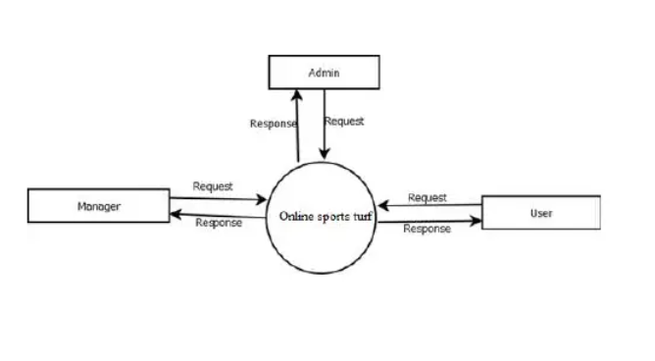

**First Level DFD:**

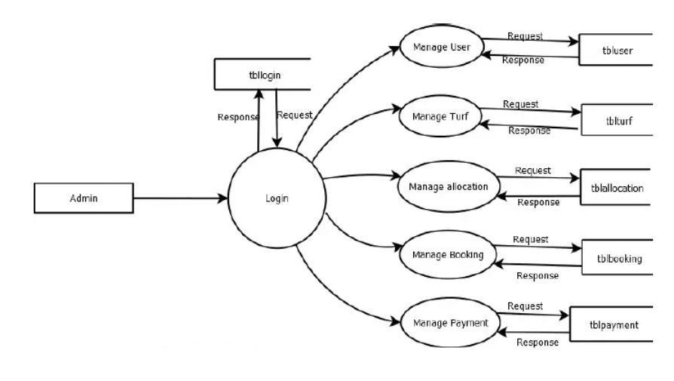

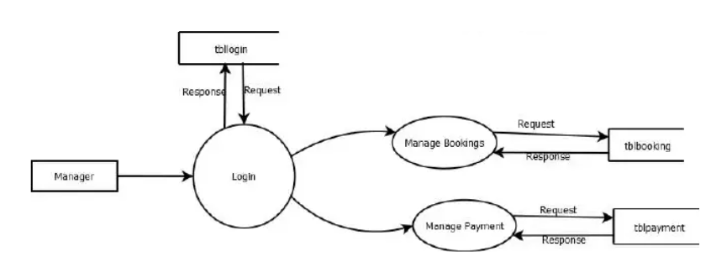

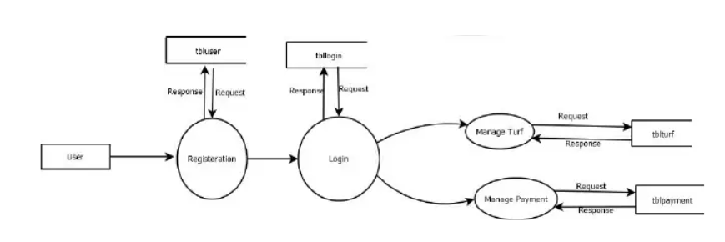

**Entity Relationship Diagram:**

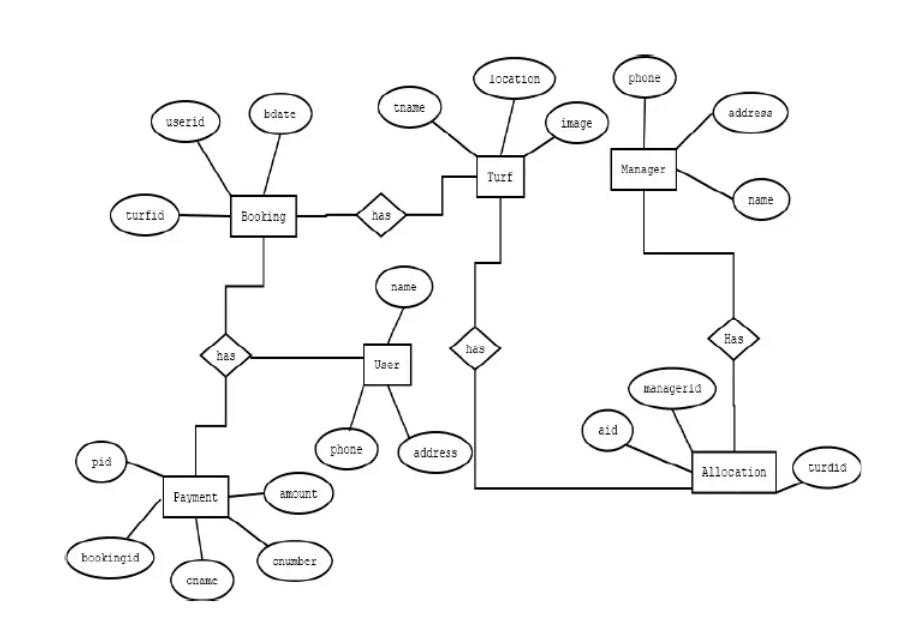

**Workflow Diagram:**

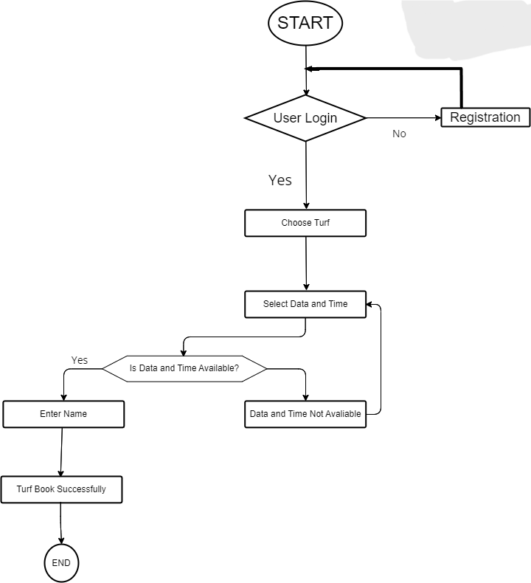

1. **Functional Requirements:**

**Insert records:** This action is done to add new records into fields.

**Update records:** This event is to modify or update the information on each process.

**Delete records:** This action is to remove records from the system whenever they are no longer needed.

**Search for records:** Whenever the admin wants to search for a record, this action is performed.

The validation of data entered should be done.

Specific condition has to be met.

1. **Non-functional Requirements:**

**Reliability:** The software should not have any reliability issues. The software will be thoroughly tested and any issues resolved.

**Availability:** The software will execute as a standalone system so as long as the machine is running, the program will be available. The key to maintaining availability will be by ensuring a connection to the database server is available. Failure to connect to the database will make data unavailable.

**Security:** This software is intended to communicate over an internal network;

therefore security is of little concern. The user will have to enter the username and password so the program can connect to the database server. The username and password will not be stored because encryption of such information is outside the scope of the project.

**Maintainability:** The software will be composed of various modules decreasing the complexity of expansion.

1. **Technical Requirements :**

* **Used Technology:**

1. HTML
2. CSS
3. JavaScript
4. MySQL
5. PHP

* **Software requirement:**

1. Microsoft Visual Studio Code.
2. Any Web Browser.
3. MySQL
4. PHP Servers.

* **Any other requirement:**

An Internet Connection is required to access.

## 7. Expected Outcomes :

Web application is develop which can Successfully Book and Cancel the Turf playground online. This application can be used by the Cricket and Football enthusiastic players to book the available turf according to their need.

The web based application mainly focuses into the location based service providing such as nearby turfs recommending system and its online booking and registrations. The system also provides its users to view upcoming tournaments hosted on particular locations and its registrations. The system helps out the users to search and find the nearby turfs or the turfs available in the particular location. So, the system studied the existing online turf booking systems and added on the above stated features into the proposed system to provide better user experiences.

Overall the application provides a complete solution for the turf booking and its registrations.

## 8. Conclusion :

Online Turf Playground Booking System this project Sends message reminders to managers and users whenever slots are booked, canceled or rescheduled. And your users can easily and securely authenticate themselves by linking their existing service by using a password.

Turf Near You, The web based application mainly focuses into the location based service providing such as nearby turfs recommending system and its online booking and registrations. The system also provides its users to view upcoming tournaments hosted on particular locations and its registrations. The system helps out the users to search and find the nearby turfs or the turfs available in the particular location. So, the system studied the existing online turf booking systems and added on the above stated features into the proposed system to provide better user experiences.

Overall the application provides a complete solution for the turf booking and its registrations. Currently, our application consists of turfs details which relay on the data that are fed by the organizers. To enhance this feature we need to construct a built-in chatting system for the teams to interact with organizers for more details of tournaments and turfs.

The application we developed is a web application, this can also be implemented as a mobile application. Also a custom filtering recommendation system based on the turfs quality, features etc., need to be implemented for distance calculation and best top rated turfs listing. A lidar-based scanning facility is to be implemented for import and view the 3D model or AR of the turfs for its users.