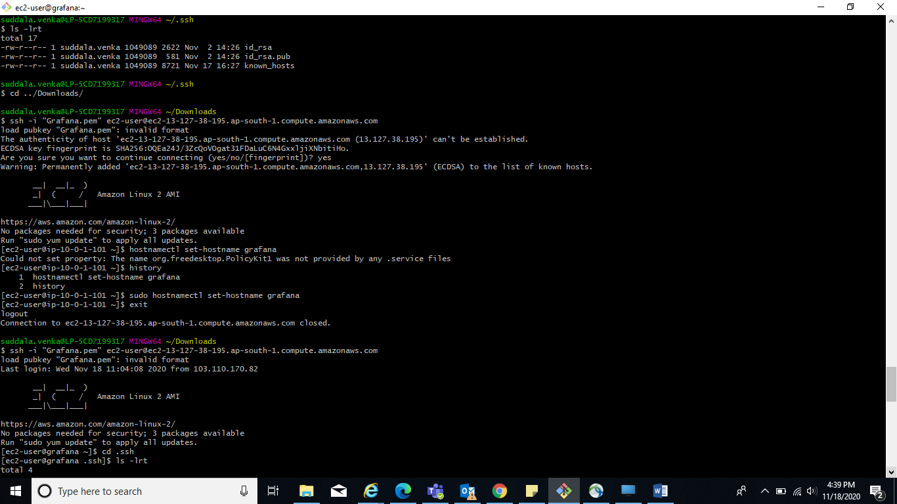

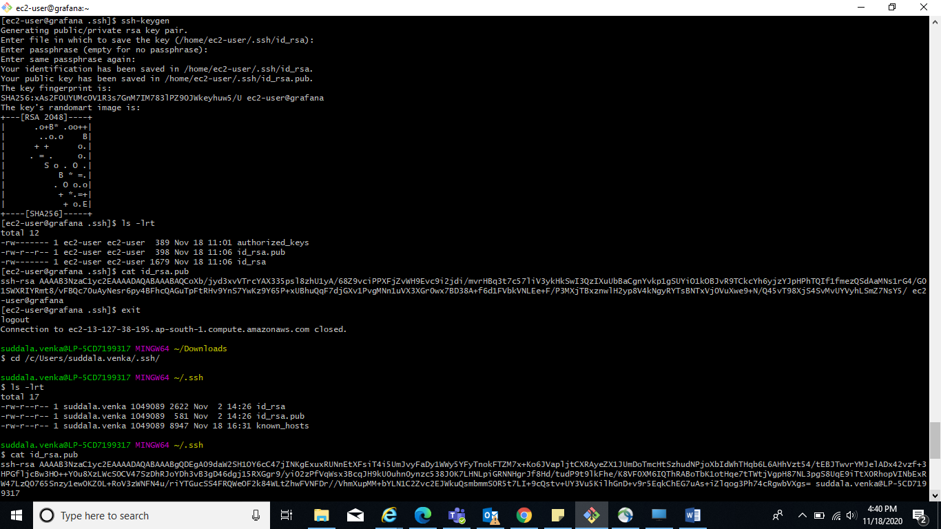

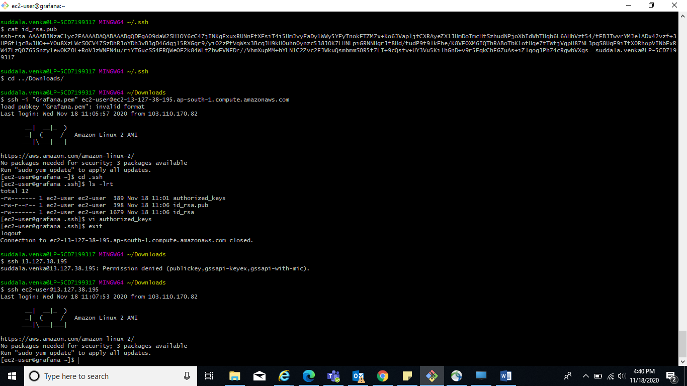

**Step :-1** :- [root@grafana ~]# yum update -y

**Step :-2** :- [root@grafana ~]# nano /etc/yum.repos.d/grafana.repo

[root@grafana ~]# cat /etc/yum.repos.d/grafana.repo

[grafana]

name=grafana

baseurl=https://packages.grafana.com/oss/rpm

repo_gpgcheck=1

enabled=1

gpgcheck=1

gpgkey=https://packages.grafana.com/gpg.key

sslverify=1

sslcacert=/etc/pki/tls/certs/ca-bundle.crt

**Step :-3** :- [root@grafana ~]# yum install grafanayum install grafana

Allow SG for grafana default as “3000”

Login with PublicIP:port



**Prometheus :**

