MINI PROJECT REPORT

**Banking System**

**NAME: -** Swaraj Das

**PS NO: -**40020583

**TABLE OF CONTENTS**

|  |  |  |
| --- | --- | --- |
| **SERIAL NO.** | **CONTENT** | **PAGE NO.** |
| 1 | Introduction | 3 |
| 2 | Features | 3 |
| 3 | 4W’s 1-H | 3-4 |
| 4 | SWOT Analysis | 4 |
| 5 | Design | 5-6 |
| 6 | Test plan | 6-7 |
| 7 | Output | 8-9 |

**INTRODUCTION: -**

The Banking Management System is an application for maintaining a person's account in a bank. In this project I tried to show the working of a banking account system and cover the basic functionality of a Bank Account Management System. To develop a project for solving financial applications of a customer in banking environment in order to nurture the needs of an end banking user by providing various ways to perform banking tasks. Also to enable the user’s work space to have additional functionalities which are not provided under a conventional banking project. The Bank Account Management System undertaken as a project is based on relevant technologies. The main aim of this project is to develop software for Bank Account Management System. This project has been developed to carry out the processes easily and quickly, which is not possible with the manuals systems, which are overcome by this software. This project is developed using C language only. Thus, above features of this project will save transaction time and therefore increase the efficiency of the system.

**Features**

1. The transactions are executed in off-lineode, hence on-line data for Accounts, Internet Banking capture and modification is not possible.
2. Manage their formation of Internet Banking.
3. Shows the information and description of the Accounts, transaction.
4. All the fields such as Accounts, Transaction, Statement are validated and does not take invalid values.
5. It generates there port on Accounts ,Internet, Banking, Customer.

**4W’s 1-H: -**

**WHY:**.

* Easy to use.
* Reduces manpower.
* Less time consuming.
* Easy to maintain in future prospect.

**WHAT:**

* To transfer fund and deposit money and check for bank details

**WHERE:**

* Banks

**WHEN:**

* Checking for details and transfer in banks

**HOW:**

* Using C programming language, we can provide a flexible code to develop the application and also provide better service to the customer.

**SWOT ANALYSIS: -**

|  |  |
| --- | --- |
| **Strength**   1. The strength of my project is its flexible. 2. It reduces man power. 3. Its cost effective and less time consuming. | **Weakness**   1. This project is only suitable for small banks. 2. It’s not fully automated. 3. Authentication need to be implemented |
| **Opportunity**   1. First of all, I want to implement this project in small restaurants to prove myself then I can implement it largely by creating my own opportunity through them. 2. It will help both the customers and sellers. | **Threats**   1. If the application is not password protected any unauthorized person can get access to this application and can make miss use of it. |

**DESIGN: -**

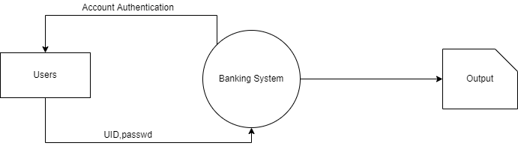

[Diagram-1]

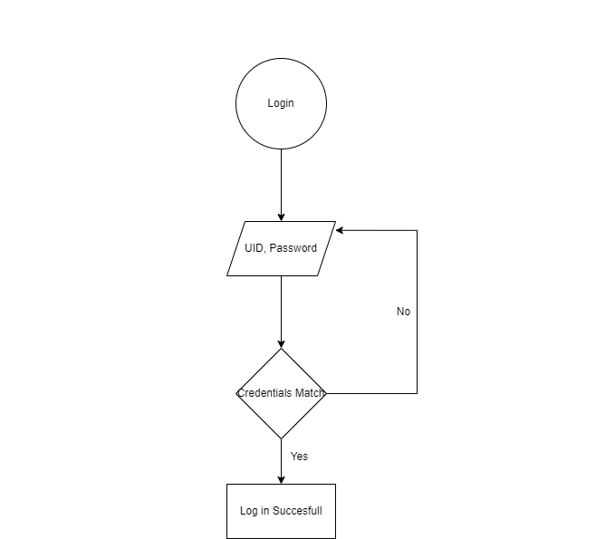

[Diagram-2]

**TEST PLAN: -**

**High-level Test Plan: -**

|  |  |  |  |  |  |
| --- | --- | --- | --- | --- | --- |
| **Test id** | **Description** | **Ex I/P** | **Ex O/P** | **Actual output** | **Type of test** |
| **1** | Select what you want to choose | 1 to 5 | Your selected option will be display. | Your selected option will be display. | Requirement  based |
| **2** | Select the amount of transfer | Less or equal to the total amount | Your amount will be transfered. | Your amount will be transfered. | Requirement  based |

[Table-1]

**Low-level Test Plan: -**

|  |  |  |  |  |  |
| --- | --- | --- | --- | --- | --- |
| **Test id** | **Description** | **Ex I/P** | **Ex O/P** | **Actual output** | **Type of test** |
| **1** | Entering UserID | MyID | Successful Login | Log In | Requirement based |

[Table-2]

**OUTPUT: -**

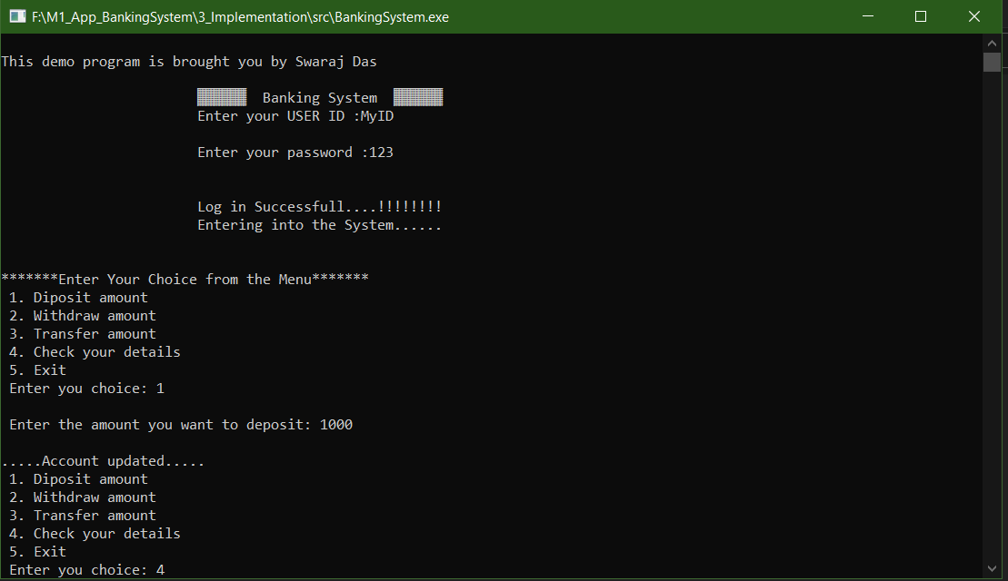

[Image-1]

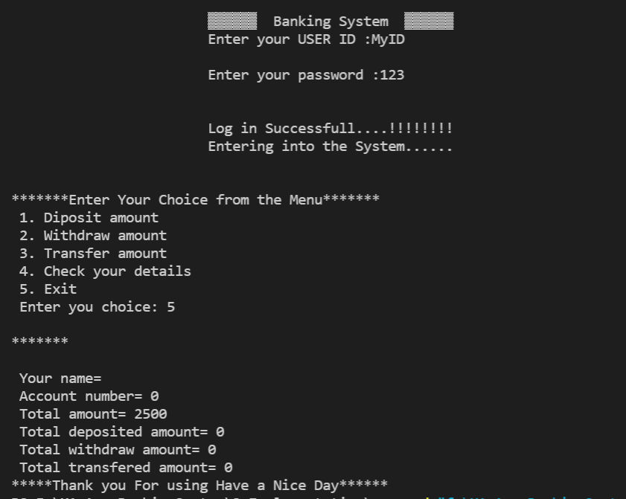

[Image-2]