Validation for NSB_SpectralAnalysis()

fs = 1000; % Sample frequency (Hz)
t = 0:1/fs:100-1/fs; % 10 sec sample
x = (1.3)*sin(2*pi*15*t) ... % 15 Hz component
+ (1.7)*sin(2*pi*40*(t-2)) ... % 40 Hz component
+ (2.5)*randn(size(t)); % Gaussian noise;

options.SPTmethod = 'welch';

%plot Signal
plot(x)

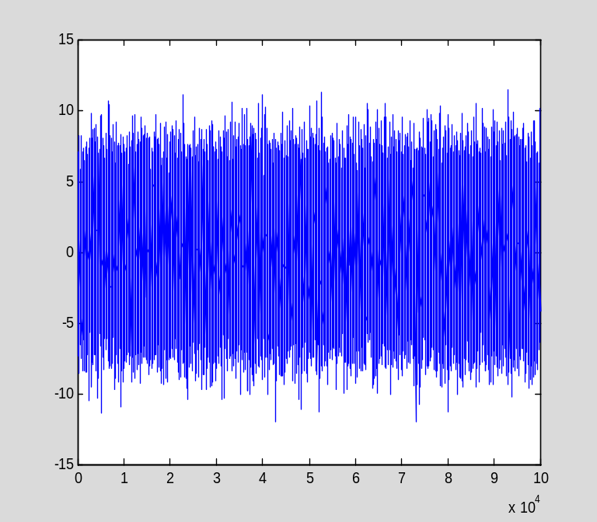

%Zoom in and plot for 1 second
plot(x(1:1000));

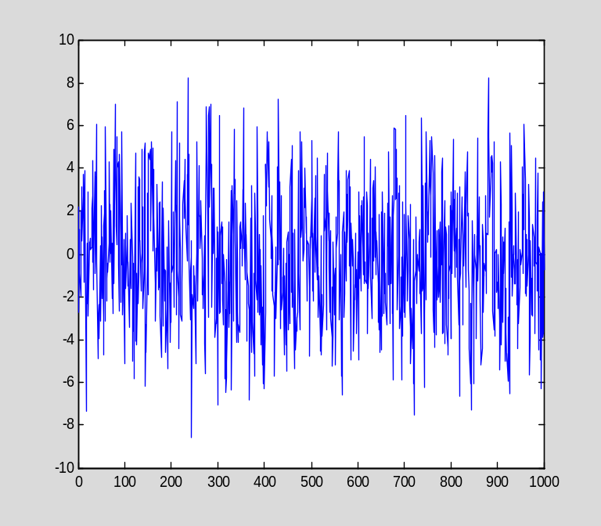

% run spectral analysis using welch method and toolbox
% and plot
cd 'Y:\UserData\NexStepBiomarkers\NSB_AnalyticFramework';

options.SPTmethod = 'welch';
profile on;
starttime = tic;
[Pyy,CI,T,F,validBins,status] = NSB_SpectralAnalysis(x, 10, fs,options);
toc(starttime);
profile viewer;

Elapsed time is 23.559955 seconds.

goertzel() 10.061 s << main time sink.

%pyy is a 2D plot so use mesh
figure; plot(F(1,1:60),Pyy(1,1:60));hold on;
plot(F(1,1:60),CI.Lo(1,1:60),':','Color',[0.2,0.2,0.2]);
plot(F(1,1:60),CI.Hi(1,1:60),':','Color',[0.2,0.2,0.2])

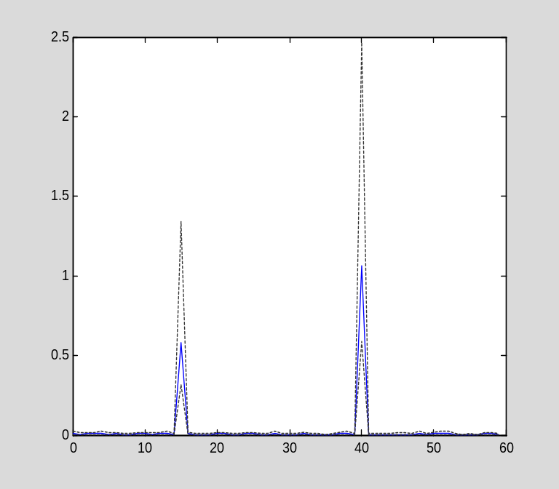

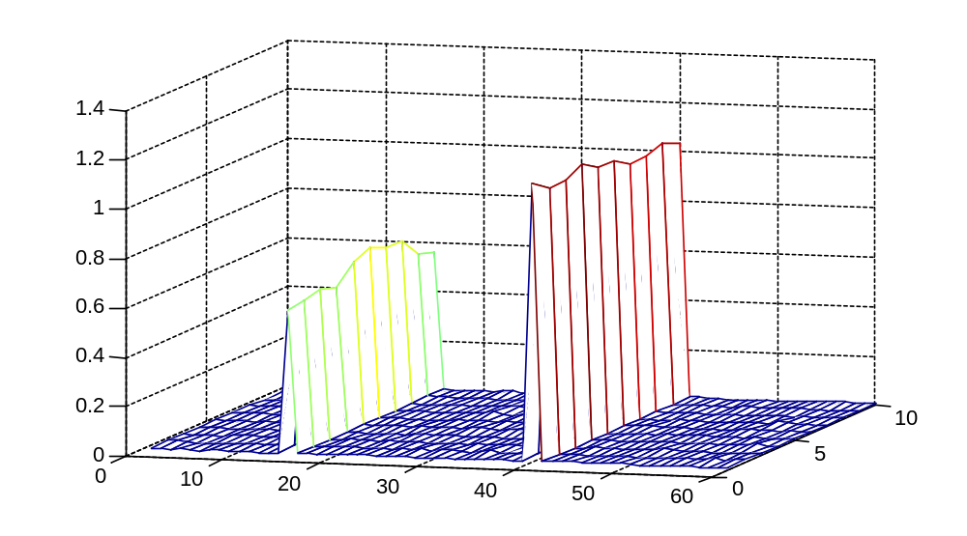
Acurate frequency response, consistant over crossvalidations

% run spectral analysis using mtm method and toolbox
% and plot

options.SPTmethod = 'mtm';
profile on;
starttime = tic;
[Pyy,CI,T,F,validBins,status] = NSB_SpectralAnalysis(x, 10, fs,options);
toc(starttime);
profile viewer;

Elapsed time is 5.635496 seconds.

SB_SpectralAnalysis 9.070 s << main time sink.

%pyy is a 2D plot so use mesh
figure; plot(F(1,1:60),Pyy(1,1:60));hold on;
plot(F(1,1:60),CI.Lo(1,1:60),':','Color',[0.2,0.2,0.2]);
plot(F(1,1:60),CI.Hi(1,1:60),':','Color',[0.2,0.2,0.2])

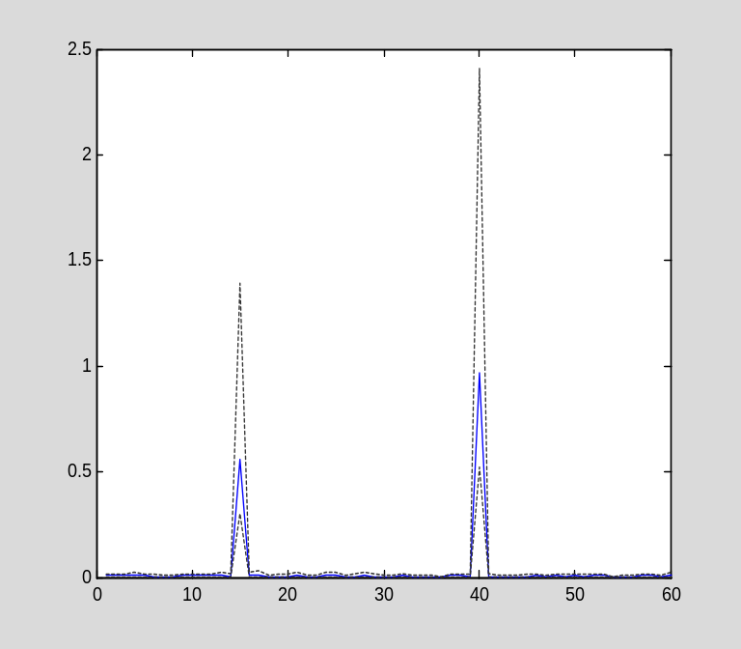

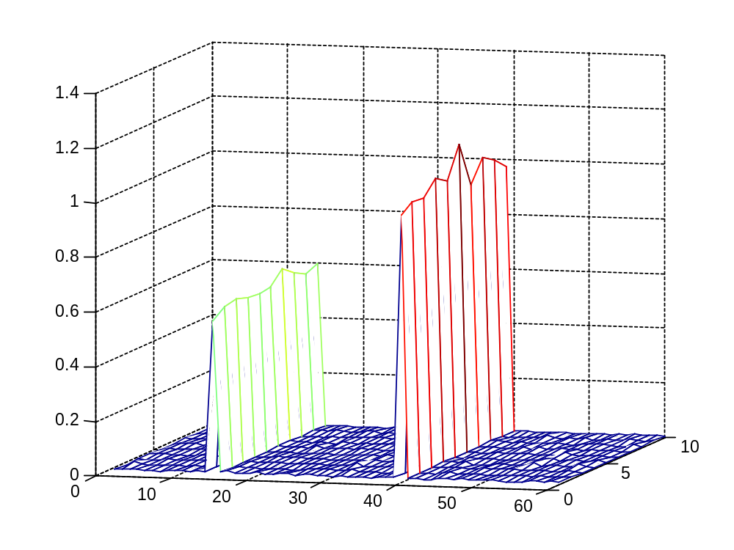
Same as welch

% run spectral analysis using FFT method without toolbox
% and plot

options.SPTmethod = 'FFT';
profile on;
starttime = tic;
[Pyy,CI,T,F,validBins,status] = NSB_SpectralAnalysis(x, 10, fs,options);
toc(starttime);
profile viewer;

Elapsed time is 0.185863 seconds.

NSB_SpectralAnalysis 0.058 s << main time sink.

%pyy is a 2D plot so use mesh
figure; plot(F(1,1:60),Pyy(1,1:60));

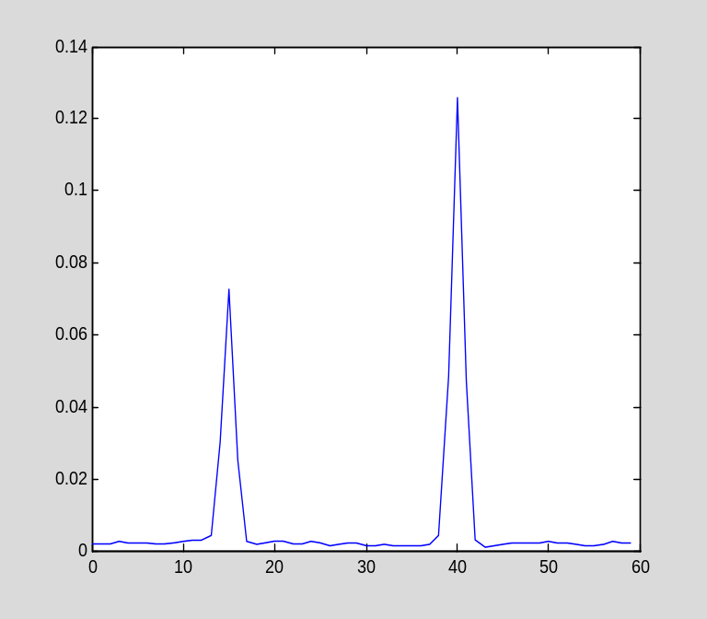

Extremely fast, Scaling is a bit off likely due to windowing and other differences between MTM/Welch object and raw FFT code.

ToDo:
Beat up parameters to see if errors

