**DATA ANALYSIS OF CRIME AGAINST WOMEN IN INDIA**

*EPICS PROJECT REPORT*

*Submitted by*

**P.CHANDANA (208W1A1245)**

**CH.DEVI LIKHITHA (208W1A1210)**

**SHAIK SHAHIN (218W5A1206)**

*Under the Guidance of*

**DR.K.Sita kumari**

**Assistant Professor**

*For the award of the degree*

**BACHELOR OF TECHNOLOGY**

**IN**

**INFORMATION TECHNOLOGY**



**DEPARTMENT OF INFORMATION TECHNOLOGY**

**V R SIDDHARTHA ENGINEERING COLLEGE**

**(AUTONOMOUS - AFFILIATED TO JNTU-K, KAKINADA)**

**Approved by AICTE &Accredited by NBA**

**KANURU, VIJAYAWADA-7**

**ACADEMIC YEAR**

**(2022-23)**

**V.R. SIDDHARTHA ENGINEERING COLLEGE**

(Affiliated to JNTUK: Kakinada, Approved by AICTE, Autonomous)

(An ISO certified and NBA accredited institution)

Kanuru, Vijayawada – 520007



**CERTIFICATE**

This is to certify that this project report titled **“DATA ANALYSIS OF CRIME AGAINST WOMEN IN INDIA”** is a Bonafede record of work done by **P.CHANDANA(208W1A1245),CH.DEVILIKHITHA(208W1A12C3),(218W5A1206) SK.SHAHIN** under my guidance and supervision is submitted in partial fulfillment of the requirements for the award of the degree of Bachelor of Technology in Information Technology, **V.R. Siddhartha Engineering College** (Autonomous under JNTUK) during the year **2021-2022**.

**Dr.K. SITA KUMARI Dr. M. SUNEETHA**

Assistant Professor Professor & Head

Dept. of Information Technology Dept. of Information Technology

**TABLE OF CONTENTS**

ACKNOWLEDGEMENT iii

LIST OF FIGURES iv

ABSTRACT v

**CHAPTER-1 Introduction**  1

1.1 Origin of the Problem 1

1.2 Basic definitions and Background 2

1.3 Problem Statement with Objectives and Outcomes 4

1.4 Real time Applications of Proposed work 5

**CHAPTER-2 Review of Literature**  6

2.1 Description of Existing Systems 6

2.3 Summary of Literature Review 9

**CHAPTER-3 Proposed Method** 10

3.1 System Architecture Diagram 10

3. Description of datasets, Requirements and Tools 11

**CHAPTER-4 Results and Observations** 12 4.1 Stepwise description of Results 14

4.2 Test case results/Result Analysis 14

4.3 Observations from the work 16

**CHAPTER-5 Conclusion and Future work**  18

5.1 Conclusion 18

5.2 Future study 18

References 19

**ACKNOWLEDGEMENT**

First and foremost, I sincerely salute our esteemed institution **V.R SIDDHARTHA ENGINEERING COLLEGE** for giving me this opportunity for fulfilling my project. I am grateful to our principal **Dr. A.V.RATNA PRASAD**, for his encouragement and support all through the way of my project.

On the submission of this Project report, I would like to extend my honour to **Dr. M. Suneetha**, Head of the Department, IT for her constant motivation and support during the course of my work.

I feel glad to express my deep sense of gratefulness to my project guide **DR.K.SitaKumari Assistant Professor** for her guidance and assistance in completing this project successfully.

I would also like to convey my sincere indebtedness to all faculty members, including supporting staff of the Department, friends and family members who bestowed their great effort and guidance at appropriate times without which it would have been very difficult on my part to finish the project work.

**LIST OF FIGURES**

**Figure Page**

Figure 3.1: System Architecture Diagram 12

Figure 3.4: Dataset 13

Figure 4.2.1: Total Crime state wide 14

Figure 4.2.2: Sum of assault of women with intent to outrage 14

Figure 4.3.1: State wise and Year wise sum of rape 15

Figure 4.3.2 State wise sum of rape 15

**ABSTRACT**

Crime against women, a global human rights issue, has emerged as impediment to the ideals of equality and freedom. Crime against women is a powerful control of their lives; it affects women of every age, ethnicity, region or religion. Studies have found that women are most at risk from men known to them. Methodologically, this paper is based on data extracted from NCRB reports and supplemented by other published resources such as books, articles and reports of governmental/ non-governmental organizations. This paper attempts to examine various types of crimes committed against women. It also attempts to engage rather theoretically with the notions of and inter-linkages between law, crime and women. Towards the end, the paper offers an analysis of various crimes committed against women in India, in addition to exploring the consequences thereof. This paper will serve as a guide to design mechanisms to counter this menace.

ABSTRACT

The criminal cases in India are increasing rapidly due to which number of

cases pending are also piling up. This continuous increase in the criminal cases is

proving to be difficult to be classified and to be solved. Recognizing the criminal activity

patterns of a place is important in order to prevent it from happening. The crime solving

agencies can do a better work if they have a good idea of the pattern of criminal activities

that are happening in a particular area. This can be done by using machine learning by

employing different algorithms to find the patterns of the criminal activities in a

particular area. This paper uses crime data set and predicts the types of crimes in a

particular area which helps in speeding up the classification of criminal cases and

ABSTRACT

The criminal cases in India are increasing rapidly due to which number of

cases pending are also piling up. This continuous increase in the criminal cases is

proving to be difficult to be classified and to be solved. Recognizing the criminal activity

patterns of a place is important in order to prevent it from happening. The crime solving

agencies can do a better work if they have a good idea of the pattern of criminal activities

that are happening in a particular area. This can be done by using machine learning by

employing different algorithms to find the patterns of the criminal activities in a

particular area. This paper uses crime data set and predicts the types of crimes in a

particular area which helps in speeding up the classification of criminal cases and

**Keywords**: Women in India, Assault On Women with Intent to Outrage Her Modesty.

**CHAPTER -1**

**Introduction**

It provides an overview of the project's goal, inception, and applications. It also outlines the project's requirement and scope, as well as showing project stoppers, which detail where the project is appropriate.

* 1. **Origin of the problem**

The National Crime Records Bureau data brings out a scary picture of India, a country where women are revered as goddesses. Most women between ages 18 to 30 are vulnerable and are not even safe in their homes as they are targeted by husbands, relatives or friends. Despite various rules and regulations, evil social practices such as dowry, genital mutilation continue. More than a third of the reported cases fall in the category of cruelty by husbands or relatives.

Assam has the highest rate of crimes against women in 2021. Odisha, Haryana, Rajasthan, Maharashtra, West Bengal and Telangana are also among worst places for women. Uttar Pradesh comes on top in terms of highest number of cases registered. There has been a 40% increase in crimes against women and children in the national capital territory of Delhi in 2021. The rate has risen by over 15%, the NCRB data says.

**1.2 Basic Definitions and Background**

In the 1980s, Gelles identified eight domestic violence theoretical streams. Throughout the last few decades, however, the literature has increasingly become divided into two distinct opposing perspectives those who support a “feminist” approach, and those who support a “family violence” approach. The central debate between these two camps is over whether research should focus on the underlying patriarchal causes of violence against women, or on the structural inequalities and individual dynamics of violence perpetrated by both partners in the home (Dutton & Nicholls, Straus). Romans et al. have suggested that this theoretically based division is exacerbated by narrowly enacted research agendas, on both sides; specifically, “different research methodologies capture different types of interpersonal violence preferentially”. The two paradigms and their advocates, therefore, appear to conflict on both theoretical and methodological grounds.

**1.3 Problem Statement with Objectives and Outcomes**

**1.3.1 Problem Statement:**

* The main objective of this project is to understand whether the rate of Crime against Women has increased or decreased.
* To estimate which cities has maximum crime rate.
* To analyze violent crimes occurring in a particular region in such a way that it can be used by police to reduce crime rates in the society.

**1.3.2 Objectives:**

* To uncover previously unseen problems
* To find patterns that can help improve the quality and efficiency of the justice system.
* Law enforcement agencies from across the nation can input data from crime scenes into databases designed to find connections between cases

**1.3.3 Outcomes:**

* Proactively informs law enforcement officers of crime trends and develops threat
* vulnerability, and risk assessments
* Criminal Identification
* Helps solve criminal investigations

**CHAPTER-2**

**Review of Literature**

A literature review is a piece of academic writing demonstrating knowledge and understanding of the academic literature on crimes happening against women in india.

**2.1 Description of Existing Systems**

This section primarily focuses on research publications, covering the paper's primary details. It contains the findings and conclusions from each study**.**

* + 1. **Learning to detect patterns of crime**

**Authors:** **Wang, Tong, et al.**

**Year of publishing:** 2022

**Observations:**

Our goal is to automatically detect patterns of crime. Among a large set of crimes that happen every year in a major city, it is challenging, time-consuming, and labor-intensive for crime analysts to determine which ones may have been committed by the same individual(s). If automated, data-driven tools for crime pattern detection are made available to assist analysts, these tools could help police to better understand patterns of crime, leading to more precise attribution of past crimes, and the apprehension of suspects

**2.1.2 Crime Analysis: a general framework and some examples**

**Authors:** Chen, H.,Xu, J J Wangsac, Qin Y

**Year of publishing:** 2020

**Observationss:**

A major challenge facing all law-enforcement and intelligence-gathering

organizations is accurately and efficiently analyzing the growing volumes of crime

data. Detecting cybercrime can likewise be difficult because busy network traffic and

frequent online transactions generate large amounts of data, only a small portion of

which relates to illegal activities. Data mining is a powerful tool that enables criminal

investigators who may lack extensive training as data analysts to explore large

databases quickly and efficiently. We present a general framework for crime data

mining that draws on experience gained with the Coplink project, which researchers

at the University of Arizona have been conducting in collaboration with the Tucson

and Phoenix police departments since 1997

A major challenge facing all law-enforcement and intelligence-gathering

organizations is accurately and efficiently analyzing the growing volumes of crime

data. Detecting cybercrime can likewise be difficult because busy network traffic and

frequent online transactions generate large amounts of data, only a small portion of

which relates to illegal activities. Data mining is a powerful tool that enables criminal

investigators who may lack extensive training as data analysts to explore large

databases quickly and efficiently. We present a general framework for crime data

mining that draws on experience gained with the Coplink project, which researchers

at the University of Arizona have been conducting in collaboration with the Tucson

and Phoenix police departments since 1997

A major challenge facing all law-enforcement and intelligence-gathering

organizations is accurately and efficiently analyzing the growing volumes of crime

data. Detecting cybercrime can likewise be difficult because busy network traffic and

frequent online transactions generate large amounts of data, only a small portion of

which relates to illegal activities. Data mining is a powerful tool that enables criminal

investigators who may lack extensive training as data analysts to explore large

databases quickly and efficiently. We present a general framework for crime data

mining that draws on experience gained with the Coplink project, which researchers

at the University of Arizona have been conducting in collaboration with the Tucson

and Phoenix police departments since 1997.

A major challenge facing all law-enforcement and intelligence-gathering

organizations is accurately and efficiently analyzing the growing volumes of crime

data. Detecting cybercrime can likewise be difficult because busy network traffic and

frequent online transactions generate large amounts of data, only a small portion of

which relates to illegal activities. Data mining is a powerful tool that enables criminal

investigators who may lack extensive training as data analysts to explore large

databases quickly and efficiently. We present a general framework for crime data

mining that draws on experience gained with the Coplink project, which researchers

at the University of Arizona have been conducting in collaboration with the Tucson

and Phoenix police departments since 1997.

A major challenge facing all law-enforcement and intelligence-gathering

organizations is accurately and efficiently analyzing the growing volumes of crime

data. Detecting cybercrime can likewise be difficult because busy network traffic and

frequent online transactions generate large amounts of data, only a small portion of

which relates to illegal activities. Data mining is a powerful tool that enables criminal

investigators who may lack extensive training as data analysts to explore large

databases quickly and efficiently. We present a general framework for crime data

mining that draws on experience gained with the Coplink project, which researchers

at the University of Arizona have been conducting in collaboration with the Tucson

and Phoenix police departments since 1997.

A major challenge facing all law-enforcement and intelligence-gathering

organizations is accurately and efficiently analyzing the growing volumes of crime

data. Detecting cybercrime can likewise be difficult because busy network traffic and

frequent online transactions generate large amounts of data, only a small portion of

which relates to illegal activities. Data mining is a powerful tool that enables criminal

investigators who may lack extensive training as data analysts to explore large

databases quickly and efficiently. We present a general framework for crime data

mining that draws on experience gained with the Coplink project, which researchers

at the University of Arizona have been conducting in collaboration with the Tucson

and Phoenix police departments

**2.1.****3** **Enhance Algorithm To Predict a crime**

**Authors:**Hardi, M.patel, Ripal patel

**Year of publishing:** 2021

**Observations:**

xtensively in terms of analysis and investigation of

patterns for occurrence of different crime. Data mining can be used to model crime

detection problems. Crimes are a social nuisance and cost our society dearly in several

ways. Our aim is to predict the crime and location in which specific types of crime

will occur. Our approach is based on sentimental analysis by applying lexicon-based

method. We have to use here twitter data set. We are predicting future crime in

particular area (illinoise, Chicago)

xtensively in terms of analysis and investigation of

patterns for occurrence of different crime. Data mining can be used to model crime

detection problems. Crimes are a social nuisance and cost our society dearly in several

ways. Our aim is to predict the crime and location in which specific types of crime

will occur. Our approach is based on sentimental analysis by applying lexicon-based

method. We have to use here twitter data set. We are predicting future crime in

particular area (illinoise, Chicago)

xtensively in terms of analysis and investigation of

patterns for occurrence of different crime. Data mining can be used to model crime

detection problems. Crimes are a social nuisance and cost our society dearly in several

ways. Our aim is to predict the crime and location in which specific types of crime

will occur. Our approach is based on sentimental analysis by applying lexicon-based

method. We have to use here twitter data set. We are predicting future crime in

particular area (illinoise, Chicago)

This is extensively in terms of analysis and investigations of patterns for occurance of different crime. This can be used to model crime dectection problems. Crimes are a social nuisance and cost our society dearly in several ways. Our aims is to predict the crime and location in which specific types of crime will occur. Our approach is based on sentimental analysis by applying lexicon based method.

* 1. **Summary of Literature Study**

Violence against women and girls is a human rights violation, and the immediate and long-term physical, sexual, and mental consequences for women and girls can be devastating, including death. Violence negatively affects women's general well-being and prevents women from fully participating in society.

**CHAPTER-3**

**Proposed Method**

This chapter focuses on a procedure for identifying plant leaf disease that produces excellent results.

**3.1 System Architecture Diagram**

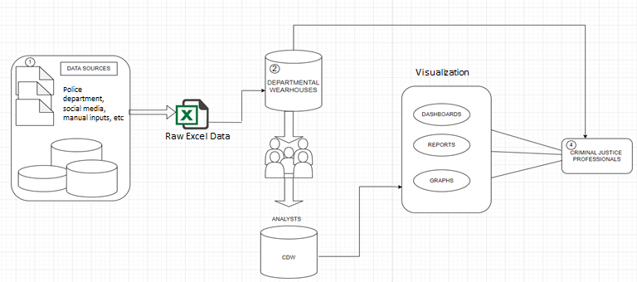

Figure 3.1: System Architecture Diagram

**3.2 Description of datasets, Requirements and Tools**

**3.2.1 Dataset:**

* The dataset was from the information collected by Ministry of Home Affairs, Department of States and National Crime Records Bureau (NCRB).
* The data refers to State/UT-wise crime committed against women categorized by different crime heads.The different crime heads covered are

1. Rape

2. Kidnapping and Abduction

3. Dowry Deaths

4. Assault On Women with Intent to Outrage Her Modesty

5. Insult To The Modesty Of Women

6. Cruelty By Husband Or His Relative

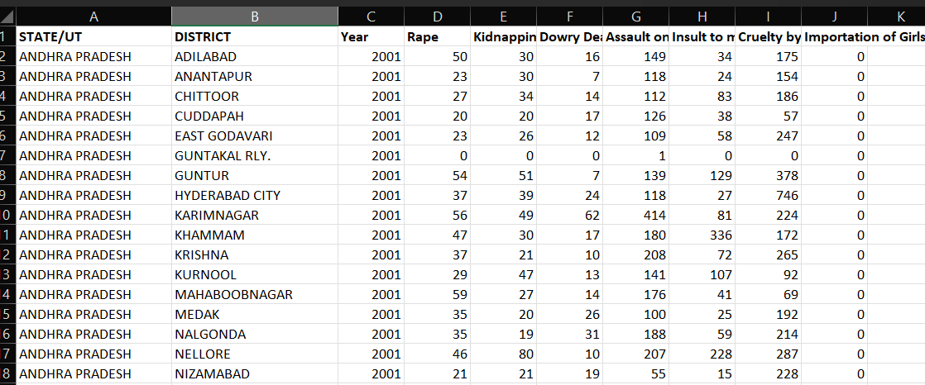

Figure 3.4: Dataset

**3.2.2 Software Requirements:**

* Python idel 3.7 version (or) Google Colab
* Visualization : Power BI
* Web Framework :

Frontend: HTML and CSS

Backend: Flask

.

**Chapter-4**

**Results & Observations**

**4.1 Stepwise description of Results**

* **Crime Records as Input** : It takes the crime records as input from various sources like police department, social media, manual inputs, etc.
* **Crime Analysis** : It makes an analysis on that crime records through visualization.
* Creating a blog website to showcase the result

**4.2 Test case results**

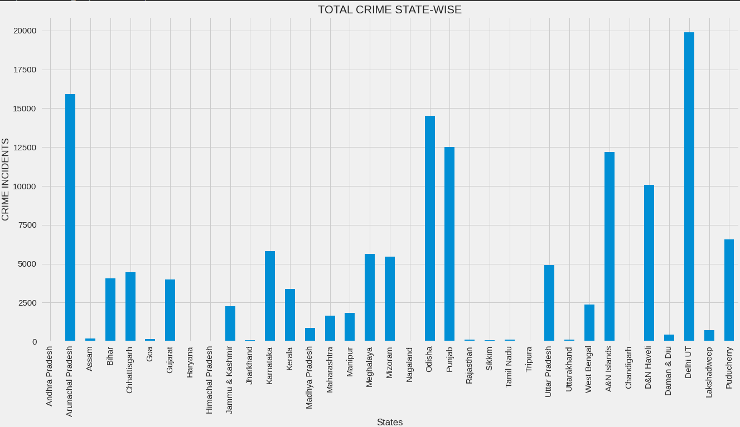

Figure 4.2.1: Total crimes state wide

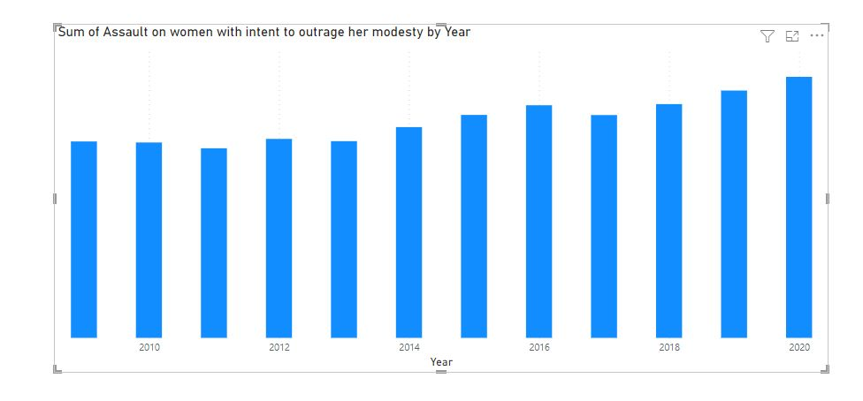

Figure 4.2.2: Sum of assault of women with intent to outrage

**4.3 Observations from the work**

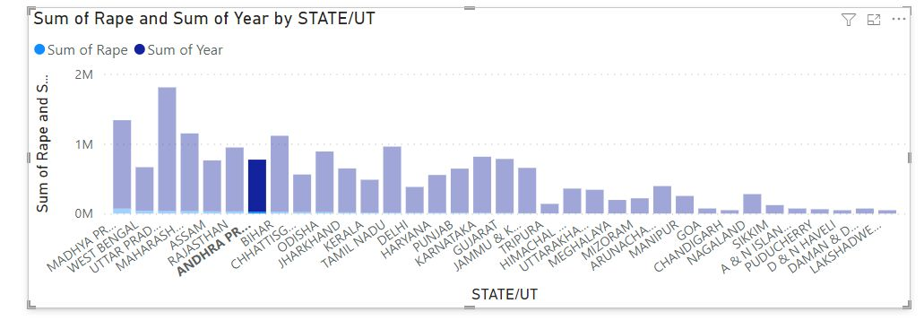

Figure 4.3.1: State wise and year wise sum of rape

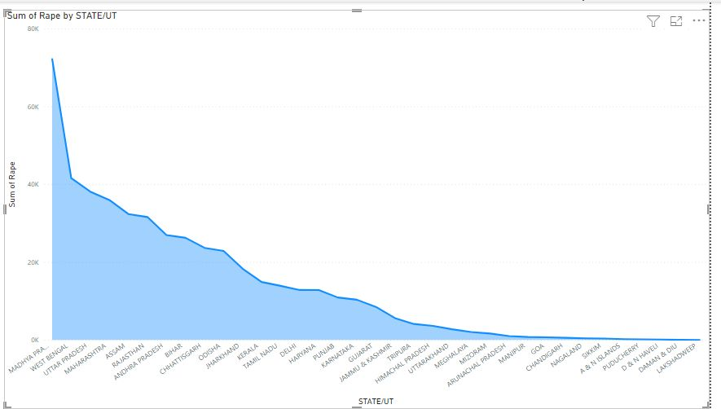

Figure 4.3.2 : State wise sum of rape

**CHAPTER-5**

**Conclusion and Future work**

**5.1 Conclusion**

In conclusion, I would like emphasize that sexual violence poses an obstacle to peace and security. It impedes women from participating in peace and democratic processes and in post-conflict reconstruction and reconciliation. As a tool of war it can become a way of life: once entrenched in the fabric of society, it lingers long after the guns have fallen silent. Many women lose their health, livelihoods, husbands, families and support networks as a result of rape. This, in turn, can shatter the structures that anchor community values, and with that disrupt their transmission to future generations. Children accustomed to acts of rape can grow into adults who accept such acts as the norm. This vicious cycle must stop, as we cannot accept a selective zero-tolerance policy

**References**

[1]  Quadir, Serajul (12 November 2017). [*"U.N. official says will raise sexual violence against Rohingya with ICC"*](https://www.reuters.com/article/us-bangladesh-myanmar-idUSKBN1DC0N7). Reuters*. Retrieved 12 November 2020*.

[2] [IGE](https://en.wikipedia.org/wiki/European_Institute_for_Gender_Equality) (24 August 2015). ["What is gender-based violence?"](http://eige.europa.eu/content/what-is-gender-based-violence). *eige.europa.eu*. [European Institute for Gender Equality](https://en.wikipedia.org/wiki/European_Institute_for_Gender_Equality). Retrieved 18 November 2013.

**DEPARTMENT OF INFORMATION TECHNOLOGY**

**V.R. SIDDHARTHA ENGINEERING COLLEGE**

**PROJECT SUMMARY**

|  |  |  |
| --- | --- | --- |
| S.No | Item | Description |
| 1 | **Project Title** | **DATA ANALYSIS OF CRIME AGAINST WOMEN** |
| 2 | **Batch Names & Numbers** | **P. Chandana (208W1A1245)**  **CH.Devi likhitha(208W1A1210)**  **SK.Shahin(218W5A1206)** |
| 3 | **Name of The Guide** | **Dr. K.Sita kumari** |
| 4 | **Name of The Mentor** | **Y.Sangeetha** |
| 5 | **Research Group** | **Data Analytics** |
| 6 | **Application Area** | **Criminal Law Of Enforcement** |
| 7 | **Aim of the Project** | **Data Analysis Of Crime Against Women** |
| 8 | **Project Outcomes** | **The goal of this work Proactively informs law enforcement officers of crime trends and develop threat,vulnerability, and risk assessments,Criminal Identification**  **Helps solve criminal investigations** |

**Student Signatures**

1. **P. Chandana**
2. **CH. Devi likhitha**
3. **SK. Shahin**