Game Design Document

Fill up the Following document

1. Write the title of your project.

SpaceGame

1. What is the goal of the game?

Reach to end with out crashing the rocket

1. Write a brief story of your game?

You are a astronaut trying to reach a unknow planet. The path to the planet is very dangerous

You make your way through the asteroid .You can choose one your space craft out of three

1. Which are the playing characters of this game?

* Playing characters are the ones which respond to the user based on the input from the user
* Cars, monkeys, dinos, wizards etc, are the playing characters in the game.

|  |  |  |
| --- | --- | --- |
| Number | Character Name | What can this character do? |
| 1 | Rocket | Move though space |
| 2 | Special power | Clear path |
| 3 |  |  |
| 4 |  |  |
| 5 |  |  |
| 6 |  |  |
| 7 |  |  |
| 8 |  |  |

1. Which are the Non Playing Characters of this game?

* Non Playing characters are the ones which don't have an action or a behaviour when the user interacts with the game.
* Hurdles, stones, bananas, coins, etc are non playing characters in the game.

|  |  |  |
| --- | --- | --- |
| Number | Character Name | What can this character do? |
| 1 | Asteroids | Obstruct path |
| 2 | UFO | Shoot you |
| 3 |  |  |
| 4 |  |  |
| 5 |  |  |
| 6 |  |  |
| 7 |  |  |
| 8 |  |  |

Draw your imagination of this game. What does this game look like?

* Draw the game either on your computer or on paper,
* Add images of scenes of the game to show each of the playing and non-playing characters at least once.

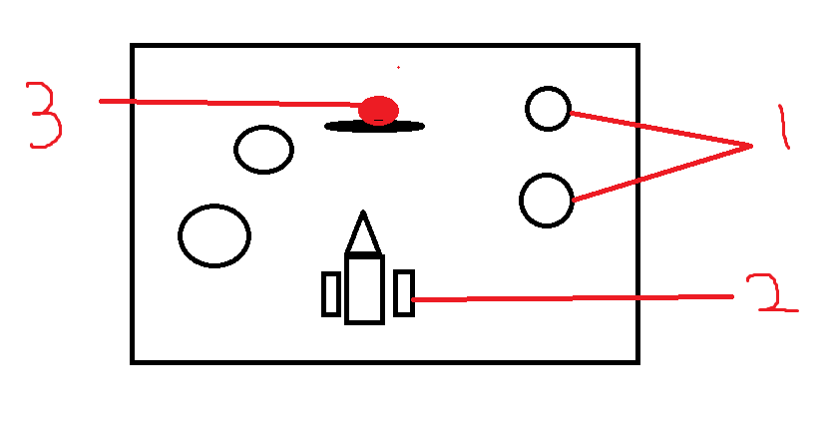

1-Asteroids

2-Rocket

3-UFO

How do you plan to make your game engaging?

You have to battle UFOS and escape asteriods and collects points to get power ups