ULTIMATE CRYPTO GAMBLING ANALYSIS Complete Technical & Player Investigation of Proov Network
I EXECUTIVE SUMMARY
 | This comprehensive investigation reveals that while Proov Network uses sophisticated cryptographic techniques (VRF proofs, Ed25519 signatures), the fundamental trust model is centralized. All oracles are controlled by the same entity, creating significant risks for players.
 |  | Technical Detail | Player Impact | Risk Level
Centralized Oracles |  | All VRF oracles control | led by Proov Cannot verify true rand | omness I HIGH
Off-chain Logic |  | Game algorithms exec | uted off-chain Cannot audit game fair | ness I HIGH
Limited Audit Scope |  | Halborn only audited s | mart contracts RNG/fairness not verifi | edI HIGH
No Regulatory Over |  | sight Operates without gamb | ling licenses No player protection | I HIGH
Hidden Odds |  | Win probabilities not di | sclosed Players gambling blind | I HIGH
VRF Implementatio |  | n Cryptographically soun | dMath is verifiable | I LOW
Blockchain Recordi |  | ngTransactions properly r | ecorded Payout transparency | I LOW

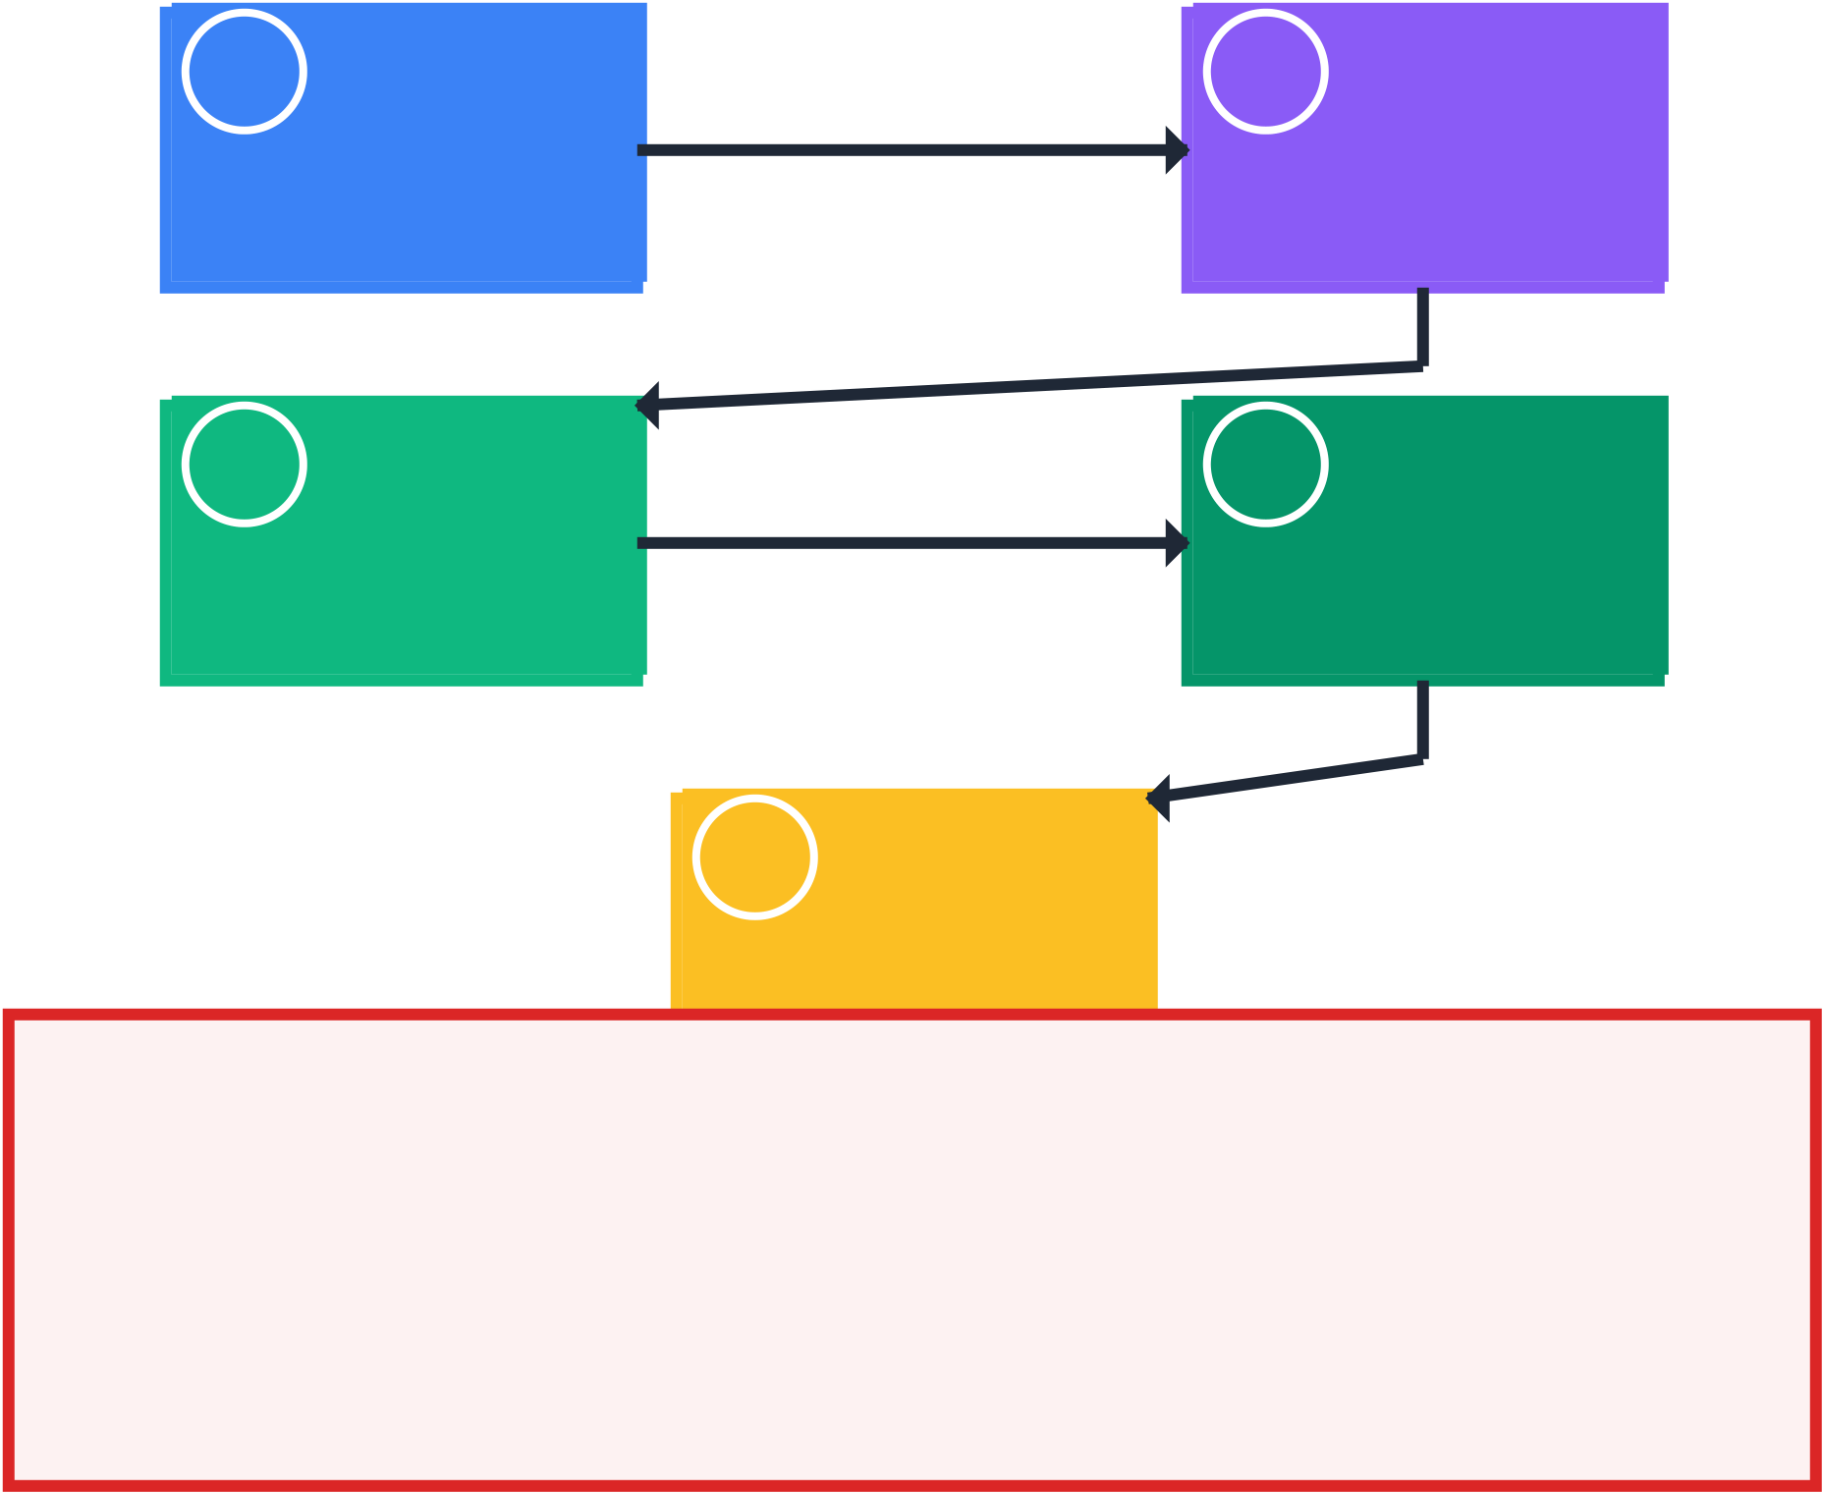
PART I: THE COMPLETE PLAYER JOURNEY
Complete Player Journey: What REALLY Happens
1Player Action  • Click 'SPIN'  • Money leaves wallet  • Bet recorded  Game Algorithm  • Randomness processed  • Outcome calculated  • Payout determined | 2Oracle Network  • VRF proof generated  • Multiple signatures  • Cryptographically valid  4Result Display  • Outcome shown  • Transaction posted  • Blockchain record
5 Verification
• 7-step process
• Cryptographic proof
• Mathematical validity
I CRITICAL TRUST ISSUES
1. All oracles controlled by same company - no independence 2. Verification only checks math, not oracle coordination 3. No external oversight or independent auditing
4. Players must trust company won't manipulate outcomes 5. No legal recourse if manipulation is discovered
Detailed Step-by-Step Analysis:
Step 1 - Player Action: You click 'SPIN' and your money immediately leaves your wallet. This part is transparent and verifiable on the blockchain.
Step 2 - Oracle Network: Multiple oracles generate VRF proofs. While cryptographically valid, all oracles are controlled by Proov Network.
Step 3 - Game Algorithm: Your outcome is calculated using the VRF output. The math is correct, but relies on the centralized randomness.

Step 4 - Result Display: The predetermined outcome is shown to you and recorded on blockchain. You see the result, not the process.
Step 5 - Verification: The 7-step verification process confirms mathematical correctness but cannot verify oracle independence.

PART II: COMPREHENSIVE RISK ASSESSMENT
Comprehensive Risk Assessment Matrix
  HIGH | Legal Risk
  No Regulatory Protection
  MEDIUM
  Operational Risk
  Key Management
  HIGH | Technical Risk
  Oracle Centralization
  HIGH | Financial Risk
  Payout Manipulation
  HIGH
  Transparency Risk
  Hidden Odds
  MEDIUM
  Verification Risk
  Limited Audit Scope

Risk Level Guide HIGH: Significant player risk, minimal protection MEDIUM: Moderate risk, some mitigation possible
Comparison with Traditional Gambling:
Aspect | Traditional License | d Casino Proov Network | Risk Assessment
Randomness Sou | rceCertified physical/digita | l RNG Company-controlled V | RF oracles I Higher risk
Regulation | Government licensed & | audited Self-regulated | I Higher risk
Odds Disclosure | Required by law | Not disclosed | I Higher risk
Dispute Resolutio | n Gambling commission | No clear process | I Higher risk
Audit Scope | Full game auditing | Limited to smart contra | ctsI Higher risk
Technology | Traditional systems | Advanced cryptograph | y I More sophisticate
Transparency | Regulated transparenc | y Blockchain transparenc | yI Different model


PART III: ALGORITHM & VERIFICATION ANALYSIS
MADAMEFORTUNE Algorithm Flow Analysis
VRF Input | Hash to Int | Weight Map | Multiplier
Cryptographic | Convert to | Map to outcome | Calculate final
randomness | uniform integer | weight ranges | payout amount
 |  |  | independently verified
  Distribution
  5000x: 100 weight 1000x: 400 weight ...
  Total Weight Sum all possible
  outcome weights
  Selection
  Random integer selects outcome
  Verification Math can be

I ALGORITHM ANALYSIS
Mathematics are sound and verifiable
Code implementation matches published algorithms II BUT: Randomness source is controlled by single entity
VRF Implementation Analysis:
# Core VRF verification function (simplified) def verify_vrf(public_key: bytes, message: bytes, proof: bytes) -> tuple[bool, bytes]: gamma = proof[:32] # VRF output point c = proof[32:48] # Challenge hash s = proof[48:] # Scalar response # Verify proof equations h = hash_to_curve(public_key, message) U = s*B - c*public_key # Equation 1 V = s*h - c*gamma # Equation 2 # Check if proof is valid valid = hash_points(h, gamma, U, V) == c randomness = hash(gamma) if valid else b"" return valid, randomness
Critical Analysis:
The VRF implementation is cryptographically sound and follows established standards. However, the security depends entirely on the assumption that oracle private keys are independently controlled and not coordinated.

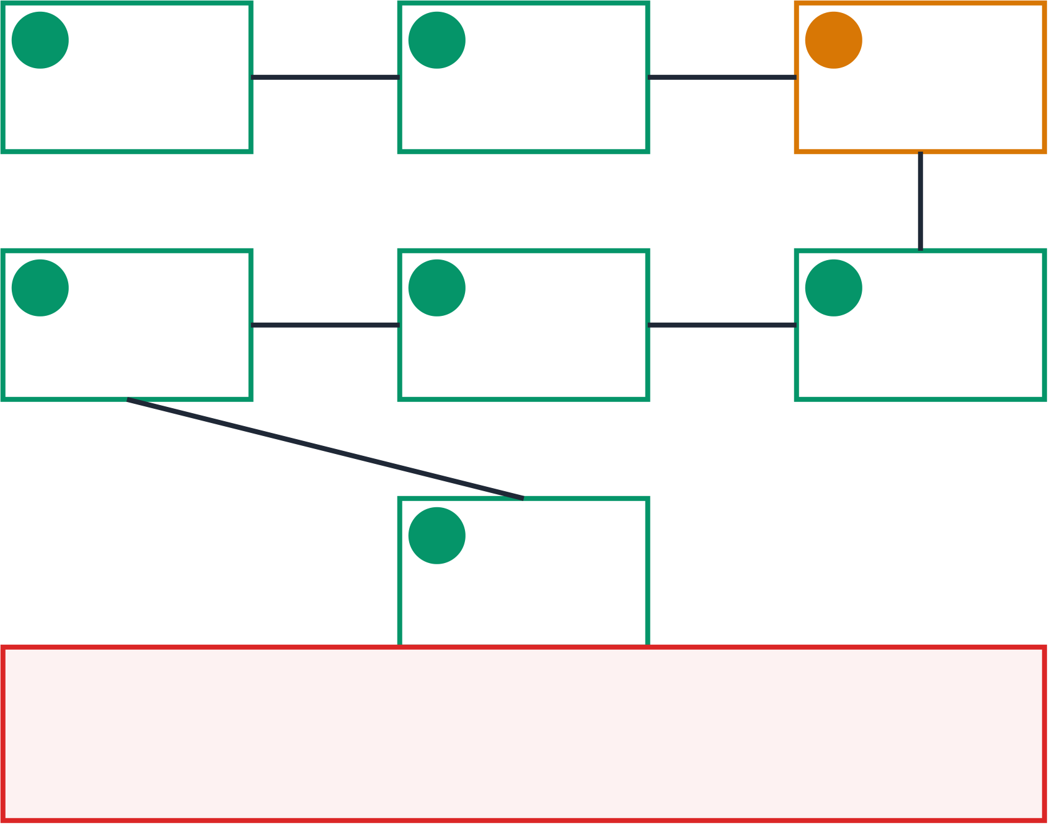
PART IV: VERIFICATION PROCESS DEEP DIVE
Proov's 7-Step Verification Process (Detailed)
1Login Signature | 2 Bet Request | 3 Oracle VRF
Wallet signs login message | Auth key signs bet request | Oracles generate VRF proof
SECURE | SECURE | II TRUST REQUIRED
4 Payout Calc | 5Shard Award | 6 Settlement

Algorithm calculates payout | Bonus shard calculation | Settlement math verification
VERIFIABLE | VERIFIABLE | VERIFIABLE
7 Blockchain
On-chain transaction match
VERIFIABLE
II STEP 3 CRITICAL ANALYSIS
VRF verification only confirms cryptographic validity
It does NOT verify oracle independence or prevent coordination All oracles could be controlled by the same entity

PART VI: CONCLUSIONS & RECOMMENDATIONS
For Players:
Understand the Risks: This platform has higher risks than licensed casinos due to centralized control. No Regulatory Protection: You have no gambling commission to appeal to if issues arise.
Hidden Odds: You're gambling without knowing your true chances of winning.
Trust Requirements: You must trust that the company won't manipulate outcomes.
For Journalists & Investigators:
Focus on Centralization: The key issue is oracle control, not cryptographic validity. Compare to Standards: Contrast with truly decentralized systems like Chainlink VRF. Investigate Patterns: Look for suspicious win patterns from specific wallets.
Regulatory Gaps: Highlight the lack of oversight in crypto gambling.
For the Platform (Proov Network):
Decentralize Oracles: Use independent third-party oracle providers. Publish Odds: Disclose win probabilities for all games.
Independent Audit: Have RNG and fairness audited by external firms. Transparency Reports: Publish regular fairness and operation reports.
BOTTOM LINE: While Proov Network uses advanced cryptography, the centralized trust model creates risks that players should understand. The platform would benefit from true decentralization and regulatory oversight to protect players.
Complete Analysis Report | Generated: 2025-09-07 17:54:39 | Transaction:
2U3HXJiFXgqzSSbRTMWedrv1NGKydjytpBBfByWPpXrTTLp5NBtwsfuDxmsVoUpqYs6Rz31c1RAnWCUZp3bJ8ZPs | Analysis covers: Player Journey, Risk Assessment, Algorithm Analysis, Verification Process, and Recommendations

