S E - C o m p - A O b j e c t O r i e n t e d P r o g r a m m i n g L a b
Shubham malik 3249

Experiment No.4

- Title: Demonstrate use of File Handling Concept.

- Problem Statement:

Write a C++ program that creates an output file, writes information to it, closes the file and open it again as an input file and read the information from the file.

- Objectives:

  - To learn and understand file handling functions.

  - To demonstrate file reading and writing functions on a file.

- Outcomes:

Students will be able to learn and understand file handling operations.

- Software/Hardware/Other Requirements:

Any CPU with Pentium Processor / similar, 256 MB RAM/ more, 1GB HDD / more. Operating System – ubuntu/Fedora 64bit OS
Software: G++ compiler/ GCC compiler, Code Editor

- Theory: A. File

A file is a stream of bytes/ set of characters stored on some secondary storage devices. Types of Files:

o Text file: A text file stores information in readable and printable form. Each line of text is terminated with an EOL (End of Line) character.
o Binary file: A binary file contains information in the non-readable form i.e. in the same format in which it is held in memory.

We can read as well as write data in the file whenever required.

File handling possible with stream classes. I/O system handles file more like input output with console.

Stream which feeds data to program through file is known as file input stream. Stream which stores program data to file is known as output file stream.
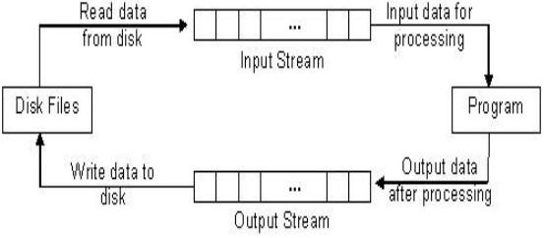

Fig: Working of Disk File IO

36 | P a g e A r m y I n s t i t u t e o f T e c h n o l o g y , P u n e

S E - C o m p - A O b j e c t O r i e n t e d P r o g r a m m i n g L a b

B. Stream:

A stream is a sequence of bytes. It acts as source from which the input data can be obtained or as a destination to which the output data can be sent.
1. InputStream

Input Streams are used to hold input from a data producer, such as a keyboard, a file, or a network. The source stream that provides data to the program is called the input stream. A program extracts the bytes from the input stream.

In most cases the standard input device is the keyboard. With the cin and “extraction” operator (>>) it is possible to read input from the keyboard.

2. OutputStream

Output Streams are used to hold output for a particular data consumer, such as a monitor, a file, or a printer. The destination stream that receives data from the program is called the output stream. A program inserts the bytes into an output stream. By default, the standard output of a program points at the screen.

So, with the cout operator and the “insertion” operator (<<) you can print a message onto the screen.

iostream standard library provides cin and cout methods for reading from standard input and writing to standard output respectively.

File handling provides three new datatypes:


Data Type |  | Description
ofstream |  | This data type represents the output file stream and is used to create files
 |  | and to write information to files.
ifstream |  | This data type represents the input file stream and is used to read
 |  | information from files.
fstream |  | This data type represents the file stream generally, and has the capabilities
 |  | of both ofstream and ifstream which means it can create files, write
 |  | information to files, and read information from files.

C. Opening a File:

A file must be opened before you can read from it or write to it.

Either the ofstream or fstream object may be used to open a file for writing and ifstream object is used to open a file for reading purpose only.
Following is the standard syntax for open () function, which is a member of fstream, ifstream, and ofstream objects.

void open (const char *filename, ios::openmode mode);

Here, the first argument specifies the name and location of the file to be opened and the second argument of the open () member function defines the mode in which the file should be opened.
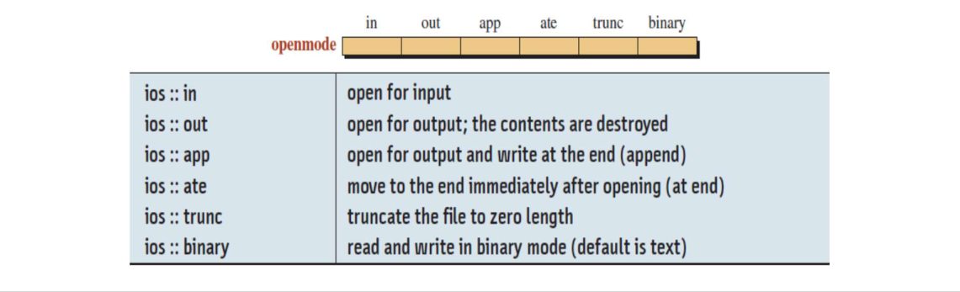

37 | P a g e A r m y I n s t i t u t e o f T e c h n o l o g y , P u n e

S E - C o m p - A O b j e c t O r i e n t e d P r o g r a m m i n g L a b

D. Closing a File:

When a C++ program terminates it automatically closes flushes all the streams, release all the allocated memory and close all the opened files. But it is always a good practice that a programmer should close all the opened files before program termination.

Following is the standard syntax for close () function, which is a member of fstream,

ifstream, and ofstream objects.

void close ();

E. Writing to a File:

While doing C++ programming, you write information to a file from your program using the stream insertion operator (<<) just as you use that operator to output information to the screen. The only difference is that you use an ofstream or fstream object instead of the cout object.

F. Reading from a File:

You read information from a file into your program using the stream extraction operator (>>) just as you use that operator to input information from the keyboard.

The only difference is that you use an ifstream or fstream object instead of the cin object.

- getline() Function:

For reading line by line file we require the getline() function

getline() is a standard library function in C++ and is used to read a string or a line from input stream.

Prototype Syntax:

Syntax 1: istream& getline (istream& is, string& str, char delim);

o is : object of istream/ifstream class and tells the function about the stream from where to read the input from.
o str : string object, the input is stored in this object after being read from the stream.
o delim : delimitation character which tells the function to stop reading further input after reaching this character. It is optional. Default is ‘\n’.
Syntax 2: istream& getline (istream& is, string& str, streamsize n); o The second declaration is almost same as that of the first one.

o The only difference is, it does not accept streamsize(including terminating null character).

So basically, what the getline function does is extracts characters from the input stream and appends it to the string object until the delimiting character is encountered.

- Detecting End-of-File

When we read a file little by little. We will eventually encounter an end-of-file(EOF) condition.

The EOF is a signal sent to the program from the operating system when there is no more data to read.

38 | P a g e A r m y I n s t i t u t e o f T e c h n o l o g y , P u n e

S E - C o m p - A | O b j e c t O r i e n t e d P r o g r a m m i n g L a b
1. For this we will checking an eof bit by using eof() method. Like:
while(!infile.eof()) | //until eof encountered

{ …..}

- Alternatively we check good bit too through good() method. Like:

while(infile.good()) //until any error encountered 3. You can also test the stream directly.
- Any stream object, such as infile, has a value that can be tested for usual error conditions including EOF. If any such condition is true, the object return a zero value otherwise it returns nonzero value.
- Thus, we can rewrite our while loop like:

while(infile) //until any error encountered

7. Flowchart Diagram:
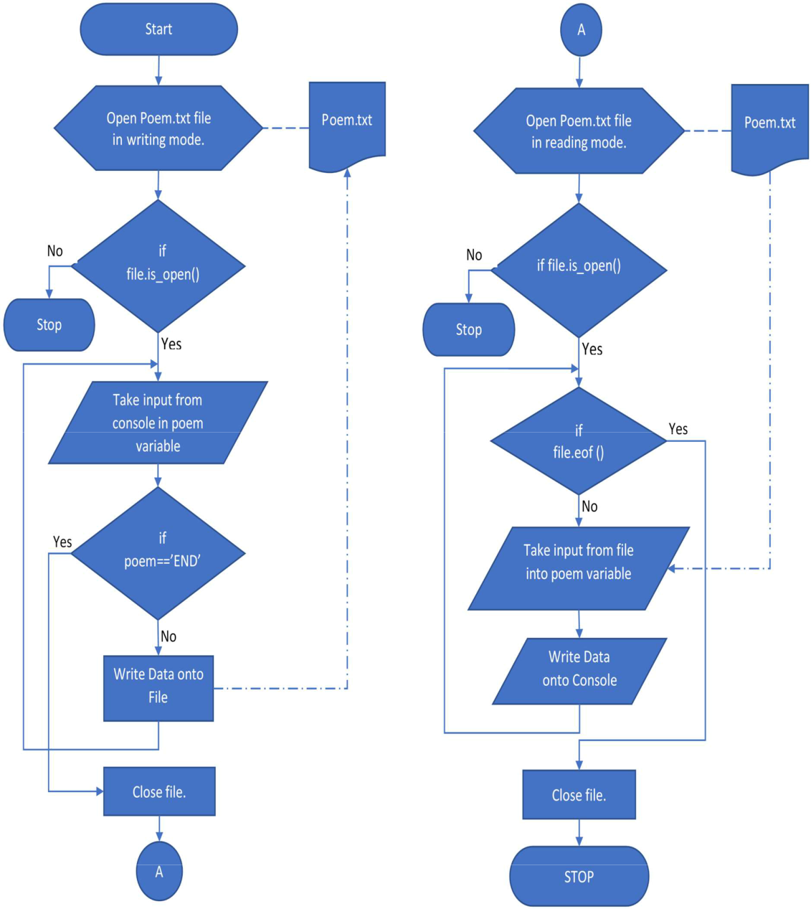

Fig: Flowchart Diagram for Writing Data onto file & Reading data from file

39 | P a g e A r m y I n s t i t u t e o f T e c h n o l o g y , P u n e
S E - C o m p - A O b j e c t O r i e n t e d P r o g r a m m i n g L a b

8. Implementation:


C++ Program for Writing Data onto File & Reading Data from File

#include <fstream> | // Include filestream support.
#include <string>
#include <iostream>
using namespace std ;
int main() {
string poem;
ofstream fout("Poem.txt",ios::app);
if (!fout.is_open())
{

cerr <<"Error opening file for output"<< endl ;

return -1 ; // Signal an error then exit the program.

}

cout<<"\n\t Enter your Data here(type 'End'for end Data):";

while(1)

{

getline(cin,poem);

if(poem=="End")

break;

fout<<poem<< endl ;

// Write output.

}

fout.close() ;

ifstream fin("Poem.txt",ios::in);

if ( ! fin )

{

// Close filestream*/

//reading data

cout <<"Error opening file for input"<< endl ; return -1 ; // Signal an error then exit the program.

}

cout<<"\n File Contents are:\n";

while(!fin.eof())

{

getline(fin,poem);

cout<<"\n"<<poem;

}

fin.close();

return 0 ;

}

Output:

Enter your Data here (type 'End' for end Data):

Army Institute of Technology, Pune is an Engineering Institute.

It is situated in Dighi, Pune.

This College is affiliated with AICTE & SPPU University, Pune.

End

File Contents are:

Army Institute of Technology, Pune is an Engineering Institute.

It is situated in Dighi, Pune.

This College is affiliated with AICTE & SPPU University, Pune.

40 | P a g e A r m y I n s t i t u t e o f T e c h n o l o g y , P u n e

S E - C o m p - A O b j e c t O r i e n t e d P r o g r a m m i n g L a b

- Conclusion:

Hence, we have studied, used and demonstrated use of File concept and learn how to implement read & write operation onto file.

- Review Questions & Exercises:

  - Fill in the Blanks

    - The fstream file stream data type is for output files, input files, or files that perform both input and output.
    - The get() member function reads a single character from a file.

    - If a file fails to open, the file stream object will be set to NULL or 0.

      - The put() member function writes a single character to a file.

      - If we want to write data in existing file but keeping all data as it is then file must be opened in append mode.
  - Answer the following:

    - Describe the difference between reading a file with the >> operator and the getline () function.
Ans: The >> operator considers whitespaces as delimiters and does not read then while the getline () member function does read whitespace characters.

    - How do you combine multiple file access flags when opening a file?
Ans: By file.open(“data.txt”, ios::in | ios::out);

    - How do you read the contents of a text file that contains whitespace characters as part of its data?
Ans: By using getline() member function,
Eg. getline (cin, poem);

  - Algorithm Assignments:

    - Assume that the file data.txt already exists, and the following statement executes. What happens to the file?
fstream file ("data.txt", ios::out);.
Ans: Data will be written to the file. By default, the file’s contents will be deleted if it already existed, as given in the question.

  - Write two statements that use a file stream object named people to open a file named people.dat. (Show how to open the file with a member function and at the definition of the file stream object.) The file should be opened for output.
Ans: fstream fs;
fs.open(“people.dat”, ios::in);

- Programming Assignments:

  - Write a program that asks the user for the name of a file. The program should display the first 10 lines of the file on the screen (the “head” of the file). If the

file has fewer. than 10 lines, the entire file should be displayed, with a message indicating the entire file has been displayed.
Ans : #include <bits/stdc++.h>
#include <fstream>
using namespace std;

int main(){
cout<<"Enter name of file.\n";
string s; cin>>s;
fstream fs;
fs.open(s, ios :: in);
int cnt = 0;
while(cnt < 10 && !fs.eof()){
string t;
getline(fs, t);
cout<<t<<endl;
++cnt;
}
if(cnt < 10) cout<<"Entire file has been displayed.";
return 0;
}

    - Write a program that asks the user for a file name and a string to search for. The program should search the file for every occurrence of a specified string. When the string is found, the line that contains it should be displayed. After all the occurrences have been located, the program should report the number of times the string appeared in the file.
Ans : #include <iostream>
#include <string>
#include <fstream>
using namespace std;

int main(){
cout<<"Enter name of file.\n";
string s; cin>>s;
fstream fs;
fs.open(s, ios :: in);
int c = 0;
if(!fs){
cout<<"File doesn't exist!."; return 0;
}
cout<<"Enter string to be searched.\n";
string pattern; cin>>pattern;

while(!fs.eof()){
string line;
getline(fs, line);
if(line.find(pattern, 0) < line.length()){
c++;
cout<<line<<endl;
}
}
cout<<pattern<<" appeared "<<c<<" lines in given file.";
return 0;
}

    - Write a program that reads a text file. Let the user enter the name of the file.

      - Changes each character in the file to uppercase.

      - Convert each letter into its equivalent binary format.

Ans: #include <bits/stdc++.h>
#include <fstream>
using namespace std;

int main(){
cout<<"Enter name of file.\n";
string s; cin>>s;
fstream fs;
fs.open(s, ios :: in);
int occurrence = 0;
if(!fs){
cout<<"File doesn't exist!."; return 0;
}
cout<<"1. Change each character in the file to uppercase."<<"\n";
while(!fs.eof()){
char ch;
fs.get(ch);
if(ch >= 'a' && ch <= 'z') ch = toupper(ch);
cout << ch ;
}

cout<<"\n2. Convert each letter into its equivalent binary format."<<"\n";
fs.close();
fs.open(s, ios :: in);
while(!fs.eof()){
char ch;
fs.get(ch);
int val= int(ch);
string bin = "";
while (val > 0){
(val % 2)? bin.push_back('1'): bin.push_back('0');
val /= 2;
}
reverse(bin.begin(), bin.end());
cout << bin << " ";
}
fs.close();
return 0;
}

- References:

  - E Balagurusamy Object-Oriented Programming with C++.7th edition. McGraw-Hill Publication, ISBN 10: 9352607996 ISBN 13: 9789352607990
  - K. R. Venugopal, B. Rajkumar, and T. RaviShankar Mastering C++ by K. R. Venugopal; with 2nd edition. McGraw-Hill Publication, ISBN13: 9781259029943.

41 | P a g e A r m y I n s t i t u t e o f T e c h n o l o g y , P u n e

