**DEVELOPMENT OF MACHINE LEARNING BASED**

**USER FRIENDLY CONTROL CHARTS**

SUBMITTED BY

|  |  |
| --- | --- |
| **Chetan Paliwal** | **19109021** |
| **Sidharth Goyal** | **19109026** |
| **Pradhuman Jain** | **19109034** |

IN PARTIAL FULFILMENT OF THE REQUIREMENTS

FOR THE AWARD OF

**BACHELOR OF TECHNOLOGY IN   
PRODUCTION AND INDUSTRIAL ENGINEERING**



DEPARTMENT OF

PRODUCTION AND INDUSTRIAL ENGINEERING

**PUNJAB ENGINEERING COLLEGE, CHANDIGARH**

(DEEMED TO BE UNIVERSITY)

2023

**DECLARATION**

I hereby certify that the work which is being presented in the project report entitled **Development of** **Machine Learning based User Friendly Control Charts** in the partial fulfilment of the requirements for the award of the **Bachelor of Technology** in **Production and Industrial Engineering** and submitted in **Production and Industrial Engineering** of the Punjab Engineering College, Chandigarh (Deemed to be University) is an authentic record of our own work carried out during the period from August 2022 to May 2023 under the Supervision of Prof. **Suman Kant** and Dr. **Mandeep Dhanda**.

The matter presented in this project report has not been submitted by us for the award of any other degree of this or any other University/Institute.

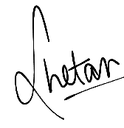

**Chetan Paliwal Sidharth Goyal Pradhuman Jain**

**19109021 19109026 19109034**

Date: 26/05/2023

This is to certify that the above statement made by the candidates is correct to the best of our knowledge.

|  |  |
| --- | --- |
| Prof. Suman Kant  Associate Professor  Department of Production and  Industrial Engineering  Punjab Engineering College, Chandigarh  (Deemed to be University)  Chandigarh – 160012, India  Date: 26/05/2023 | Dr. Mandeep Dhanda  Assistant Professor  Department of Production and  Industrial Engineering  Punjab Engineering College, Chandigarh  (Deemed to be University)  Chandigarh – 160012, India  Date: 26/05/2023 |

*Punjab Engineering College, Chandigarh (Deemed to be University),*

*Sector12, Chandigarh- 160012*

*Tel. (0172) 2753072 Fax No.: (0172) 2745175*

*Website: www.pec.ac.in*

**ACKNOWLEDGEMENT**

We express our deep sense of gratitude to our respected and learned guides **Prof. Suman Kant**

**and Dr. Mandeep Dhanda Department of Production and Industrial Engineering, Punjab Engineering College, Chandigarh** for their valuable help and guidance. We are thankful to them for the encouragement they have given us in completing this project.

We are also grateful to respected **Head of Department, Dr. RS Walia** and to our respected Director **Dr. Baldev Setia,** for giving us the opportunity to work on this project.

We are also grateful to all the other faculty & staff members of our department for their kind co-operation and help. Also, we would like to express our deep appreciation towards our classmates and our indebtedness to our parents for providing us the moral support and encouragement.

**TABLE OF CONTENTS**

**TITLE PAGE NO. CERTIFICATE**

**ACKNOLEDGEMENT**

**ABSTRACT**

**CHAPTER 1: INTRODUCTION 1**

* 1. Overview
  2. Importance of Quality
  3. Quality Control Charts
  4. Machine Learning
  5. Machine Learning Applications in Control Chart
  6. User Interface
  7. Description of Python
  8. Description of Numpy
  9. Description of Pandas
  10. Description of Flask
  11. Description of JavaScript

**CHAPTER 2: LITERATURE REVIEW 7**

* 1. Review Of “Application of Machine Learning in Statistical Process Control Charts: A Survey and Perspective”
  2. Review Of “Integration of Machine Learning Techniques and Control Charts for Multivariate Processes”
  3. Review Of “Control Chart Pattern Recognition Method Based on Improved One-dimensional Proved Convolutional Neural Network”
  4. Review Of “Application of Machine Learning in Statistical Process Control Charts: a survey and perspective”
  5. Review Of “Control Charts and Machine Learning for Anomaly Detection in Manufacturing”
  6. Review Of “Machine Learning Control Charts for Monitoring Serially Correlated Data”
  7. Review Of “On flexible Statistical Process Control with Artificial Intelligence: Classification control charts”
  8. Review Of “Deep learning-based residual control chart for count data”
  9. Review Of “Concurrent Control Chart Pattern Recognition: A Systematic Review”
  10. Review Of “Abnormal Patterns Detection in Control Charts using Classification Techniques.”

**CHAPTER 3: RESEARCH GAP 11**

**CHAPTER 4: PROBLEM FORMULATION 12**

**CHAPTER 5: OBJECTIVES 13**

**CHAPTER 6: METHODOLOGY 14**

**CHAPTER 7: VISUALISATION OF ALGORITHM 17**

7.1 Decision Tree

7.2 Support Vector Machine

7.3 X bar R Chart

7.4 X bar S Chart

7.5 C-Chart

7.6 P-Chart

7.7 XmR-Chart

7.8 Trend Analysis

7.9 Anomaly Detection

**CHAPTER 8: RESULTS AND DISCUSSION 34**

**CHAPTER 9: CHALLENGES FACED 48**

**CHAPTER 10: FUTURE SCOPE 49**

**CHAPTER 11: CONCLUSION 50**

**REFERENCES 51**

**LIST OF FIGURES**

|  |  |  |
| --- | --- | --- |
| **Figure** | **Description** | **Page No** |
| Fig No. 1 | Flow of Machine Learning Model | 19 |
| Fig No. 2 | Website Structure | 21 |
| Fig No. 3 | User Interface | 22 |
| Fig No. 4 | Basic Decision Tree | 24 |
| Fig No. 5 | Decision Tree | 25 |
| Fig No. 6 | X Bar R Chart | 29 |
| Fig No. 7 | X Bar S Chart | 32 |
| Fig No. 8 | C Chart | 34 |
| Fig No. 9 | P Chart | 36 |
| Fig No. 10 | XmR Chart | 37 |
| Fig No. 11 | Code of Trend Analysis | 38 |
| Fig No. 12 | Anomaly Detection | 40 |

**ABSTRACT**

Control charts are the most effective tool in quality control. Control chart detects, analyses and monitors process performance. This Project consists of development of user-friendly control chart with the use of machine learning this developed control chart may be effectively used for trend analysis and error detection. This project consists of a machine learning algorithm to analyze data and automatically identify patterns and trends, making it easier for supervisor and workers to make accurate and effective control charts.

The results of the study demonstrate the effectiveness of the user-friendly interface in making control charts that accurately identify process variations and trends. The paper concludes with a discussion of the potential applications of technology in industry and the potential for future research in this area.

**CHAPTER 1 __ INTRODUCTION**

* 1. **OVERVIEW**

Statistical quality control is the use of statistical methods in the monitoring and maintaining of the quality of products and services. One method, referred to as acceptance sampling, can be used when a decision must be made to accept or reject a group of parts or items based on the quality found in a sample. A second method, referred to as statistical process control, uses graphical displays known as control charts to determine whether a process should be continued or should be adjusted to achieve the desired quality.

* 1. **IMPORTANCE OF QUALITY**

Quality refers to the degree to which a product, service, or process meets or exceeds customer expectations, regulatory requirements, and industry standards. Quality can be defined in many ways, depending on the context and industry, but it generally refers to the ability of a product or service to meet its intended purpose or function.

In manufacturing industries, quality can be defined as the degree to which a product meets its design specifications, performs reliably, and is free from defects or errors. In service industries, quality can be defined as the ability to deliver services that meet customer needs and expectations, are delivered in a timely manner, and are free from errors or defects.

Quality can be measured in different ways, such as through inspections, testing, customer feedback, or statistical analysis. Quality management systems, such as ISO 9001, help companies to establish processes and procedures for ensuring quality throughout the entire production or service delivery process.

Quality is essential in industries for several reasons, including:

1. Customer satisfaction: Quality products and services help in building customer loyalty and satisfaction. When customers get high-quality products, they are likely to become repeat customers and recommend the brand to others.

2. Brand reputation: Quality products and services help in building a brand reputation. A company that is known for providing quality products and services is likely to have a good reputation in the market, which can attract more customers.

3. Cost savings: Implementing quality management systems can help companies reduce costs in the long run by minimizing waste, rework, and defects. This can lead to cost savings and increased profitability.

4. Regulatory compliance: Many industries have regulations and standards that require companies to maintain a certain level of quality. Compliance with these regulations and standards is essential to avoid legal and financial penalties.

5. Employee satisfaction: Quality work environments help in building employee satisfaction and morale. When employees are working in a high-quality environment with quality tools and equipment, they are likely to be more productive and motivated.

In summary, quality is critical in industries because it helps in building customer satisfaction, brand reputation, cost savings, regulatory compliance, and employee satisfaction. By focusing on quality, companies can improve their bottom line and build a sustainable business.

* 1. **QUALITY CONTROL CHARTS**

Control charts are a statistical tool used in quality control to monitor and control a process over time. Control charts are used to identify when a process is performing within acceptable limits and when it is out of control. Control charts are useful in quality control because they help to identify potential issues before they result in defects or errors.

The basic idea behind control charts is to plot data points on a chart over time and analyze the pattern of the data points. Control charts typically have a centerline, which represents the mean or average value of the data, and upper and lower control limits, which represent the range of variation that is acceptable for the process. Control charts may also have warning limits, which indicate when the process is moving towards being out of control.

There are different types of control charts used in quality control, depending on the type of data being analyzed. Some of the most common control charts include:

1. X-bar and R Chart: This chart is used for variables data, such as measurements or weights. The X-bar chart shows the average value of the data over time, while the R chart shows the range of variation in the data.

2. Individual and Moving Range (I-MR) Chart: This chart is used for variables data, such as measurements or weights, when the sample size is small. The I chart shows the individual data points over time, while the MR chart shows the range of variation in the data.

3. P Chart: This chart is used for attribute data, such as the number of defects or errors. The P chart shows the proportion of defective items over time.

4. C Chart: This chart is used for attribute data, such as the number of defects or errors, when the sample size is constant. The C chart shows the count of defects or errors over time.

In conclusion, control charts are an essential tool in quality control because they help to identify when a process is performing within acceptable limits and when it is out of control. By using control charts, companies can take corrective actions to bring a process back into control and prevent defects or errors, leading to improved product or service quality.

* 1. **MACHINE LEARNING**

Machine learning is a subfield of artificial intelligence (AI) that involves creating computer algorithms and models that can automatically learn and improve from experience without being explicitly programmed. Machine learning algorithms use statistical techniques to enable computer systems to identify patterns and insights from large amounts of data and use those insights to make predictions or take actions.

Machine learning algorithms can be divided into three main categories: supervised learning, unsupervised learning, and reinforcement learning.

Supervised learning involves using labeled data to train a machine learning model. The labeled data includes input data, such as images or text, and corresponding output labels that the model is expected to predict. The machine learning model learns to recognize patterns in the labeled data and can then make predictions on new, unlabeled data.

Unsupervised learning involves using unlabeled data to train a machine learning model. The machine learning model learns to identify patterns and structure in the data without being given specific output labels. Unsupervised learning is often used in data clustering and dimensionality reduction.

Reinforcement learning involves training a machine learning model to make decisions based on feedback received from the environment. The model learns through trial and error to take actions that maximize a reward or minimize a penalty.

Machine learning is used in a wide range of applications, including natural language processing, image and speech recognition, recommendation systems, and predictive modeling. The availability of large amounts of data and advances in computing power have driven significant progress in machine learning over the past decade, and machine learning is expected to continue to have a significant impact on various industries and sectors in the future.

* 1. **MACHINE LEARNING APPLICATION IN CONTROL CHARTS**

Machine learning has a growing role in quality control and can be used to enhance the traditional control charts used in statistical process control. Control charts are a widely used tool in quality control to monitor and control a process over time. Traditional control charts use statistical methods to identify when a process is performing within acceptable limits and when it is out of control.

Machine learning can be used to improve the accuracy and speed of identifying out-of-control situations in a process. By using machine learning algorithms, it is possible to identify patterns in the data that may not be immediately apparent to human analysts, and thus identify potential issues earlier than traditional control charts.

One example of using machine learning in control charts is to predict the next data point on the chart, based on historical data. By predicting the next data point, it is possible to identify if the process is moving out of control before it happens. This can help to reduce the time it takes to detect issues and can prevent further waste and defects.

Another example of using machine learning in control charts is to automate the identification of patterns and trends in the data. This can help to reduce the workload of human analysts and enable them to focus on interpreting the results and making decisions.

Machine learning can also be used to enhance the accuracy of control charts by identifying the most relevant data to use for the chart. By using machine learning algorithms to analyze the data, it is possible to identify the most important variables to include in the control chart and eliminate variables that are not significant.

In conclusion, machine learning can be used to enhance traditional control charts in quality control by improving the accuracy and speed of identifying out-of-control situations, automating the identification of patterns and trends, and enhancing the accuracy of the control chart. The use of machine learning in control charts has the potential to improve the efficiency and effectiveness of quality control processes and reduce the costs associated with defects and waste.

* 1. **USER INTERFACE**

A user interface (UI) is how a user interacts with a computer system, including hardware and software. The quality of the user interface can have a significant impact on the user experience, and ultimately on the success of a product or system. Here are a few ways in which a good user interface can help:

1. Ease of use: A well-designed user interface can make it easy for users to interact with a system, reducing the learning curve and increasing efficiency. A clear and intuitive interface can reduce the amount of time and effort required to perform tasks and can prevent users from making errors.
2. Efficiency: A good user interface can increase productivity and efficiency by streamlining tasks and providing easy access to information. By presenting information and functionality in a clear and organized manner, a UI can reduce the amount of time and effort required to complete tasks.
3. User satisfaction: A user interface that is easy to use and efficient can lead to increased user satisfaction. A positive user experience can lead to higher adoption rates and increased usage of a system, as well as positive word-of-mouth recommendations.
4. Accessibility: A user interface can be designed to be accessible to a wide range of users, including those with disabilities or limitations. By incorporating features such as adjustable font sizes, high-contrast modes, and support for assistive technologies, a UI can ensure that all users are able to interact with a system.
5. Branding: A well-designed user interface can also help to establish and reinforce a brand identity. Consistent use of branding elements such as logos, colors, and typography can help to create a cohesive and recognizable user experience.

In summary, a good user interface can help to make a system easy to use, efficient, and accessible, leading to increased user satisfaction and adoption rates. A well-designed UI can also help to establish and reinforce a brand identity.

* 1. **DESCRIPTION OF PYTHON**

Python is a high-level, interpreted, interactive and object-oriented scripting language. Python is designed to be highly readable. It uses English words frequently whereas other languages use punctuation, and it has fewer syntactic constructions than other languages. Created by Guido van Rossum and first released in 1991, Python's design philosophy emphasizes code readability with its notable use of significant whitespace. Its language constructs and object- oriented approach aim to help programmers write clear, logical code for small and large-scale projects. Python is dynamically typed and garbage- collected. It supports multiple programming paradigms, including procedural, object-oriented, and functional programming. Python is often described as a "batteries included" language due to its comprehensive standard library.

* 1. **DESCRIPTION OF NUMPY**

NumPy is a general-purpose array-processing package. It provides a high-performance multidimensional array object, and tools for working with these arrays. It is the fundamental package for scientific computing with Python. Besides its obvious scientific uses, NumPy can also be used as an efficient multi-dimensional container of generic data. Arbitrary data-types can be defined using NumPy which allows NumPy to seamlessly and speedily integrate with a wide variety of databases.

* 1. **DESCRIPTION OF PANDAS**

Pandas is an open-source library that is built on top of NumPy library. It is a Python package that offers various data structures and operations for manipulating numerical data and time series. It is mainly popular for importing and analysing data much easier. Pandas is fast and it has high-performance & productivity for users. After the pandas have been installed into the system, you need to import the library.

* 1. **DESCRIPTION OF FLASK**

Flask is a lightweight web application framework for Python. It is designed to be simple and flexible, allowing developers to quickly build web applications using Python programming language. Flask is based on the WSGI (Web Server Gateway Interface) specification and can be used with any web server that supports the WSGI interface.

Flask provides several features to make web development easier, such as template rendering, URL routing, and request handling. It also allows developers to easily integrate third-party libraries and plugins, making it a popular choice for web development.

* 1. **DESCRIPTION OF JAVASCRIPT**

JavaScript is a high-level programming language that is commonly used for creating interactive and dynamic web pages. JavaScript allows web developers to add functionality to their websites, such as form validation, pop-up windows, and animations, among others.

JavaScript is a client-side language, which means that it runs in the user's web browser, rather than on the server-side. This allows for faster and more responsive web applications as users can interact with the website without the need for page reloads.

**CHAPTER 2 LITERATURE REVIEW**

In this chapter a brief description of the various research papers that were studied is provided. These papers helped in identify the gaps and helped in the formation of the objectives.

**2.1 REVIEW OF “Application of Machine Learning in Statistical Process Control Charts: A Survey and Perspective”**

 The purpose of this study was first to presents a survey on the applications of ML techniques in the stages of designing, pattern recognition, and interpreting of control charts respectively in SPC especially in the context of SM for AD. Second, difficulties and challenges in these areas are discussed. Third, perspectives of ML techniques-based control charts for AD in SM are proposed. Finally, a case study of an ML-based control chart for bearing failure AD is also provided in this chapter.

**2.2 REVIEW OF “Integration of Machine Learning Techniques and Control Charts for Multivariate Processes”**

The aim of the study in this paper was to determine the machine learning techniques that will accurately estimate the type of fault. With the Hotelling T2 chart, out of control signals are identified and the types of faults affected by the variables are defined. Various machine learning techniques are used to compare classification performances. The developed model was applied in the evaluation of the paint quality in a painting process. ANN was determined as the most successful techniques according to performance criteria. The novelty of the study was to classify the fault according to the types of faults, not the variables. Defining the faults according to its types will enable to take effective corrective actions quickly.

**2.3 REVIEW OF “Control Chart Pattern Recognition Method Based on Improved One-dimensional Proved Convolutional Neural Network”**

In this paper, the one-dimensional CNN is applied to the recognition of CCPs and achieves 98.96% average recognition accuracy in 30 tests. What’s more, even if there is a deviation between the distribution of test data and training data, the model still shows excellent generalisation performance.

**2.4 REVIEW OF “Application of Machine Learning in Statistical Process Control Charts: a survey and perspective”**

The purpose of this paper was first to present a survey on the applications of ML techniques in the stages of designing, pattern recognition, and interpreting of control charts respectively in SPC especially in the context of SM for AD. Second, difficulties and challenges in these areas were discussed. Third, perspectives of ML techniques based control charts for AD in SM are proposed. Finally, a case study of an ML-based control chart for bearing failure AD is also provided in this paper.

**2.5 REVIEW OF “Control Charts and Machine Learning for Anomaly Detection in Manufacturing”**

This paper introduces the latest research on advanced control charts and new machine learning approaches to detect abnormalities in the smart manufacturing process. By approaching anomaly detection using both statistics and machine learning, the paper promotes interdisciplinary cooperation between the research communities, to jointly develop new anomaly detection approaches that are more suitable for the 4.0 Industrial Revolution. The paper provides ready-to-use algorithms and parameter sheets, enabling readers to design advanced control charts and machine learning-based approaches for anomaly detection in manufacturing.

**2.6 REVIEW OF “Machine Learning Control Charts for Monitoring Serially Correlated Data”**

This chapter suggests using certain existing machine learning control charts together with a recursive data de-correlation procedures. It has been well demonstrated in the SPC literature that control charts designed for monitoring independent data would not be reliable to use in applications with serially correlated data. It is shown that the performance of these charts can be substantially improved for monitoring serially correlated processes after data de-correlation.

**2.7 REVIEW OF “On flexible Statistical Process Control with Artificial Intelligence: Classification control charts”**

In this paper, SPC and AI techniques are used to present a new process monitoring tool. The proposed classification control chart, which we call class-chart, offers a more robust and flexible alternative to traditional SPC tools. In addition to the ability to recognize patterns and diagnose problems, regardless of the sample scenario, this new approach is capable of performing its monitoring functions on a large scale, predicting market scenarios and processes on large volumes of data. We evaluate the performance of the class-chart by the average run length in extensive numerical simulations. Finally, two real data sets are used to illustrate the applicability of the proposed control chart for classification data.

**2.8 REVIEW OF “Deep learning-based residual control chart for count data”**

In this paper, different methods such as neural network, deep learning, principal component analysis-based Poisson regression, principal component analysis based negative binomial regression, nonlinear principal component analysis based Poisson regression, and nonlinear principal component analysis based negative binomial regression in terms of the root mean squared error have been implemented and compared. Using two asymmetrical simulated datasets generated by the combined multivariate normal, binary and copula functions, the neural network and deep learning have a smaller mean, median, and interquartile range when compared to the principal component analysis-based Poisson regression, principal component analysis based negative binomial regression, nonlinear principal component analysis based Poisson regression, and nonlinear principal component analysis based negative binomial regression.

**2.9 REVIEW OF “Concurrent Control Chart Pattern Recognition: A Systematic Review”**

This paper aims to present a classification framework based on categories to systematically organise and analyse the existing literature regarding concurrent CCP recognition to provide a concise summary of the developments performed so far and a helpful guide for future research. The search only included journal articles and proceedings in the area. The literature search was conducted using Web of Science and Scopus databases. As a result, 41 studies were considered for the proposed classification scheme. It consists of categories designed to assure an in-depth analysis of the most relevant topics in this research area. Results concluded a lack of research in this research field. The main findings include the use of machine learning methods; the study of non-normally distributed processes; and the consideration of abnormal patterns different from the shift, trend, and cycle behaviours.

**2.10 REVIEW OF “Abnormal Patterns Detection in Control Charts using Classification Techniques**”

This paper presents the performance of five classification methods on a set of large data for anomaly patterns detection in control charts. The control chart dataset has its specific features that need specific data pre-processing procedures. It is crucial and involves a number of stages of data preparation procedures. Firstly, the Principal Component Analysis is employed for similarity measure. Secondly, the Piecewise Aggregate Approximation and Symbolic Aggregate Approximation are used as data representation. The pre-processed data are fitted to the classification algorithms to extract important knowledge. The algorithms are support vector machine, decision tree, MLP networks, RIDOR algorithm and JRip algorithm. Numerical results showed that the JRip algorithm has the best performance compared to the others. It achieved highest detection accuracy about 99.66 % and the lowest error rate is 2.987.

**CHAPTER 3 RESEARCH GAP**

1. Substantial efforts have been made by various researchers for the development and application of control charts in conjunction with machine learning. However, limited attention has been given to the imperative aspect of enhancing user-friendliness, allowing individuals with minimal expertise to seamlessly incorporate them into their everyday activities.
2. Research has reported that control charts used in Statistical Process Control often encounter challenges in real-world applications, particularly during key phases such as design, pattern identification, and interpretation.
3. The traditional techniques prepared by researchers lie on the assumption that the main parameters are known or estimated from historical data. However, this approach may face difficulties in some real situations of industry process when considering in the new context as dynamic behavior environment or sampling regularly.

**CHAPTER 4 PROBLEM FORMULATION**

For the major project, a control chart generating user interface has been built which can be used to build a specific control chart based on the type of data provided to it. The choice of control chart has been done by the system using machine learning algorithms in the form of a decision tree which differentiates between the type of data and builds the appropriate control chart. Anomaly detection in real time data has been made possible in this project. Some of the control charts built would be X-R chart, X-S chart, C chart. The project has been created entirely using python and its libraries.

* To develop control charts user interface
* To develop and illustrate the control charts with data.

Data

Figure- 1, Flow of Machine Learning Model

**CHAPTER 5 OBJECTIVES**

* To study existing statistical process control techniques
* To make a user-friendly interface which is able to make control charts using user data.
* To determine any anomalies and analyse the trend in the process detected through the data provided.
* To be able to handle huge datasets.

**CHAPTER 6 METHODOLOGY**

The following methodologies are used in the development of this project. This is illustrated using the following figures.

**6.1 STRUCTURE OF THE WEBSITE**

Figure- 2, Website Structure

**6.2 USER INTERFACE OF THE WEB APPLICATION**

:

Figure- 3, User Interface

**6.3 PARTS OF THE APPLICATION**

1. Frontend of the website which is the user interface.
2. The website's backend includes a server and an Application Programming Interface (API) responsible for transmitting user-uploaded data to the backend for processing.
3. Machine Learning algorithms which process the data and create the control charts.

**6.4 FEATURES INCLUDED**

1. Data Upload button (formats allowed: xlsx, pdf)
2. Control Chart built by AI based on the data given.
3. Simple User Interface which is easy to understand.
4. A How to Use section for the user.
5. Process Control Detection
6. Trend Analysis of the data.
7. Some general insights about the data.

**6.5 APPLICATION FLOW**

1. Data Uploaded by user through the user interface.
2. Data goes to the backend.
3. Data is processed by the decision tree algorithm.
4. The algorithm recommends an appropriate control chart.
5. With the help of python libraries like PANDAS and NUMPY, a control chart is created.

Also, machine learning algorithms give analysis of trends and process control analysis.

**CHAPTER 7 VISUALISATION OF ALGORITHM**

**7.1 DECISION TREE**

Decision tree algorithm is one of the most popular machine learning algorithms. It is a supervised machine learning algorithm, used for both classification and regression task. It is a model that uses set of rules to classify something.

Let’s see decision tree with this simple example, it is normal “AND’ operation problem, where ‘A’, ‘B’ are features and “A and B” are corresponding labels.

Figure- 4, Basic Decision Tree

If A=F then result=F

If A=T and B=T, then result=T

If A=T and B=F, then result = F

This is an example of binary classifier. It classifies “And” operation is ‘False’ or ‘True’.

**Decision Tree Algorithm**

Decision tree algorithm is a tree where nodes represent features (attributes), branch represents decision (rule) and leaf nodes represents outcomes (discrete and continuous)

**Construction of Decision Tree**

A tree can be “learned” by splitting the source set into subsets based on an attribute value test. This process is repeated on each derived subset in a recursive manner called recursive partitioning. The recursion is completed when the subset at a node all has the same value of the target variable, or when splitting no longer adds value to the predictions. The construction of a decision tree classifier does not require any domain knowledge or parameter setting, and therefore is appropriate for exploratory knowledge discovery. Decision trees can handle high-dimensional data. In general decision tree classifier has good accuracy. Decision tree induction is a typical inductive approach to learn knowledge on classification.

Figure- 5, Decision Tree

**7.2 SUPPORT VECTOR MACHINES**

Support vector machines (SVMs) are a type of supervised machine learning algorithm that have been successfully applied to a wide range of classification and regression problems. SVMs have been used in various applications in manufacturing and quality control, including the development of control charts.

Control charts are typically constructed using statistical methods, but machine learning techniques such as SVMs have been proposed as an alternative method for constructing control charts.

One of the advantages of SVMs is their ability to handle non-linear relationships between variables, which may be useful for identifying complex patterns in the data. SVMs can also handle datasets with high dimensionality, making them useful for processing large amounts of data.

In the context of control chart analysis, SVMs have been used to identify abnormal patterns in the data that may indicate an out-of-control process. SVMs can be used to classify new data points as either in control or out of control based on patterns in the historical data. SVMs can also be used to estimate the control limits for the control chart, which can be useful when the underlying distribution of the data is not well-defined.

SVMs have been shown to be effective in identifying complex patterns in the data and have been used successfully in a variety of applications.

**7.3 X-R CHART**

X Bar R charts are the widely used [control chart](https://sixsigmastudyguide.com/control-charts-study-guide/) for [variable dat](https://sixsigmastudyguide.com/data-analysis/)a to examine the process stability in many industries (like Hospital patients’ blood pressure over time, customer call handle time, length of the part in production process etc.,).

X bar R chart is used to monitor the process performance of a continuous data and the data to be collected in subgroups at a set time periods. It is actually takes two plots to monitor the process mean and the process variation over the time and is an example of [statistical process control](https://sixsigmastudyguide.com/statistical-process-control-spc/). These combination charts help to understand the stability of processes and also detects the presence of [special cause variation](https://sixsigmastudyguide.com/variation/).

## **7.3.1 X Bar R Control Chart Definitions**

**X-bar chart:**The mean or average change in process over time from subgroup values. The control limits on the X-Bar brings the sample’s mean and centre into consideration.

**R-chart:** The range of the process over the time from subgroups values. This monitors the spread of the process over the time.

## **How to Interpret the X Bar R Control Charts**

* To correctly interpret X bar R chart, always examine the R chart first.
* The X bar chart control limits are derived from the R bar (average range) values, if the values are out of control in R chart that means the X bar chart control limits are not accurate.
* If the points are out of control in R chart, then stop the process. Identify the special cause and address the issue. Remove those subgroups from the calculations.
* Once the R bar chart is in control, then review X bar chart and interpret the points against the control limits.
* All the points to be interpret against the control limits but not specification limits. As specification limits are provided by customer or management whereas control limits are derived from the average and range values of the subgroups.
* If any point out of control in X bar chat. Identify the special cause and address the issue.
* Process capability studies can be performed only after both X bar and R chart values are within the control limits. There is no meaning to perform process capability studies of an unstable process.

**7.3.2 Determine the Control Limits**

The first set of subgroups are to determine the process mean and standard deviation, these values are to be consider for creation of control limits for both range and mean of each subgroup.

The process to be in control in the early phase of the production.  Special causes to be identified if any of the points are out of control during initial phase and also the subgroup has to be removed for calculation.

Sometimes in the initial phase it would be also good to have few points out of control on the x-bar portion. Otherwise, if all the values are within the control limits may be because of slop in the measurement system, team won’t focus on it. Identify appropriate [Measurement System Evaluation (MSE).](https://sixsigmastudyguide.com/evaluating-the-measurement-systems-emp-studies/)

**Where**

* X is the individual value (data)
* n is the sample size (subgroup size)
* X bar is the average of reading in a sample
* R is the Range, in other words the difference between largest and smallest value in each sample
* R bar is the average of all the ranges.
* UCL is Upper control limit
* LCL is Lower control limit

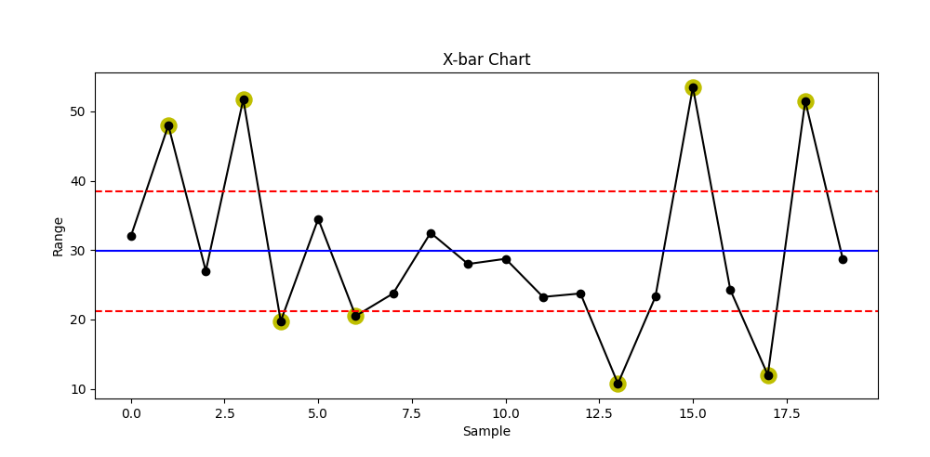

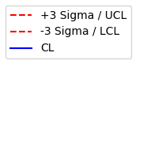

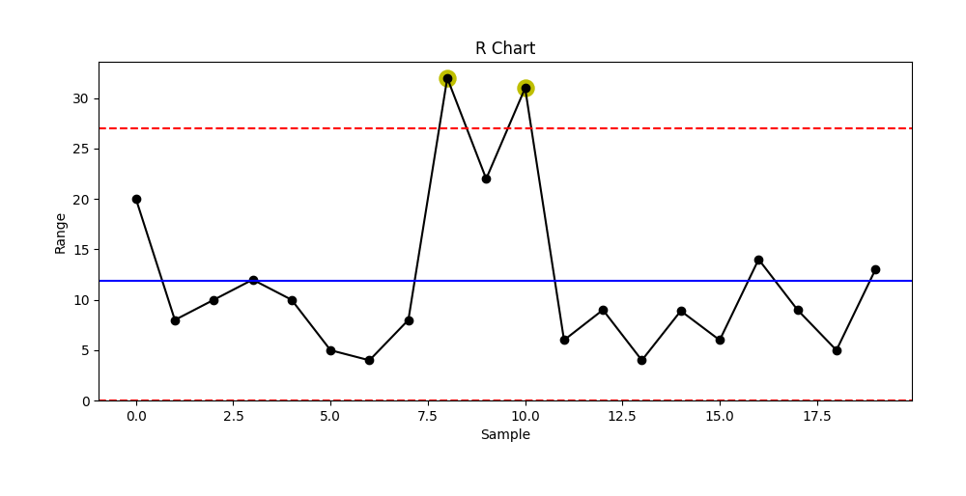



Figure- 6, X Bar R Chart

**7.4 X-S CHART**

X Bar S charts often used [control chart](https://sixsigmastudyguide.com/control-charts-study-guide/) to examine the process mean and standard deviation over the time. These charts are used when the subgroups have large sample size and S chart provides better understanding of the spread of subgroup data than range. X bar S charts are also similar to [X Bar R Control chart](https://sixsigmastudyguide.com/x-bar-r-control-charts/), the basic difference is that X bar S charts plots the subgroup standard deviation whereas R charts plots the subgroup range

**7.4.1 X Bar S Control Chart Definitions**

**X-bar chart:**The mean or average change in process over time from subgroup values. The control limits on the X-Bar brings the sample’s mean and centre into consideration.

**S-chart:** The standard deviation of the process over the time from subgroups values. This monitors the process [standard deviation](https://sixsigmastudyguide.com/standard-deviation/) (as approximated by the sample moving range)

**7.4.2 How to Interpret the X Bar S Control Charts**

* To correctly interpret X bar S chart, always examine the S chart first.
* The X bar chart control limits are derived from the S bar (average standard deviation) values, if the values are out of control in S chart that means the X bar chart control limits are not accurate.
* If the points are out of control in S chart, then stop the process. Identify the special cause and address the issue. Remove those subgroups from the calculations.
* Once the S chart is in control, then review X bar chart and interpret the points against the control limits.
* All the points to be interpret against the control limits but not specification limits.
* If any point out of control in X bar chat. Identify the special cause and address the issue.

X Bar S Control Chart

### **7.4.3 Determine the Control Limits**

The first set of subgroups are to determine the process mean and standard deviation, these values are to be consider for creation of control limits for both standard deviation and mean of each subgroup

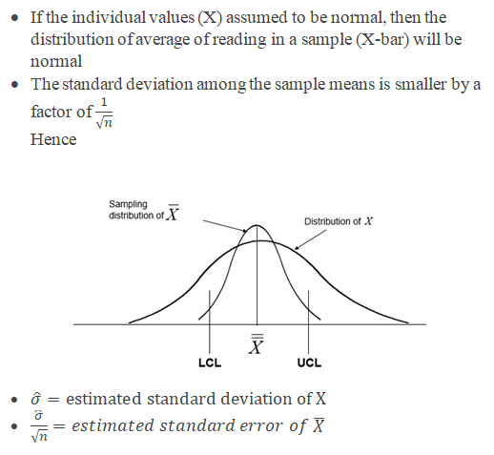



The process to be in control in the early phase of the production.  Special causes to be identified if any of the points are out of control during initial phase and also the subgroup has to be removed for calculation.

Sometimes in the initial phase it would be also good to have few points out of control on the x-bar portion. Otherwise, if all the values are within the control limits may be because of slop in the measurement system, team won’t focus on it. Identify appropriate [Measurement System Evaluation (MSE).](https://sixsigmastudyguide.com/evaluating-the-measurement-systems-emp-studies/)

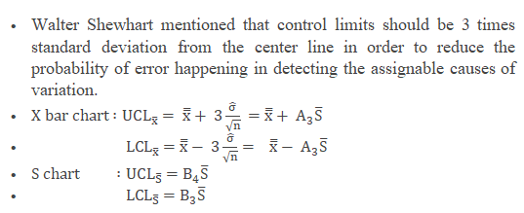

**Where**

* + X is the individual value (data)
  + n is the sample size
  + X bar is the average of reading in a sample
  + S is the standard deviation
  + S bar is the average of all the standard deviation.
  + UCL is Upper control limit
  + LCL is Lower control limit

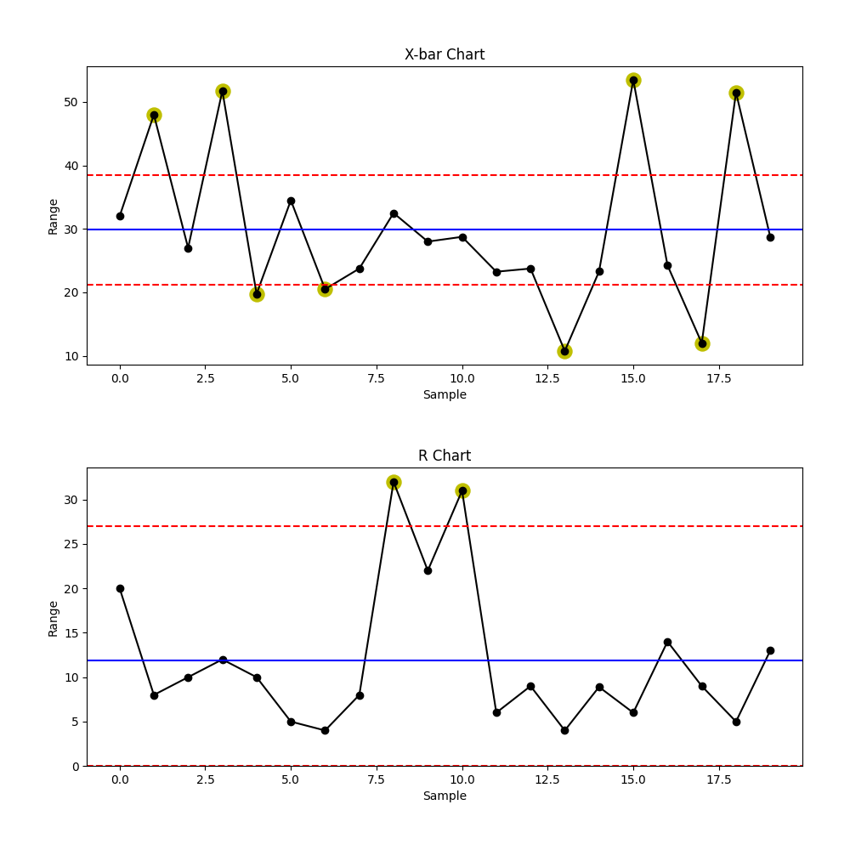



Figure- 7, X Bar S Chart

**7.5 C CHART**

Attribute chart: c chart is also known as the control chart for [defects](https://sixsigmastudyguide.com/defects-vs-defectives/) (counting of the number of defects). It is generally used to monitor the number of defects in constant size units. There may be a single type of defect or several different types, but the c chart tracks the total number of defects in each unit and it assumes the underlying data approximate the [Poisson distribution](https://sixsigmastudyguide.com/poisson-distribution/). The unit may be a single item or a specified section of items—for example, scratches on plated metal, number of insufficient soldering in a printed circuit board.

c chart takes into account the number of [defects](https://sixsigmastudyguide.com/defects-vs-defectives/) in each defective unit or in a given sample. While [p chart](https://sixsigmastudyguide.com/p-attribute-charts/) analyses the proportions of non-conforming or defective items in a process.

c chart, the number of defects is plotting on the y-axis and the number of units on the x-axis. The centreline of the c chart (c̅) is the total number of defects divided by the number of samples.

Attribute Chart: c Chart

## **7.5.1 Selection of Control chart**

The [control chart](https://sixsigmastudyguide.com/control-charts-study-guide/) is a graph used to study how process changes over time. A control chart always has a central line for average, an upper line for upper control limit, and lower line for the lower control limit. The control limits are ±3σ from the centreline.

Selection of appropriate [control chart](https://sixsigmastudyguide.com/control-charts-study-guide/) is very important in control charts mapping, otherwise ended up with inaccurate control limits for the data.

[X̅ and R chart](https://sixsigmastudyguide.com/x-bar-r-control-charts/) are used for measurable quantities such as length, weight height.  [Attribute control charts](https://sixsigmastudyguide.com/attribute-charts/) are used for attribute data.  In other words, the data that counts the number of defective items or the number of defects per unit. For example, number of tubes failed on a shop floor. Unlike variable charts, only one chart is plotted for attributes.

C-chart is one of the quality control charts used to track the number of defects in a product of constant size, while [u chart](https://sixsigmastudyguide.com/attribute-chart-u-chart/)is used for a varying size.

C-chart is used to determine if the process is stable and predictable and also to monitor the effects of before and after process improvements. c chart is especially used when there are high opportunities for defects in the subgroup, but the actual number of defects is less.

C-chart requires that each subgroup’s sample size be the same and compute control limits based on the [Poisson distribution.](https://sixsigmastudyguide.com/poisson-distribution/)

**7.5.2 Assumptions of C-Chart**

* The probability of defect is the same for each item
* Each unit is independent of the other
* The testing procedure should be the same for each lot

**7.5.3 C-Chart formulas**

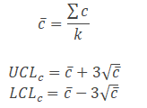

Where

c = number of defects

k= number of samples

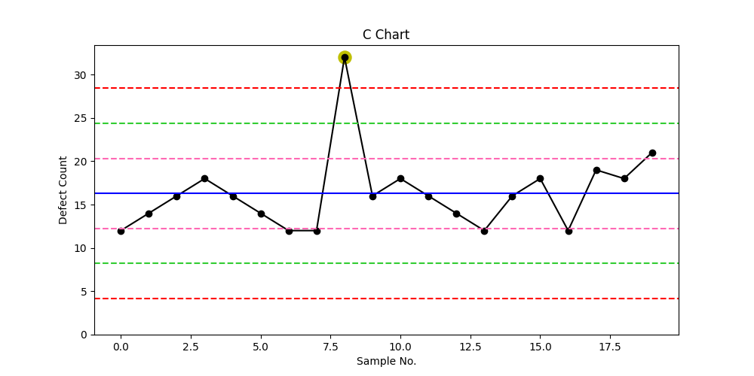

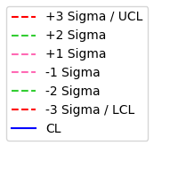

Figure- 8, C Chart

**7.6 P CHART**

P chart is also known as the control chart for proportions. It is generally used to analyse the proportions of non-conforming or defective items in a process.  It uses [binomial distributio](https://sixsigmastudyguide.com/binomial-distribution/)n to measure the proportion of defectives or non-confirming units in a sample.

In p-chart, proportions are plots on the y-axis and the number of samples on the x-axis. The centerline of p chart (p̅) is the total number of [defectives](https://sixsigmastudyguide.com/defects-vs-defectives/)or non-conforming units divided by the total number of items sampled.

Attribute Charts: p Chart

## **7.6.1 Selection of Control chart**

The [control chart](https://sixsigmastudyguide.com/control-charts-study-guide/) is a graph used to study how process changes over time. A control chart always has a central line for average, an upper line for upper control limit, and lower line for the lower control limit. The control limits are ±3σ from the centerline.

Selection of appropriate [control chart](https://sixsigmastudyguide.com/control-charts-study-guide/) is very important in control charts mapping, otherwise ended up with inaccurate control limits for the data.

[X̅ and R chart](https://sixsigmastudyguide.com/x-bar-r-control-charts/) are used for measurable quantities such as length, weight height.  [Attribute control charts](https://sixsigmastudyguide.com/attribute-charts/) are used for attribute data.  In other words, the data that counts the number of defective items or the number of defects per unit. For example number of tubes failed on a shop floor. Unlike variable charts, only one chart is plotted for attributes.

**7.6.2 Assumptions of P chart**

* The probability of non-conformance is the same for each item
* There should be two events (pass or fail), and they are mutually exclusive
* Each unit is independent of the other
* The testing procedure should be the same for each lot

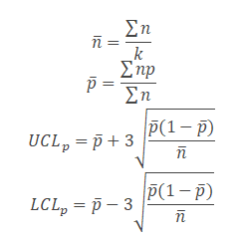**7.6.3 P Chart formulas**

np = number of defectives in the sample

k = number of lots

n = sample size

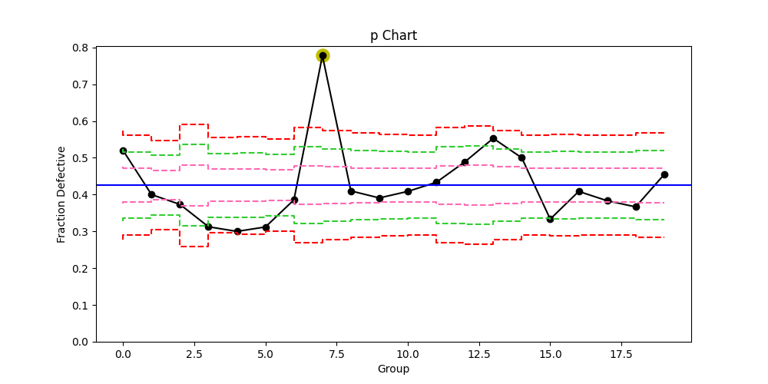



Figure- 9, P Chart

**7.7 XmR CHART**

An XmR chart (aka Shewhart’s Control Chart) calculates the control limits from the moving average range.

**7.7.1 How to Interpret the XmR Control Charts**

Always look at Moving Range chart first. The control limits on the Individual-X chart are derived from the average moving range, so if the Moving Range chart is out of control, then the control limits on the Individual-X chart are meaningless.

However, research has shown that for Normally distributed processes, when a special cause is detected on the Moving Range Chart, it will also appear on the Individual-X chart, thus making the Moving Range chart somewhat redundant; however, if you are using the run test rules on the Moving Range chart, some value may be evident depending on the process conditions.

Also on the moving range chart, there should be more than five distinct values plotted, and no one value should appear more than 25% of the time. If there are values repeated too often, then you have inadequate resolution of your measurements, which will adversely affect your control limit calculations. An important consideration for the Individual-X Chart is the choice of Curve Fit used for determining the control limits. There is a fundamental problem here, in that a distribution should not be fit to the data unless the data is from a controlled process. Unfortunately, you may need to fit a distribution to the data to effectively use the Individual-X chart to determine if the process is in control. Because of this limitation, you may consider using other control charts, such as the X-bar Chart or Moving Average chart to first define process control.

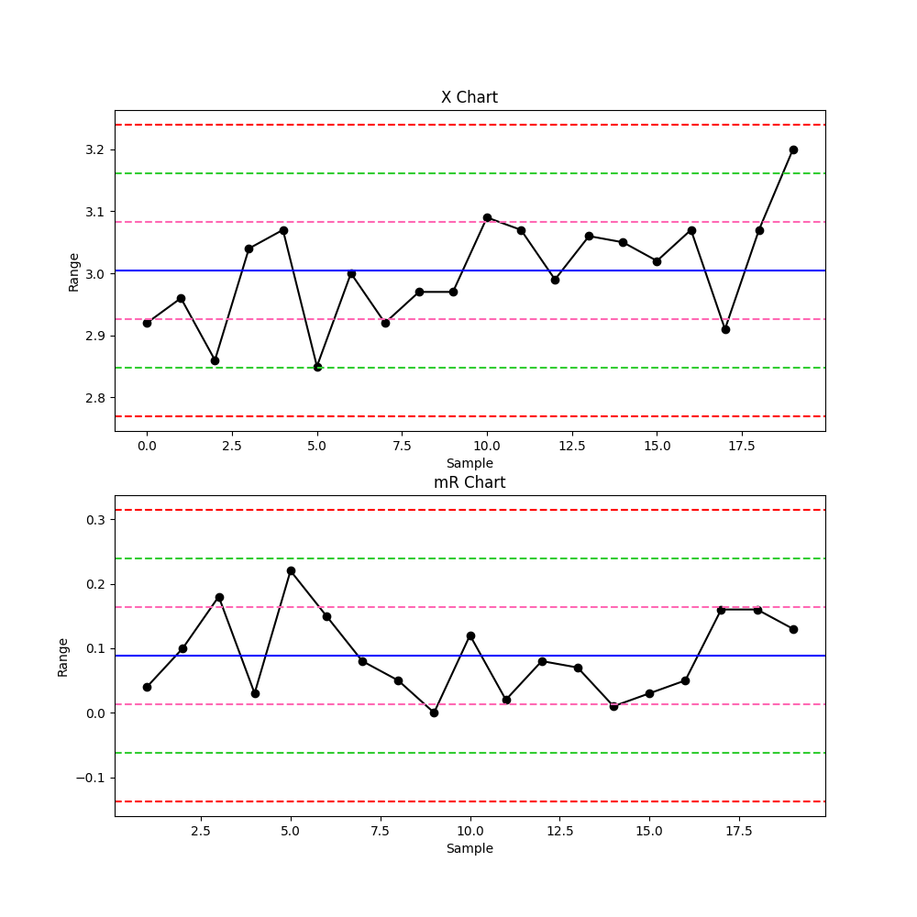



Figure- 10, XmR Chart

**7.8 TREND ANALYSIS**

The trend is the component of a time series that represents variations of low frequency in a time series, the high and medium frequency fluctuations having been filtered out. The objective of this analysis is to understand if there is a trend in the data and whether this pattern is linear or not.

**Upward Trend and Downward Trend:**

Trends are usually due to a gradual wearing out or deterioration of a tool or some other critical process components. They may also be caused by worker fatigue, accumulation of waste products, and deterioration of environmental conditions.

**Upward Shift and Downward Shift:**

These shifts may result from the introduction of new workers, methods, raw materials, or machine, a change in the inspection method or standards, or change in either the skill, attentiveness, or motivation of the operators. Sometimes an improvement in the process performance is noted following introduction of a control chart program, simply because of motivational factors influencing the workers.

**Cyclic Pattern:**

Cyclic pattern occasionally appears on the control charts. Such a pattern on the X chart may result from systematic environmental changes such as temperature, operator fatigue, regular rotation of operators and/or machine, or fluctuation in voltage or pressure or some other variable in the production equipment. R chart will sometimes reveal cycles because of maintenance schedule, operator fatigue, tool wear resulting in excessive variability.

Figure- 11, Code of Trend Analysis

**7.9 ANOMALY DETECTION**

Monitoring complex production systems is elemental to ensure reliability while maintaining the desired product quality. Early detection of emerging anomalous behaviour in these complex systems enables proactive intervention to avoid dire repercussions. It also enables improved system operations, while maintaining lower manufacturing risk and/or cost.

Dozens of anomaly detection algorithms have been developed using Machine Learning and statistical approaches. In the field of anomaly detection, it is often the case that only data describing normal behaviour are available. Here, we try to explain one of the simplest algorithms which use such data. The idea is to learn to distinguish and identify only the features which contribute to normal behaviour. The absence of these distinguishing features denotes the anomalous event.

Roughly, there are two types of variation detection

• Anomaly detection

• Misuse detection

An anomaly is when the system exhibits abnormal behavior that is different from the normal statistical behavior of the past. Misuse is when the system behavior matches a preset attack pattern. It’s a way of thinking.

The two key features/assumptions of anomaly detection

• An anomaly is a very rare event

• The anomalous event differs from the normal event significantly

Selection of the correct type of control chart is important to ensure the underlying statistical concepts are appropriate for the feature or attribute being measured.

A process is said to be in control when the control chart does not indicate any out-of-control condition and contains only common causes of variation. If the common cause variation is small, then a control chart can be used to monitor the process. If the common cause variation is too large, the process will need to be modified or improved to reduce the amount of inherent variation to an acceptable level.

When a control chart indicates an out-of-control condition (a point outside the control limits or matching one or more of the criteria in the rules below), the assignable causes of variation must be identified and eliminated.

The following rules can be used to properly interpret control charts:

* Rule 1 – One point beyond the 3 σ control limit
* Rule 2 – Eight or more points on one side of the centreline without crossing
* Rule 3 – Four out of five points in zone B or beyond
* Rule 4 – Six points or more in a row steadily increasing or decreasing
* Rule 5 – Two out of three points in zone A
* Rule 6 – 14 points in a row alternating up and down
* Rule 7 – Any noticeable/predictable pattern, cycle, or trend





Figure- 12, Anomaly Detection

**CHAPTER 8 RESULTS AND DISSCUSION**

A web-based application was developed that allows users to upload data and generate control charts based on their input, using machine learning techniques to automatically detect out-of-control points. The application was built using Python and its Flask web framework and incorporates machine learning libraries such as PANDAS.

Users are presented with a simple interface that allows them to upload data in CSV format, choose a type of control chart, and customize chart parameters such as chart title, x and y axis labels, chart width and height, and other options. The application calculates the relevant control chart statistics based on the uploaded data using statistical methods and libraries such as NumPy in Python.

In addition to the standard control chart calculations, the application also uses machine learning techniques to automatically detect out-of-control points in the data. This has been done using the help of machine learning algorithms like support vector machines (SVMs). Overall, the application was found to be a useful tool for generating control charts based on user-uploaded data, incorporating machine learning to automatically detect out-of-control points. Future work could include improving the accuracy and efficiency of the machine learning approach, adding more machine learning algorithms and incorporating additional types of control charts.

The use of machine learning in control charts has the potential to improve the accuracy and efficiency of control chart analysis, providing a useful tool for practitioners in the field of statistical process control.

The following code has been written to develop a part of this project:

**8.1 IMPORTING LIBRARIES**

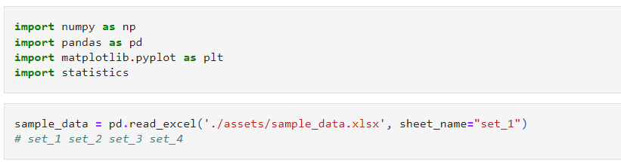

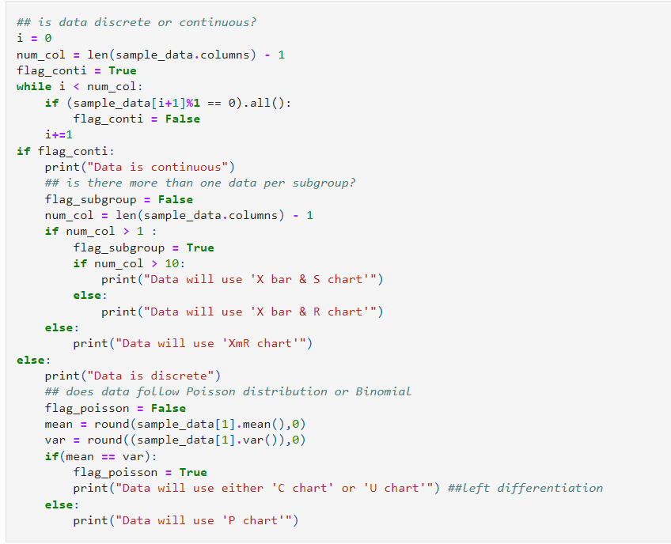**8.2 DECISION TREE**

**8.3 BUILDING X BAR – R CHART**

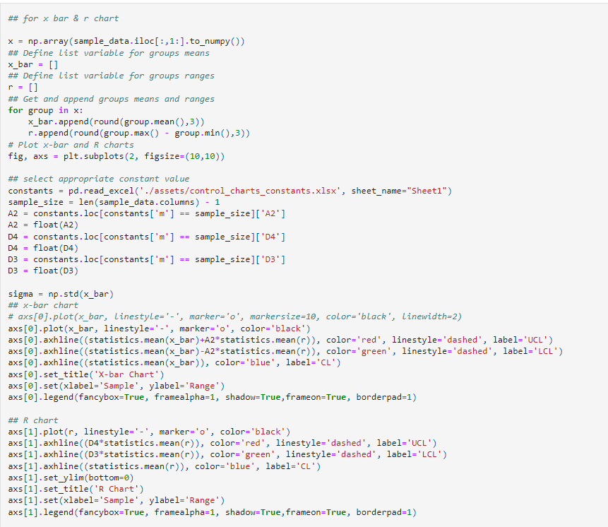

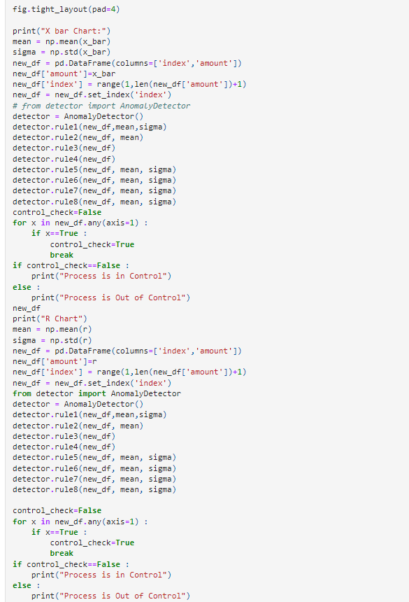

**8.4 BUILDING X BAR – S CHART**

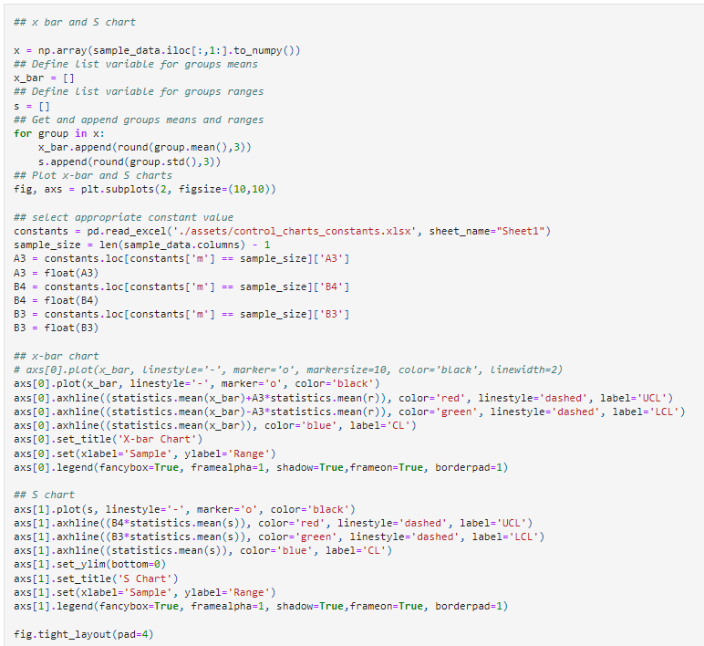

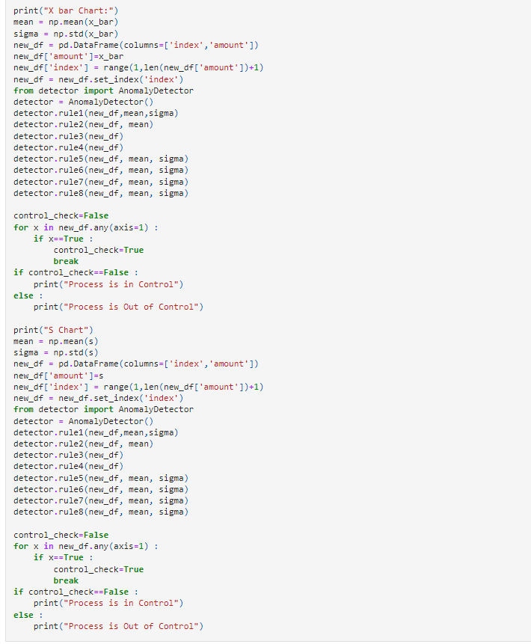

**8.5 C-CHART**

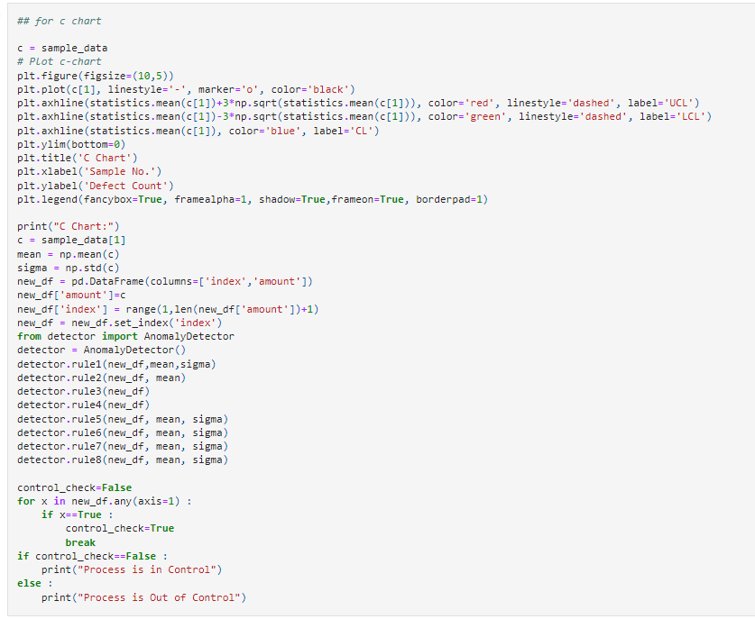

**8.6 P-CHART**

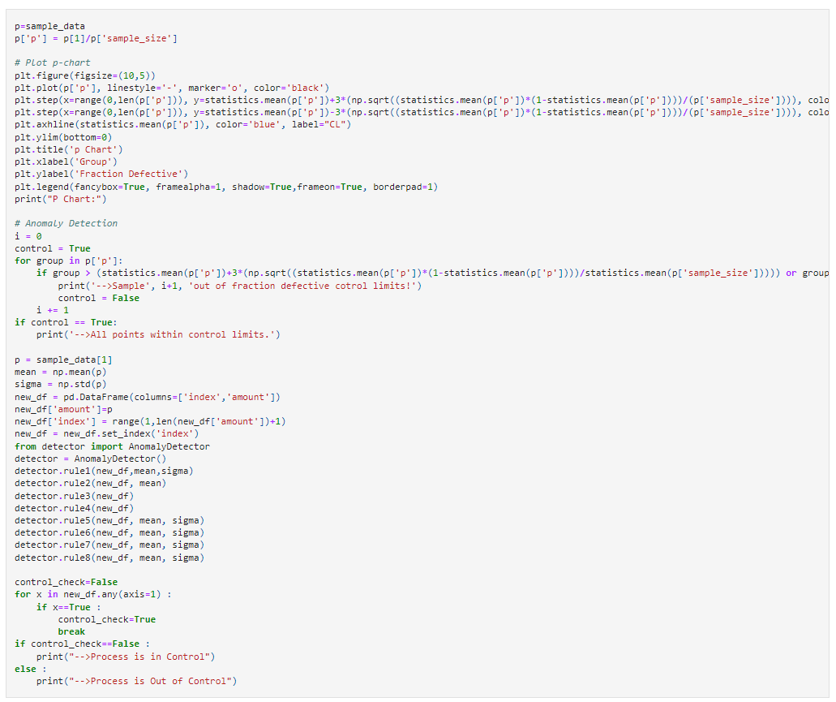

**8.7 XMR-CHART**

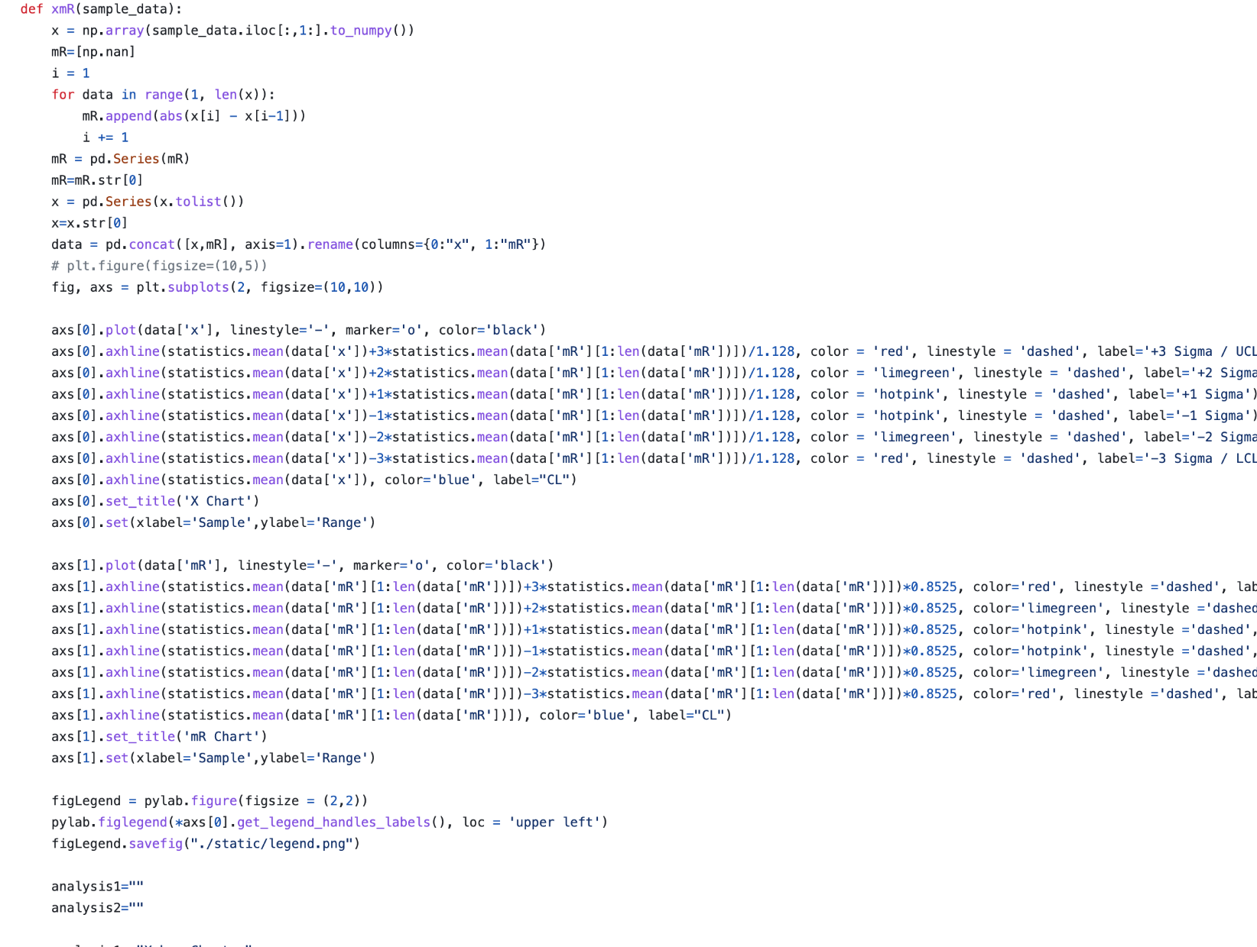

**8.8 TREND ANALYSIS**

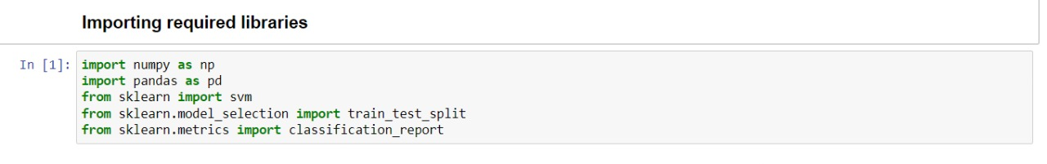

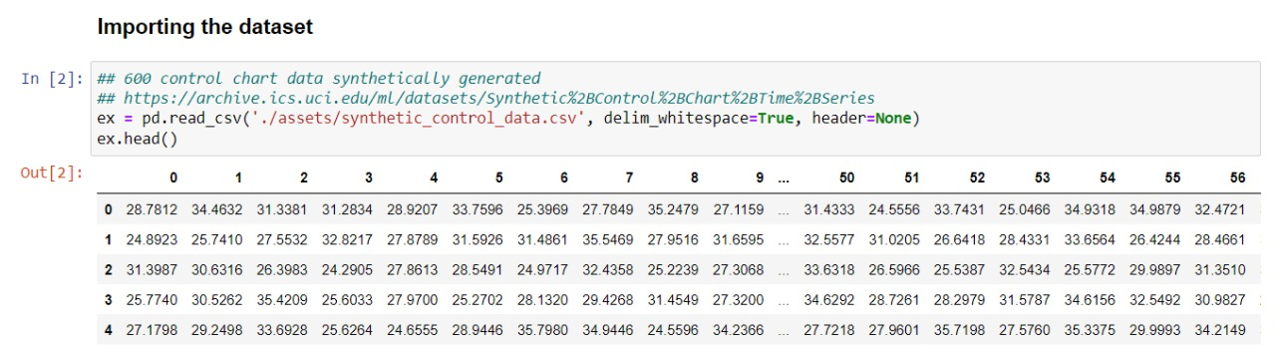

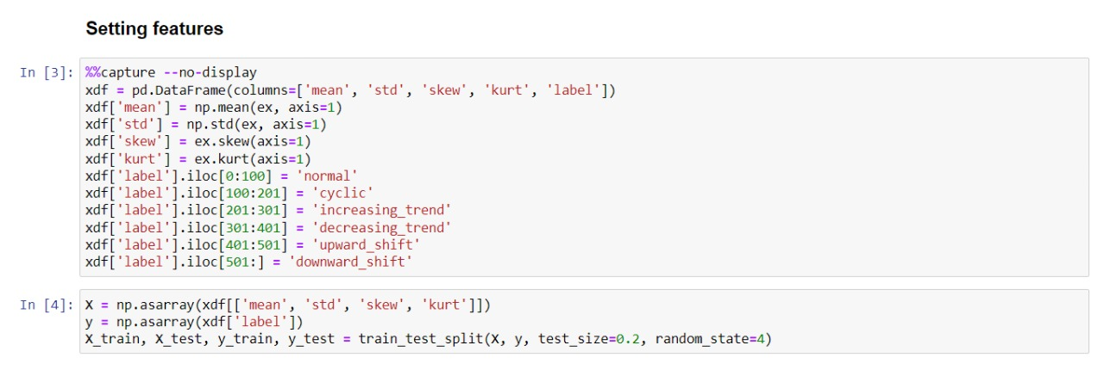

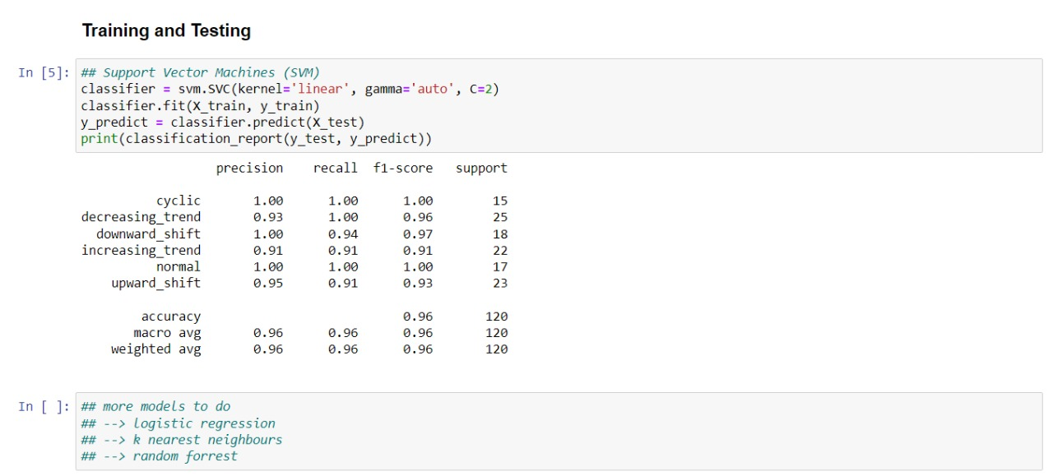

**8.9 ANOMALY DETECTION**

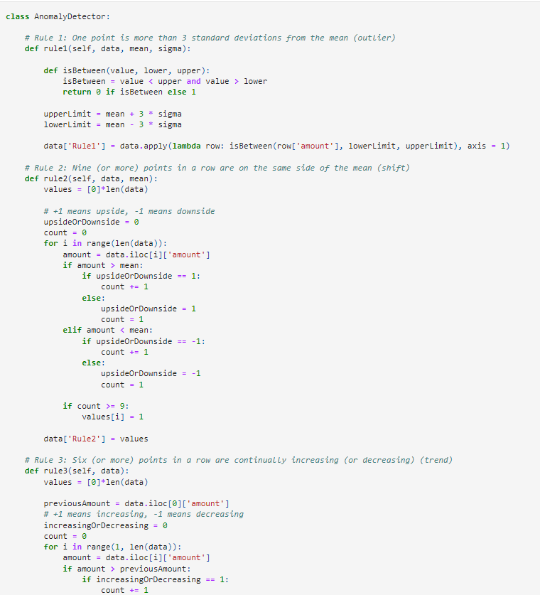

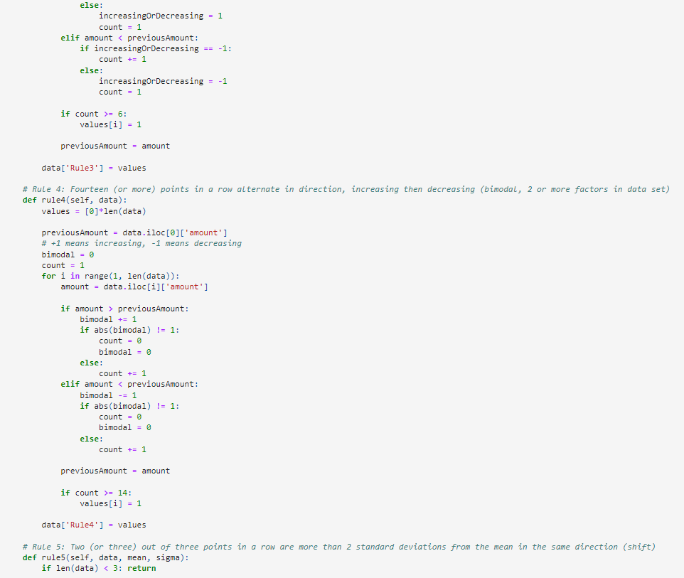

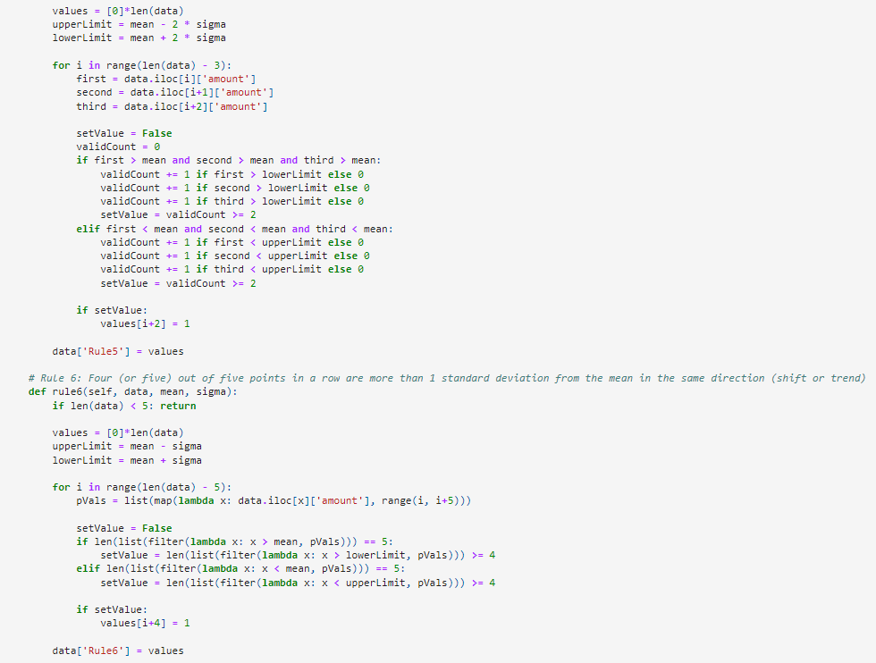

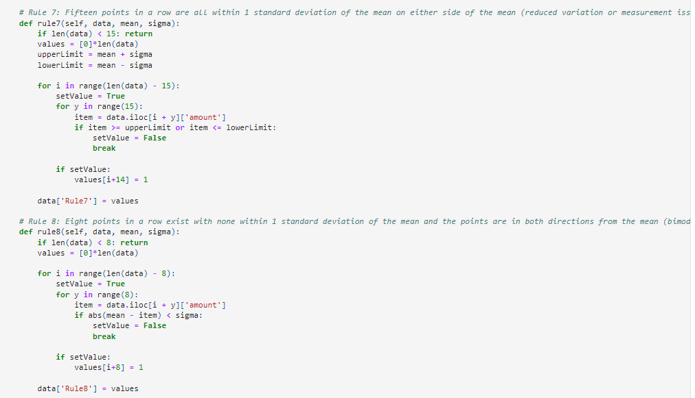

**CHAPTER 9 CHALLENGES FACED**

* Creating the algorithm for building decision tree.
* Lack of datasets based on industrial processes.
* The existing software on control charts are not open source.

**CHAPTER 10 FUTURE SCOPE**

Control charts are an essential tool in statistical process control, which is used to monitor and control a process to ensure that it operates within specified limits. Machine learning can help to enhance the accuracy and efficiency of control charts by automating the process of detecting patterns and anomalies in data.

1. Real-time process monitoring: With the use of machine learning, control charts can be updated in real-time, allowing operators to quickly identify and respond to any deviations from the normal process. This can help to reduce waste, improve quality, and increase productivity.

2. Predictive maintenance: By analyzing historical data from control charts, machine learning algorithms can identify patterns that indicate when equipment is likely to fail. This can enable operators to perform maintenance proactively, reducing downtime and saving costs.

3. Quality control in manufacturing: Machine learning-powered control charts can be used to monitor various stages of the manufacturing process, ensuring that products meet the required specifications. This can help to improve quality control, reduce defects, and increase customer satisfaction.

4. Anomaly detection: Machine learning algorithms can detect anomalies in data that may not be apparent to human operators, enabling them to take corrective action quickly. This can help to reduce the risk of costly errors and improve overall process performance.

Overall, the future scope of software applications that create control charts using machine learning is vast and holds great potential for improving various industries' operations.

**CHAPTER 11 CONCLUSION**

In this paper, we presented a web-based application that allows users to upload data and generate control charts based on their input, incorporating machine learning techniques to automatically detect out-of-control points.

Future work could include improving the efficiency and robustness of the machine learning approach and incorporating additional types of control charts. In addition to SVMs, other machine learning techniques such as neural networks and decision trees have also been proposed for constructing control charts.

Overall, this research demonstrates the potential of machine learning in the field of statistical process control, providing a useful tool for practitioners in a variety of industries and applications, including manufacturing, quality control, and data analysis. The integration of machine learning techniques in control chart analysis has the potential to improve the accuracy and efficiency of control chart analysis, providing a valuable contribution to the field.

**REFERENCES**

* International Standards Organization (ISO). ISO 15189:2007. Medical Laboratories –

Requirements for Quality and Competence. 2nd ed. 2007

* Semra Boran, Ibrahim Cil, Deniz Demircioglu Diren. ArticlePDF Available Integration of Machine Learning Techniques and Control Charts for Multivariate Processes
* Phuong Hanh Tran, Adel Ahmadi Nadi, Duc Tran Kim. Application of Machine Learning in Statistical Process Control Charts: A Survey and Perspective
* P. H. Tran and C. Heuchenne. Monitoring the coefficient of variation using variable sampling interval cusum control charts. Journal of Statistical Computation and Simulation, 91(3):501–521, 2021.
* V. Chandola, A. Banerjee, and V. Kumar. Anomaly detection: A survey. ACM computing surveys (CSUR), 41(3):1–58, 2009.
* F. Y. Edgeworth. Xli. on discordant observations. The london, edinburgh, and dublin philosophical magazine and journal of science, 23 (143):364–375, 1887.
* W. A. Shewhart. Some applications of statistical methods to the analysis of physical and engineering data. Bell System Technical Journal, 3(1):43–87, 1924.
* L. C. Alwan. Effects of autocorrelation on control chart performance. Communications in statistics-Theory and Methods, 21(4):1025–1049, 1992.
* R. Noorossana and S. J. M. Vaghefi. Effect of autocorrelation on performance of the mcusum control chart. Quality and Reliability Engineering International, 22(2):191–197, 2006.
* A.F.B. Costa and P. Castagliola. Effect of measurement error and autocorrelation on the X¯ chart. Journal of Applied Statistics, 38(4): 661–673, 2011.
* R. C. Leoni, A. F. B. Costa, and M. A. G. Machado. The effect of the autocorrelation on the performance of the t2 chart. European Journal of Operational Research, 247(1):155–165, 2015.
* Xie M, Lu XS, Goh TN, Chan LY. A quality monitoring and decision-making scheme

for automated production processes. International Journal of Quality and Reliability

Management. 1999;16(2):148-157

* Antony J, Kaye M, Frangou A. A strategic methodology to the use of advanced statistical

quality improvement techniques. The TQM Magazine. 1998;10(3):169-176

* Hairulliza MJ, Hazura M, Erna BN. Aplikasi Carta Kawalan Dalam Industri Produk

Minuman. Seminar Kebangsaan Komputeran IndustriI Comp. 2005:43-47

* Montgomery DC. Introduction to Statistical Quality Control. 4th ed. New York: John Wiley & Sons, Inc.; 2001. 796 pp
* Atilla A. Exercises on ISO 9001 Quality Insurance System (ISO 9001) Kalite Güvence Sisteminin Örnekleri. İstanbul: Çağlayan Publications (Kitabevi); 1996. 412 pp
* Taiwo, O. A. (2010). Types of Machine Learning Algorithms, New Advances in Machine Learning, Yagang Zhang (Ed.), ISBN: 978-953-307-034-6, InTech, University of Portsmouth United Kingdom. Pp 3 – 31
* Barlow, H. B., "Unsupervised learning," Neural computation, Vol.1, No.3, pp.295-311, 1989.
* S. Russell and P. Norvig, Artificial Intelligence: A Modern Approach, 3rd ed. Pearson, 2009.
* Z. Kang, C. Catal, and B. Tekinerdogan. Machine learning applications in production lines: A systematic literature review. Computers & Industrial Engineering, 149:106773, 2020.
* P. Qiu and X. Xie. Transparent sequential learning for statistical process control of serially correlated data. Technometrics, (just-accepted): 1–29, 2021.
* M. Weese, W. Martinez, F.M. Megahed, and L.A. Jones-Farmer. Statistical learning methods applied to process monitoring: An overview and perspective. Journal of Quality Technology, 48(1):4–24, 2016.