Trello Board pictures from sprint week!☺

First days of the sprint as you can see there is still lots of work to be done.

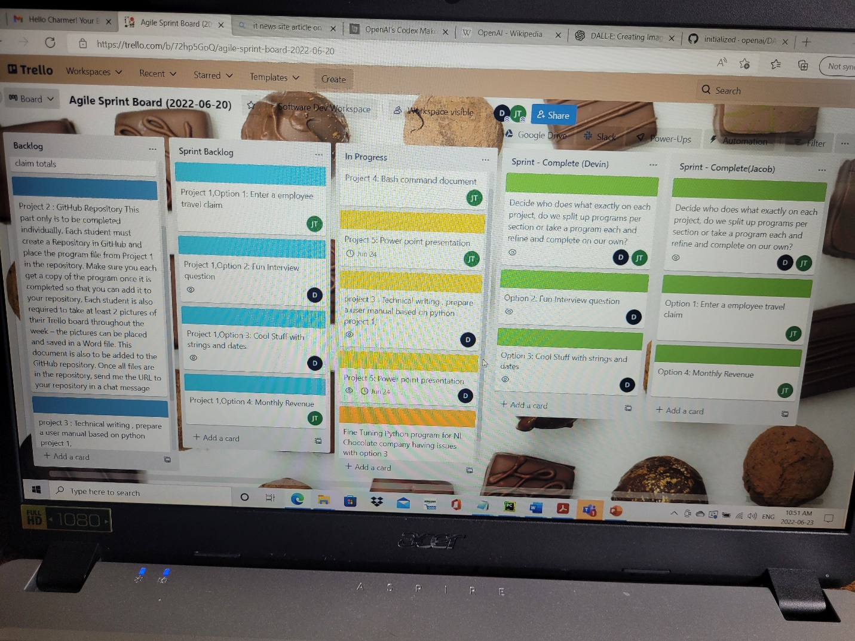

In this picture from you can see work is progressing and tasks are being completed in an orderly manner.

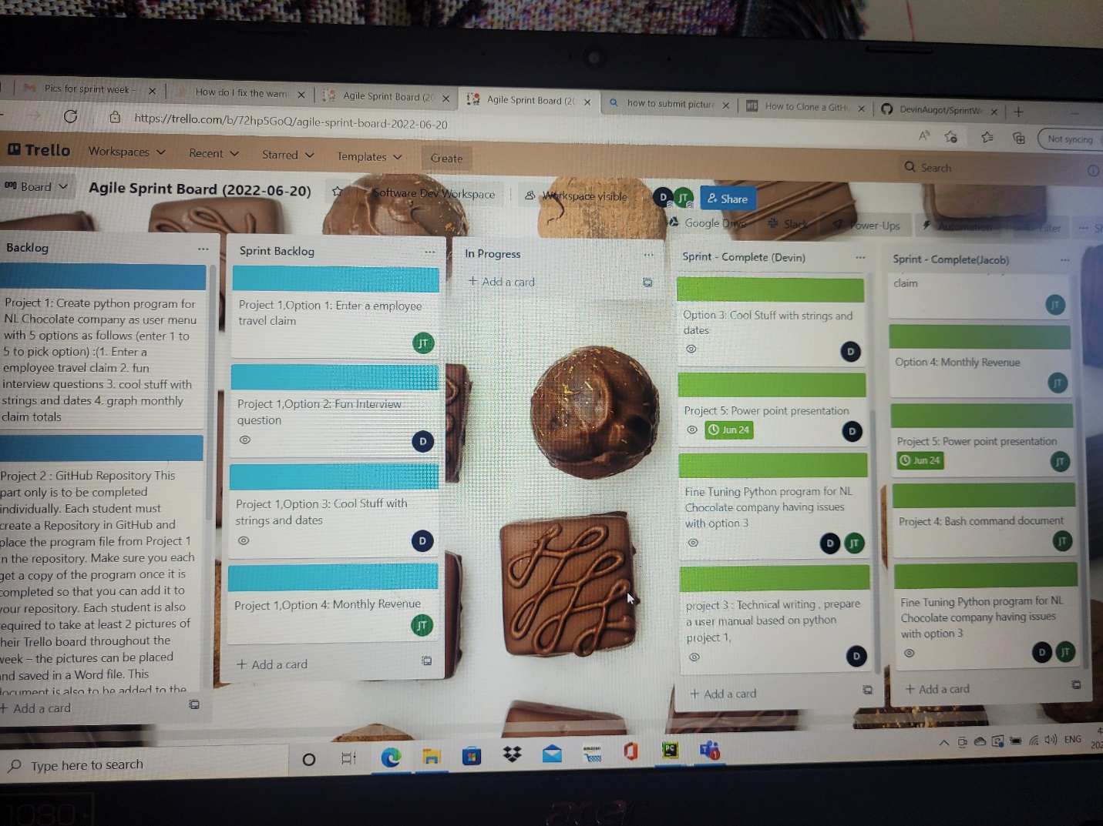

Last day of project June 26th, 2022, as you can see everything that was in progress is now completed.