CLOUD SECURITY
HARDENING PROJECT
AWS Home Lab: Public/Private Architecture,
IAM Least Privilege & Centralized Logging
Prepared by Devin Phillips
August 2026
github.com/DevinCodes13

OVERVIEW

1 Executive Summary
This project builds a small AWS environment from a default, unhardened state to a documented, defensible security posture: a public/private network split, encrypted storage, least-privilege IAM for separate developer and admin roles, and centralized logging at both the API and network level.
Every control below was built permissively first, evidenced, then hardened and re-evidenced — the screenshots throughout this report are real console output from this build, not staged examples. Three genuine incidents occurred during the work: two account self-lockouts and one blocked security-group edit, all caused by the same root issue in how AWS evaluates MFA-gated IAM policies against console sessions. Each is documented as it happened, including the diagnosis and recovery, because the incident-and-recovery record is more informative than a clean run would have been.

Controls Implemented
Control | Before | After
Network segmentation | Flat network | VPC with public + private subnets, no NAT Gateway
Security groups | SSH open to 0.0.0.0/0; private tier open to entire VPC CIDR | SSH restricted to a single IP; private tier restricted to a security-group reference
Storage access | S3 bucket publicly readable | Block Public Access on, no bucket policy
Storage encryption | Default AWS-managed key (SSE-S3) | Customer-managed KMS key (SSE-KMS)
IAM – developer | AmazonEC2FullAccess (account-wide) | Custom least-privilege policy, tag-scoped, MFA-gated denies
IAM – admin | AdministratorAccess only | AdministratorAccess + custom MFA-gated policy, tested for gaps
API-level logging | None | CloudTrail, multi-region, log file validation enabled
Network-level logging | None | VPC Flow Logs (all traffic) to a centralized S3 bucket

ARCHITECTURE

2 Environment Overview
The environment runs in a single custom VPC (10.0.0.0/16) with one public and one private subnet, both in a single Availability Zone to keep the lab simple and free-tier-friendly. No NAT Gateway was used — the private instance has no outbound internet route at all, by design, since nothing in this lab needs it.

Components
Component | Role | Detail
public-web | Public-facing EC2 instance | Amazon Linux 2023, t2.micro, public subnet, public IP
private-app | Private EC2 instance | Amazon Linux 2023, t2.micro, private subnet, no public IP
devin-lab-bucket-2026 | Object storage | S3, SSE-KMS encrypted, public access blocked
devin-lab-s3-key | Encryption key | Customer-managed KMS key, usage restricted to admins
devin-lab-trail | API audit log | CloudTrail, multi-region, log file validation on
devin-flow-log | Network audit log | VPC Flow Log, all traffic, delivered to S3
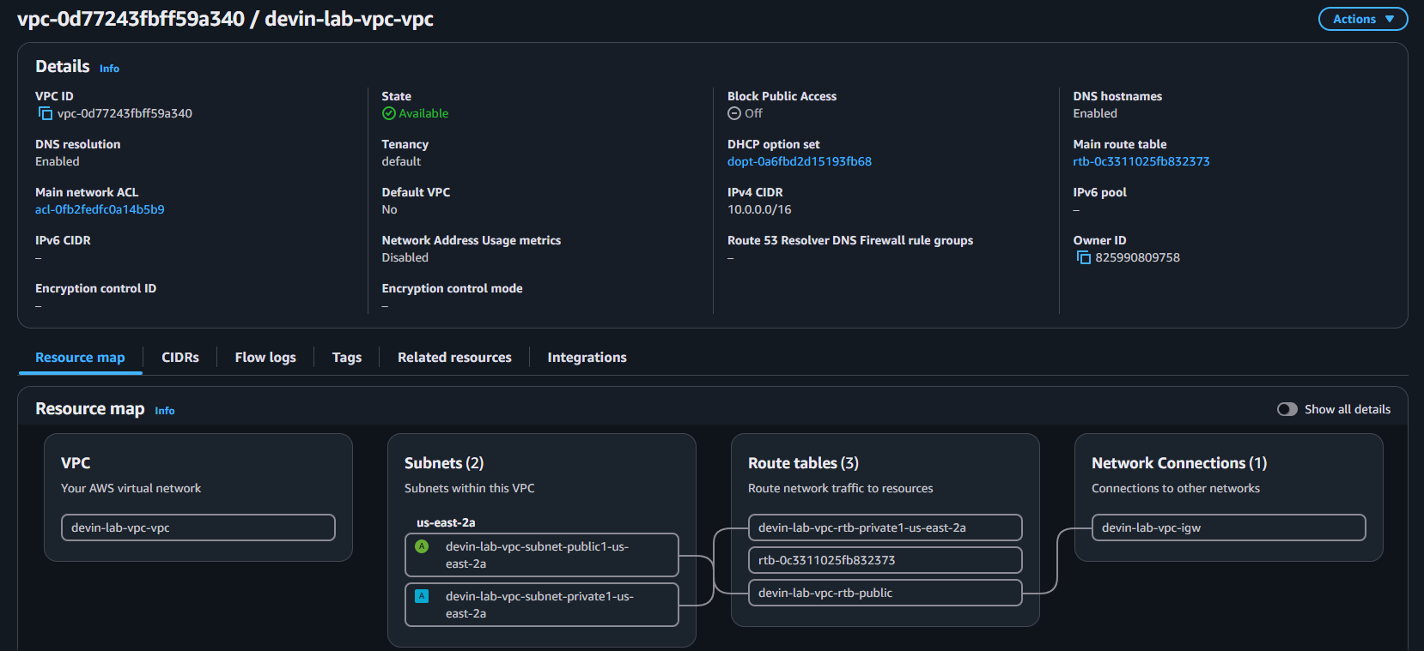
ARCHITECTURE VPC resource map: one public subnet and one private subnet, three route tables, and a single Internet Gateway. No NAT Gateway exists in this account — the private subnet's route table has no path to the internet at all.
FOUNDATION

3 Account Setup & Guardrails
Before creating any billable resource, the root account was secured and a scoped IAM identity was created for day-to-day work. Root exists in AWS as an unrestricted, unrestrictable identity — the standard practice, followed here, is to enable MFA on it, use it only for the handful of tasks that require it, and do everything else as a normal IAM user.
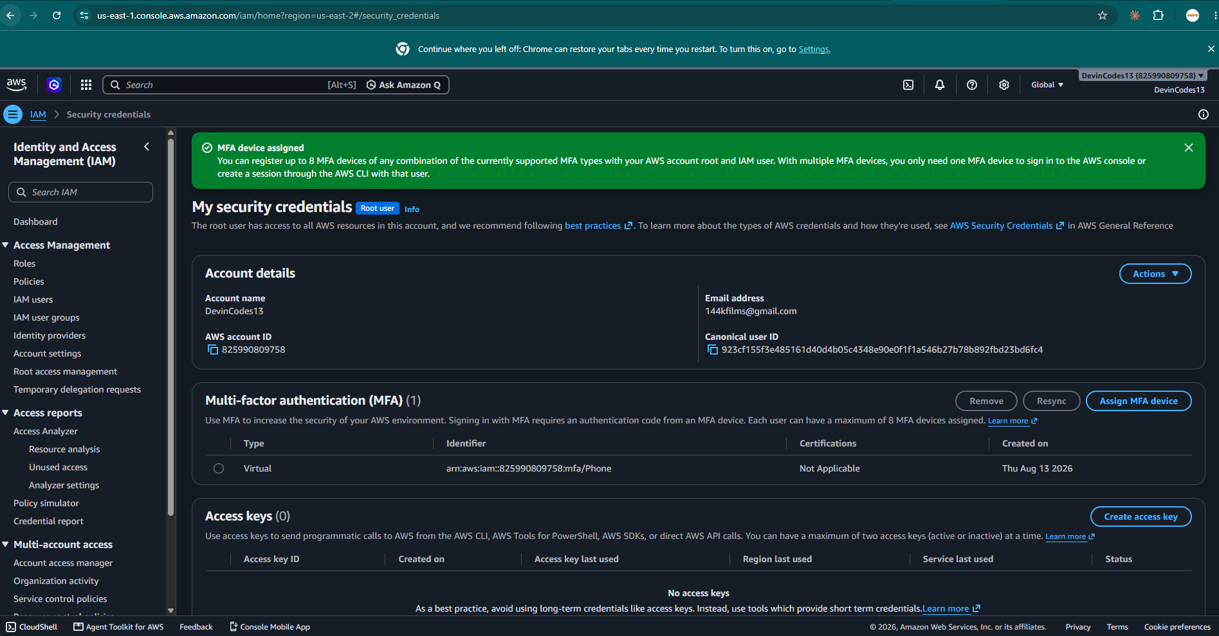
EVIDENCE Root account with a virtual MFA device assigned and zero long-term access keys — root is locked down and unused for programmatic access.
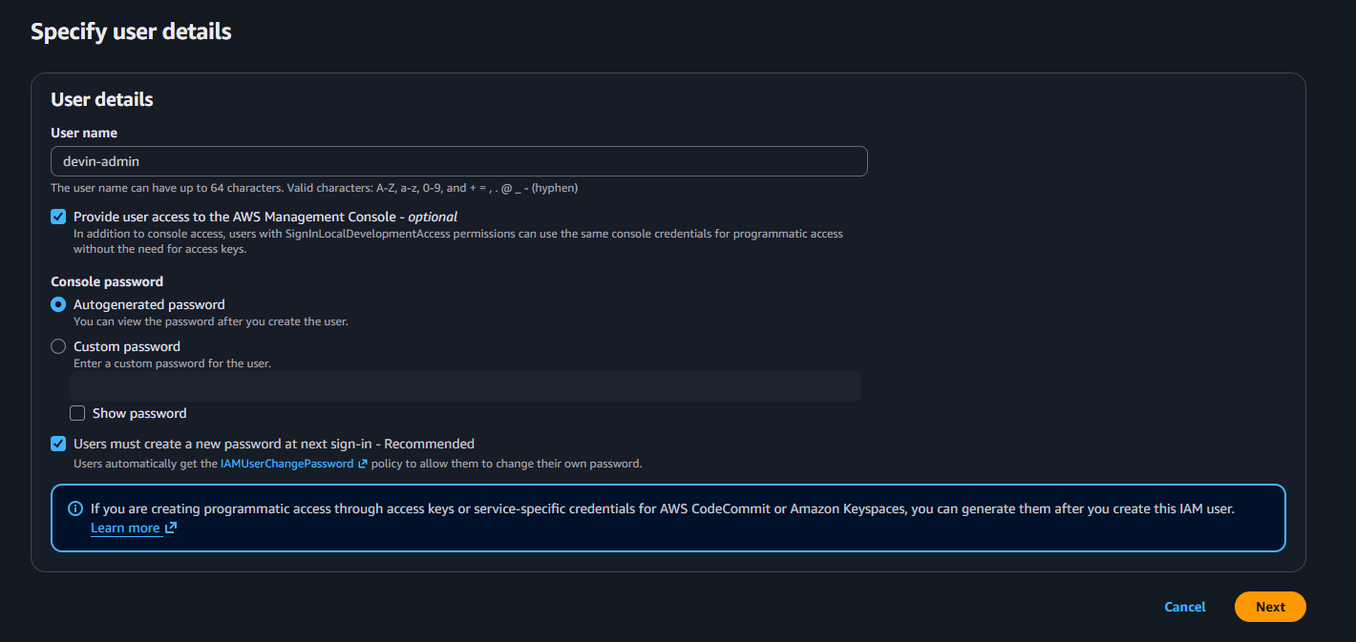
EVIDENCE Creating devin-admin as a separate IAM user rather than continuing to operate as root, with autogenerated password and forced password reset on first login.
A $5 monthly AWS Budgets alarm was also configured before any resources were created, as a safety net against unexpected charges (e.g. an accidentally-left-running NAT Gateway or KMS key).
NETWORK

4 Network Segmentation & Security Groups
Both EC2 instances and their security groups were built in a deliberately permissive state first, to capture genuine before/after evidence rather than describing a hardened config that was never actually insecure.

4.1 Security Groups — Before
public-sg allowed SSH from anywhere on the internet. private-sg allowed all traffic from the entire VPC CIDR block — far broader than the one host that legitimately needed to reach it.
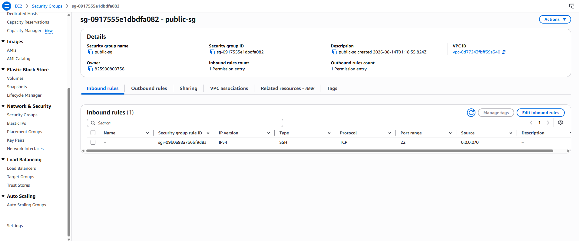
EVIDENCE public-sg inbound rule: SSH (port 22) open to 0.0.0.0/0 — any host on the internet could attempt to authenticate.
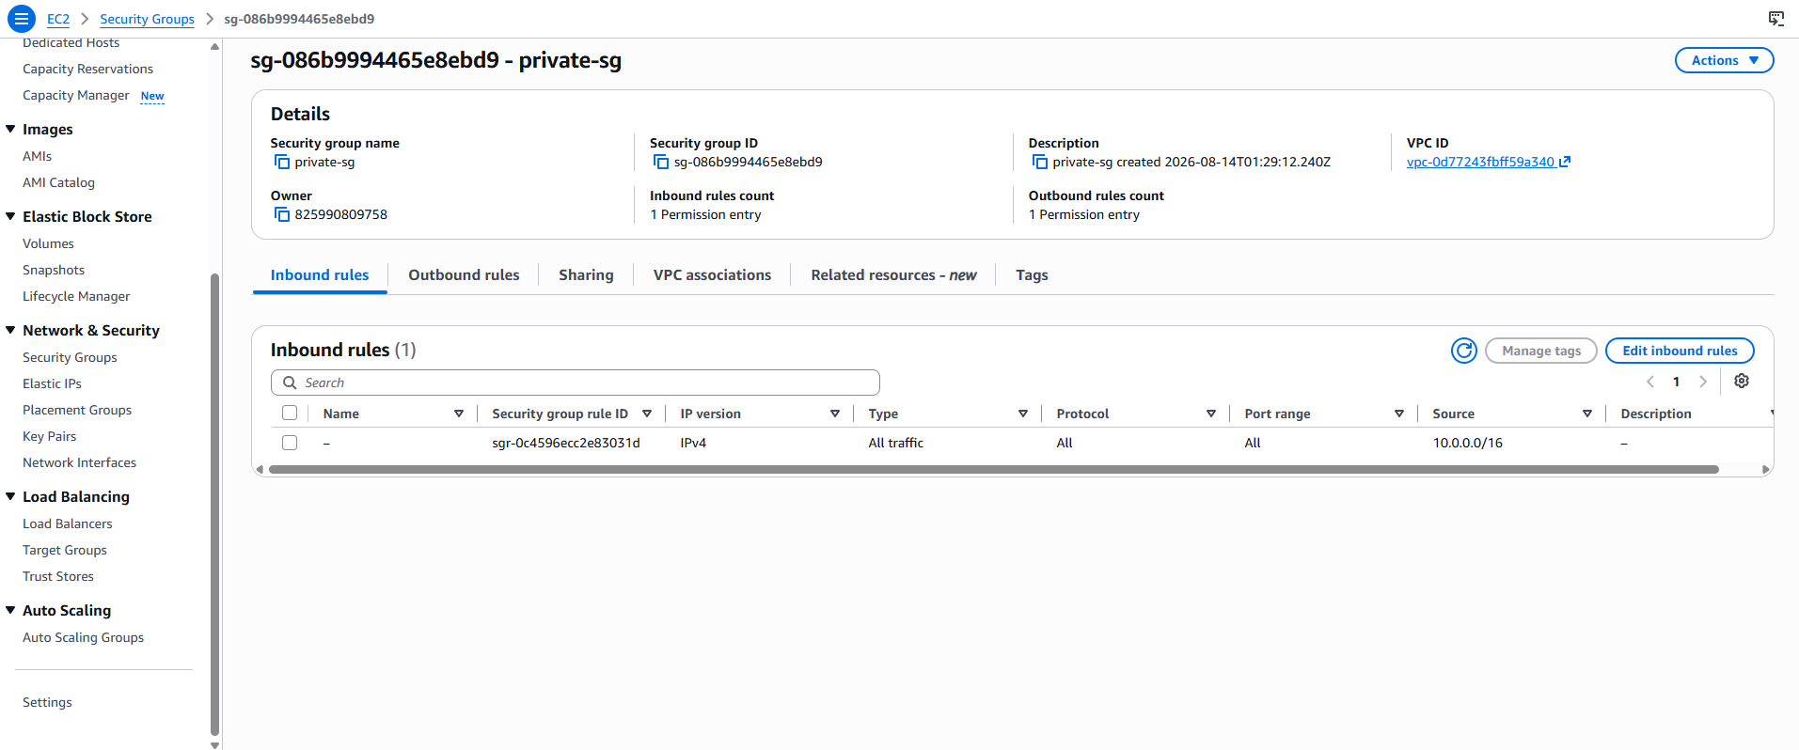
EVIDENCE private-sg inbound rule: all traffic allowed from 10.0.0.0/16, the entire VPC — broader than the single public instance that should be able to reach it.

4.2 Security Groups — After
public-sg's SSH rule was narrowed to a single /32 address. private-sg's rule was rebuilt to reference public-sg directly as its source, rather than a CIDR range — meaning only traffic actually originating from an instance wearing that specific security group is trusted, regardless of what IP addressing the VPC uses now or in the future.
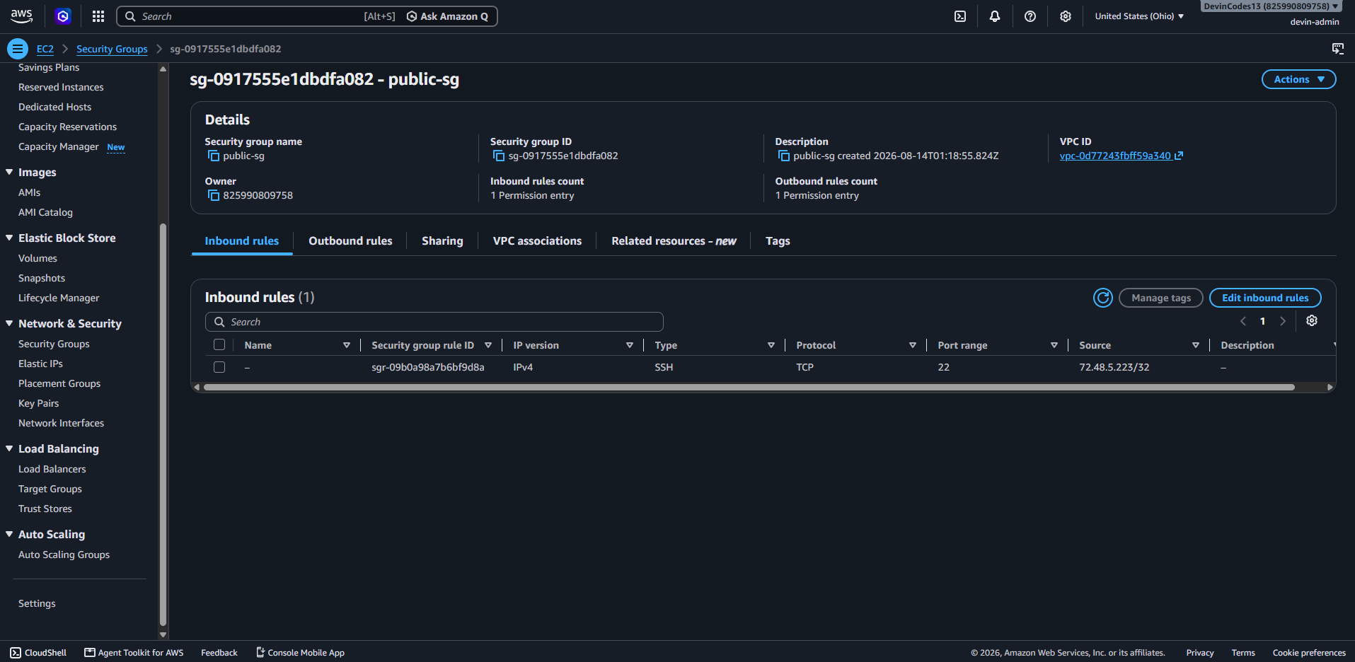
EVIDENCE public-sg after hardening: SSH restricted to 72.48.5.223/32, a single host.
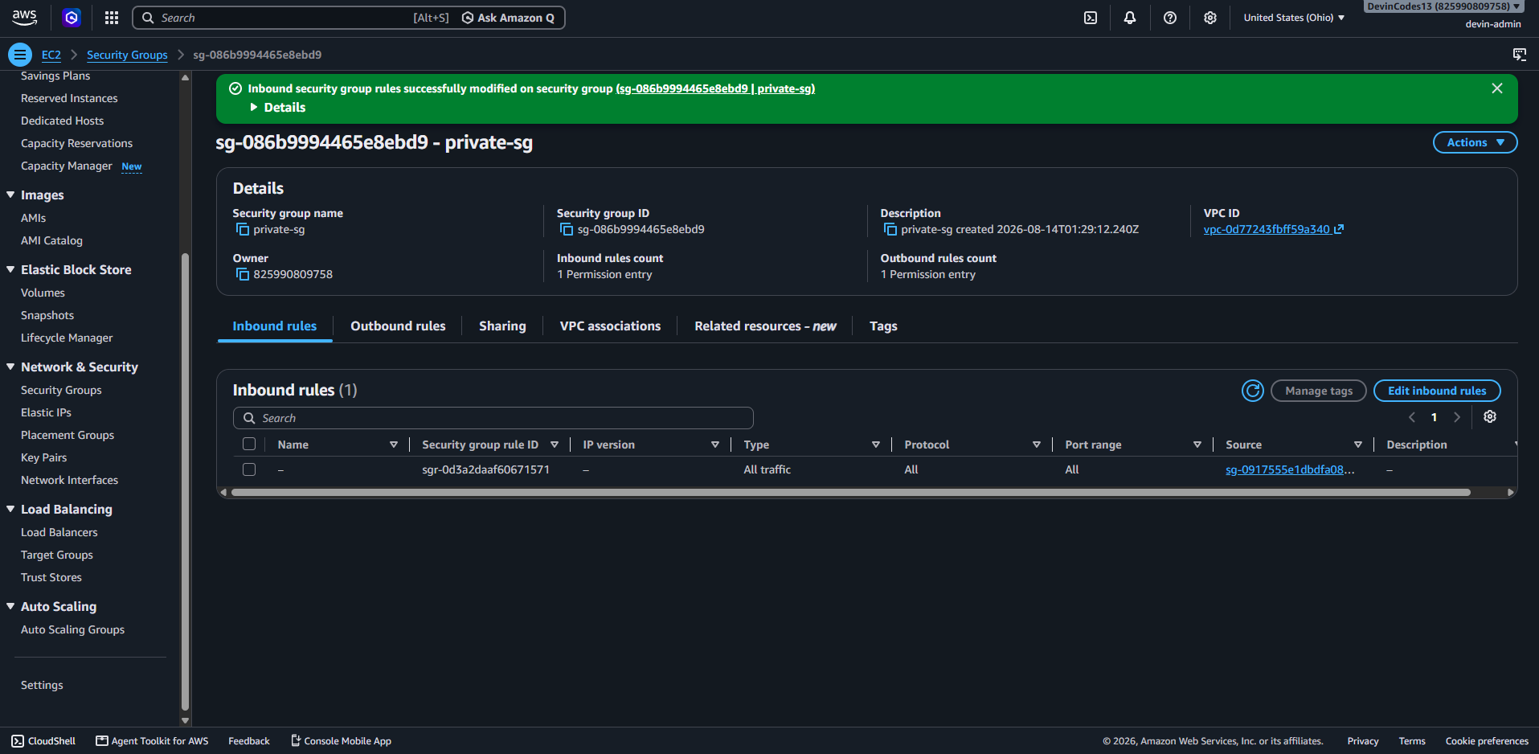
EVIDENCE private-sg after hardening: source is now sg-0917555e1dbdfa082 (public-sg) — a security-group reference, not an IP range.
Note: AWS's console auto-populates a new security group's first rule as SSH from Anywhere by default — an easy trap to leave in place unintentionally. Both groups here were deliberately built with that default first, then corrected, to document the trap as well as the fix.

4.3 Compute Access Validation
public-web was reached directly over SSH using a downloaded key pair. An early attempt failed only because of a working-directory mistake (the key file wasn't where the shell expected it) — included here because it's a common, honest first-SSH mistake, not a security finding.
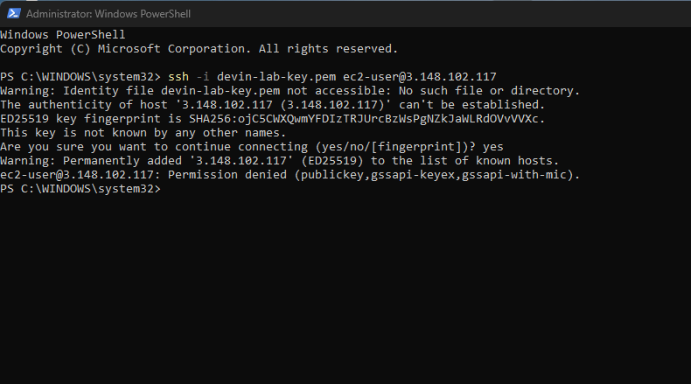
EVIDENCE First SSH attempt: key file not found in the current directory, so SSH silently fell back to other auth methods and was denied.
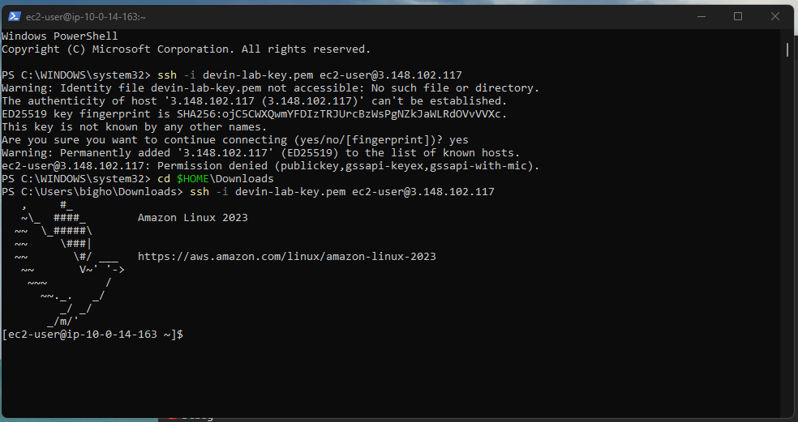
EVIDENCE Successful SSH into public-web once the key path was corrected.

4.4 Private Instance Isolation
private-app has no public IP and no route to the internet. Reachability was proven two ways: a direct connection attempt from outside the VPC, and a successful connection made only by hopping through public-web using SSH agent forwarding (so the private key itself never touches the bastion host).
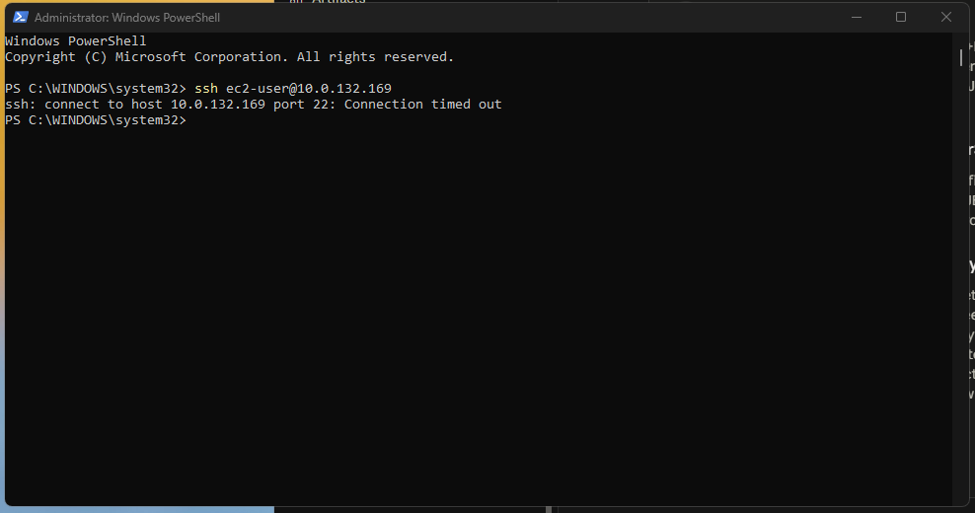
EVIDENCE Direct SSH attempt from the local machine straight to private-app's private IP — connection times out. There is no network path in from outside the VPC.
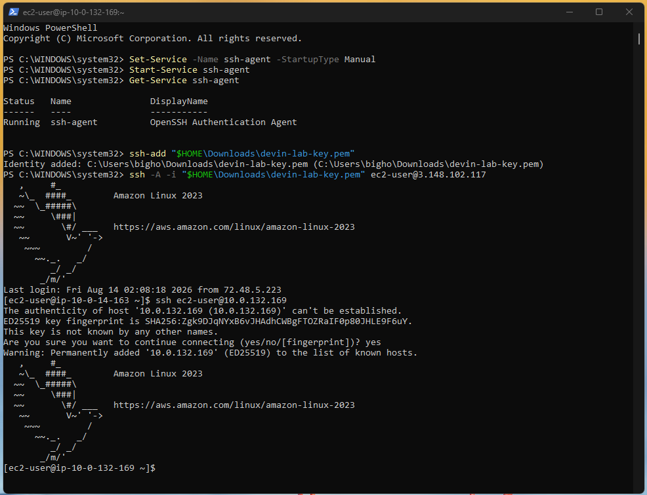
EVIDENCE SSH agent forwarding used to jump from public-web into private-app — the only working path, and it goes through the public instance by design.
STORAGE

5 S3 Access Control & Encryption

5.1 Public Access — Before
The bucket was created with Block Public Access disabled and a bucket policy granting anonymous s3:GetObject on every object — a deliberate, demo-only misconfiguration, never used to store real data.
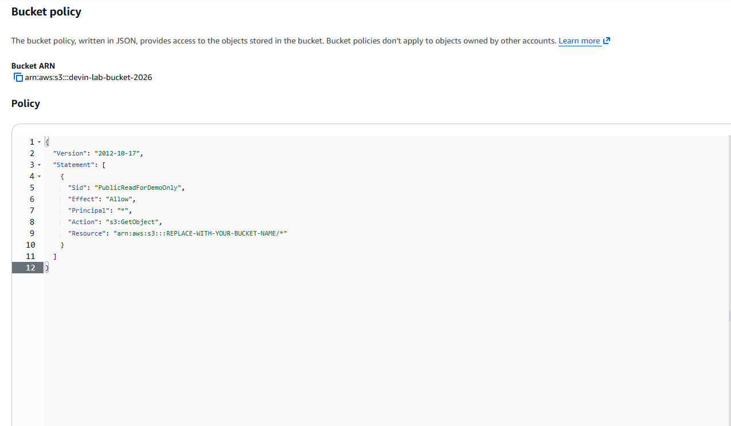
EVIDENCE Bucket policy granting public read access (Principal: "*") — the classic public-bucket misconfiguration.
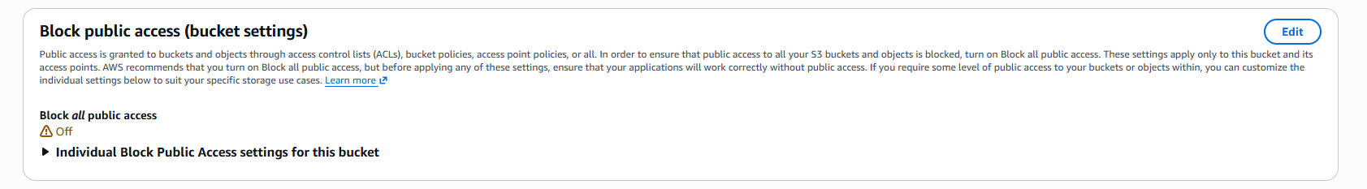
EVIDENCE Block Public Access shown Off at the bucket level, which is what allowed the policy above to take effect at all.

5.2 Public Access — After
The bucket policy was removed and Block Public Access re-enabled immediately after capturing the evidence above.
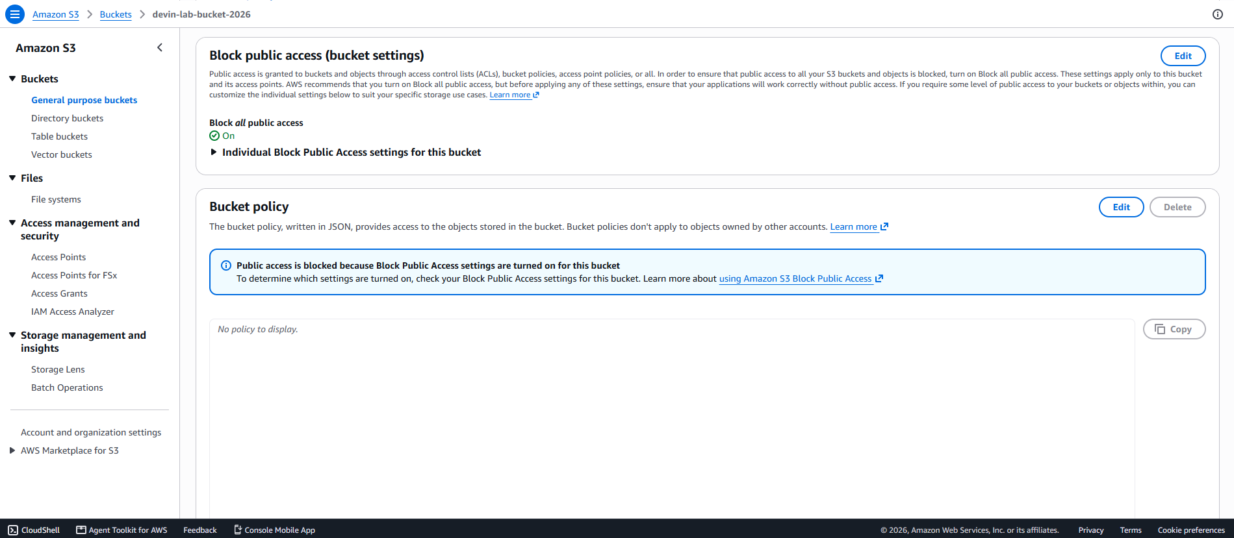
EVIDENCE Block Public Access back On, and “No policy to display” — the bucket is no longer reachable by anyone outside the account.

5.3 Encryption — Before and After
As of this project, AWS enforces default server-side encryption (SSE-S3) on every new S3 bucket automatically — there is no way to create a genuinely unencrypted bucket anymore. That made “encrypted vs. unencrypted” unavailable as a before/after story, so the encryption upgrade demonstrated here is a more realistic one: default AWS-managed keys versus a customer-managed KMS key, which adds real access control (only specific IAM principals can use the key) and an audit trail every time it's used.
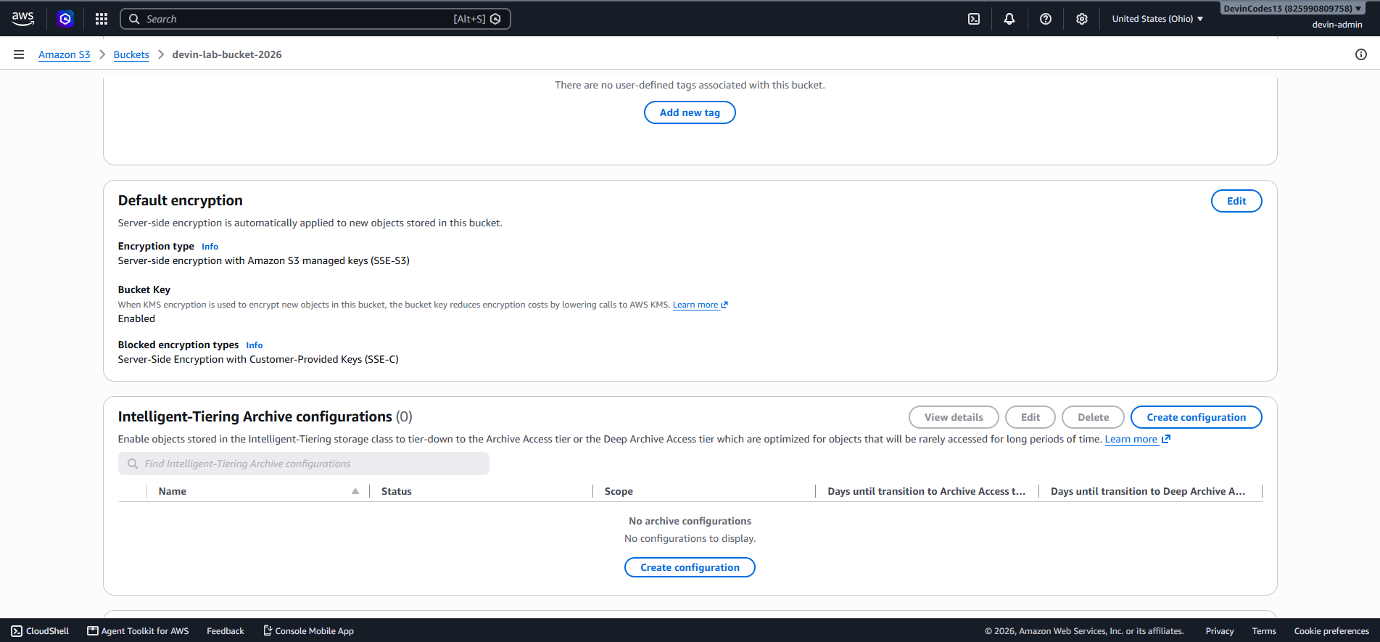
EVIDENCE Default encryption: SSE-S3 with an AWS-managed key — AWS's own baseline, but with no key-level access control.
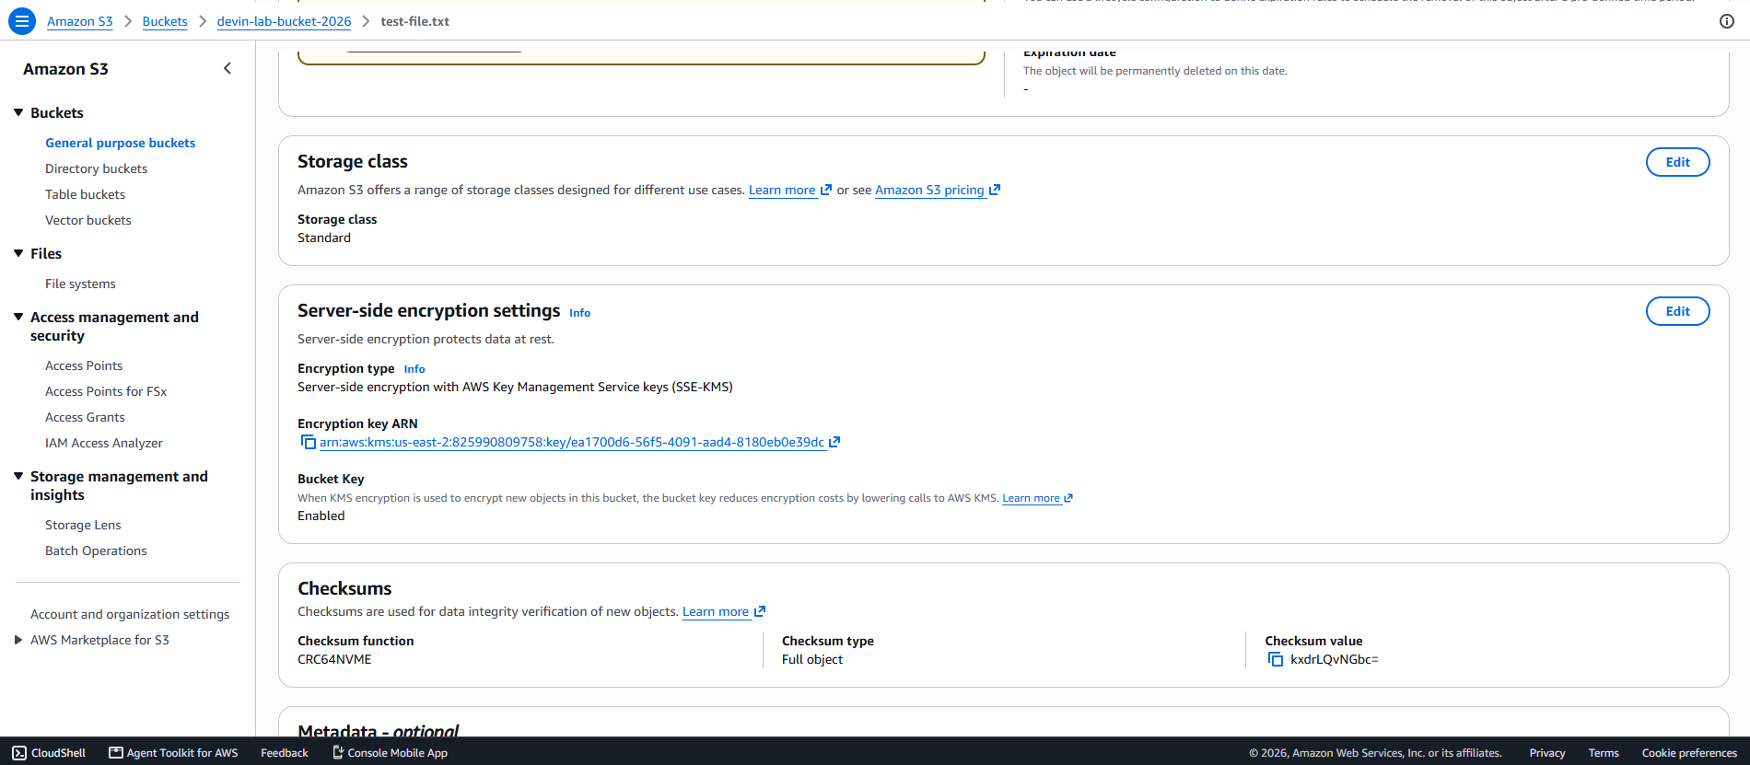
EVIDENCE A test object encrypted under devin-lab-s3-key, a customer-managed KMS key — note the specific key ARN, versus a generic AWS-managed key with no visibility into who can use it.
IDENTITY & ACCESS

6 IAM Least Privilege
Two IAM groups were built to demonstrate a real developer/admin split: Developers, scoped down to only what a developer role needs, and Admins, given broad access but with destructive or sensitive actions gated behind a live MFA session.

6.1 Developer Policy — Before and After
Developers started with AmazonEC2FullAccess — unrestricted control over every EC2 resource in the account, not just the developer's own. It was replaced with a custom policy: EC2 start/stop/reboot restricted to instances tagged Owner: developer, S3 access restricted to one specific bucket, and an explicit Deny on IAM changes, security group edits, and CloudTrail tampering — regardless of what any other policy might grant.
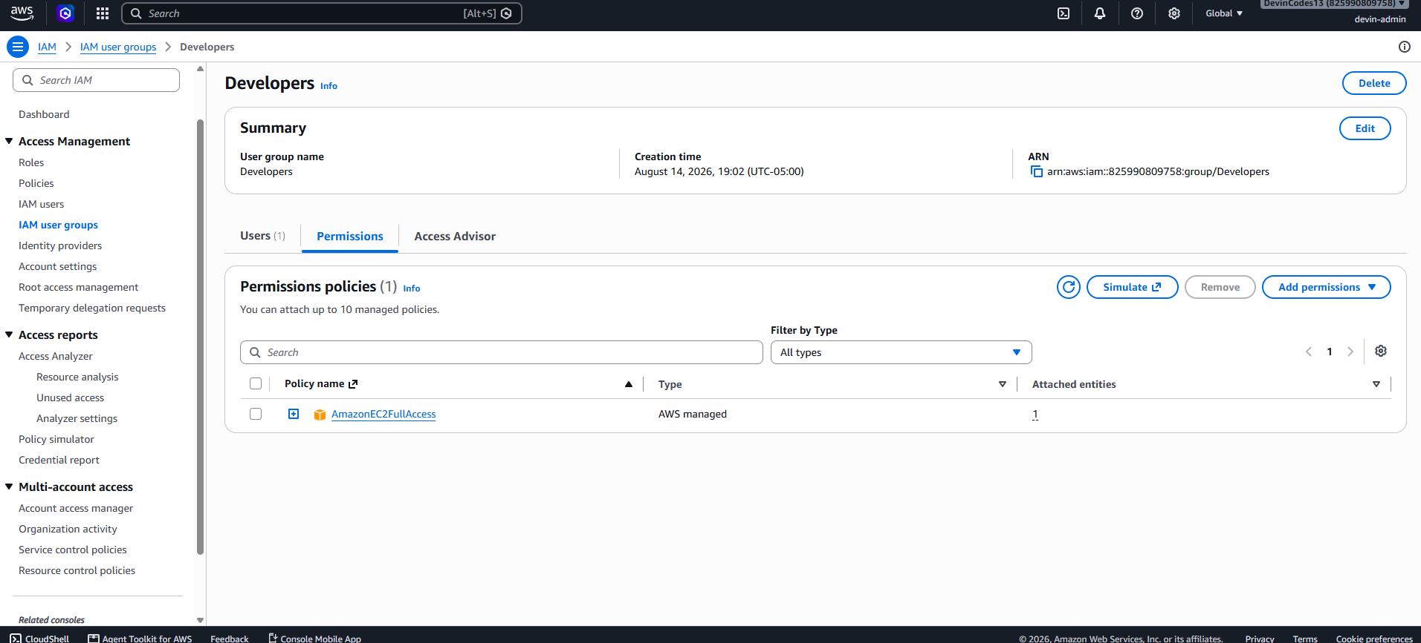
EVIDENCE Developers group with AmazonEC2FullAccess attached — full account-wide EC2 control, far beyond what a developer role needs.
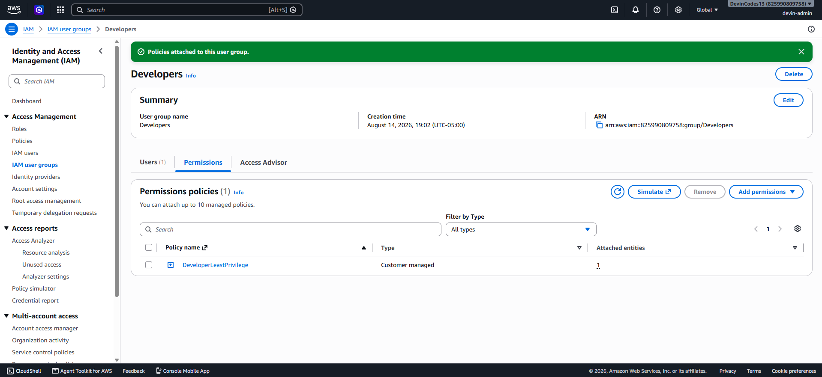
EVIDENCE Developers group after the swap — only the custom DeveloperLeastPrivilege policy attached.

6.2 Proving the Policy Actually Blocks What It Claims To
A policy document is a claim; the IAM Policy Simulator is a way to test the claim. Two actions the explicit-deny statement specifically targets — creating a new IAM user, and terminating an EC2 instance — were simulated against the developer identity.
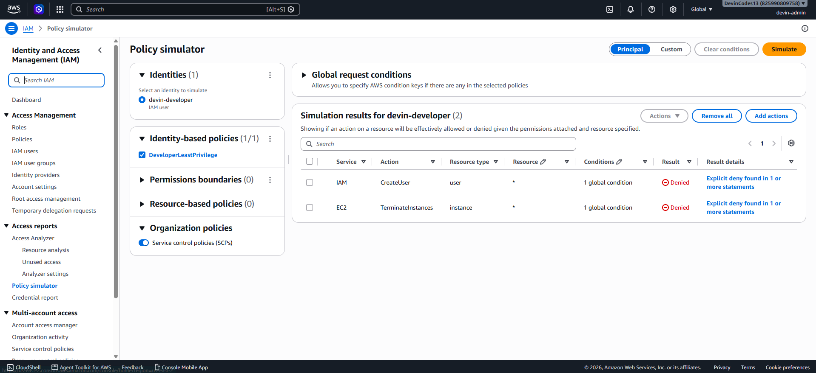
EVIDENCE Policy simulator: both iam:CreateUser and ec2:TerminateInstances come back Denied for the developer identity, with the explicit-deny statement cited as the reason — confirmed, not just claimed.

6.3 Admin Policy
Admins kept AdministratorAccess attached throughout the project as a deliberate safety net, alongside a custom AdminWithMFA policy layered on top: broad operational access (EC2, S3, CloudTrail, logs), but an explicit Deny on IAM writes, resource deletion, and CloudTrail tampering unless the session is MFA-authenticated. Two rounds of live testing surfaced real gaps in the first draft — missing IAM group-visibility actions and a newer CloudTrail API action — both patched in a corrected v2 policy (Appendix B).
A full swap to AdminWithMFA alone (removing AdministratorAccess entirely) was deliberately not carried out as the final state. After three related incidents in one build session (Section 7), doing a fourth live test of a fully-restricted single-admin account was judged to add more risk than report value — keeping AdministratorAccess attached as a safety net, with AdminWithMFA proven functional alongside it, was the more defensible engineering call.
INCIDENTS

7 Incidents & Recovery
Three real incidents occurred while building the IAM controls above. All three share the same underlying cause and are presented together for that reason, even though they happened at different points in the build.
INCIDENT 1 — Self-Lockout via Premature Policy Removal
What happened: AdministratorAccess was detached from the Admins group before AdminWithMFA had been successfully attached, on the assumption the swap would complete in one step. It did not — the attach failed, leaving the Admins group with zero policies attached.
Impact: devin-admin's only permissions came from that group. With it empty, devin-admin lost the ability to perform any IAM action — including the ability to fix its own lockout.
Recovery: logged into the root account (which bypasses all IAM restrictions by design) and re-attached AdministratorAccess to the Admins group. devin-admin regained access on next login.
Root cause & fix: the underlying lesson wasn't "don't touch IAM" — it was sequencing. Every subsequent policy swap in this project followed a strict order: attach the new policy first, confirm it works, only then remove the old one. This incident is why that pattern exists.

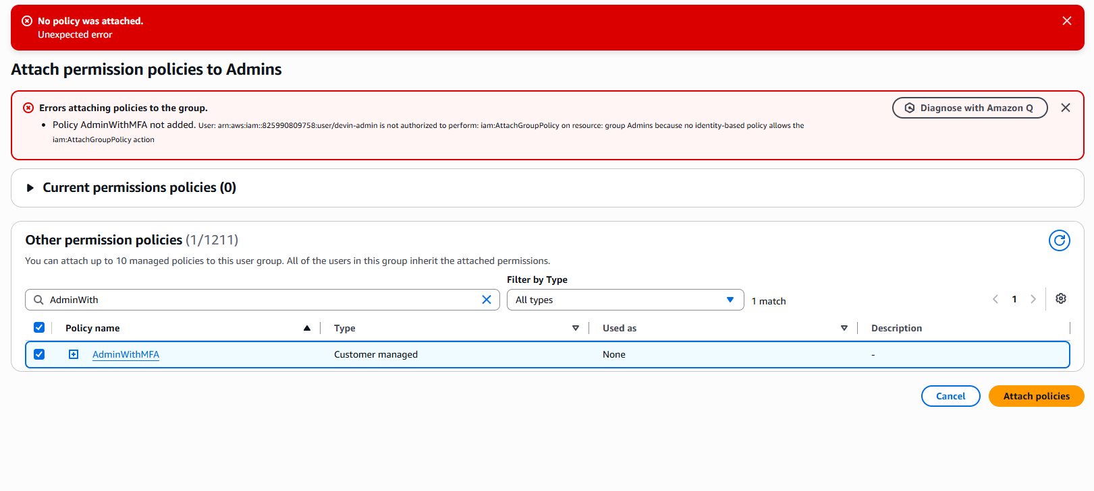
EVIDENCE The moment of lockout: attempting to attach AdminWithMFA fails, and “Current permissions policies (0)” confirms the Admins group is empty.
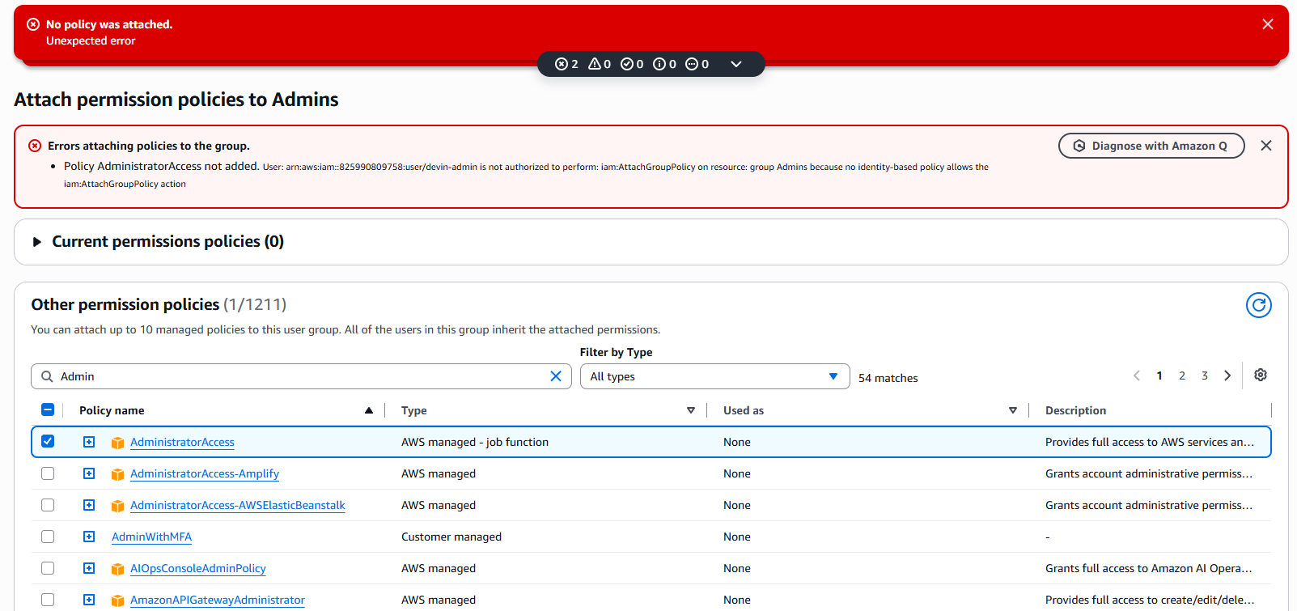
EVIDENCE A recovery attempt as devin-admin, still locked out — confirming the account genuinely had no path to self-heal and required root.
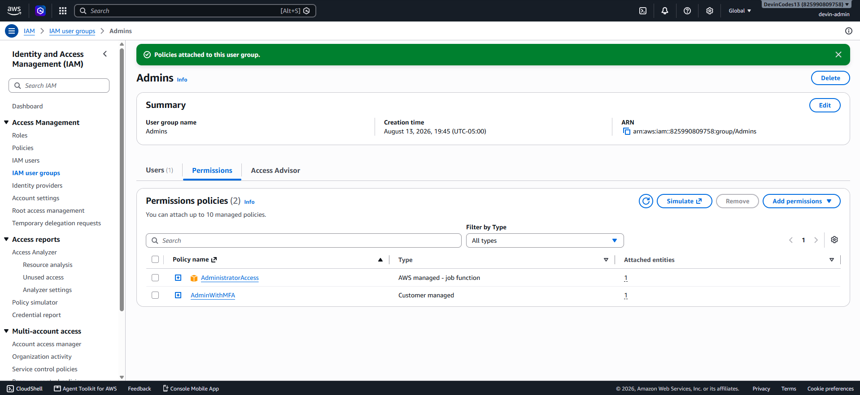
EVIDENCE Post-recovery: Admins group with both AdministratorAccess and AdminWithMFA attached, the safe pattern used for the rest of the project.
INCIDENT 2 — MFA-Gated Explicit Deny Blocking a Legitimate Admin Action
What happened: while creating the CloudTrail trail, AdminWithMFA's explicit-deny statement blocked s3:PutBucketPolicy (required to let CloudTrail write to its log bucket) — even though AdministratorAccess was still attached and would normally allow it.
Why: IAM evaluates explicit Deny as always winning over Allow, and AdminWithMFA denies specific sensitive actions unless the current session carries aws:MultiFactorAuthPresent = true. The session in use at the time did not carry that flag, despite MFA being enabled on the user.
Recovery: temporarily detached AdminWithMFA (leaving AdministratorAccess active), completed the CloudTrail setup, then re-attached AdminWithMFA afterward.
This is a genuine, defensible engineering pattern, not a workaround to be embarrassed about: temporarily loosen a restrictive control to complete a specific task, then re-tighten it — done deliberately and documented, rather than left in place accidentally.

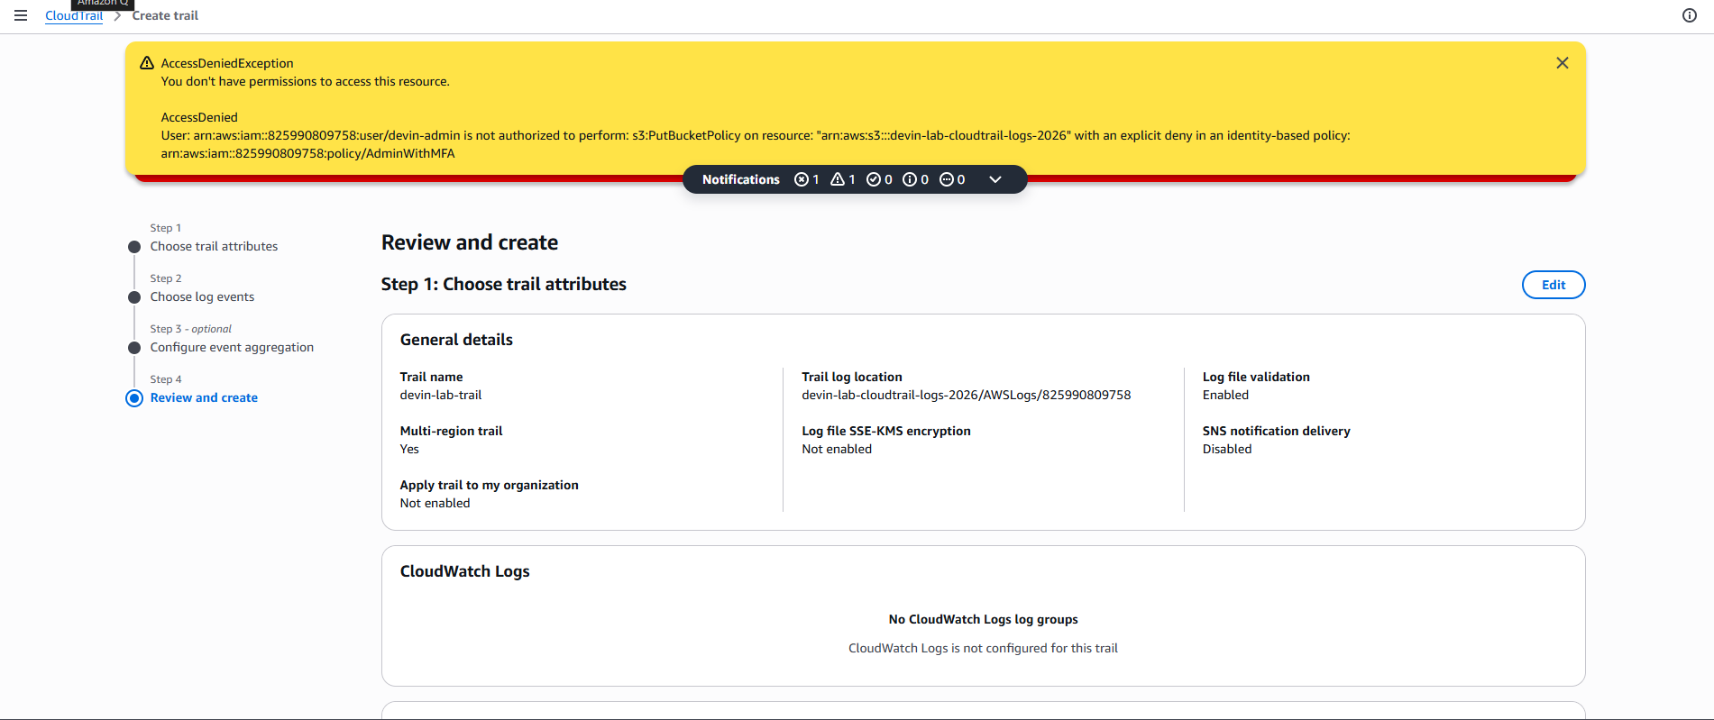
EVIDENCE AccessDeniedException on s3:PutBucketPolicy, explicitly citing “an explicit deny in an identity-based policy: AdminWithMFA” as the cause.
INCIDENT 3 — Same Pattern, Different Action (Security Group Hardening)
What happened: while hardening private-sg's inbound rule, ec2:RevokeSecurityGroupIngress was blocked by the same MFA-gated explicit deny in AdminWithMFA — identical mechanism to Incident 2, different action, different day.
By this point the fix was already known: detach AdminWithMFA, complete the security group change, re-attach it.
Pattern-level takeaway: this happened three times across two unrelated console workflows (CloudTrail setup, security group editing). That consistency suggests the issue isn't isolated bad luck — it's something about how this account's IAM console sessions set (or fail to set) the MFA-present session flag, worth investigating further as a follow-up rather than continuing to route around it indefinitely.
LOGGING

8 Centralized Logging
Two complementary logging layers were built: CloudTrail for API-level activity (who did what, via console or CLI), and VPC Flow Logs for network-level activity (what traffic actually hit the instances, accepted or rejected). Both deliver to S3, and the CloudTrail bucket is kept separate from the data bucket so that a compromise of one doesn't expose the other.

8.1 CloudTrail
devin-lab-trail is a multi-region trail with log file validation enabled — CloudTrail generates cryptographic digest files alongside the logs, so any after-the-fact tampering with a log file is detectable. Management events (both read and write) are logged, plus S3 data events, giving visibility into individual object-level access, not just bucket-level configuration changes.
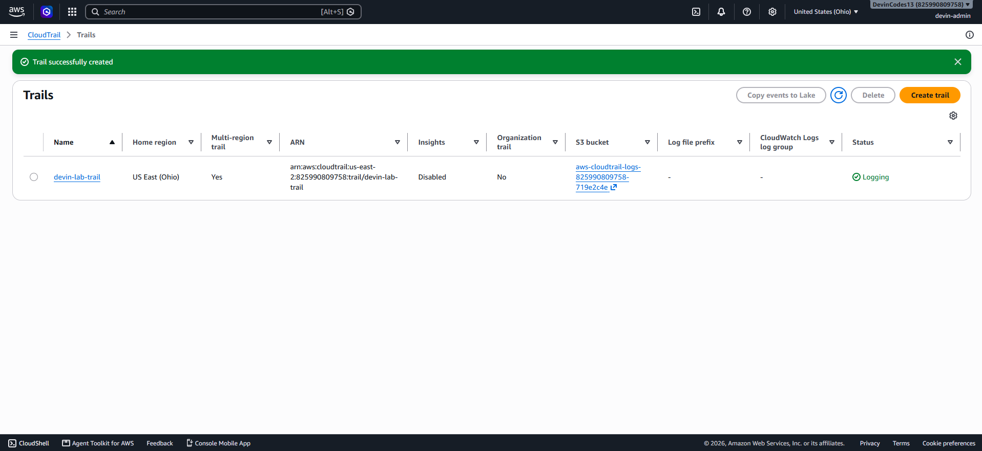
EVIDENCE devin-lab-trail successfully created and actively Logging, multi-region, delivering to a dedicated log bucket.

8.2 VPC Flow Logs
Flow logs were configured to capture all traffic (both ACCEPT and REJECT) at a 1-minute aggregation interval, delivering to the same centralized log bucket under a separate prefix.
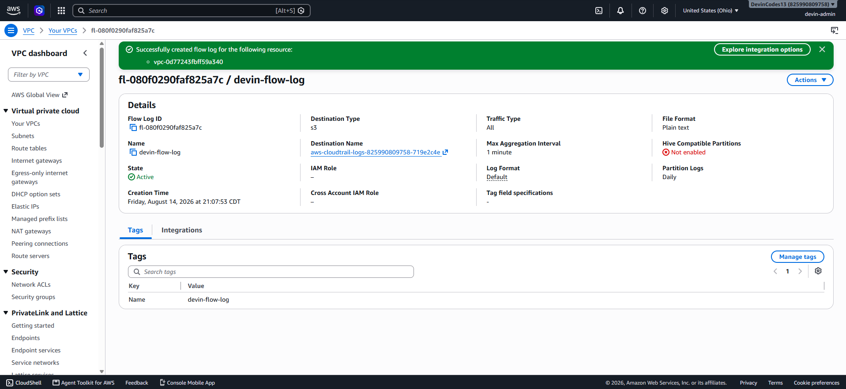
EVIDENCE VPC flow log active, Traffic Type: All, 1-minute aggregation, destination the shared S3 log bucket.
ANALYSIS

9 Threats Faced, What Was Hardened, and Why It Matters

9.1 Threats This Environment Actually Faced
Within hours of public-web receiving a public IP, its VPC Flow Logs captured repeated REJECT entries on port 22 from a wide spread of unrelated external IP addresses — automated internet background scanning, the constant baseline of traffic that hits any publicly reachable host looking for open SSH. This wasn't hypothetical: it's the same class of activity that hits every EC2 instance with a public IP, and it's the first thing the security groups in Section 4 were built to stop.
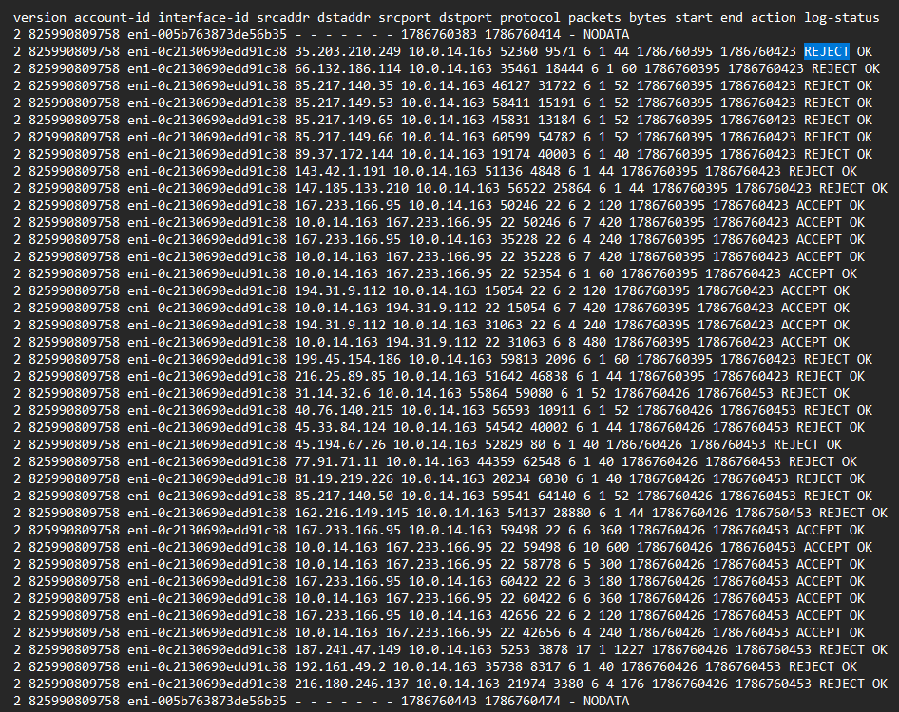
EVIDENCE Flow log excerpt: repeated REJECT entries on port 22 from many different external source IPs within seconds of each other — real, unsolicited scanning traffic, actively blocked.
Beyond that observed traffic, the environment's realistic threat model included: credential or session compromise of an over-privileged developer identity being used to pivot into unrelated account resources; a misconfigured or briefly-public S3 bucket exposing data to the internet, as happened deliberately here for demonstration; an admin account performing a destructive action (deleting a bucket, stopping the audit trail, tampering with security groups) without a second factor of confirmation; and an attacker or malicious insider covering their tracks by disabling or deleting logs after the fact.

9.2 What Was Hardened, and How It Maps to Those Threats
Threat | Control
Internet scanning / brute-force against SSH | public-sg restricted to a single known IP; private-sg reachable only from public-sg, not the internet or the whole VPC
Over-privileged identity compromise | Developer IAM policy scoped to tagged resources and one S3 bucket, with explicit denies on IAM/security-group/CloudTrail actions regardless of other grants
Accidental or malicious public data exposure | Block Public Access enforced on the bucket; customer-managed KMS key restricts who can even decrypt the data if access controls were ever bypassed
Unauthorized destructive admin action | AdminWithMFA denies IAM writes, resource deletion, and CloudTrail tampering unless the session is MFA-authenticated — proven to actually block real actions in Incidents 2 and 3
Covering tracks after a compromise | CloudTrail log file validation makes tampering detectable; the log bucket is separate from the data bucket; VPC Flow Logs provide an independent network-level record that doesn't depend on the attacker's actions inside the account being logged correctly

9.3 How This Improves the Environment's Security
The environment moved from a flat network with no logging, an internet-facing bucket, over-privileged IAM, and default encryption, to a segmented network with evidenced, tested access controls at every layer — network, storage, and identity — plus two independent, tamper-evident logging streams. Just as importantly, the controls weren't only designed; they were tested against real conditions, including three real failures, which is a more honest measure of whether a control actually works than a clean walkthrough would have been.
NEXT STEPS

10 Recommendations & Future Work

10.1 Open Items
– Investigate the root cause of the recurring aws:MultiFactorAuthPresent session gap (Incidents 2 and 3) rather than continuing to route around it — likely candidates include how the IAM console establishes session credentials versus how CLI/STS sessions do
– Complete the final swap to AdminWithMFA alone once the session-MFA issue above is understood and resolved, rather than deferred indefinitely
– Scope the CloudTrail S3 data event to the specific data bucket rather than all S3 buckets in the account — the console's simplified flow didn't expose this level of control during setup

10.2 Natural Extensions
– Add a managed database (RDS) in the private subnet to demonstrate database-specific hardening: encryption at rest, restricted security group access from the app tier only, and automated backups
– Add AWS Config rules to continuously detect drift back toward any of the “before” states documented in this report (e.g. a security group reopened to 0.0.0.0/0)
– Add GuardDuty for automated threat detection on top of the raw CloudTrail/Flow Log data already being collected

REFERENCE

11 Appendix

11.1 Appendix A — Developer IAM Policy (Final)
{
"Version": "2012-10-17",
"Statement": [
{ "Sid": "ViewOwnAccountInfo", "Effect": "Allow",
"Action": ["iam:GetUser","iam:ListUsers","iam:ChangePassword",
"iam:GetAccountPasswordPolicy"], "Resource": "*" },
{ "Sid": "Ec2DescribeAlways", "Effect": "Allow",
"Action": ["ec2:DescribeInstances","ec2:DescribeInstanceStatus",
"ec2:DescribeSecurityGroups","ec2:DescribeSubnets",
"ec2:DescribeVpcs","ec2:DescribeTags"], "Resource": "*" },
{ "Sid": "Ec2ManageOnlyOwnTaggedInstances", "Effect": "Allow",
"Action": ["ec2:StartInstances","ec2:StopInstances","ec2:RebootInstances"],
"Resource": "arn:aws:ec2:*:*:instance/*",
"Condition": {"StringEquals": {"aws:ResourceTag/Owner": "developer"}} },
{ "Sid": "S3AccessSingleBucketOnly", "Effect": "Allow",
"Action": ["s3:GetObject","s3:PutObject","s3:ListBucket"],
"Resource": ["arn:aws:s3:::devin-lab-bucket-2026",
"arn:aws:s3:::devin-lab-bucket-2026/*"] },
{ "Sid": "ExplicitDenySensitiveActions", "Effect": "Deny",
"Action": ["iam:CreateUser","iam:DeleteUser","iam:CreateAccessKey",
"iam:AttachUserPolicy","iam:PutUserPolicy","iam:CreatePolicy",
"iam:DeletePolicy","ec2:TerminateInstances",
"ec2:DeleteSecurityGroup","ec2:AuthorizeSecurityGroupIngress",
"ec2:RevokeSecurityGroupIngress","s3:DeleteBucket",
"s3:PutBucketPolicy","s3:PutBucketAcl","cloudtrail:StopLogging",
"cloudtrail:DeleteTrail","cloudtrail:UpdateTrail"],
"Resource": "*" }
]
}

11.2 Appendix B — Admin IAM Policy (v2, Corrected)
Version 2, patched after live testing surfaced gaps in IAM group-visibility and CloudTrail's newer list action (see Section 6.3).
{
"Version": "2012-10-17",
"Statement": [
{ "Sid": "BroadOperationalAccess", "Effect": "Allow",
"Action": ["ec2:*","s3:*","cloudtrail:LookupEvents",
"cloudtrail:DescribeTrails","cloudtrail:ListTrails",
"cloudtrail:GetTrailStatus","cloudtrail:GetEventSelectors",
"cloudtrail:ListTags","logs:*","iam:GetUser","iam:ListUsers",
"iam:ListRoles","iam:ListPolicies","iam:GetPolicy",
"iam:GetPolicyVersion","iam:ListGroups","iam:GetGroup",
"iam:ListGroupsForUser","iam:ListGroupPolicies",
"iam:ListAttachedGroupPolicies","iam:ListEntitiesForPolicy",
"iam:ListRolePolicies","iam:ListAttachedRolePolicies",
"iam:GetRole","budgets:ViewBudget","kms:ListKeys",
"kms:ListAliases","kms:DescribeKey"], "Resource": "*" },
{ "Sid": "RequireMfaForDestructiveOrSensitiveActions", "Effect": "Deny",
"Action": ["iam:CreateUser","iam:DeleteUser","iam:CreateAccessKey",
"iam:DeleteAccessKey","iam:AttachUserPolicy",
"iam:DetachUserPolicy","iam:PutUserPolicy","iam:CreatePolicy",
"iam:DeletePolicy","iam:CreatePolicyVersion",
"iam:AttachGroupPolicy","iam:DetachGroupPolicy",
"ec2:TerminateInstances","ec2:DeleteVpc","ec2:DeleteSubnet",
"ec2:DeleteSecurityGroup","s3:DeleteBucket","s3:PutBucketPolicy",
"s3:PutBucketPublicAccessBlock","cloudtrail:StopLogging",
"cloudtrail:DeleteTrail","cloudtrail:UpdateTrail"],
"Resource": "*",
"Condition": {"BoolIfExists": {"aws:MultiFactorAuthPresent": "false"}} }
]
}

11.3 Appendix C — Tools Used
Category | Tools
Compute | Amazon EC2 (t2.micro), Amazon Linux 2023
Networking | Amazon VPC, security groups, Internet Gateway (no NAT Gateway)
Storage | Amazon S3
Encryption | AWS KMS (customer-managed key)
Identity | IAM users, groups, customer-managed policies, IAM Policy Simulator
Logging | AWS CloudTrail, VPC Flow Logs
Cost control | AWS Budgets

