HOME SOC LITE LAB
Architecture, custom detection engineering, and end-to-end incident investigation on Wazuh and Splunk

PREPARED BY Devin
DATE August 2026
linkedin.com/in/devin-phillips-b35700269 · github.com/DevinCodes13 · 144kfilms@gmail.com
Detections built | Attack sources | SIEM platforms
3 custom Wazuh rules, tested against live attack traffic | SSH brute force (Hydra), full-port SYN scan (Nmap) | Wazuh (Manager + Dashboard) and Splunk Enterprise, run in parallel

1 Executive Summary
Three VMs, two SIEM platforms, one attacker box. This lab simulates a minimal real-world SOC: a central log aggregation/analysis host running both Wazuh and Splunk in parallel, a monitored Windows endpoint, and a separate adversarial machine used to generate genuine attack traffic — not synthetic test data.
Three custom Wazuh detections were designed, built, and validated against live attack traffic: SSH brute-force detection, a follow-on rule for a successful login immediately after a brute-force pattern, and a port-scan detection built on a custom UFW firewall-log decoder. All three were confirmed working end-to-end via wazuh-logtest and the Wazuh dashboard, using real Hydra and Nmap runs from the Kali attacker box as the trigger.
This report also documents the build's real troubleshooting history — malformed rule XML that broke the Wazuh manager outright, a UFW logging pipeline that had to be wired through rsyslog by hand, decoder parent-chain semantics that silently break child-decoder inheritance, and a Windows Event Log permissions issue on the Sysmon channel that was root-caused but not fully closed out within the captured build sessions (see Section 4.4).

2 Architecture
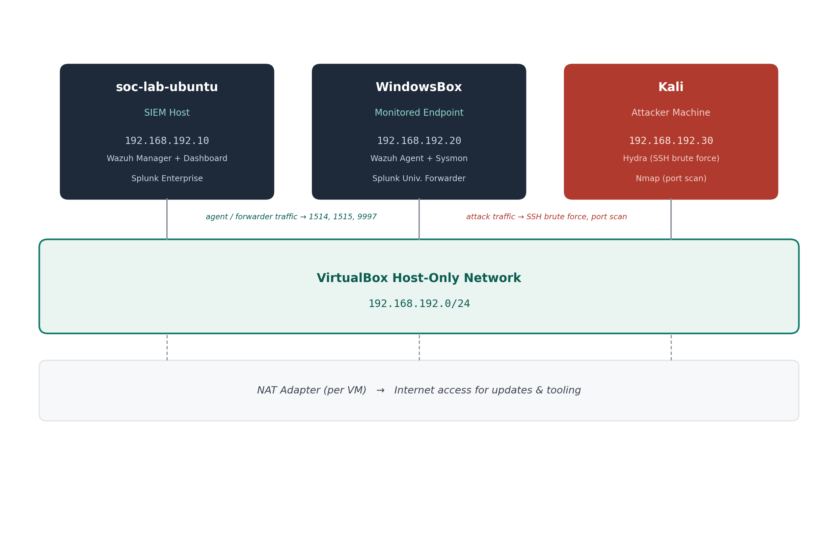
DIAGRAM Network topology as uploaded to the repo (architecture.png).
Component | Details
SIEM Host (soc-lab-ubuntu) | Ubuntu Server · 192.168.192.10 — Wazuh Manager + Dashboard, Splunk Enterprise
Monitored Endpoint (WindowsBox) | Windows 11 · 192.168.192.20 — Wazuh Agent, Sysmon (SwiftOnSecurity config), Splunk Universal Forwarder
Attacker Machine (Kali) | Kali Linux · 192.168.192.30 — Hydra, Nmap
Network | VirtualBox host-only adapter (192.168.192.0/24) for lab traffic; independent NAT adapter per VM for internet access

3 Detections
Four rules across two detection pipelines, defined in local_rules.xml and (for the port-scan pipeline) local_decoder.xml — both included verbatim in the Appendix.
Rule ID(s) | Detection | MITRE ATT&CK | Logic
100010 | SSH brute force | T1110.001 | 4+ failed SSH logins from the same source IP within 60 seconds (base rule 5760, frequency="3" = 3 matches beyond the first)
100011 | Successful login following brute force | T1110.001 | Successful SSH login (base rule 5715) from a source IP that just triggered 100010 — depends on event ordering
100012 / 100013 | Port scan (firewall block correlation) | T1046 | 100013 escalates when 10+ UFW-blocked connection attempts occur from the same source within 30 seconds
DESIGN NOTE
Rule 100012 matches directly against the raw UFW log line (<match>UFW BLOCK</match>) rather than depending on the custom ufw-block decoder's resolved name — decoder-name resolution for <decoded_as> proved unreliable after chaining under Wazuh's built-in "kernel" decoder in this environment. The decoder is still included and used for its srcip/dstip field extraction, verified working via wazuh-logtest, but rule matching itself was made more robust by not depending on it.

4 Build Narrative

4.1 SSH Brute-Force Detection
The first attack simulated was an SSH brute-force run from Kali against the SIEM host's socadmin account using Hydra with a small password wordlist. Before the attack could be reviewed, Splunk on soc-lab-ubuntu was found stopped and had to be restarted. The brute-force run (source 192.168.192.30) was then confirmed landing in /var/log/auth.log — multiple failed password attempts followed by an accepted login.
Detection work then centered on the SIEM host: verifying Wazuh manager/dashboard health after a restart, and writing rule 100010 against the default sshd "Failed password" base rule (5760). Rule 100011 was added as a second-stage escalation — a successful login (5715) from a source IP that had just triggered 100010 — deliberately designed as a stronger, lower-noise signal than either condition alone, since a successful login on its own is normal but a successful login immediately after a brute-force pattern is not.

4.2 Port-Scan Detection
The second pipeline came from repeated full-port SYN scans (nmap -sS -p-) run from Kali against the SIEM host across a session, used to generate reconnaissance traffic for detection to catch. UFW isn't understood by Wazuh's ruleset out of the box, so this required building a custom decoder from scratch (local_decoder.xml) chained under Wazuh's built-in "kernel" decoder, plus enabling UFW logging and wiring the resulting kernel log lines through rsyslog into a file Wazuh could actually read.
Once the pipeline was live, rules 100012 (any UFW block) and 100013 (10+ blocks from one source in 30 seconds — the signature of an automated port scan) were added and validated: early scans showed ports 22, 443, 1514, 1515, and 55000 open on the target; later scans after UFW hardening showed those ports narrowing to filtered/closed as firewall rules tightened.

4.3 Cross-Platform Correlation
Wazuh and Splunk were run in parallel against the same log sources deliberately, so findings on one platform could be cross-checked against the other rather than trusted on a single pipeline's say-so.

4.4 Windows Sysmon Forwarding — Diagnosed, Not Yet Closed Out
On WindowsBox, the Splunk Universal Forwarder was configured with monitor stanzas for WinEventLog:Security, WinEventLog:System, and WinEventLog:Microsoft-Windows-Sysmon/Operational. The Security and System monitors came up cleanly and confirmed real data flow via splunk.exe list inputstatus. The Sysmon monitor did not.
splunkd.log showed a channel subscription failure — errorCode=5 (Windows Access Denied) — when the forwarder's service account (NT SERVICE\SplunkForwarder) tried to subscribe to the Sysmon operational channel, which by default restricts read access to specific SIDs. Restarting the forwarder service did not clear the error, confirming this is a channel-ACL permissions issue rather than a stale service state. As captured, the fix (adding the forwarder's service account to the Sysmon channel's channelAccess ACL, or to the "Event Log Readers" group) was identified but not yet applied and re-verified by the end of that session.
OPEN ITEM
- Root cause is confirmed (channel ACL, errorCode=5) but the fix was not re-verified as applied within the captured build sessions.
- Next step: apply the channelAccess/group-membership fix on WindowsBox and confirm Sysmon events start flowing via splunk.exe list inputstatus and a live search.

5 Troubleshooting Log
The real configuration errors hit and resolved while building the detections — kept here because the fixes are non-obvious.
Issue | Cause | Fix
wazuh-manager.service failed to start; wazuh-analysisd: CRITICAL: Error loading the rules | Custom rule 100010 in local_rules.xml was missing a closing > on the opening <rule ...> tag, breaking the XML | Corrected the malformed tag and restarted wazuh-manager
wazuh-logtest matched raw SSH failure lines only to generic rule 1002 ("Unknown problem") | The custom brute-force rule wasn't yet correctly wired to the decoded event's base SID | Resolved once the correlation rule was pointed at the correct base rule (5760) and validated via wazuh-logtest
tail: cannot open '/var/log/ufw.log' (repeated) | UFW logging was enabled but no traffic had yet been blocked, and/or rsyslog wasn't routing kernel UFW messages to that file yet | Restarted rsyslog and generated blocked traffic from Kali (Nmap/Hydra); the file was created and populated once both conditions were met
wazuh-logcollector: ERROR: Could not open file '/var/log/ufw.log' | ossec.conf's <localfile> block pointed at the log path before the file existed | Resolved once UFW actually began logging block events to that path
wazuh-analysisd: ERROR: Syntax error on regex: '\[UFW BLOCK\]' | The prematch regex used escaped brackets, which Wazuh's regex engine rejected | Simplified prematch to the plain string UFW BLOCK with no escaped brackets
wazuh-analysisd: ERROR: Parent decoder name invalid: 'ufw-block' | The decoder was defined with <program_name>kernel</program_name> instead of <parent>kernel</parent>, so it wasn't a valid parent for child decoders | Changed to <parent>kernel</parent> and added <use_own_name>yes</use_own_name>
Legitimate lab traffic (agent/manager comms) dropped after tightening UFW | Narrowing "allow from subnet" to "allow ... to any port 22" also blocked port 443 traffic the Wazuh dashboard needed | Added an explicit ufw allow from 192.168.192.0/24 to any port 443 rule after observing the blocked traffic in ufw.log
Sysmon events not forwarding; WinEventLogChannel::subscribeToEvtChannel errorCode=5 | SplunkForwarder service account lacks read permission on the Sysmon operational channel's ACL | Root-caused; fix identified but not yet re-verified as applied (see Section 4.4)

6 Lessons Learned
- Malformed custom Wazuh XML (rules or decoders) causes wazuh-manager to fail to start entirely — check ossec.log / journalctl -xeu wazuh-manager immediately after any edit, not just systemd's generic failure message.
- Decoder <parent> chains must reference a decoder that itself declares <parent> correctly, plus <use_own_name>yes</use_own_name> if child decoders need to attach — using <program_name> instead of <parent> on the base decoder silently breaks inheritance.
- UFW log entries don't appear until rsyslog is actively routing kernel [UFW BLOCK] messages and at least one packet has actually been blocked — an empty/missing log file is expected before both conditions are met.
- Wazuh's frequency attribute counts matches beyond the first occurrence, not the total — frequency="3" means 4 total events.
- Broadening a firewall allow-rule to fix one problem can be too permissive from a monitoring standpoint; narrowing to specific ports is safer but requires verifying every legitimate traffic path first.
- A Windows Event Log channel can be visibly enabled (wevtutil, Get-WinEvent) while still being inaccessible to a service account due to channel ACL restrictions — restarting the consuming service does not fix an ACL problem.
- Iterative validation with wazuh-logtest against real captured log lines was essential for confirming decoder/rule fixes without regenerating attack traffic every time.

7 Limitations & Next Steps
This is a lab-scale environment, not a hardened production deployment. Detection thresholds were tuned against a single attacker on an isolated /24; all three detections are alert-only with no automated response; and coverage is currently limited to authentication abuse and network reconnaissance.
PLANNED NEXT STEPS
- Close out the Sysmon channel-ACL fix on WindowsBox and confirm Sysmon telemetry is actually flowing (Section 4.4).
- DNS-based threat detection.
- Active-response auto-blocking for the existing brute-force and port-scan rules.
- Expand the attack chain with tools like Metasploit for broader technique coverage.

8 Appendix

8.1 local_rules.xml (verbatim)
<!-- Local rules -->
<!-- Home SOC Lite Lab — custom detections -->
<!-- Wazuh manager: /var/ossec/etc/rules/local_rules.xml -->

<group name="local,syslog,sshd,">

<!--
Detection: SSH brute force attempt
MITRE ATT&CK: T1110.001 (Brute Force: Password Guessing)
Fires when the base Wazuh SSH-authentication-failure rule (5760) matches
4+ times from the same source IP within a 60-second window.

Note: Wazuh's frequency attribute counts matches beyond the first
occurrence, so frequency="3" = 4 total events, not 3.
-->
<rule id="100010" level="10" frequency="3" timeframe="60">
<if_matched_sid>5760</if_matched_sid>
<same_source_ip />
<description>Custom: SSH brute force - 4+ failed logins from same source in 60 seconds</description>
<mitre>
<id>T1110.001</id>
</mitre>
<group>authentication_failures,pci_dss_11.4,</group>
</rule>

<!--
Detection: Successful login following a brute-force pattern (possible compromise)
MITRE ATT&CK: T1110.001 (Brute Force: Password Guessing)
Fires when a successful SSH login (base rule 5715) occurs from the same
source IP that recently triggered rule 100010 above.

Note: this depends on the failed attempts being logged BEFORE the
successful one — event ordering matters for if_matched_sid to correlate.
-->
<rule id="100011" level="12">
<if_sid>5715</if_sid>
<if_matched_sid>100010</if_matched_sid>
<same_source_ip />
<description>Custom: Successful SSH login following brute force pattern - possible compromise</description>
<mitre>
<id>T1110.001</id>
</mitre>
<group>authentication_success,pci_dss_10.2.5,</group>
</rule>

<!--
Detection: Firewall block event (base rule for port-scan correlation)
Requires UFW to be enabled with logging on, and the ufw-block decoder
(see local_decoder.xml) — or, as implemented here, a direct text match
against the raw UFW log line, which proved more reliable than depending
on a custom decoder's resolved name.
-->
<rule id="100012" level="5">
<match>UFW BLOCK</match>
<description>Firewall: UFW blocked a connection attempt</description>
<group>firewall,</group>
</rule>

<!--
Detection: Possible port scan
MITRE ATT&CK: T1046 (Network Service Discovery)
Escalates when 10+ UFW-blocked connection attempts occur from the same
source IP within a 30-second window — the signature of an automated
port scan (e.g., nmap -sS -p-).
-->
<rule id="100013" level="10" frequency="10" timeframe="30">
<if_matched_sid>100012</if_matched_sid>
<same_source_ip />
<description>Custom: Possible port scan - 10+ blocked connections from same source in 30 seconds</description>
<mitre>
<id>T1046</id>
</mitre>
<group>recon,pci_dss_11.4,</group>
</rule>

</group>

8.2 local_decoder.xml (verbatim)
<!-- Local decoders -->
<!-- Home SOC Lite Lab — custom decoders -->
<!-- Wazuh manager: /var/ossec/etc/decoders/local_decoder.xml -->

<!--
Decoder: UFW firewall block events
Ubuntu's UFW does not have a dedicated decoder in Wazuh's default
ruleset. This decoder chains under Wazuh's built-in "kernel" decoder
(since UFW's blocked-connection log lines are emitted via the kernel
netfilter module) and extracts source IP / destination IP for use in
correlation rules.

Note: in this lab, decoder-name resolution for <decoded_as> in rules
proved unreliable after chaining under "kernel" — rule 100012 in
local_rules.xml ended up matching directly on the raw log text via
<match>UFW BLOCK</match> instead, which was more robust. This decoder
is kept here as a reference / for the srcip and dstip field extraction
it does provide via wazuh-logtest.
-->
<decoder name="ufw-block">
<parent>kernel</parent>
<prematch>UFW BLOCK</prematch>
<use_own_name>yes</use_own_name>
<regex offset="after_prematch">SRC=(\S+) DST=(\S+)</regex>
<order>srcip, dstip</order>
</decoder>

8.3 Session Index
This report was written from real captured terminal transcripts, screenshots, and notes across the sessions below, generated with LabScribe and checked by hand against the actual configuration files. Full per-session build logs are in this repo's docs/ folder.
Date | Session
2026-08-02 | Ubuntu Setup — Disk, LVM & Wazuh Install
2026-08-05 | Splunk Installation & HTTPS Setup
2026-08-05 | Windows VM Capture Agent Setup
2026-08-06 | Kali Capture Agent — Initial Setup
2026-08-06 | Simulating Attacks and Wazuh Filtering
2026-08-06 | Adding Wazuh Correlation Rules for Brute Force
2026-08-07 | Rule Adding and Conditions
2026-08-08 | Adding Custom Rules to Wazuh
2026-08-09 | Port Scan Detection

