## Module 1 Assignment: Web Basics

Devin Fries

Department of Information Technology, Arizona State University

IFT 458: Middleware Programming & Database Security

Dr. Dinesh Sthapit

August 27, 2023

1. App,js Code and Output Screenshots: 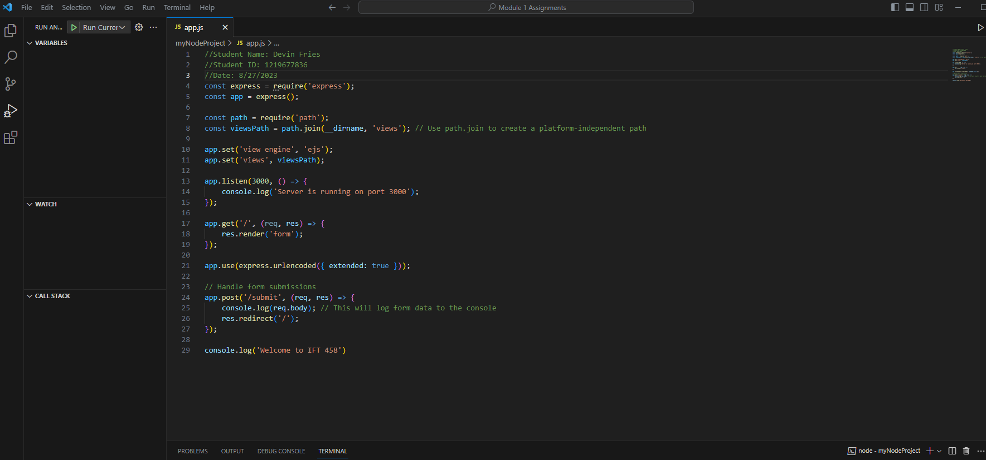



2. Form.ejs Code

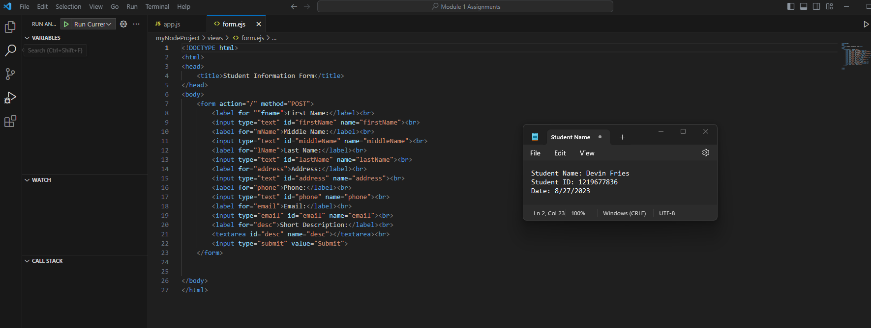

4. Localhost:3000 website: (**on the next page**)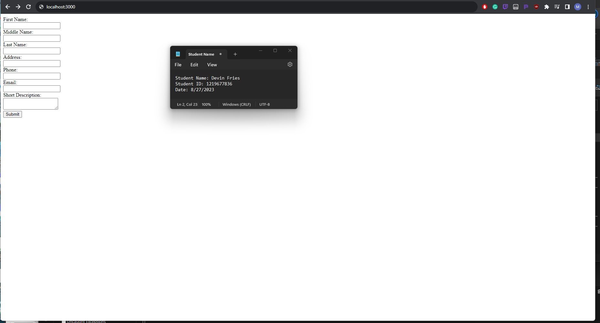

**References**

EJS. (n.d.). Embedded JavaScript templating. EJS. Retrieved from <https://ejs.co/#features>