Hyden-Assignment4.2
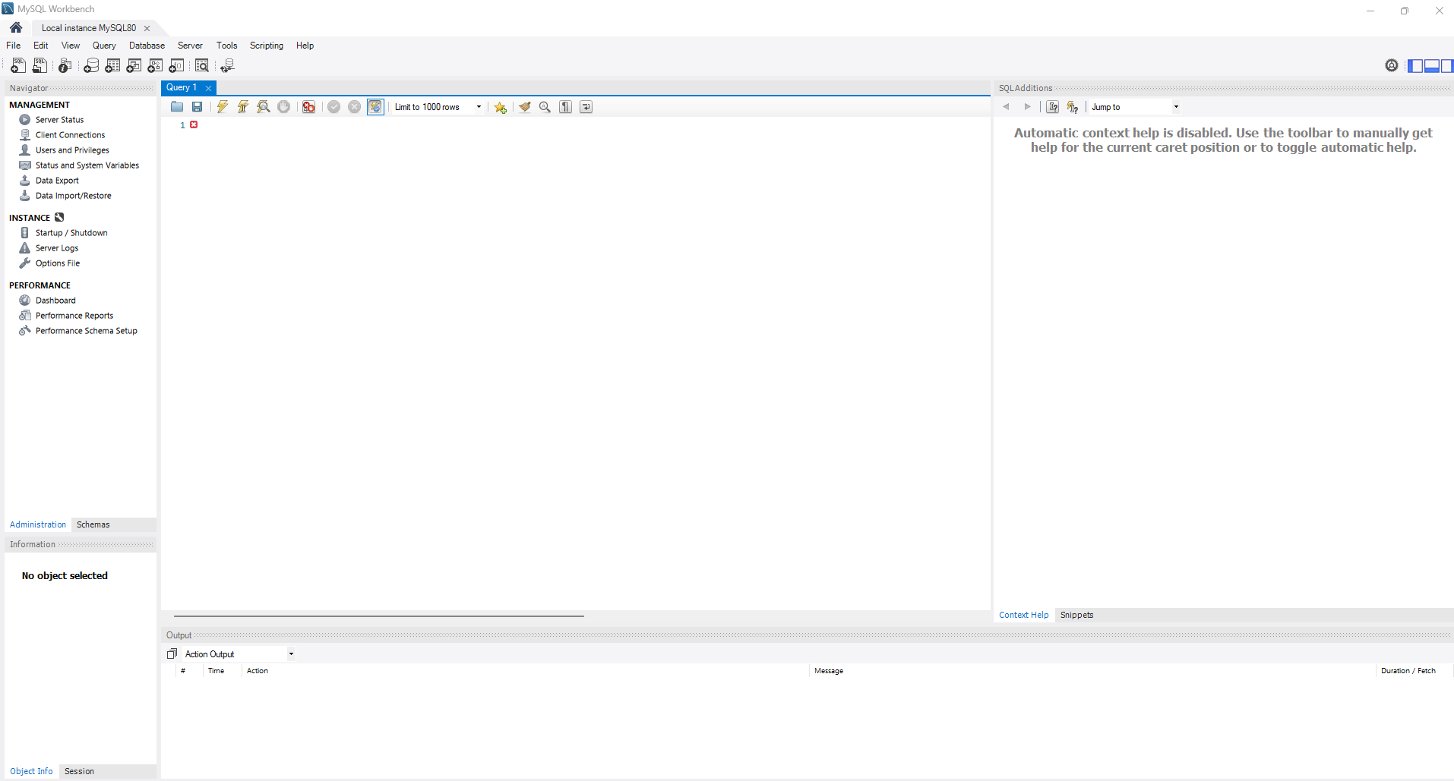
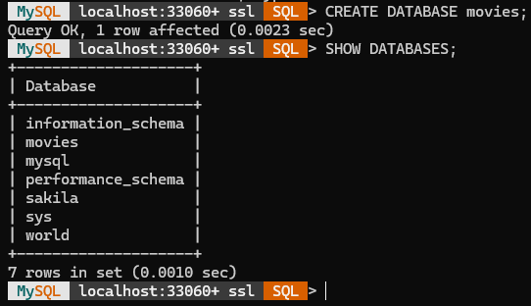

Function 1: COUNT()
When to use it: Use this when you need to know the total number of entries in a specific category, such as calculating the total inventory items or the number of customers in a specific country.
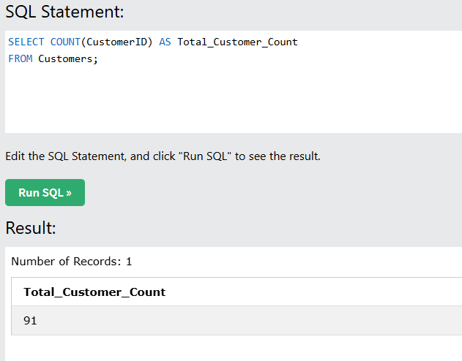
Function 2: UPPER()
When to use it: This is perfect for data normalization. If you’re preparing a mailing list or a formal report, and want all city names to look uniform regardless of how they were originally typed.
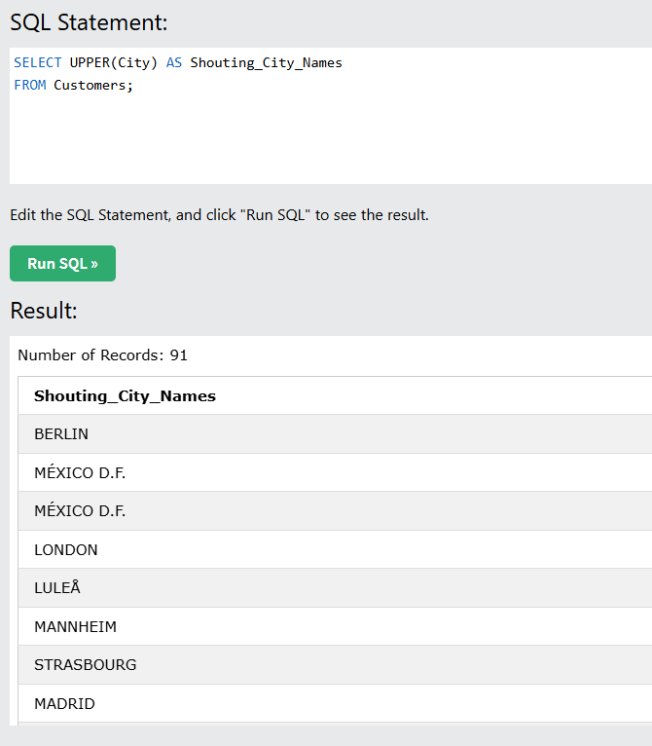
Function 3: ROUND()
When to use it: Used frequently in financial reporting. If your database stores prices with 4 decimal places, but your customer only needs to see the nearest whole dollar or 2 decimal places, ROUND() cleans that up.
