Hyden-Assignment5.2
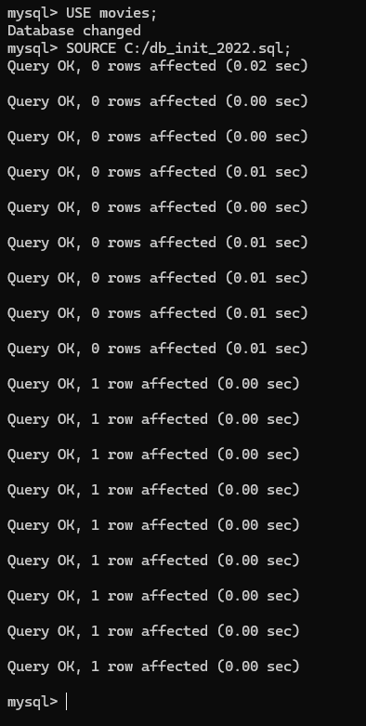
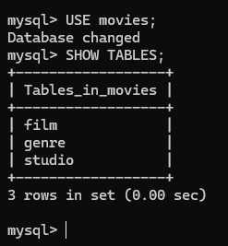

This is as far as I got. I have no clue what to do with Step 9, and I don’t have enough time in a day to figure it out.

