Devin G. Hyden
05 August 2026
Module 9.2 Assignment

Checking connection for api_tutorial: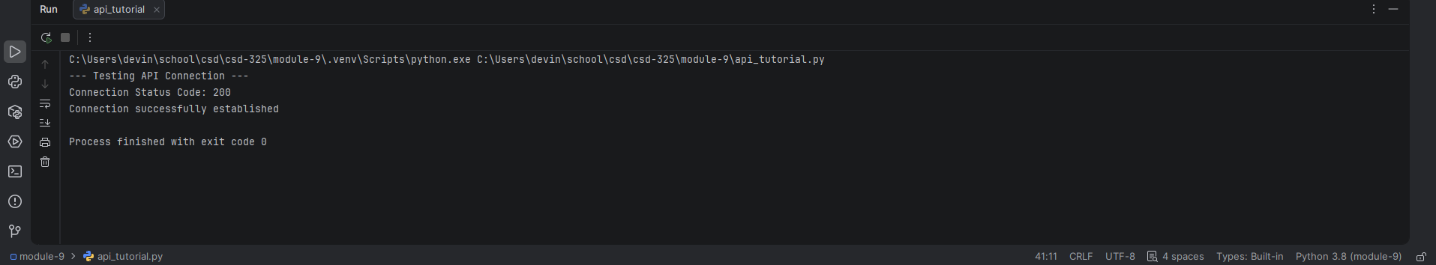
Raw Response and Formatted Response from Astronaut API: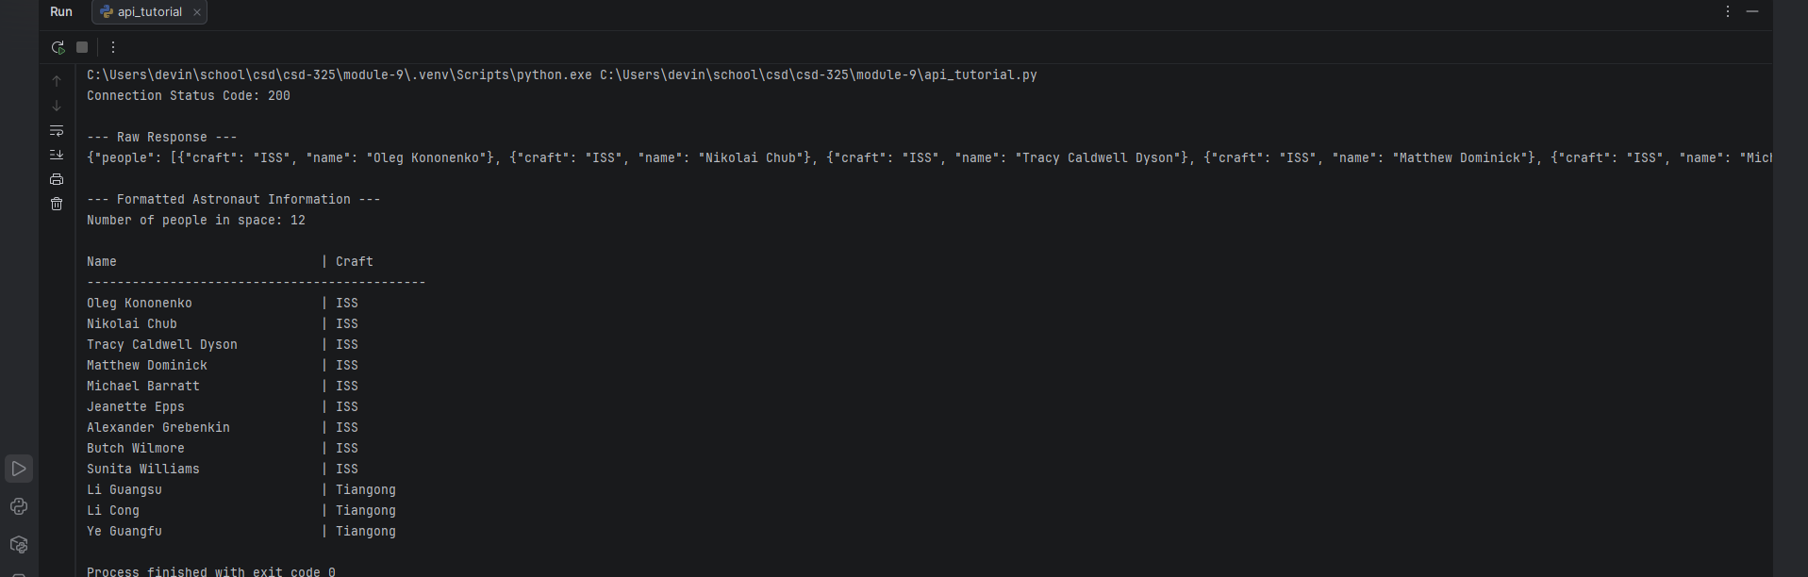
Raw Response and Formatted Response from Ice and Fire API: