Executive Summary

Description of Analysis

This document presents findings from the analysis of ITOL data collected by NYSBA’s tolling & analytics department. This consisted of compiling data into segments of interest, consisting of visuals and brief descriptions. ITOL data in the context of our analysis is used to represent both general tolling patterns as well as ITOL data, as specified in the analysis. This project was created by Jeff Weiss and Milind Bijur, as a way to gain experience in analytics while interning at NYSBA. The goal of this study is to find any patterns which might be present within our sample, and explain rationally why these might exist. Proposals of future steps regarding ITOL mitigation are included based on our research.

Each segment of this document will focus on a different element of the analysis. Segments include a visual, paired with a short write up highlighting key information from each study. Data involved pertains mostly to frequencies and percentages of transactions, where transaction dates and vehicle class are used to group data so to show any patterns present. Tag data in ITOL transactions is also included as a segment of interest, and provides insights into why these forms of tolls occur.

ITOLs

ITOLs are a form of ticketless tolling utilized by NYSBA. This form of tolling occurs when no transponder is detected during a transaction, but an E-ZPass account exists registered to the vehicle. In these cases, a license plate reader is used to identify if there is an existing account in good standing. If so, an ITOL is posted to the driver’s E-ZPass account, at a higher rate to compensate for costs associated with the process. It is important to note that during the analysis ITOL data is also used to represent other facets of tolling, such as traffic frequency and vehicle class frequencies as a whole.

Findings & Takeaways

Frequencies by date are displayed to convey traffic pattern which may occur over the course of the sample timeframe. This helps us to see when the frequency of ITOLs is at its highest, while also displaying any traffic patterns present. Patterns found can be referred to in the segment below.

From the analysis of ITOL data, an estimated *76.4 %* of transactions had no transponder/ improperly mounted transponders in their vehicles. *23.6 %* of these transactions do have a transponder mounted properly, which may reflect the issue of tags that are not reading properly. Since ITOLs have a higher fee associated, it is important that drivers realize early on when their tag is not reading properly. As time goes on this percentage may increase, as more tags reach their date of expiration. One way to mitigate these cases is to inform drivers of tag expiration, and share the process to replace expired tags.

The weekend/ weekday transaction frequency sections were purposed to show which classes are traveling on what days of the week, with weekends being the main focus. However, after the analysis it was found that Class 1 made up over *90 %* of our sample. This finding is displayed prominently on both the weekend and weekday transaction frequency graphs.

ITOLs Data Analysis

Transaction Frequency by Date

[trxbydatebarinteractive.html](file:///Z:\To%20Devin\trxbydatebarinteractive.html) [trxbydatelineinteractivedates.html](file:///Z:\To%20Devin\trxbydatelineinteractivedates.html)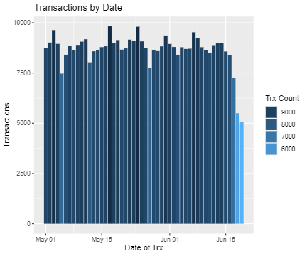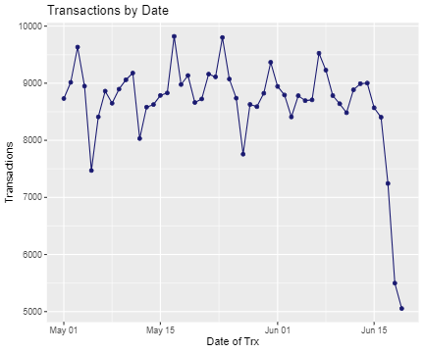

The Graphs above illustrate the frequency of ITOL transactions by date, spanning from May 1st to June 19th. On average, 8,654 ITOLs are generated each day, with the highest frequencies on Friday and lowest frequencies around Mondays. This likely fluctuates with the work week, with more drivers out on the road as the work week ends, but less as it begins. Fridays see an average of 800 more crossings than other days of the week.

With this info in mind, Fridays could be seen as an opportunity to convey messages to a large number of drivers. Roadside screens or advisories are more likely to be seen posted on these days. As you will see in the transponder data segment, reminders to properly mount tags or to replace expired tags on these days would be ideal as more drivers with ITOLs will be crossing.

Weekend Transaction Frequency

[Weekendinteractiveclean.html](file:///Z:\To%20Devin\Weekendinteractiveclean.html)

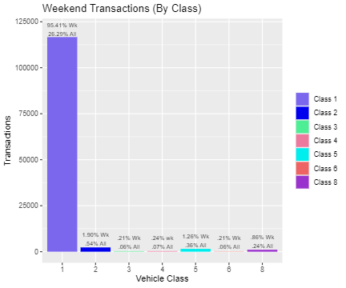

The weekend transaction graph contains frequencies of ITOL transactions occurring on weekends between 5/1 and 6/19 (14 days total). Transaction counts are sorted by vehicle class (1-6, 8) to better organize and also look into frequencies of each class.

From this data, we can see that class 1 greatly outnumbers all other vehicle classes. Over *95 %* of all weekend transactions are class 1. It is important to note that weekend transactions in class 1 make up about a quarter of all transactions recorded, despite more than 2x the number of weekdays being recorded. Class 1 also makes up a higher proportion of weekend transaction than weekday, with there being *5 %* more class 1 crossings on the weekends than weekdays. This also means that weekends have less of a diverse set of classes, with other classes making up less than *5 %* of weekend transactions.

Weekday Transaction Frequency

[Weekdayinteractiveclean.html](file:///Z:\To%20Devin\Weekdayinteractiveclean.html)

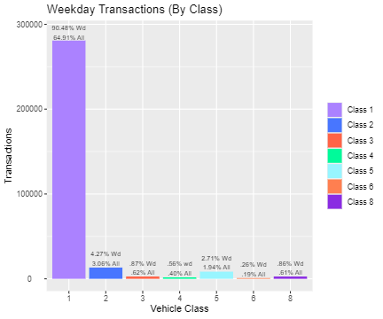

Similar to the previous graph, this graph depicts transaction frequencies by vehicle class for weekdays. Class 1 remains the primary interest, as they make up almost *65 %* of all transactions in our dataset. It should also be noted that other classes for the most part make up a larger percentage of weekday transactions than weekends (although by a small margin). All in all, class 1 transactions make up *91.2 %* of all transactions in the study. Thus, other classes occupy just *9 %* of all transactions.

ITOL Transponder Data

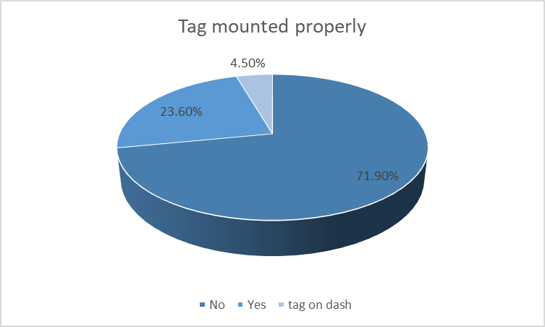

From the ITOL dataset, we further sampled data to see if vehicles tolled had a properly mounted tag. From this, three categories were extracted which made up a large portion of observations. These are:

* No (no tag, or tag mounted improperly)
* Yes (properly mounted tag present)
* Tag on dash (transponder is sitting on dashboard).

Given the percentage of vehicles with no tag or an improperly mounted tag, it is important to emphasize to E-ZPass holders the correct way to mount tags. Simply mounting a tag anywhere (or leaving it on the dash) will not guarantee a transponder will be read. By encouraging and demonstrating a proper tag placement, satisfaction among E-ZPass holders may increase, as many may feel the higher toll rate is not appropriate.

Equally important is the rate of ITOLs with a properly mounted tag. Having a properly mounted tag but generating an ITOL can be a sign that the tag has expired, or cannot be read. As time goes on, this figure is prone to increase as more and more tags reach their expiration date. Steps to take to prevent this may include an alert system, which prompts tag holders when an ITOL occurs and reminds users the proper way to mount their tag, and to replace older tags. Since there is a higher toll associated with an ITOL, it is important that drivers realize when their tag placement is off or tag is expired.