Github Fork 仓库代码协同SOP

|  |  |  |
| --- | --- | --- |
| Step | Action | Remark |
| 1.同步github 仓库和主仓库对齐 | Sync from main code base | Website |
| 2.同步本地仓库和自己github 仓库对齐 | git pull | localhost |
| 3.检查同步mysql database | Mysql import sql | Mysql |
| 4.修改提交本地仓库代码 | git status , git add ,git commit | localhost |
| 5.推送本地改动到github | git push | localhost |
| 6.创建pull request 给主仓库 | Create pull request | Website |
|  |  |  |

|  |  |  |
| --- | --- | --- |
| 1.同步github 仓库和主仓库对齐 | Sync fork main code base | Website |

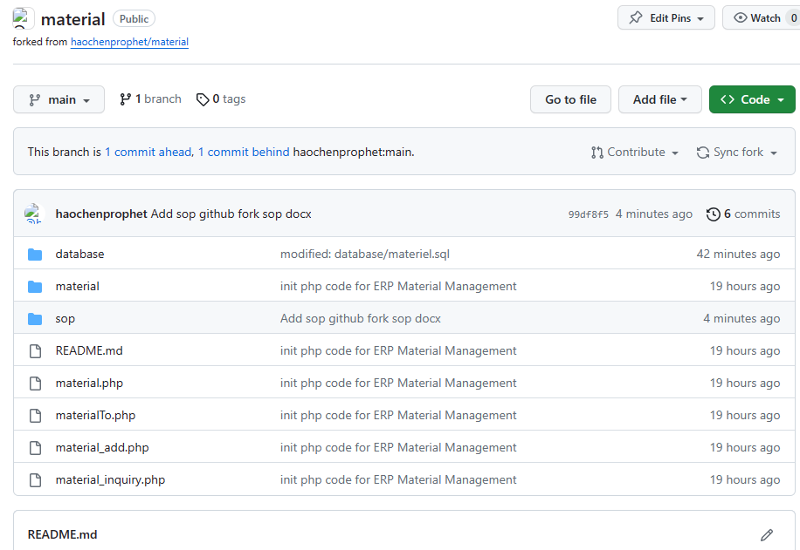

|  |  |  |
| --- | --- | --- |
| 2.同步本地仓库和自己github 仓库对齐 | git pull | localhost |

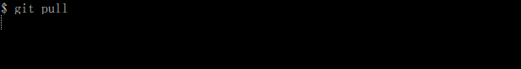

|  |  |  |
| --- | --- | --- |
| 3.检查同步mysql database | Mysql import sql | Mysql |

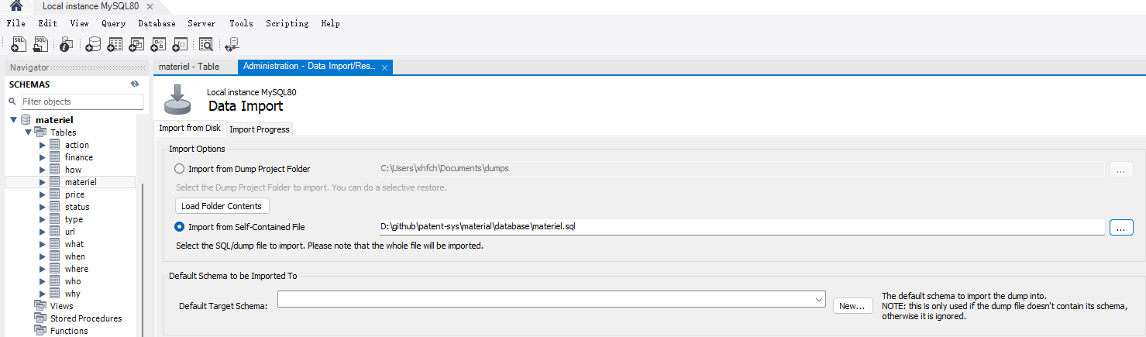

|  |  |  |
| --- | --- | --- |
| 6.创建pull request 给主仓库 | Create pull request | Website |

