A screenshot of a cell phone

Description generated with very high confidence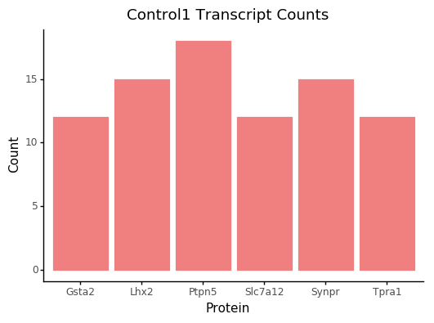A screenshot of a cell phone

Description generated with very high confidenceA screenshot of a cell phone

Description generated with very high confidenceA screenshot of a cell phone

Description generated with high confidence