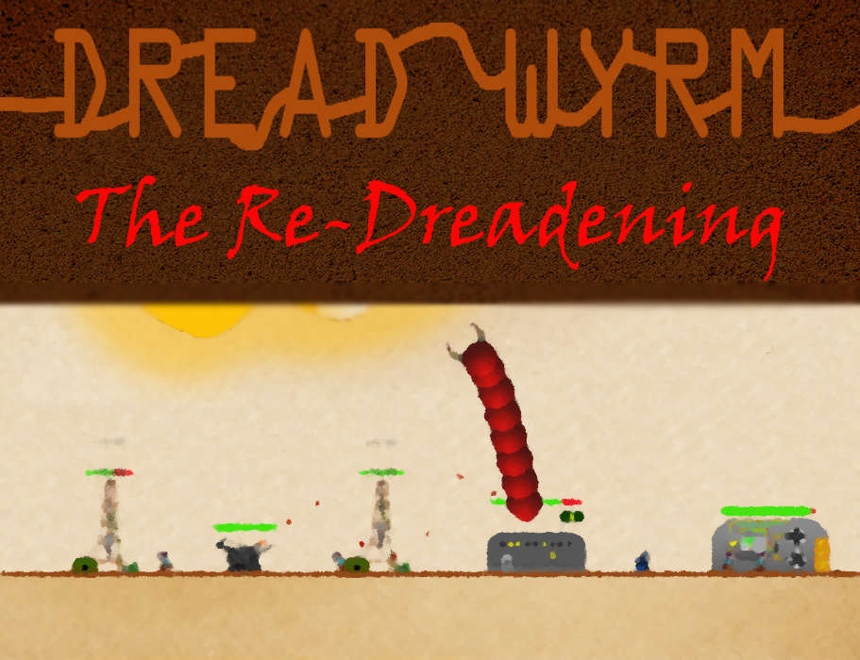

Player’s Manual

Table of Contents

Installation 1

System Requirements 1

Installation Instructions 1

Introduction 2

Gameplay 3

Singleplayer 3

*In-game Controls* 4

*Upgrade Menu* 6

*Pause Menu* 8

Multiplayer 9

*In-game Controls* 9

*Buildings* 10

*Units* 12

Acknowledgements & Credits 13

Notes 14

Installation

## System Requirements

* Windows XP or later Operating System
* Graphics Device which supports DirectX 9.0c or later
* Keyboard
* Mouse if multiplayer play is desired

## Installation Instructions

After unzipping DreadWyrm.zip, run the setup.exe located in the directory you unzipped the game to. This will install all necessary software required to run Dread Wyrm: The Re-Dreadening.

To run the game after it has been installed, just run (by double-clicking on) the DreadWyrm2.application file.

Introduction

Every 65 Million Years, a new Dread Wyrm Spawn descends from the Mother Wyrm to consume all life on Earth. Against the previous wrym spawn, the dinosaurs didn’t stand a chance. This time, however, a flourishing human civilization is ready to fight back.

It’s a life and death struggle between the giant man-eating wyrm creature that bursts forth from the flesh of the Earth to consume its quarry, and the technologically advanced human race armed with ***serious******firepower***. Choose your side, and prepare to enter the battlefield.

Gameplay

From the main title screen, selecting the options will start one of two modes: Singleplayer and Multiplayer.

In singleplayer, the player controls the wyrm to eat all of the prey and advance through the levels.

In multiplayer mode, two players compete head-to-head in a battle for survival. One player will control the wyrm, whilst the other will control the human encampment.

# Singleplayer

In singleplayer mode, the player controls the wyrm via the keyboard. There are 10 levels of increasing difficulty for the wyrm to complete. When all levels are complete, the game is over and the player has won. If the wyrm’s health is depleted before the levels are completed, the game is over and the player has lost.

## *In-game Controls*

The player is granted full control of the wyrm while the wyrm is in the ground. Once airborne, control of the wyrm is limited.

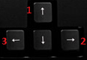

1 – Accelerates the wyrm in its current direction.

2, 3 – Turns the wyrm clockwise or counterclockwise, respectively

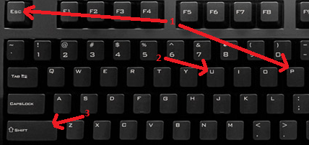

1 – Pauses the game and displays the Pause menu (see the Pause Menu section).

2 – Pauses the game and accesses the Upgrade menu (see the Upgrades section). This menu is only available in single-player.

3 – Allows the wyrm to sprint temporarily. This drains the stamina bar, which recharges when not sprinting.

## *Upgrade Menu*

Use the arrow keys to select the appropriate upgrade option. Pressing enter will purchase the selected upgrade. Note that each upgrade costs meat points, which are acquired by consuming prey. The price of these upgrades increases with subsequent purchases. Pressing U will exit the upgrade screen. Note that in multiplayer mode (see Multiplayer section, pg 7), press 1, 2, 3, or 4, to purchase the corresponding upgrade for the wyrm player.

**1. Metabolism Boost** (Health Regeneration) – This upgrade will heal 25% of the wyrm’s maximum health over a period of 10 seconds. Multiple boosts can be purchased at a time, up to a maximum of a full heal. A fully healthy wyrm may not purchase a boost.

**2. Fat Tissue** (Maximum Health Increase) – This upgrade increases the maximum health of the wyrm by 25 (starting value of 100), up to a limit. Note that increasing the maximum health does not heal the wyrm.

**3. Muscle Vibration** (Maximum Speed Increase) – This upgrade increases the maximum speed of the wyrm by 0.5 (starting value of 5), up to a limit of 7.

**4. Muscle Coiling** (Sprint Duration Increase) – This upgrade increases the stamina bar by 50 (starting value of 200), up to a limit of 500.

## *Pause Menu*

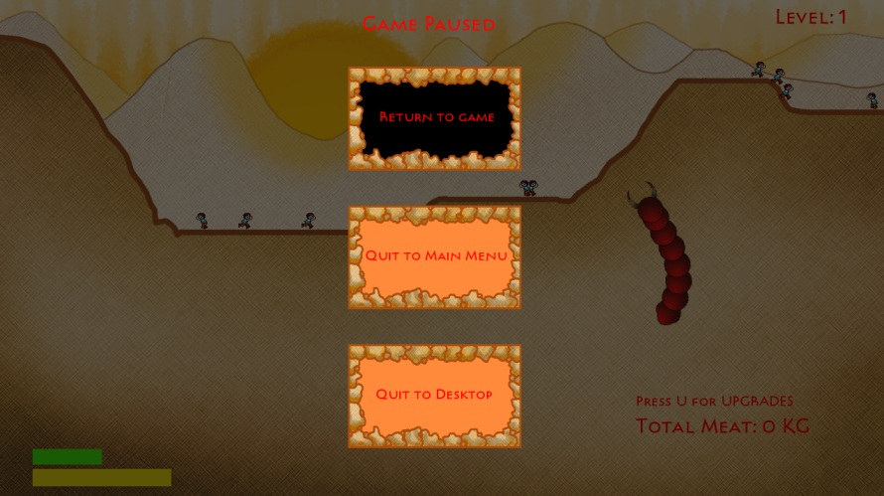

Use the arrow keys to navigate the pause menu. Press enter to select an option. The options are:

1. **Return to Game**: This option will unpause the game. You can also press the Esc or P key again to unpause.

2. **Quit to Main Menu:** This option quits the current game and returns to the game’s main menu.

3. **Quit to Desktop:** This option quits the game’s operation entirely.

# Multiplayer

In the multiplayer game mode, two players compete as the wyrm and the humans. The wyrm is controlled with the keyboard, and the humans are controlled using the mouse. The goal of the wyrm player is to destroy the human’s generator. The goal of the human player is to deplete the wyrm’s health. Whichever player reaches their goal first is determined to be the winner, and the game is over.

## *In-game Controls*

The wyrm player is controlled identically as in singleplayer, except concerning upgrades. There is no Upgrades menu, and instead the 1, 2, 3, and 4 keys purchase upgrades in real time.

The human player uses the mouse (by left-clicking) to purchase and place buildings, and to recruit soldiers. Building placement can be canceled with a right-click. Note that troops will act on their own accord, and are uncontrollable by either player.

## *Buildings*

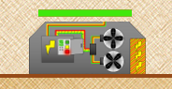

The human player’s **generator**, which is randomly placed at the beginning of the game. The human must protect this building at all costs. (PRICE: N/A)

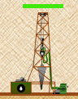



The **oil derrick** is used to generate funds for the human player every second. More than one of these buildings may be placed at once. When destroyed, this building will spawn unarmed humans. (PRICE: $1500)



The **turret** is the primary defensive structure. It will shoot at the wyrm if it is within range. Multiple of these buildings may be placed at once. When destroyed, this building will spawn soldiers. (PRICE $2500)

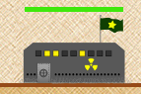



The **barracks** allows for the recruitment of soldiers. The soldiers will appear at the barracks door and are uncontrollable. Only one of these buildings may be placed at once. (PRICE: $3000)

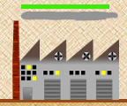



The **factory** allows for the construction of tanks. The tanks will appear at the factory door and are uncontrollable. Only one of these building may be placed at once. (PRICE: $6000)

## *Units*



Creates an **infantryman** at the barracks. These are basic infantry fighting units. They shoot at the Wyrm when it appears above the surface. (PRICE: $500)



Creates an **engineer** at the barracks. These lay mines and depth charges that the Wyrm must avoid. (PRICE: $800)

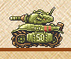



Creates a **tank** at the factory. These powerful vehicles can only shoot forward, but do massive damage on impact with the Wyrm. (PRICE: $2000).

Acknowledgements & Credits

Software Engineer

* Patrick Bloem

Creative Designer

* Jess Tate

Game Engine Resource Manager

* Caleb Pentecost

Technical Artist

* Devin Pentecost

Building Artist

* Sarah Thomas

Music

* Chris Dunleavy

Notes

**________________________________________________________________________________________________________________________________________________________________________________________________________________________________________________________________________________________________**

**________________________________________________**