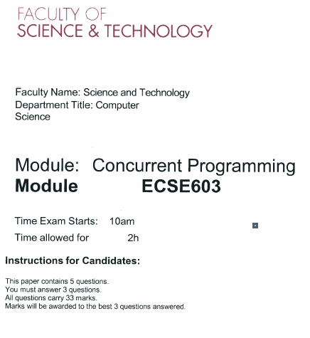

# Question 1

1. What is concurrent programming?
2. Issues with concurrent programming?

Concurrency issues you found: Need to explain these issues with example race conditions and interference

1. What are desired properties of concurrent programming (Safety properties & liveness properties, Deadlock, live lock differences)

Live lock – programme is running, but it doesn’t achieve the aim of the program

1. **Write a composite program to solve the problem of concurrency** 
   * 1. Define 2 FSP code
     2. Solve concurrent issues by modifying composite process

Process - Stage, Event

(Marks 19)

(Marks 33)

# Question 2

Venn diagram

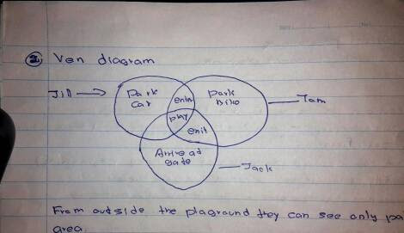

From outside the playground they can see only parking area

3 people Jack, Jill, Tom -> primitive process

Park car, park bike, arrive at gate are actions

1. Write a primitive process for Jack, Tom, Jill
2. Write a FSP for each primitive process
3. Write process alphabet for all the actions of the composite process in the diagram
4. Draw the trace tree for Jack
5. Draw LTSA graph for Tom
6. Briefly explain the following constructs used in FSP
   * 1. Single pipe (|)
     2. STOP
     3. When (Boolean expression) – This is a guarded condition
     4. -> explain the symbol (transition)

(Marks 33)

# Question 3

1. What are the 2 ways of implementing concurrent programming in java

(2014, 3, a)

1. Write a concurrent java program which consists of 2 threads, the 1st thread prints numbers 1-100 and the 2nd thread the letters a-z. Start both threads. Explain what is happening.

(Marks 12)

1. Modified the code you have written in previous question. So that the 2nd thread waits for the 1st thread to terminate before it begins the output.

(Marks 6)

1. Modify the subsection (3), so that each thread sleeps for 1 second after printing a number or a letter. Explain the output.

Ex: Output cannot be determined.

(Marks 7)

(Marks 33)

# Question 4

1. Explain the word monitor with suitable example (refer lecture note 7 and 9)

**Key words: encapsulating, controlled way, require in**

Example code: write producer consumer code

1. Compare CAR Hoare monitor concept with java monitor concepts.

Explain with suitable examples.

No need of a complete code. But you should include a **class**, a **method, a shared** **variable, value for isAvailable** variable and a **while loop**

(Marks 10)

1. Implement the following requirements using the most suitable concurrent programming concepts

Case Study: house based husband and career minded wife

(Marks 33)

# Question 5 - Semaphore

1. What do you understand by the term semaphore?

Operations: claim(), acquire(), release()

1. What are the different types of semaphores?
   1. General semaphore
   2. Binary semaphore
2. What are the differences between 2 types of semaphores?

(use a table format)

1. Write the code for semaphore using the producer consumer problem

(Marks 20)

(Marks 33)