Performance on X_train (No Scaling)
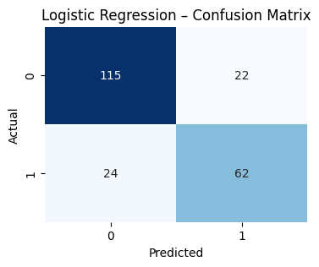
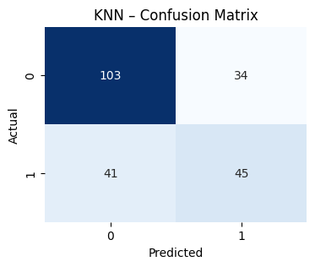
Accuracy: 66.37% Accuracy: 79.37%

Performance on X_train (With Scaling)
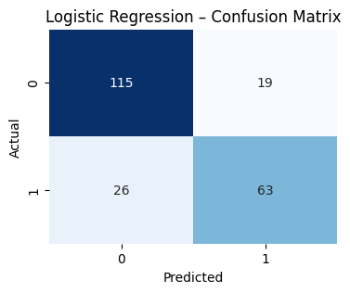
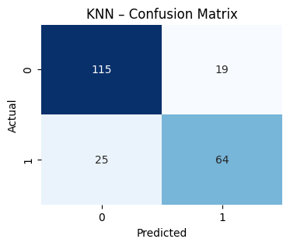
Accuracy: 80.27% Accuracy: 79.82%

Performance on X_train_linear (no scaling)
KNN
Accuracy: 70.85%
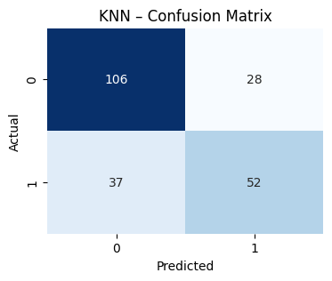
Logistic Regression
Accuracy: 80.27%
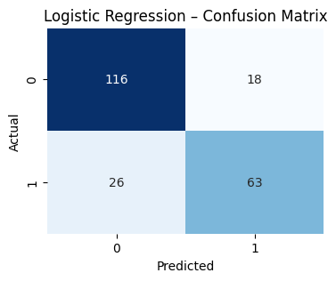
Performance on X_train_linear (With Scaling)
KNN
Accuracy: 81.17%
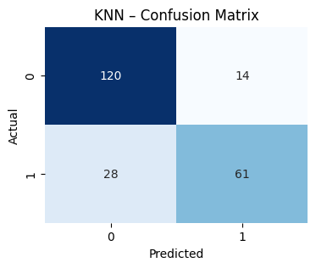
Logistic Regression
Accuracy: 80.27%
Performance on X_train_tree (no scaling)
KNN
Accuracy: 84.30%
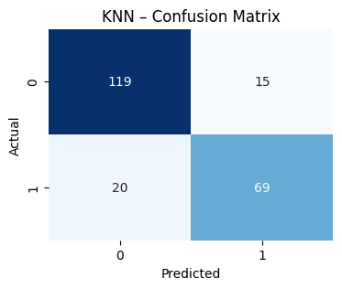
Logistic Regression
Accuracy: 80.27%
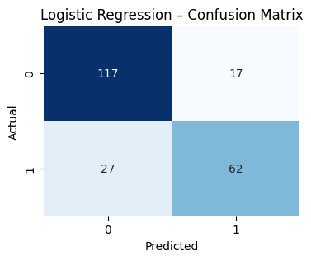
Performance on X_train_tree (With scaling)
KNN
Accuracy: 82.06%
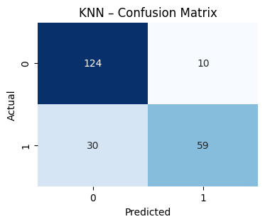
Logistic Regression
Accuracy: 79.82%

